[1] Appium is used for automated testing of Andriod and IOS apps.

[2] Use Eclipse for the IDE to write Appium code.

# [3] Appium setup:-

## (a) Download Java and set environment variable – JAVA_HOME

### You need to download Java 8 (as Appium is only compatible with Java 8)

<https://www.oracle.com/java/technologies/javase-downloads.html>

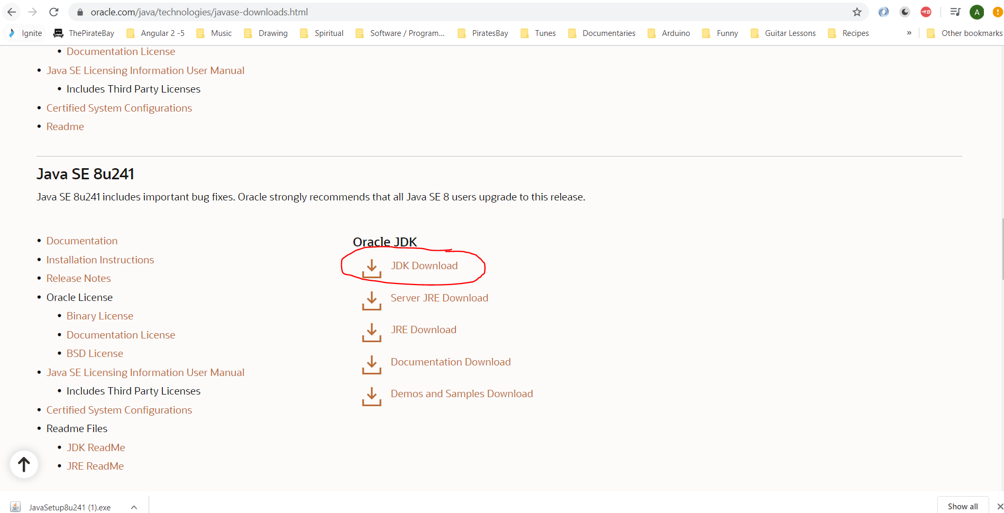

Then click on this:-

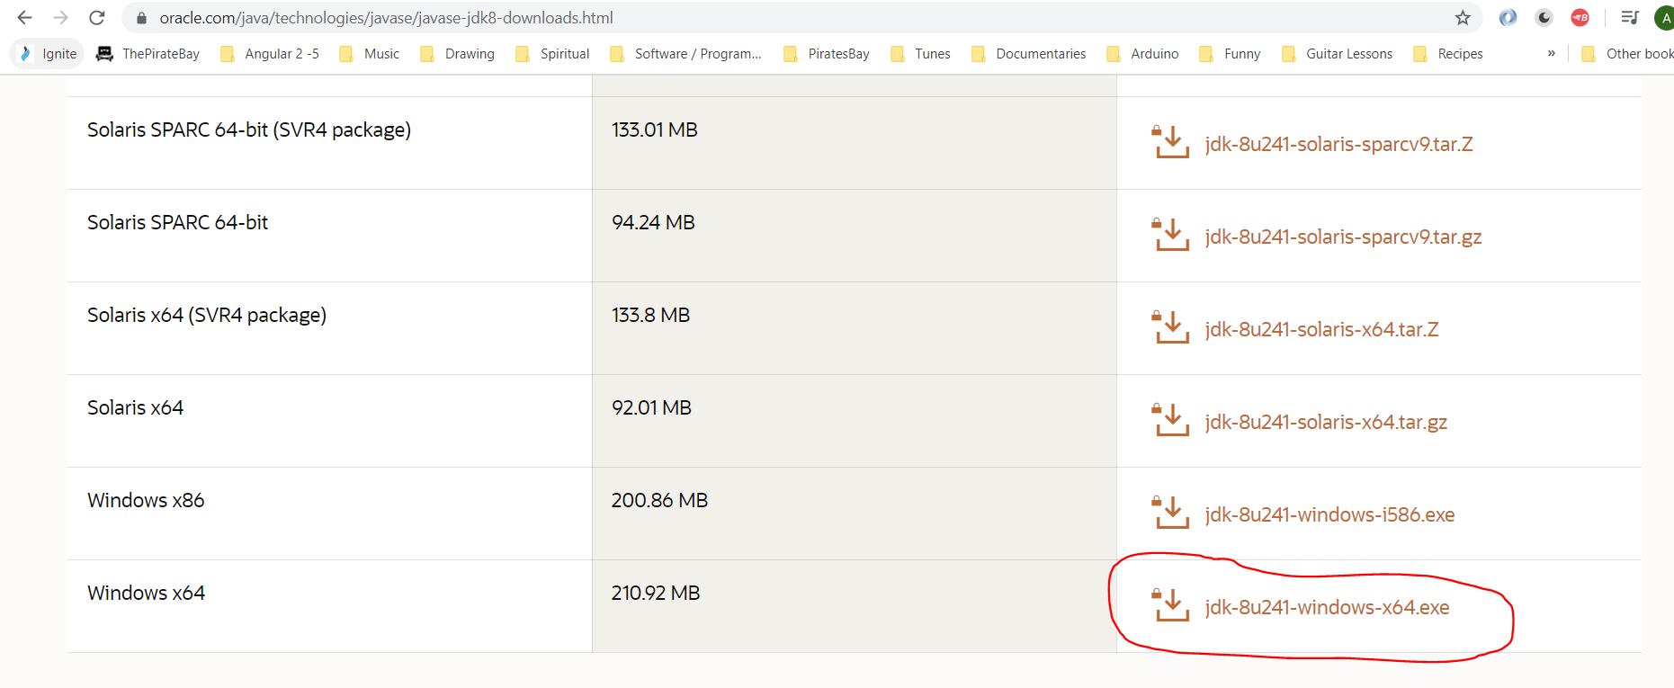

Sign into Oracle:-

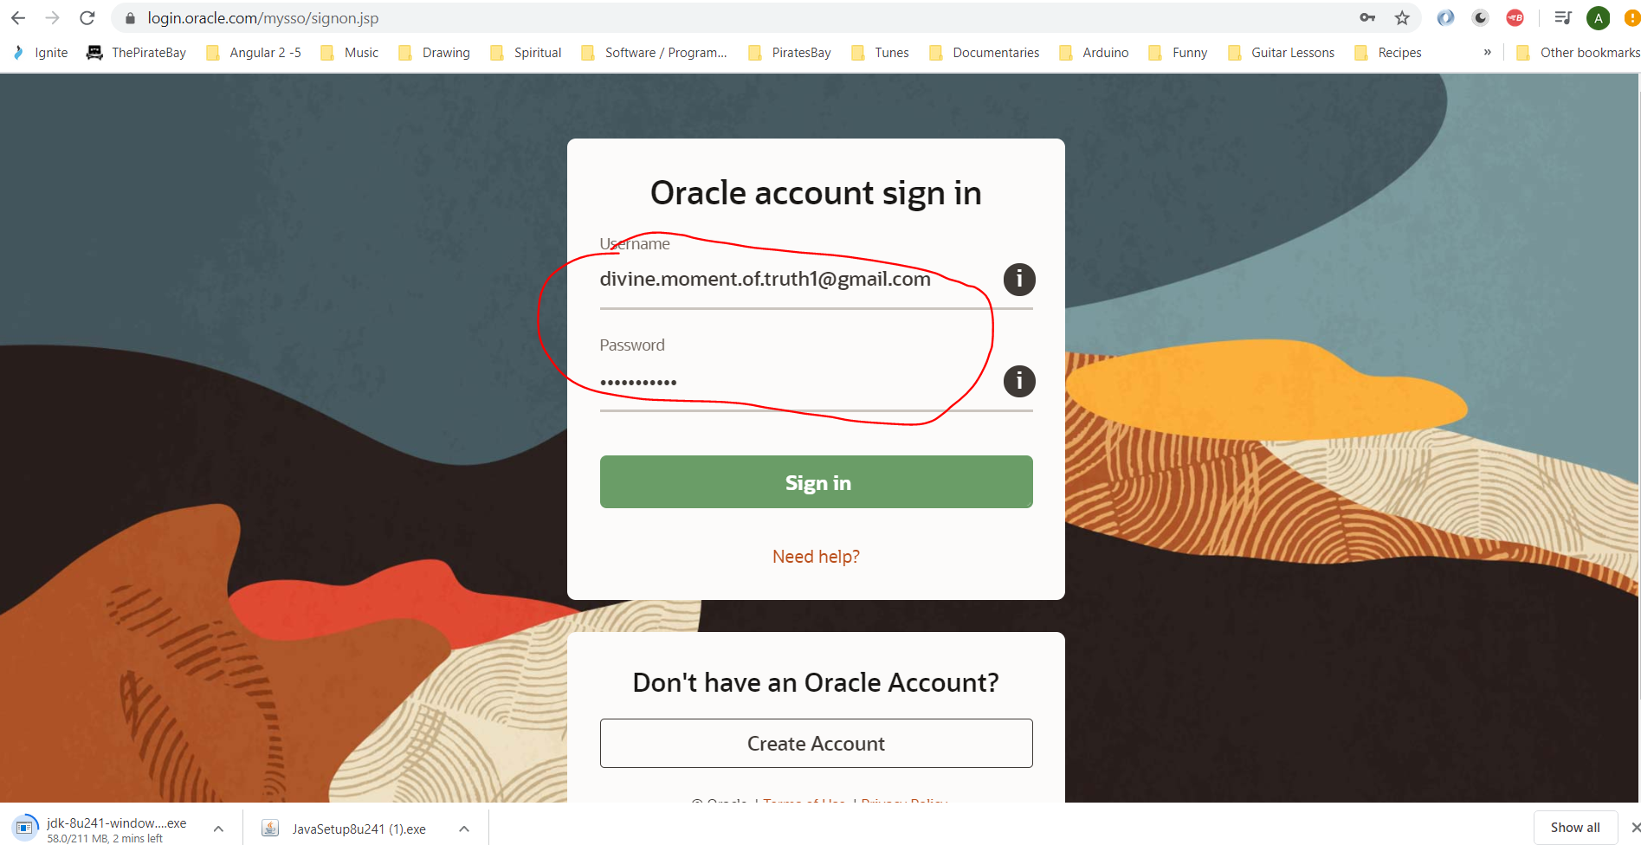

#### [Divine.moment.of.truth1@gmail.com](mailto:Divine.moment.of.truth1@gmail.com)

Dudeegg1977

See download file that needs to be installed:-

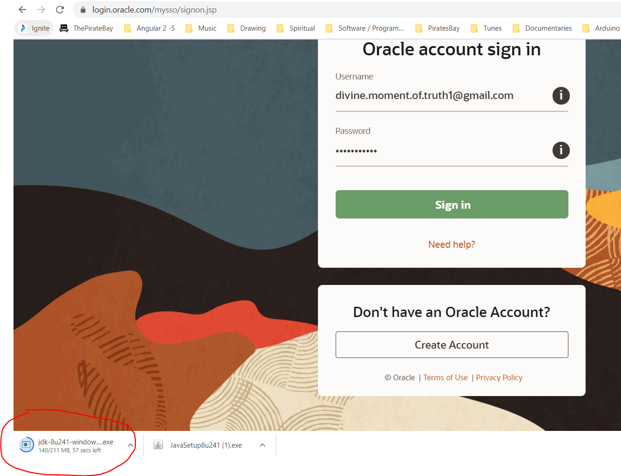

See downloaded file here:-

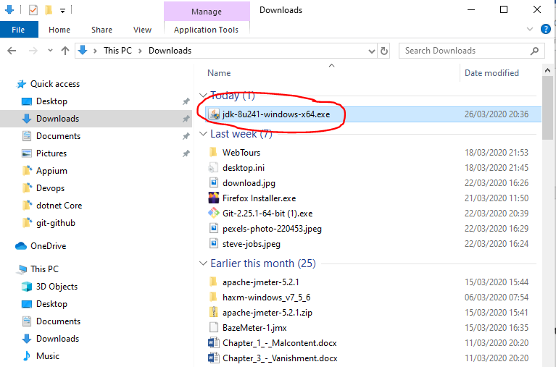

Double click it to install Java version 8.

After it is installed see the folder where it is installed;-

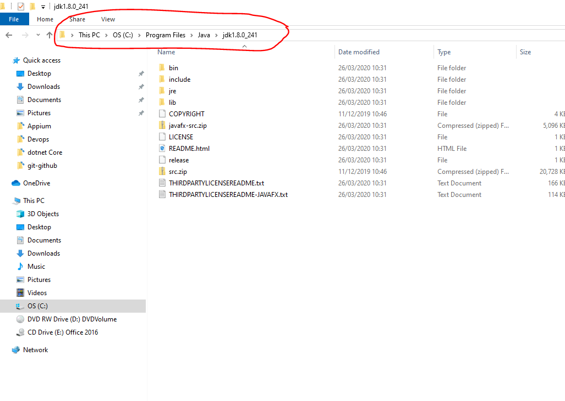

Add this location (C:\Program Files\Java\jdk1.8.0_241) to your environment variables:-

Set JAVA_HOME environment path:-

Copy the above path and open environment variables and create the following:-

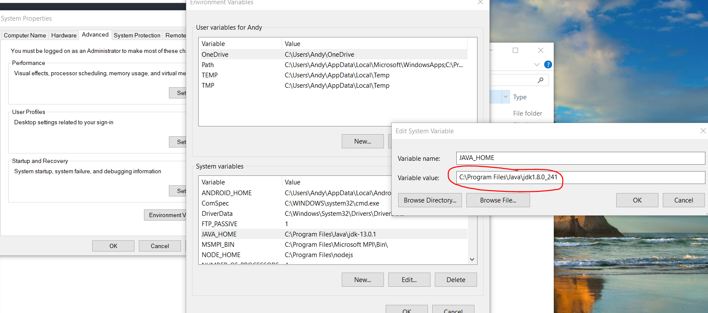

Also, add the SDK bin to the path environment variable:-

Copy bin folder path:-

C:\Program Files\Java\jdk1.8.0_241\bin

Paste into path environment variable:-

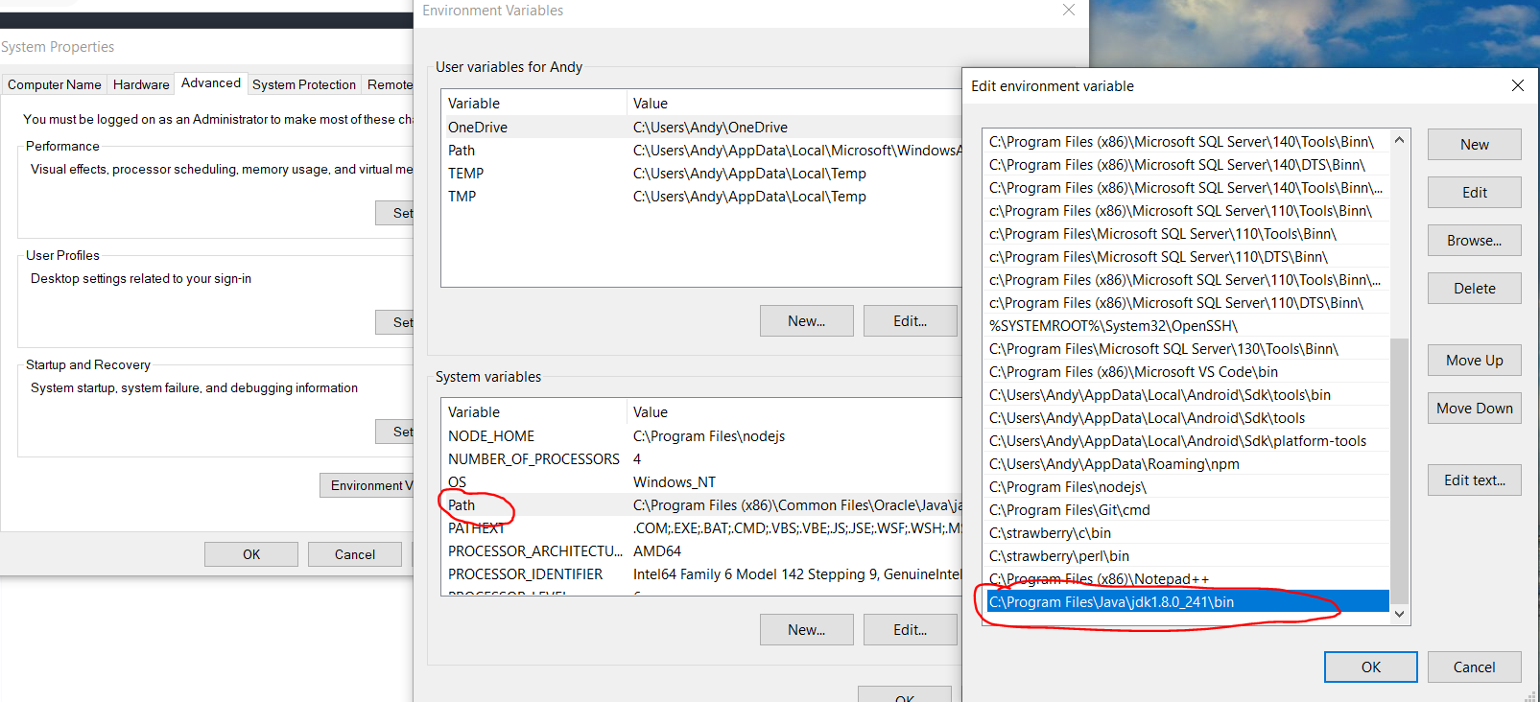

## (b) Download Android Studio:-

<https://developer.android.com/studio>

## (c) Set ANDROID_HOME environment variable path and SDK location:-

Get location of Andrew SDK:-

C:\Users\Andy\AppData\Local\Android\Sdk

Copy the above path and then open environment variable and create a new system variable:-

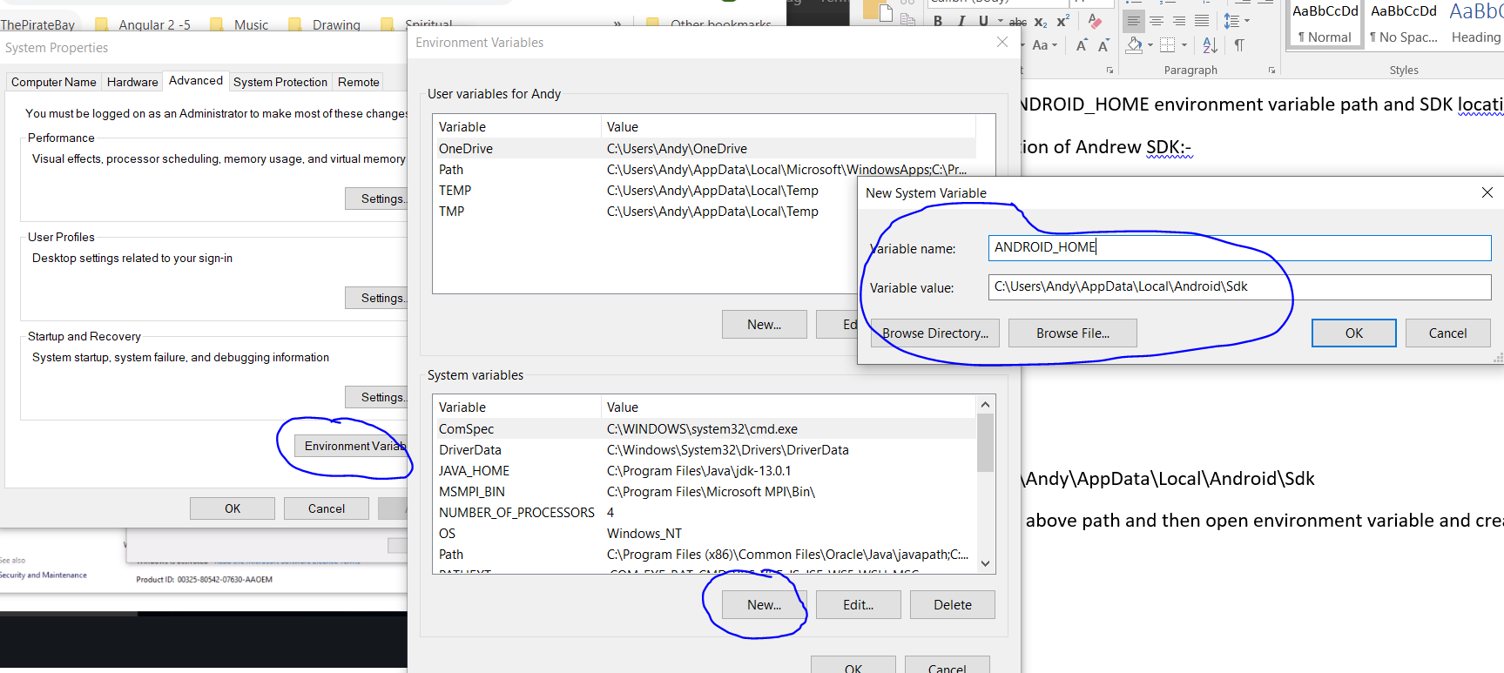

Also copy the following location to:-

C:\Users\Andy\AppData\Local\Android\Sdk\tools\bin

And paste into path environment variable:-

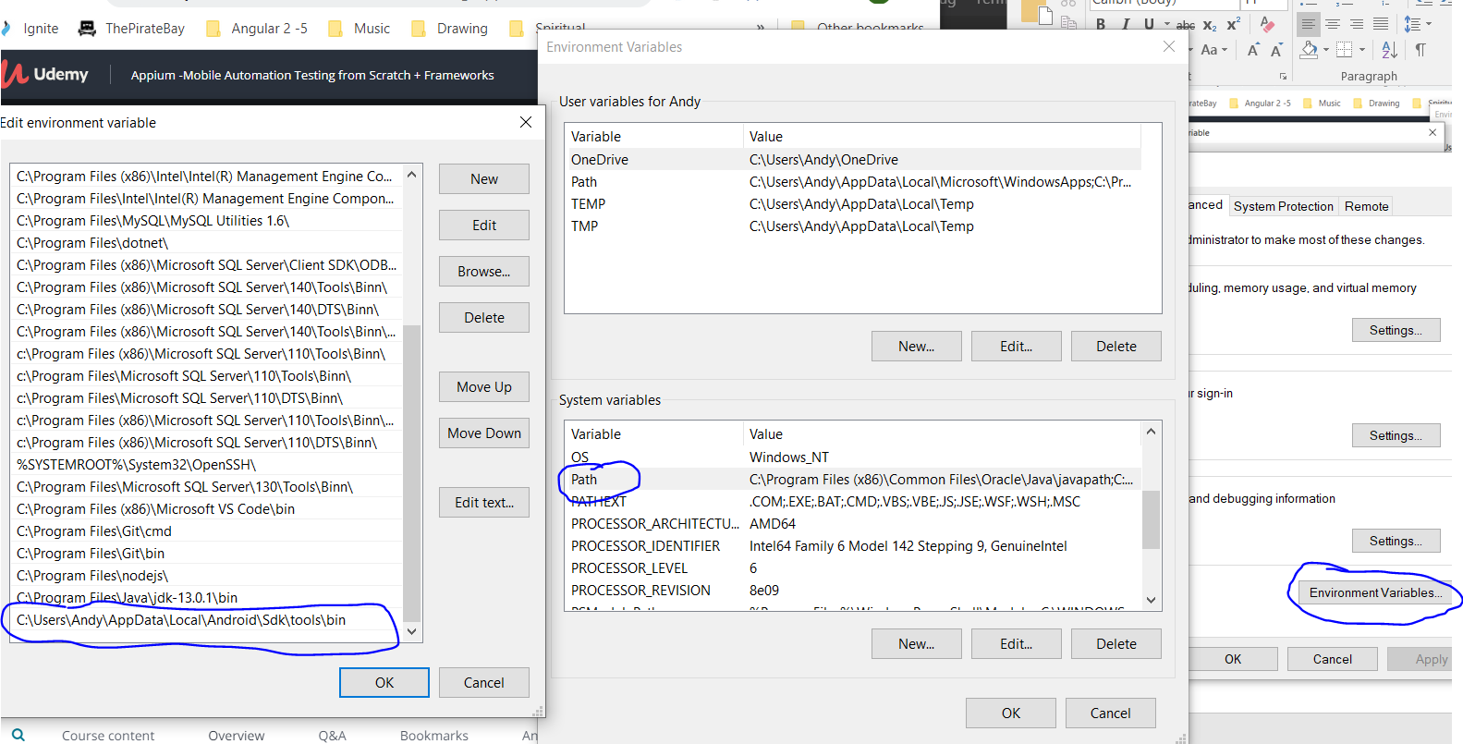

Also, copy the following path:-

C:\Users\Andy\AppData\Local\Android\Sdk\tools

And paste into system path:-

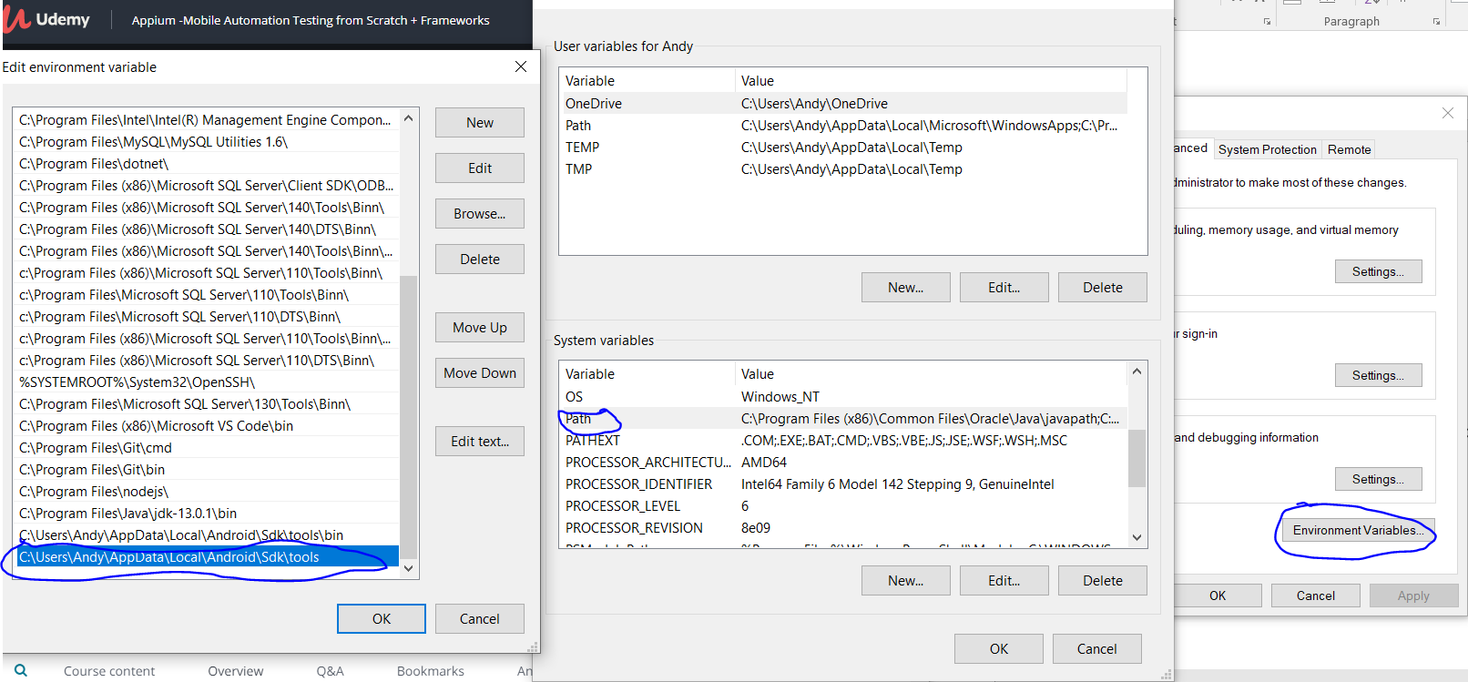

Also, copy the following path:-

C:\Users\Andy\AppData\Local\Android\Sdk\platform-tools

And paste into system path:-

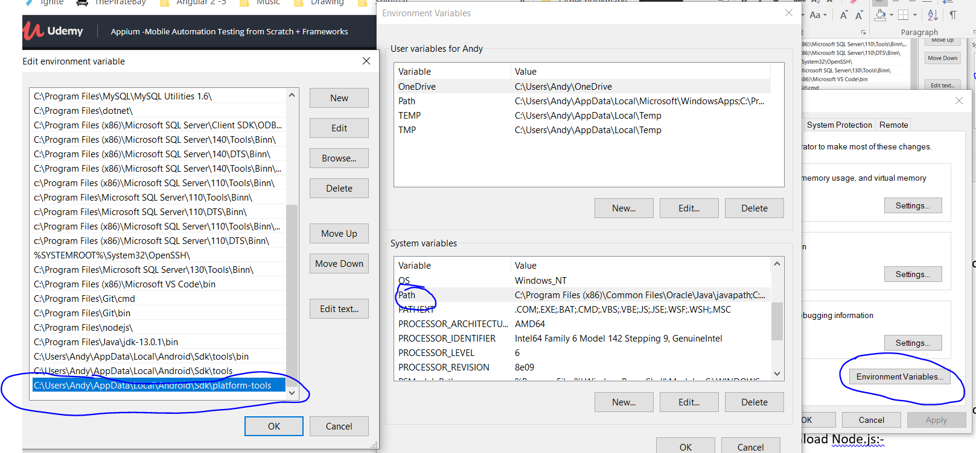

Also, copy the following path:-

C:\Users\Andy\AppData\Roaming\npm

And paste into system path:-

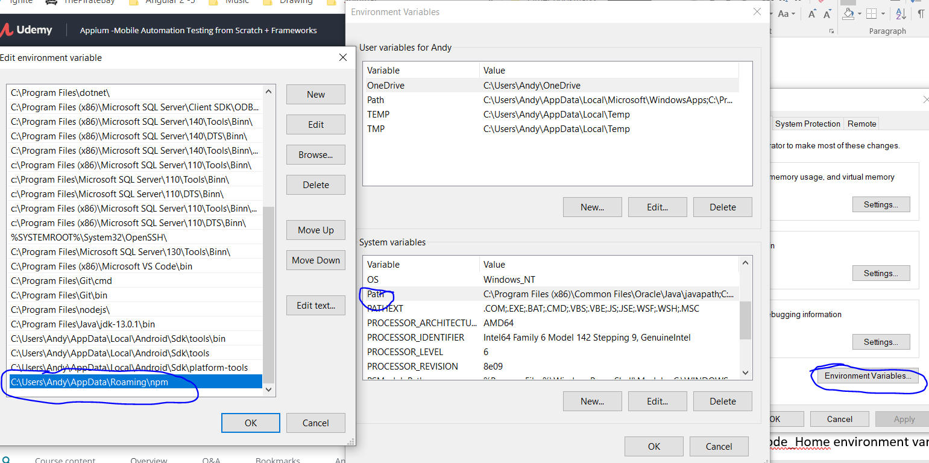

## (d) Open emulator and check that it works

## (e) Open Android Studio and configure virtual device/emulator:-

Android Studio is found here:-

C:\Program Files\Android\Android Studio\bin

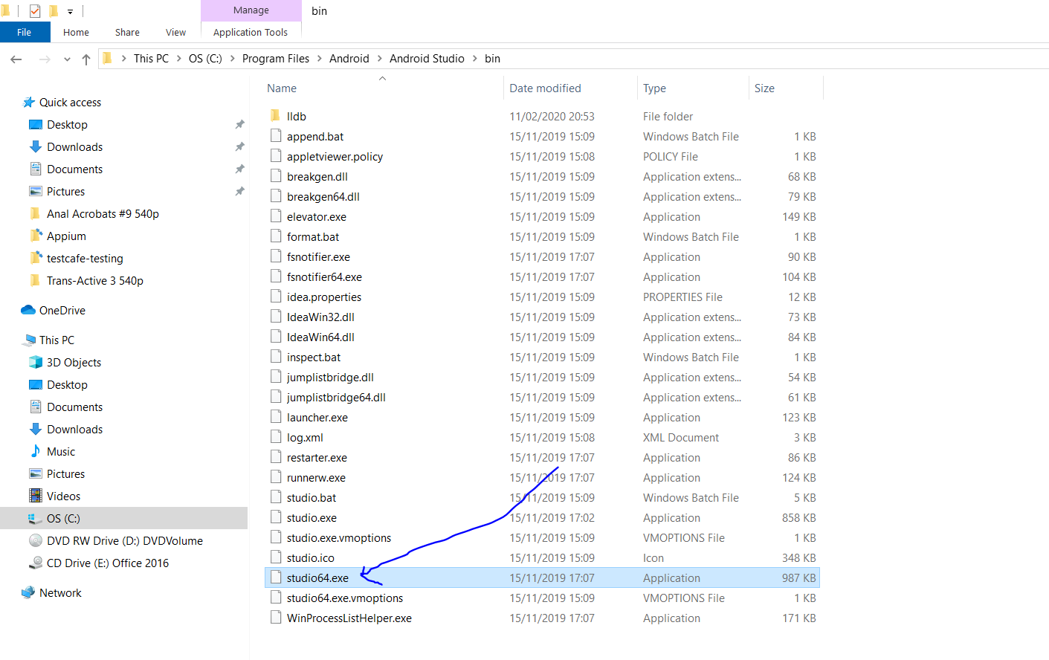

Click on the tools then > AVD Manager:-

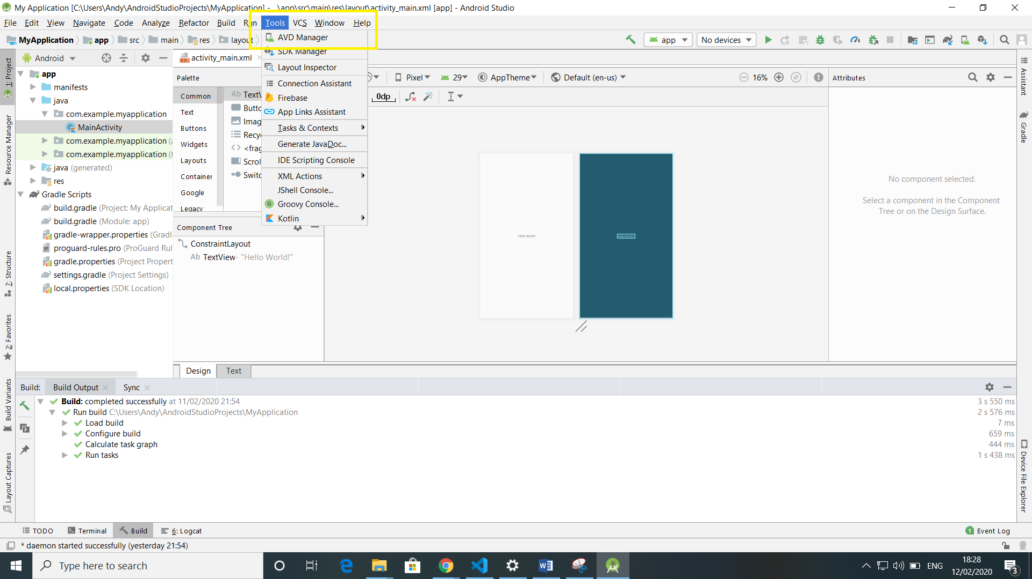

The click Create Virtual Device:-

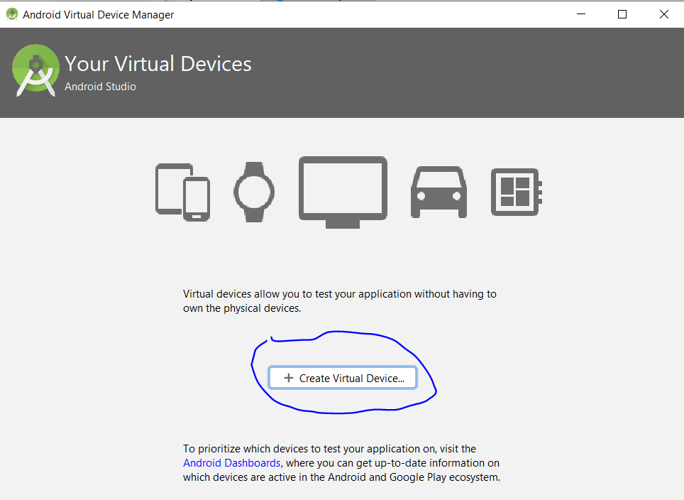

Select any mobile device of screen size from here:-

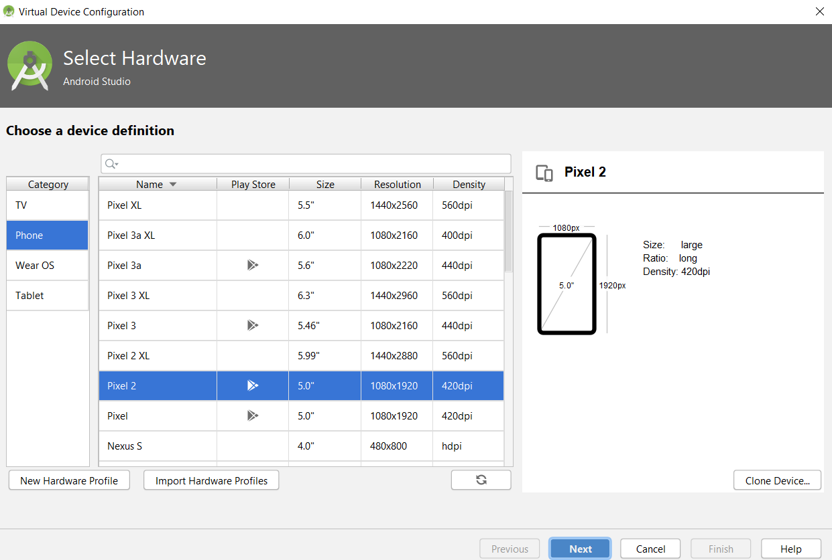

Then click ‘Next’.

Click ‘Download’ next to the option which uses Android version 9 - ‘Pie’ (API Level 28):-

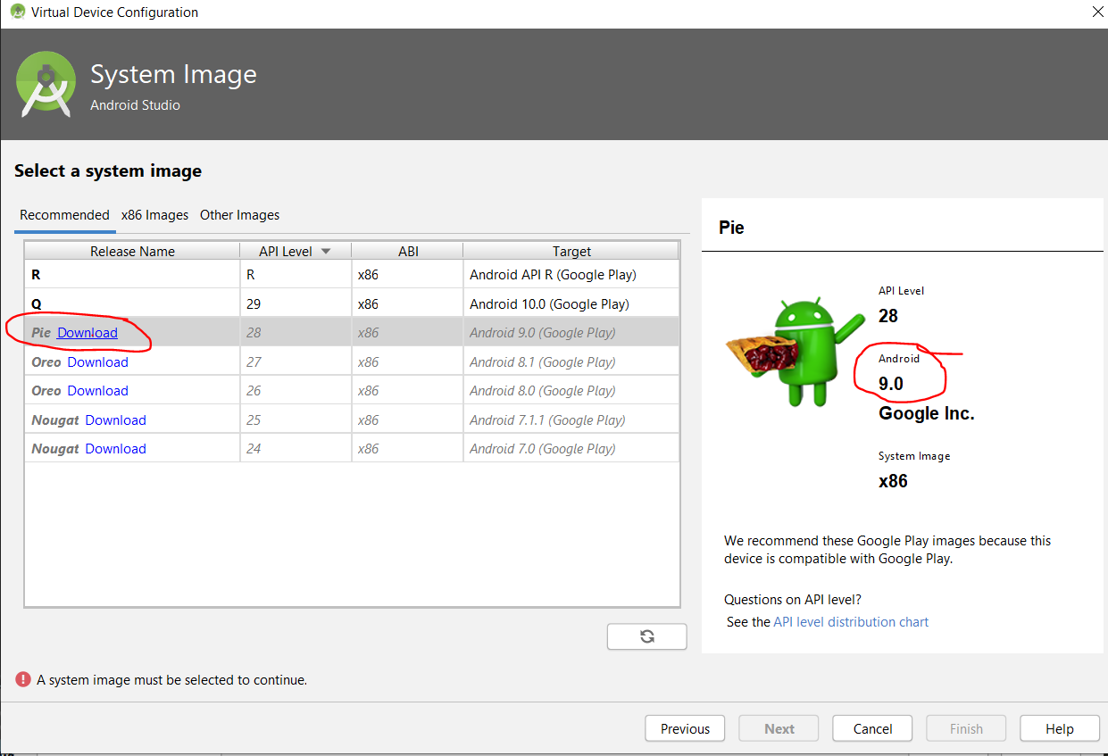

Click ‘Accept’ radio button, then click ‘Next’ button:-

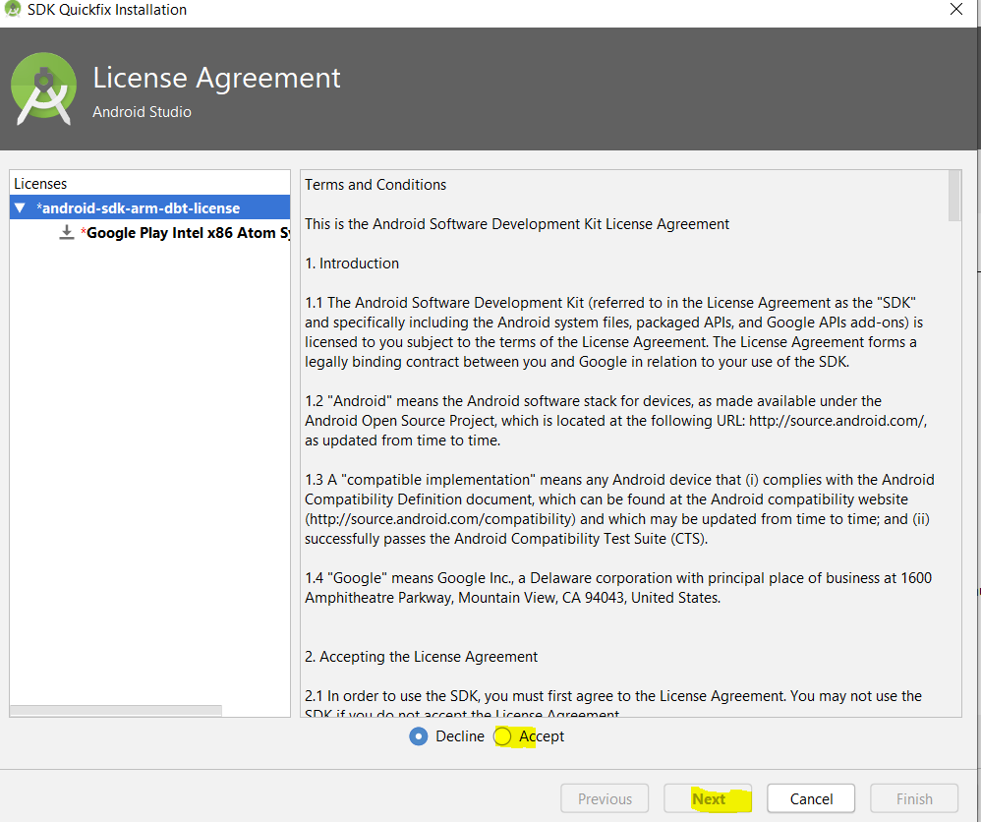

Wait for download to finish (it will take quite a long time – 1.1gigs).

Then click ‘Finish’. Then click ‘Next’.

Give your AVD (Android Virtual Device) a name:-

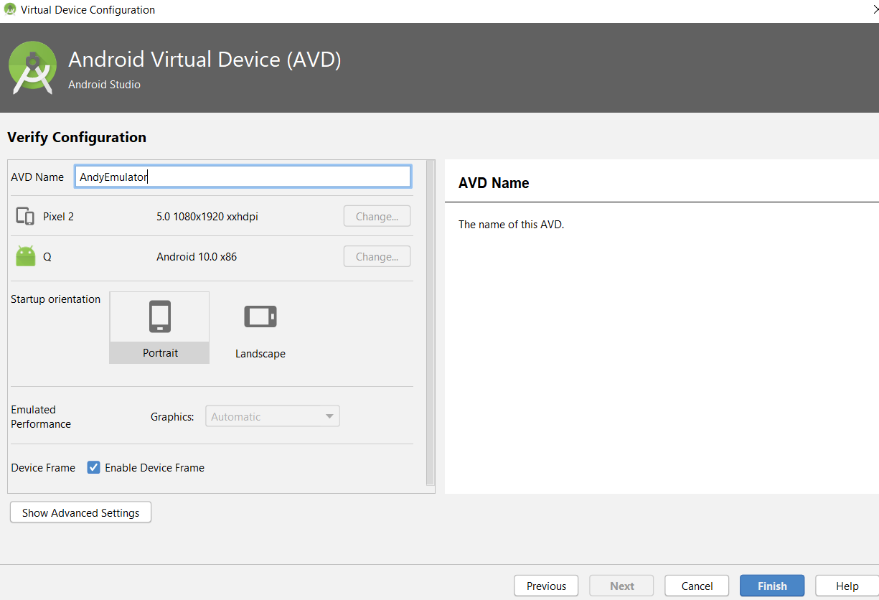

Then click ‘Finish’.

To launch device click the right pointing arrow icon:-

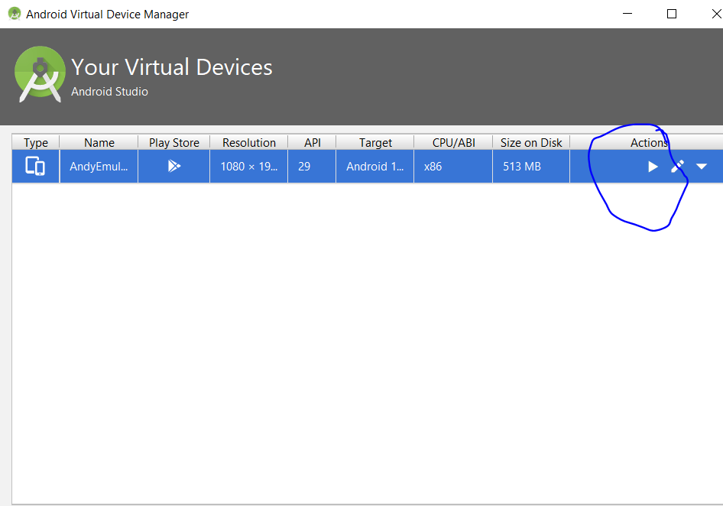

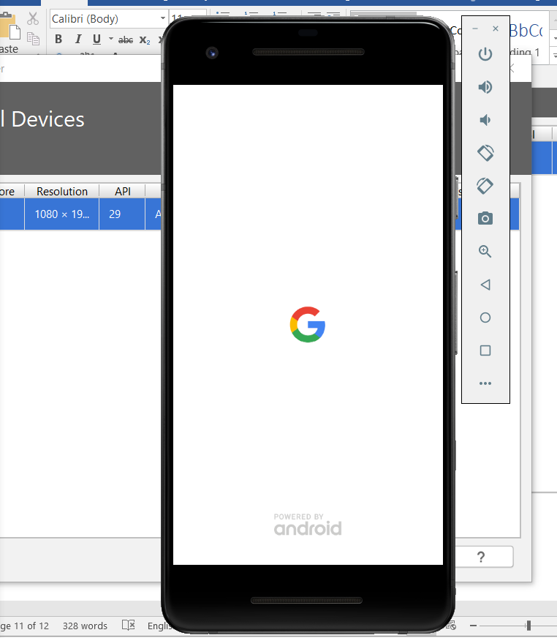

Now, you can open your virtual device without having to open Android Studio. This is done using the command prompt:-

Open command prompt as admin

Navigate to where your Android SDK Emulator folder is:-

cd C:\Users\Andy\AppData\Local\Android\Sdk\emulator

Then type:-

emulator -avd AndyEmulator3

Replace ‘AndyEmulator3’ with what ever you saved your virtual emulator device as.

## (f) Download and install Node.js:-

<https://nodejs.org/en/>

## (g) Set Node_Home environment variable path.

Copy the following path:-

C:\Program Files\nodejs

Open Environment variables and create a new System variable:-

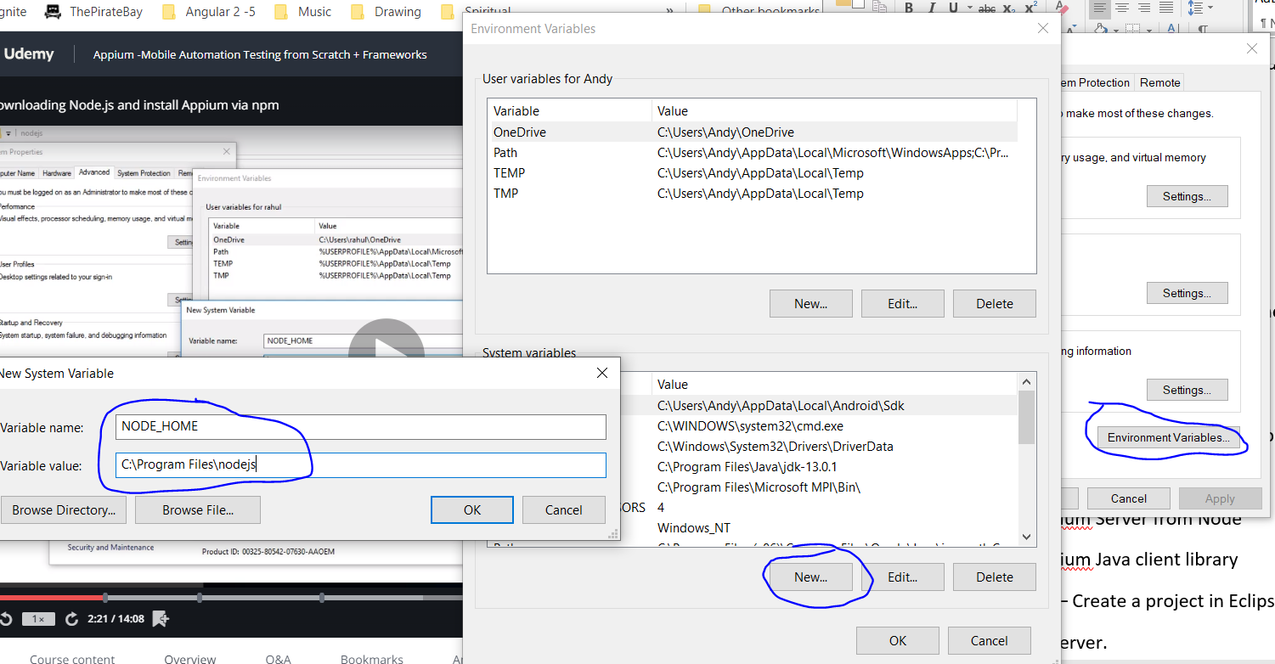

## (h) Set npm environment variable path.

Also, add the following into the system path variable:-

C:\Program Files\nodejs\node_modules\npm\bin

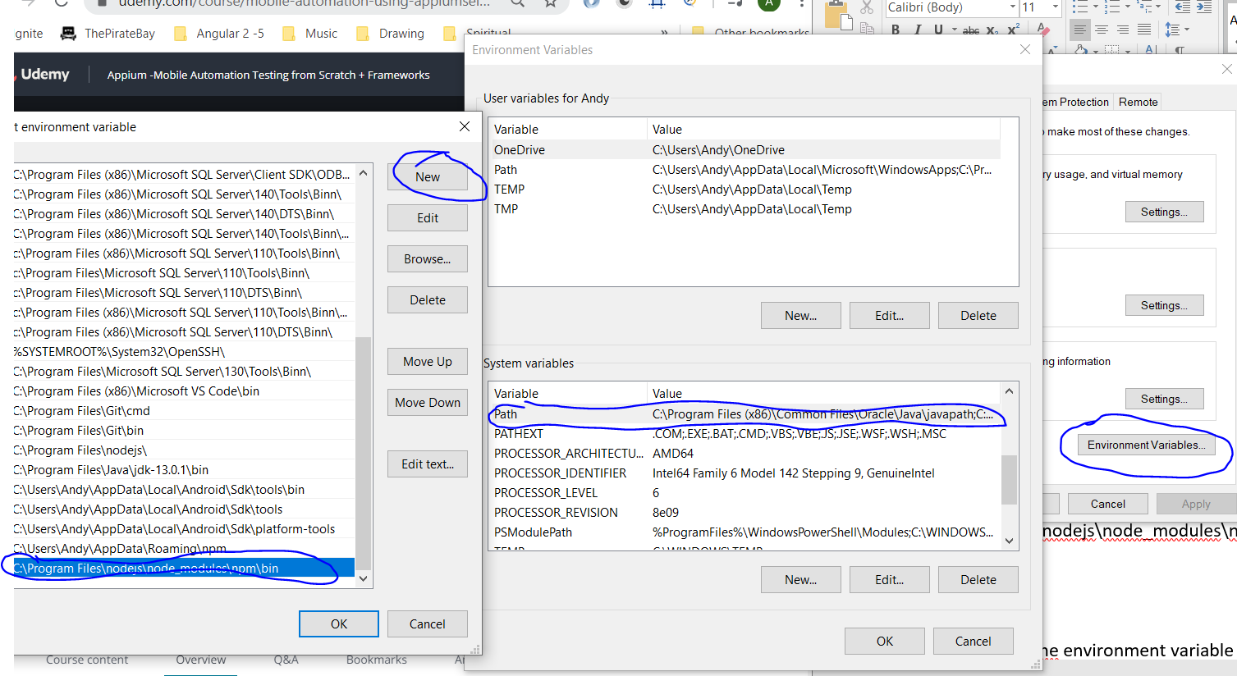

## (i) Download Appium Server from Node

Appium can be used with many different language, but this tutorial is for java. Therefore, use:

// Client – Appium java client

// Server – Appium Server

Open command prompt as admin.

Type the following to install Appium:-

npm install -g appium

When Appium has finished installing start the Appium server by typing the following into command prompt:-

*appium*

To stop server press [ctrl] + c:-

## (j) Download Appium and Selenium Java client library:-

<http://appium.io/downloads.html>

Select java then select download jar:-

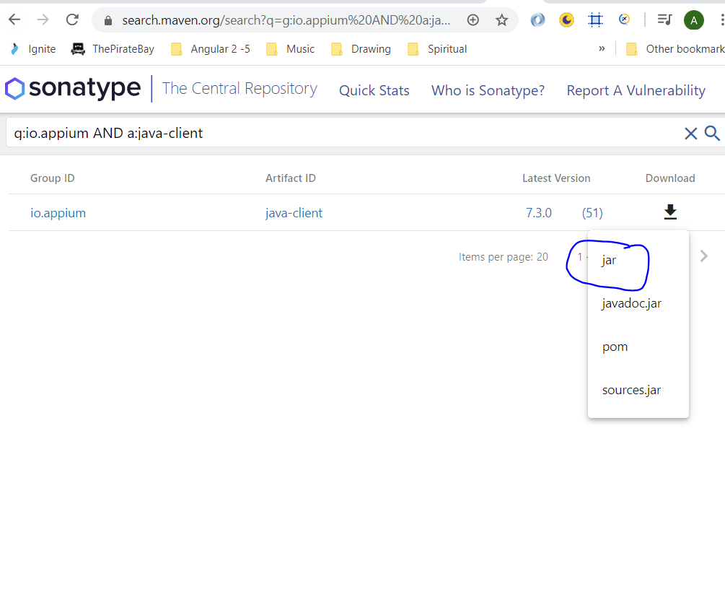

## **(k) Install Eclipse – Create a project in Eclipse – configure Appium libraries** <https://www.eclipse.org/downloads/>

### When downloaded and installed, open Eclipse. Click on ‘Workbench’:-

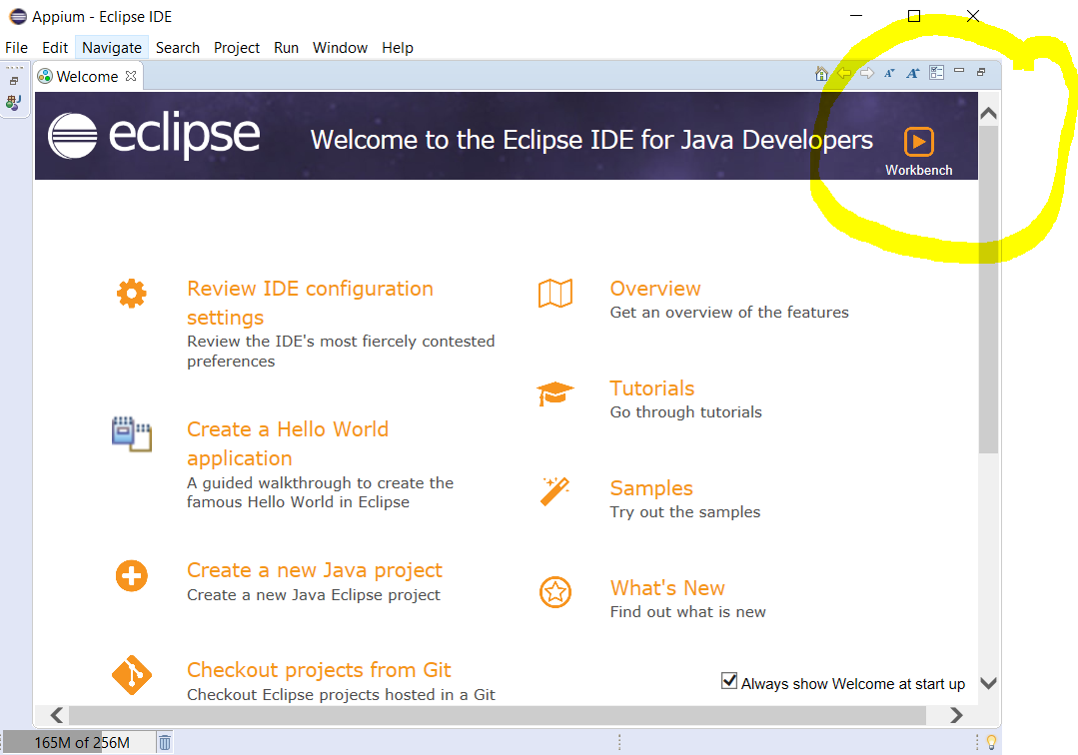

### Create a new Java project:-

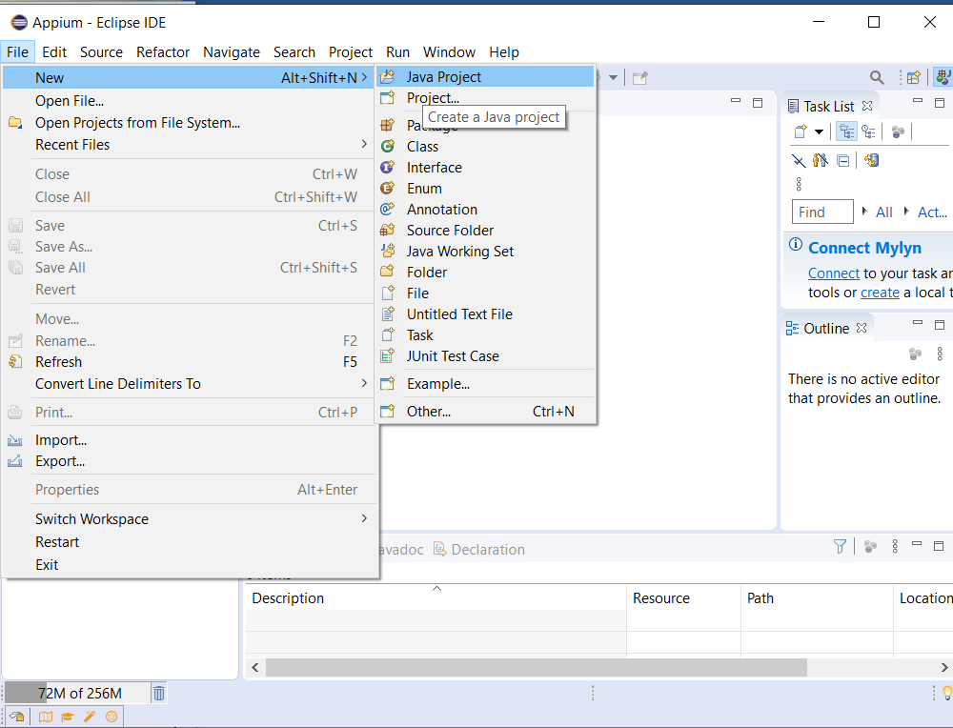

Create a new class under ‘Appium Tutorial/ src’:-

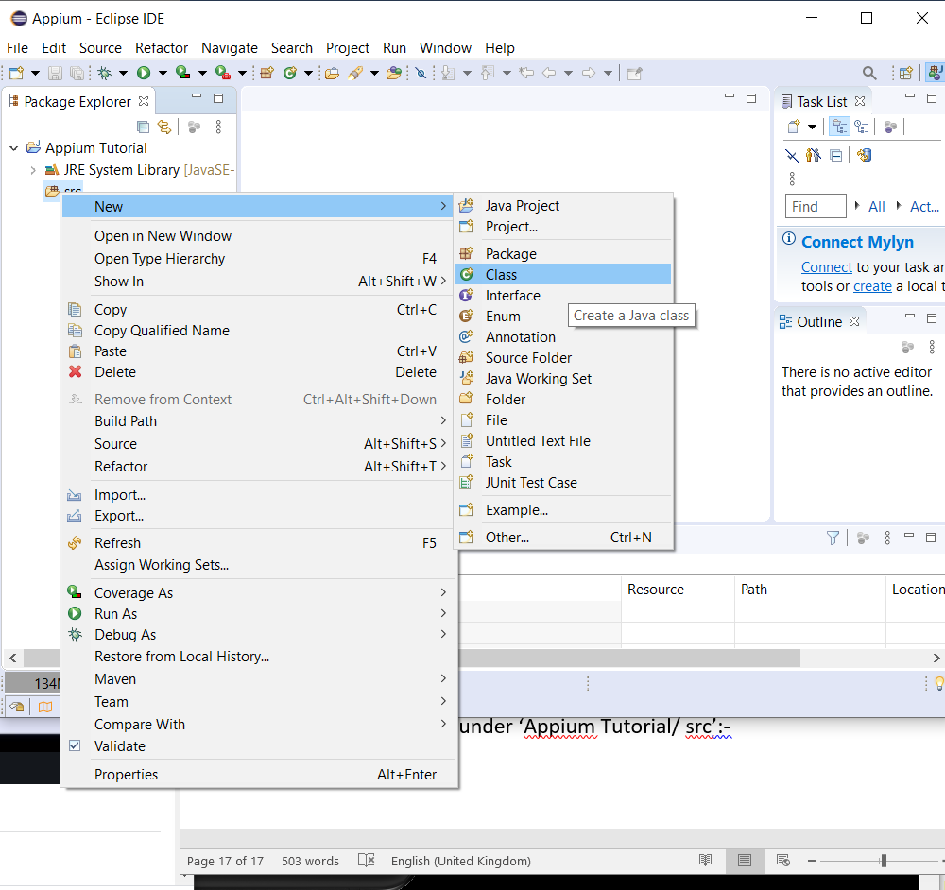

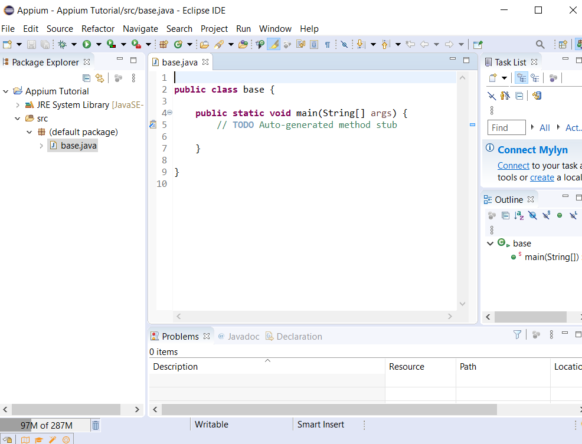

Project name – this is the test suite

Project class – Used for test cases

Import downloaded jar file from the previous step (j). Right click project in Eclipse and select ‘Properties’. Select ‘Java Build Path’. Click on ‘Libraries’ tab. Click on ‘Add external JARs’. Then navigate to where you downloaded the jar file in the previous step.

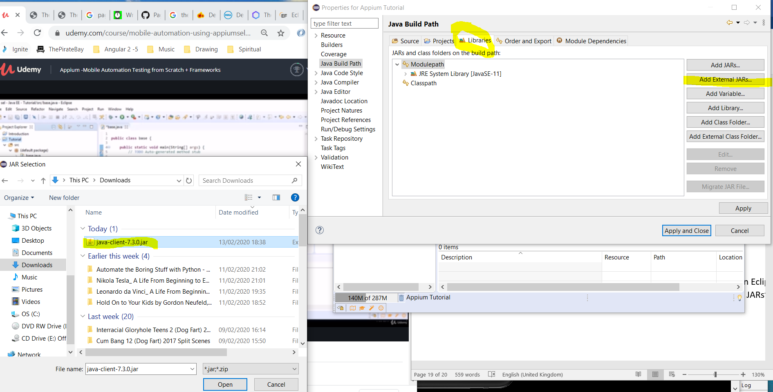

Also, download Selenium JARs. Go to this website:-

<https://selenium.dev/downloads/>

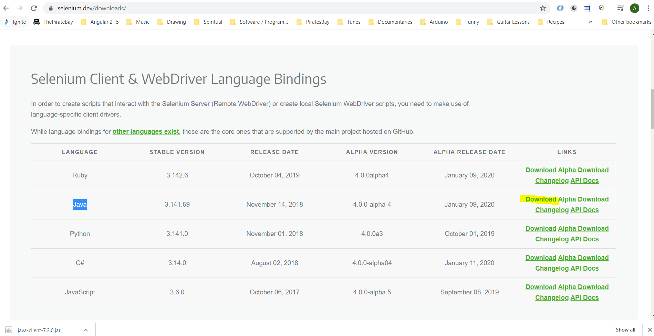

#### Unzip downloaded file

Then go back to Eclipse and import the JAR files as previously done:-

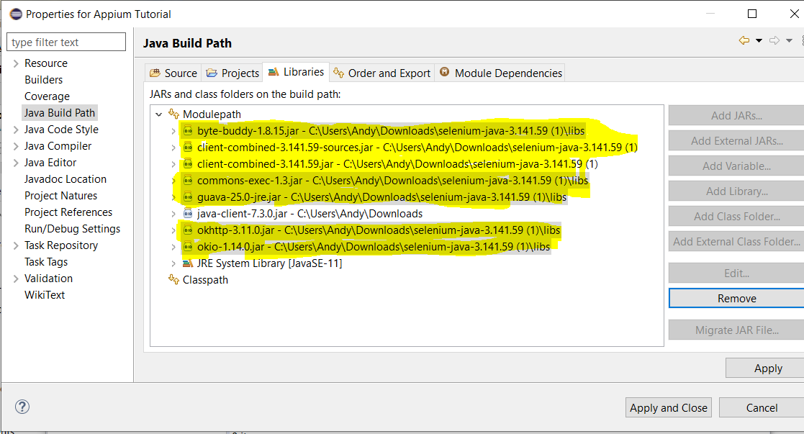

## (l) Start Appium server:-

Type the following in command prompt:-

appium

[4] To run Android Studio double click the following .exe:-

C:\Program Files\Android\Android Studio\bin\studio64.exe

[5] To run tests make sure Appium server is running and also that the emulator is also open. Type the following into command prompt to get appium server running:-

appium

To get emulator running do the following:-

Open command prompt as admin

Navigate to where your Android SDK Emulator folder is:-

cd C:\Users\Andy\AppData\Local\Android\Sdk\emulator

Then type:-

emulator -avd AndyEmulator3

**[6] Download the following file from here:-**

# ApiDemos-debug.apk



<https://www.udemy.com/course/mobile-automation-using-appiumselenium-3/learn/lecture/6843020#questions/4664052>

Paste the above file into your project here:-

# C:\Users\Andy\Documents\software\Appium\Appium Tutorial\src

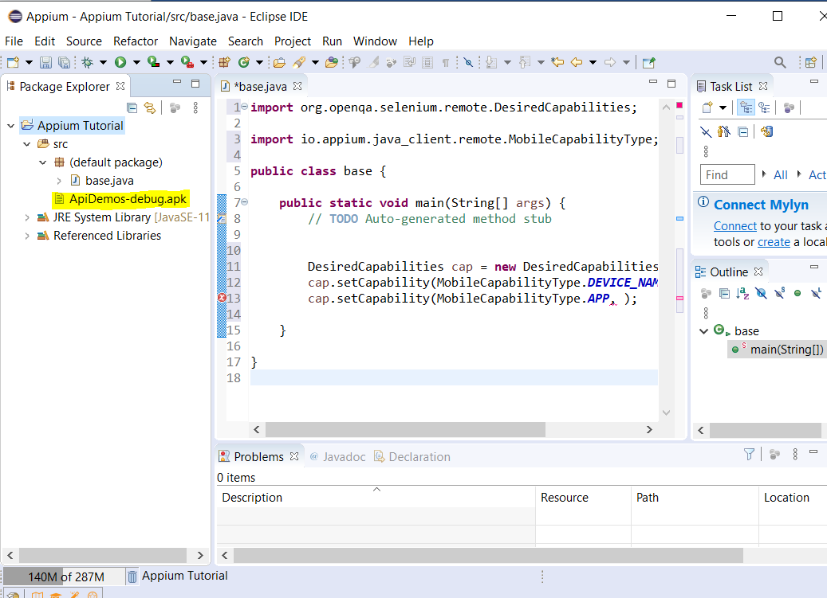

**[7] Setup Desired Capabilities in Eclipse:-**

## In Eclipse ‘base’ class add the following code:-

import java.io.File;

import java.net.MalformedURLException;

import java.net.URL;

import org.openqa.selenium.remote.DesiredCapabilities;

import io.appium.java_client.android.AndroidDriver;

import io.appium.java_client.android.AndroidElement;

import io.appium.java_client.remote.MobileCapabilityType;

public class base {

public static void main(String[] args) throws MalformedURLException {

// TODO Auto-generated method stub

### String connectionToServerLink = “<http://127.0.0.1:4723/wd/hub>”;

File f = new File(“src”);

File fs = new File(f, “ApiDemos-debug.apk”);

DesiredCapabilities cap = new DesiredCapabilities(); cap.setCapability(MobileCapabilityType.DEVICE_NAME, “AndyEmulator3”); cap.setCapability(MobileCapabilityType.AUTOMATION_NAME,”uiautomator2”); cap.setCapability(MobileCapabilityType.APP, fs.getAbsolutePath());

## // Make a connection to the Appium server

AndroidDriver<AndroidElement> driver = new AndroidDriver<>(new URL(connectionToServerLink), cap);

}

}

[8] To setup a Maven project use the following link:-

<https://www.techbeamers.com/create-selenium-webdriver-maven-project/>

# Add the two following dependencies to the pom.xml file:-

*<project xmlns=”*[*http://maven.apache.org/POM/4.0.0*](http://maven.apache.org/POM/4.0.0)*” xmlns:xsi=”*[*http://www.w3.org/2001/XMLSchema-instance*](http://www.w3.org/2001/XMLSchema-instance)*” xsi:schemaLocation=”*[*http://maven.apache.org/POM/4.0.0 https://maven.apache.org/xsd/maven-4.0.0.xsd*](http://maven.apache.org/POM/4.0.0%20https://maven.apache.org/xsd/maven-4.0.0.xsd)*”>*

<modelVersion>4.0.0</modelVersion>

<groupId>AppiumTests</groupId>

<artifactId>AppiumMavenProject</artifactId>

<version>0.0.1-SNAPSHOT</version>

<name>Appium Maven Project</name>

<dependencies>

<!-- <https://mvnrepository.com/artifact/org.seleniumhq.selenium/selenium-java> -->

## <dependency>

<groupId>org.seleniumhq.selenium</groupId>

<artifactId>selenium-java</artifactId>

<version>3.141.59</version>

</dependency>

<!-- <https://mvnrepository.com/artifact/io.appium/java-client> -->

<dependency>

<groupId>io.appium</groupId>

<artifactId>java-client</artifactId>

<version>7.0.0</version>

</dependency>

</dependencies>

</project>

### Quick Start

[1] Open AVD Emulator:-

Command Prompt as admin

cd C:\Users\Andy\AppData\Local\Android\Sdk\emulator

emulator -avd AndyEmulator3

#### Or start emulator this way:-

Open Android Studio and start the device from here (click the green play button/icon):-

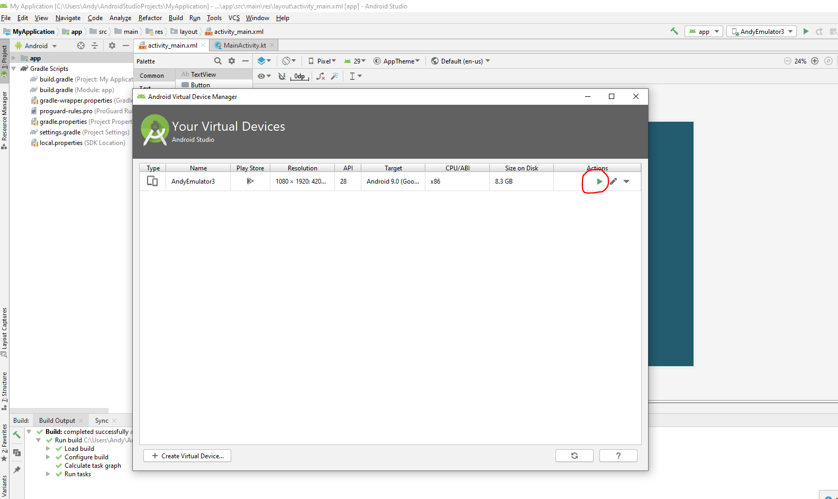

[2] Start Appium Server:-

Command Prompt as admin

Type:-

appium

**[3] Open Eclipse solution:-**

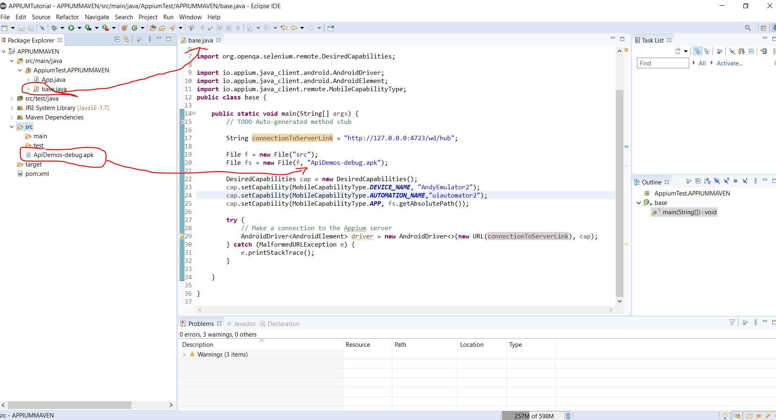

Recommend creating a Maven Project and referencing the ‘Apium’ and ‘Selenium’ dependencies in the pom.xml file as I struggled with the the following error when importing ‘jar’ files:-

#### “DesiredCapabilities cannot be resolved to a type”

To create a Maven Java project do this:-

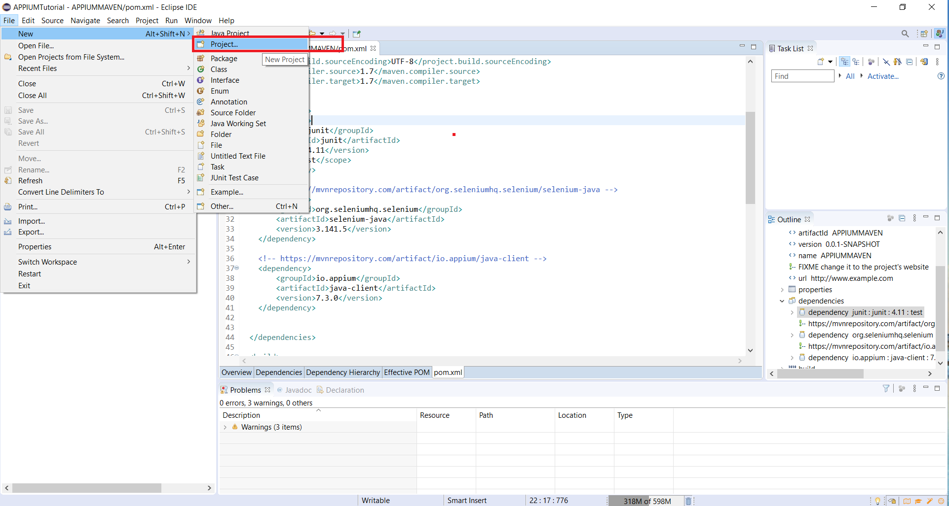

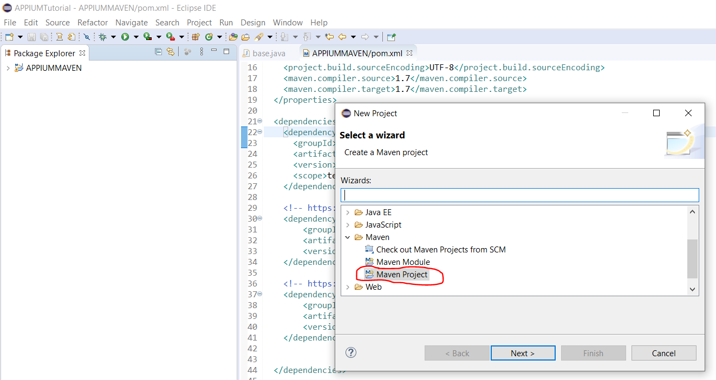

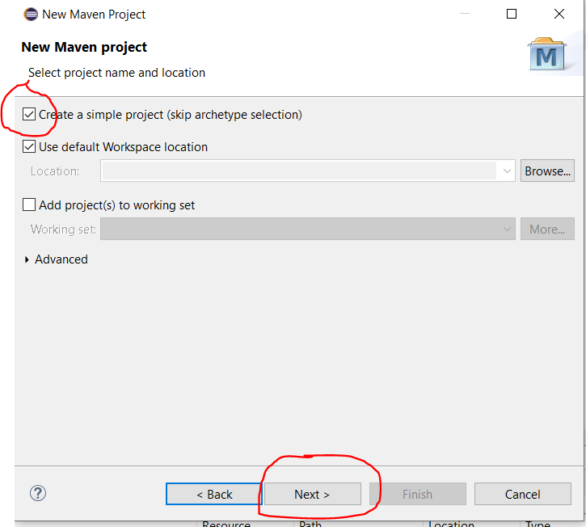

Enter GroupId and ArtifactId:-

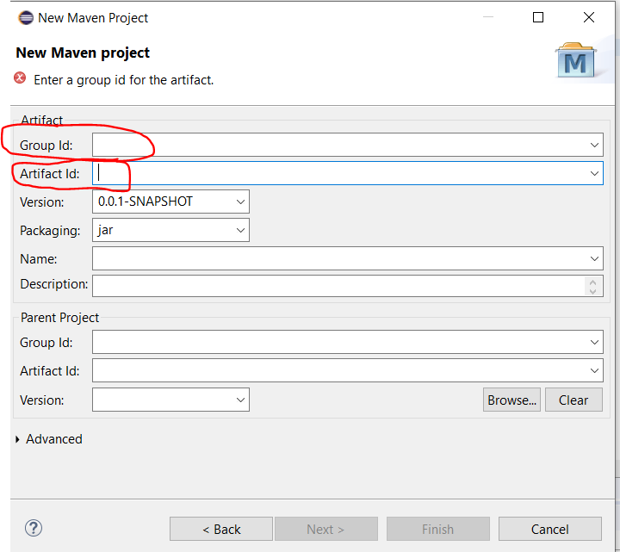

GroupId – This appears in the pom.xml file:-

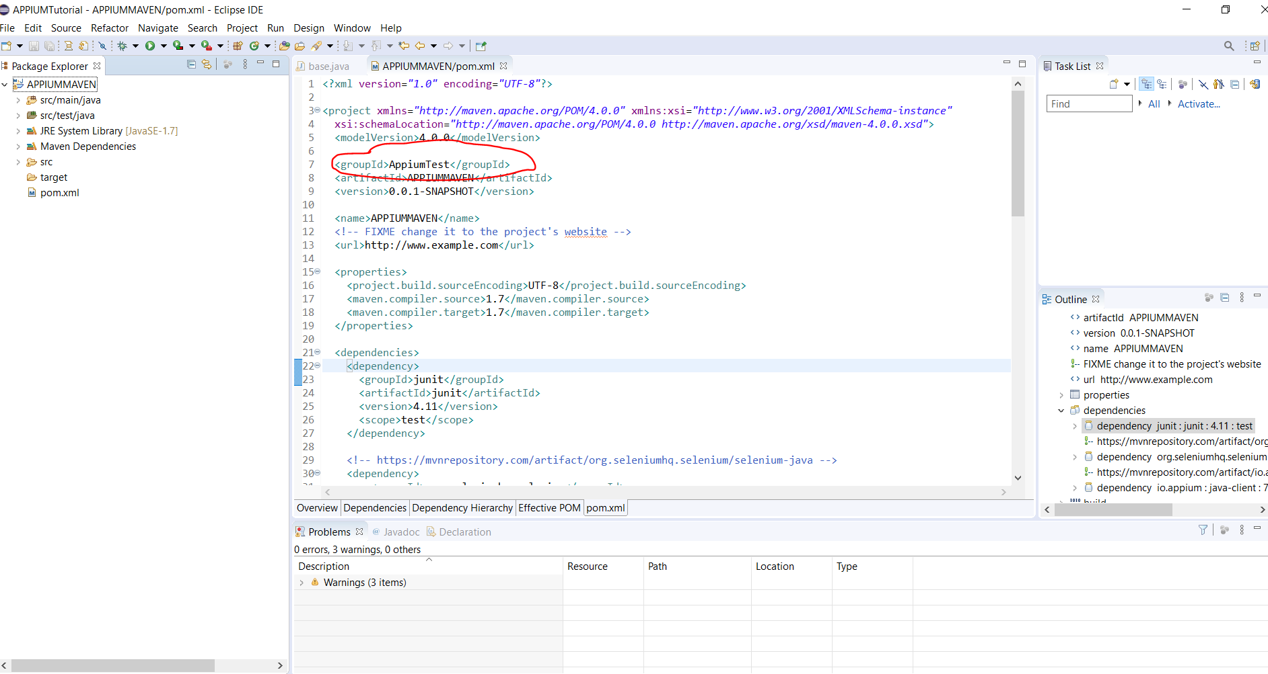

ArtifactId – Project Name:-

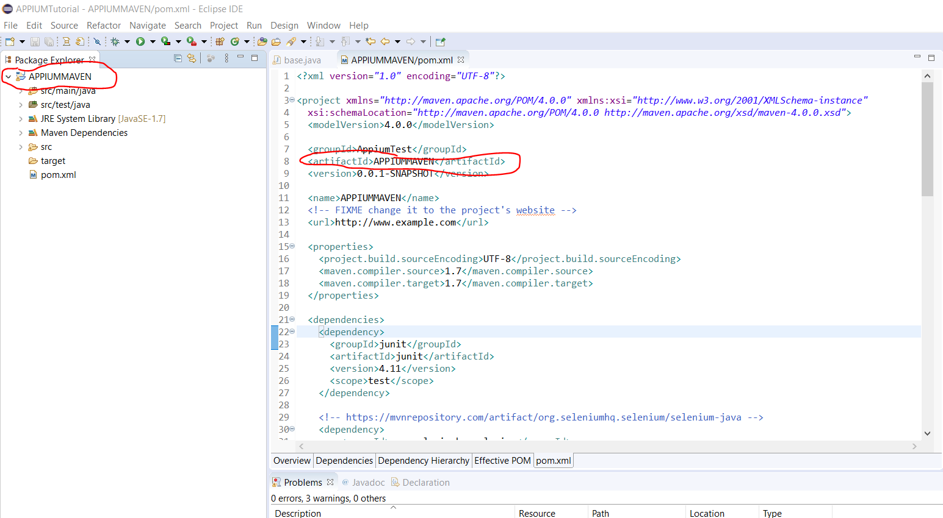

Add these two dependencies into the pom.xml file:-

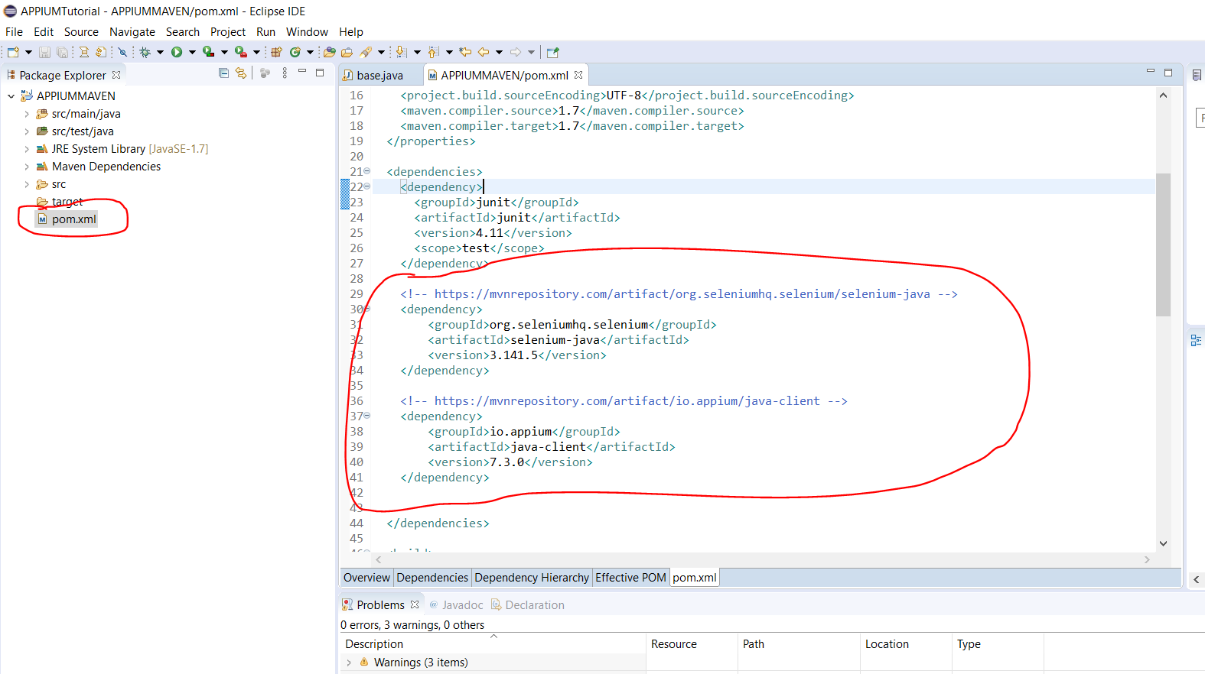

Add the app (ApiDemos-debug.apk) here:-

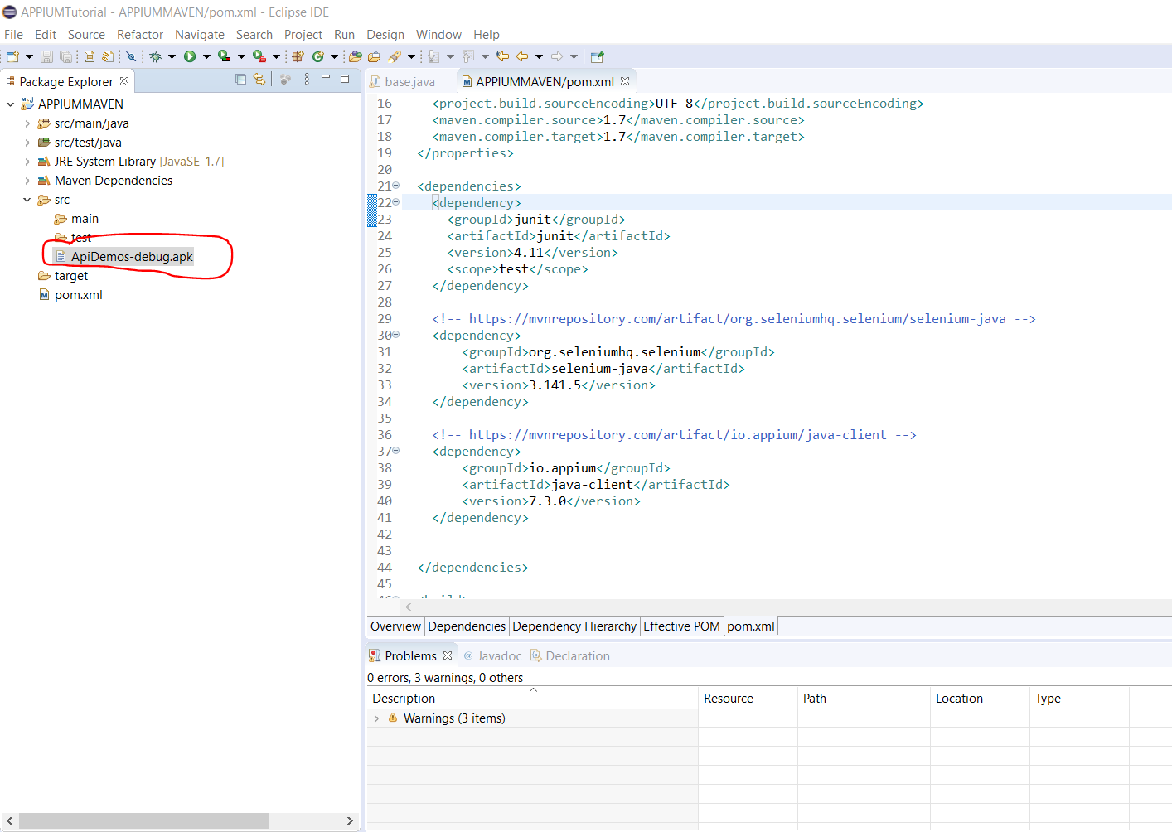

Set the Installed JREs in Eclipse ‘Preferences’ to this:-

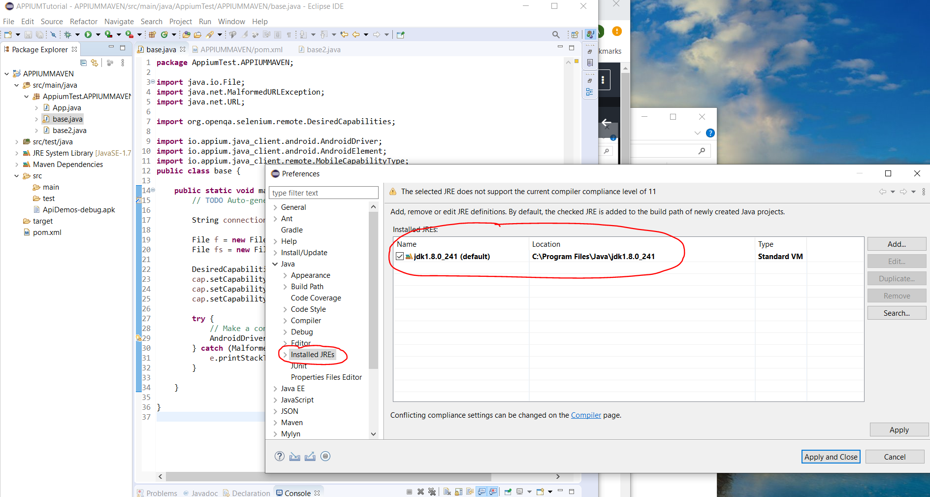

Add the base class here:-

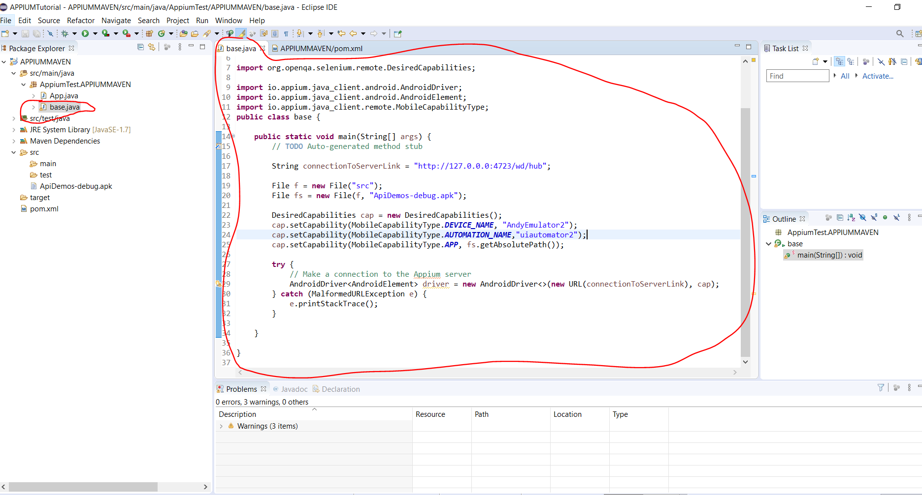

Run code by:-

Right clicking anywhere in ‘base.java’ class and selecting ‘Run As -> 1 Java Application’:-

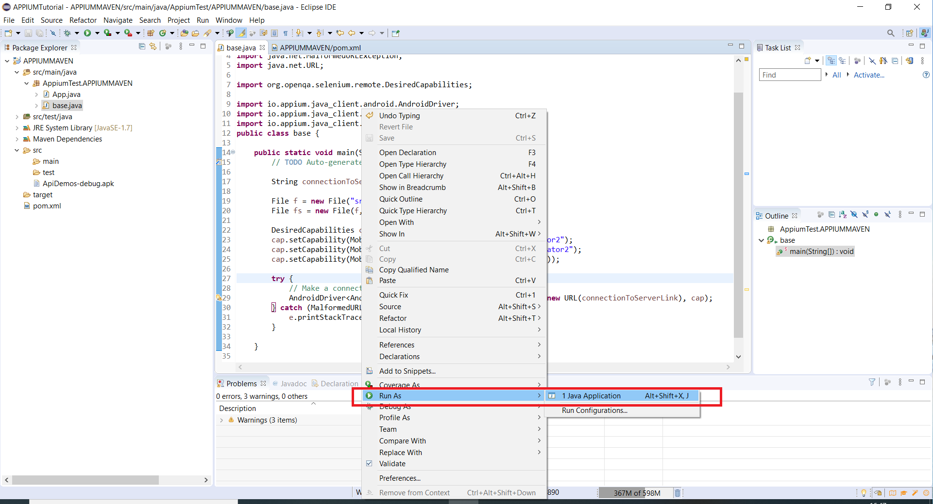

Lets make the above class method more reusable. So lets create a new class called base2 and add this code:-

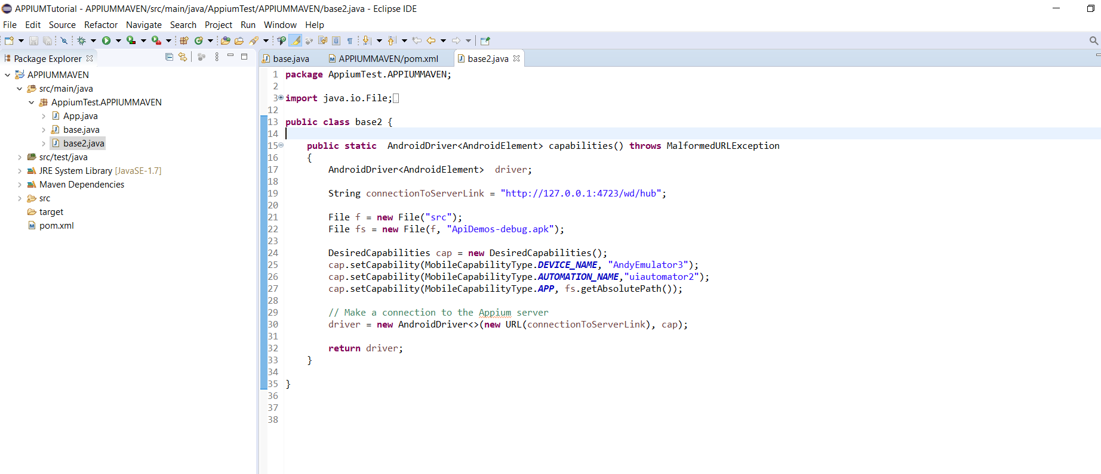

### Writing Appium Tests

*Note:- After running one test it takes 60 seconds for a session to close. If you want to start a new test straight after a test has completed then you have to forcefully close the connection and then re-open the connection.*

# The tool for getting the elements in the below Android app:-

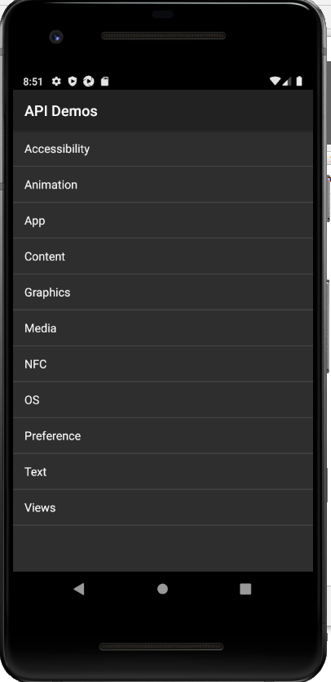

The tool can be found here:-

# C:\Users\Andy\AppData\Local\Android\Sdk\tools\bin\uiautomatorviewer.bat

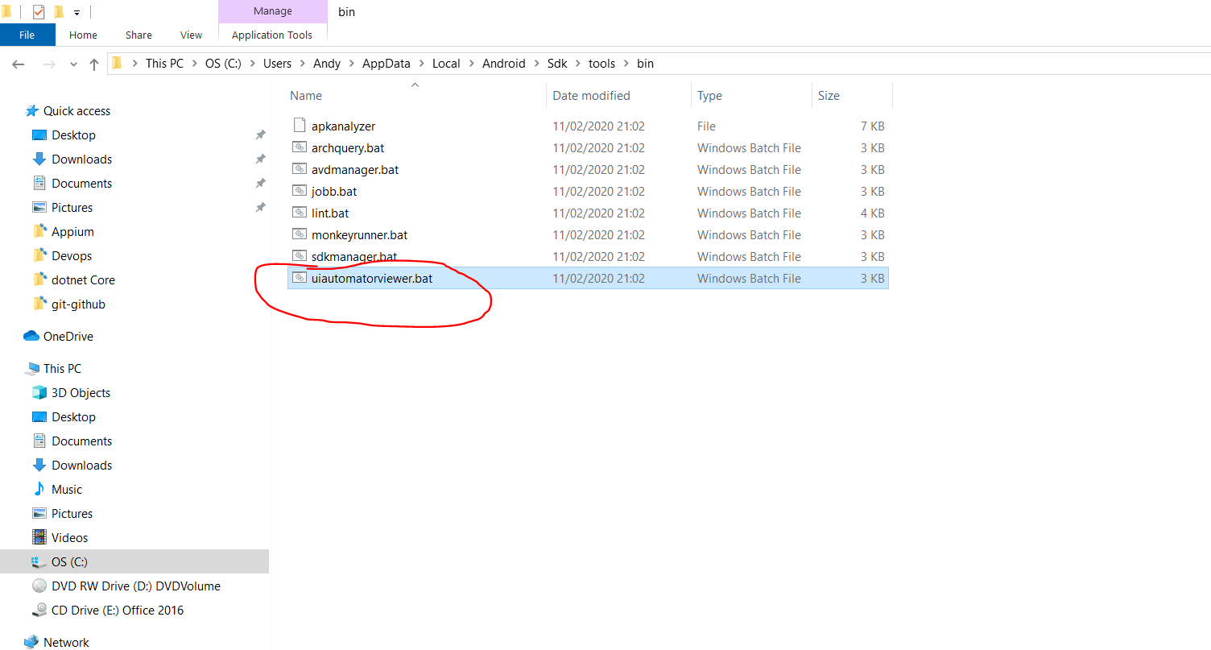

Double click the above .bat file. This will open the following:-

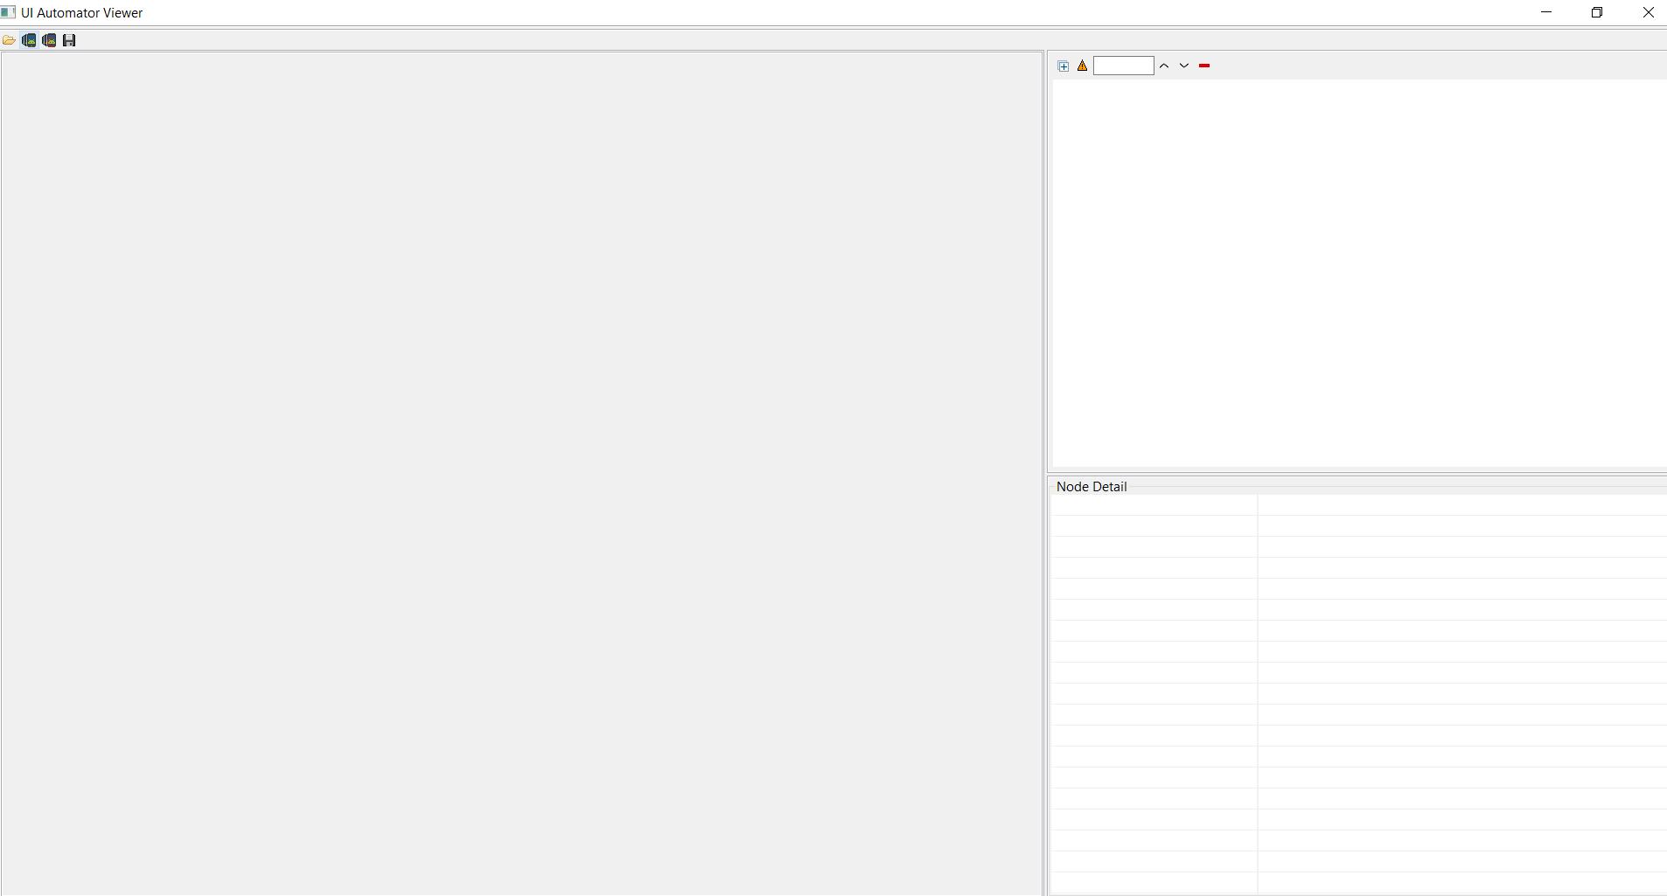

Click this button to synch with the Android emulator device app:-

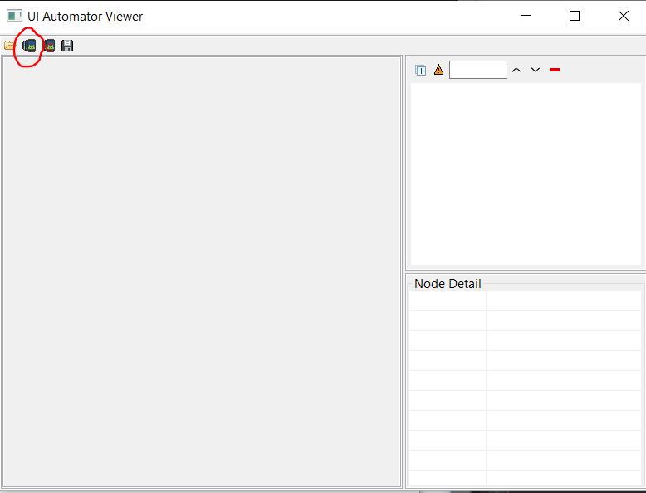

This creates this:-

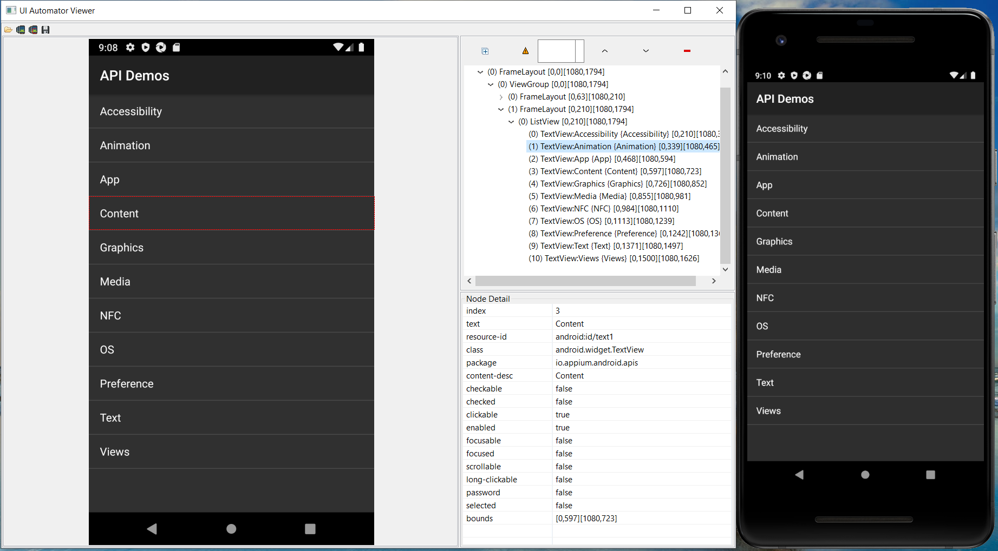

To show how Appium is used create a new class called ‘basics.java’:-

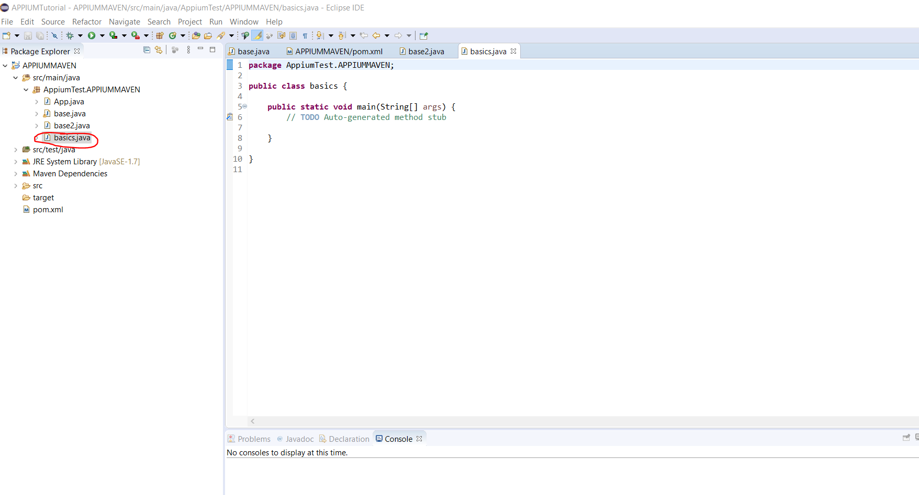

Add the following code to the class:-

[1] first inherit from the ‘base2.java’ class:-

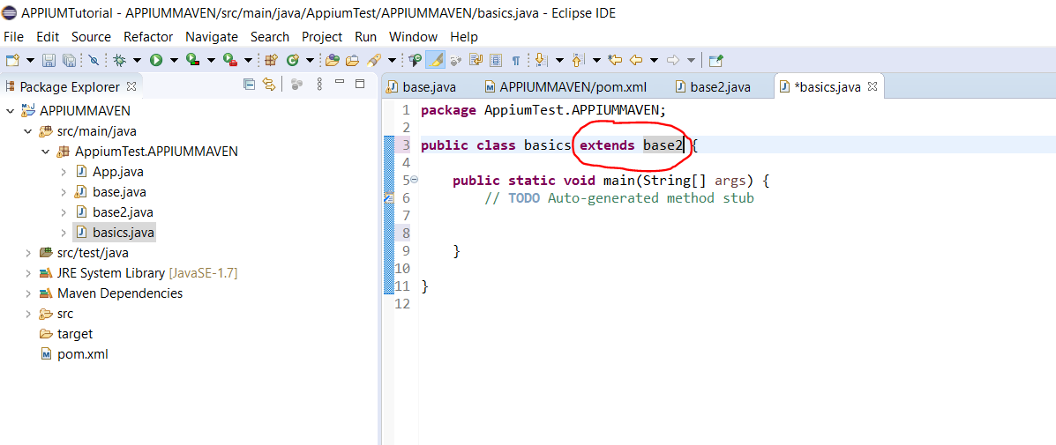

[2] Now call the ‘capabilities’ method from the base2 (base2.java) class:-

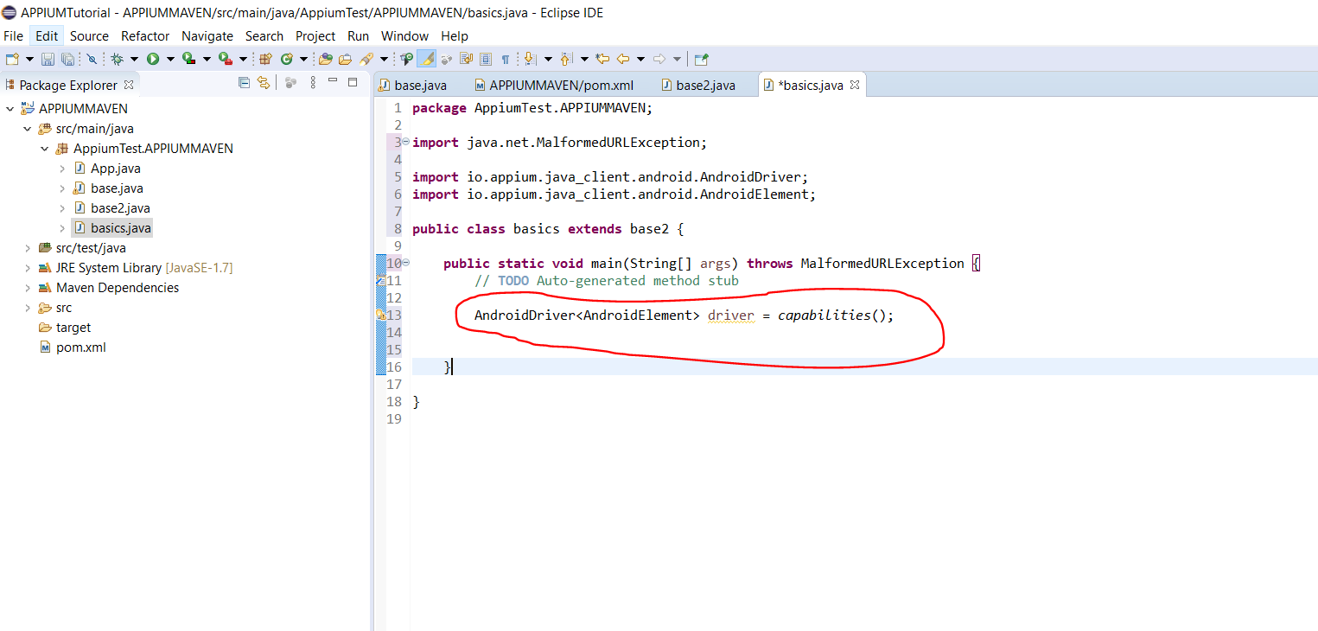

Write code to do this scenario:-

[1]

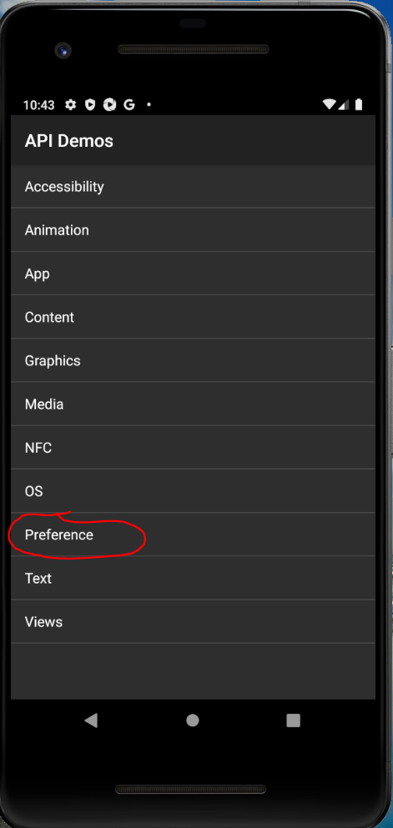

[2]

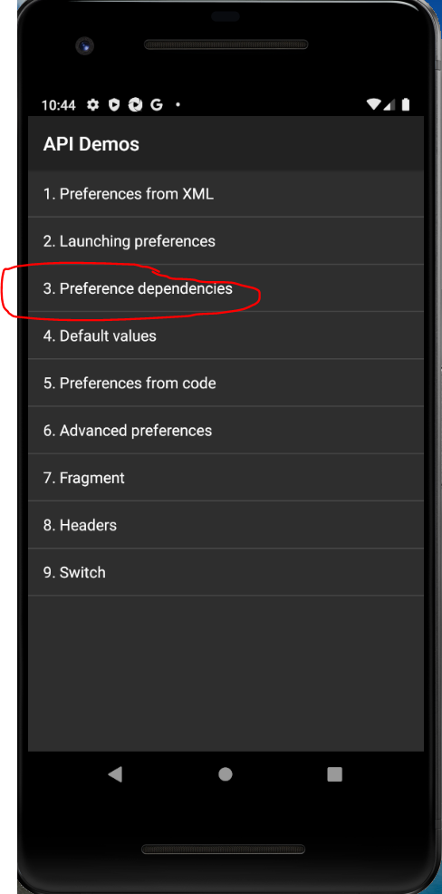

[3]

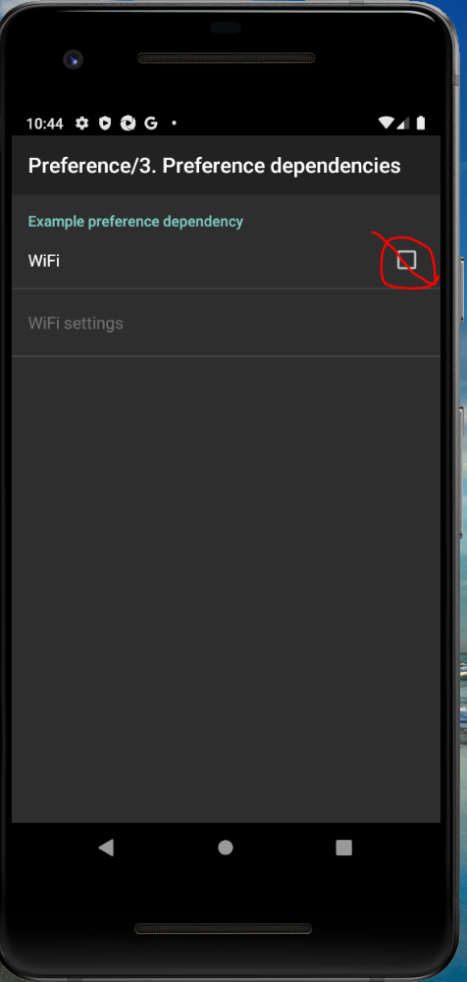

[4]

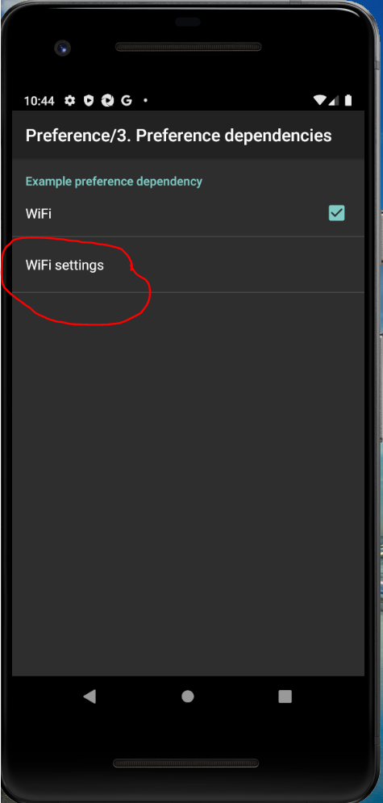

[5]

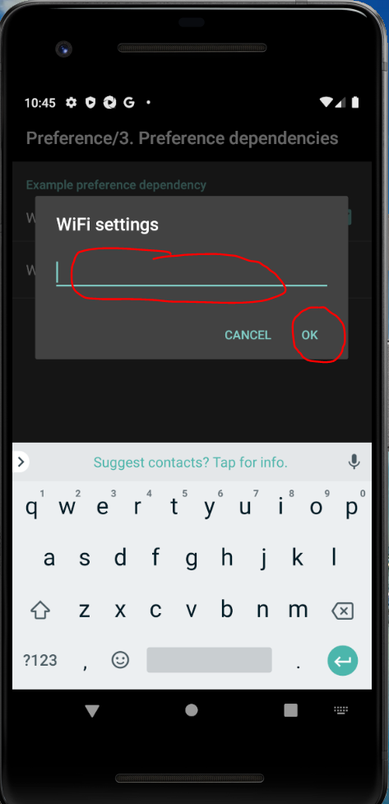

Do the following to click the ‘Preference’ option [1]:-

Use the ‘class’ text (android.widget.TextView) and also the ‘text’ text (‘Preference’)

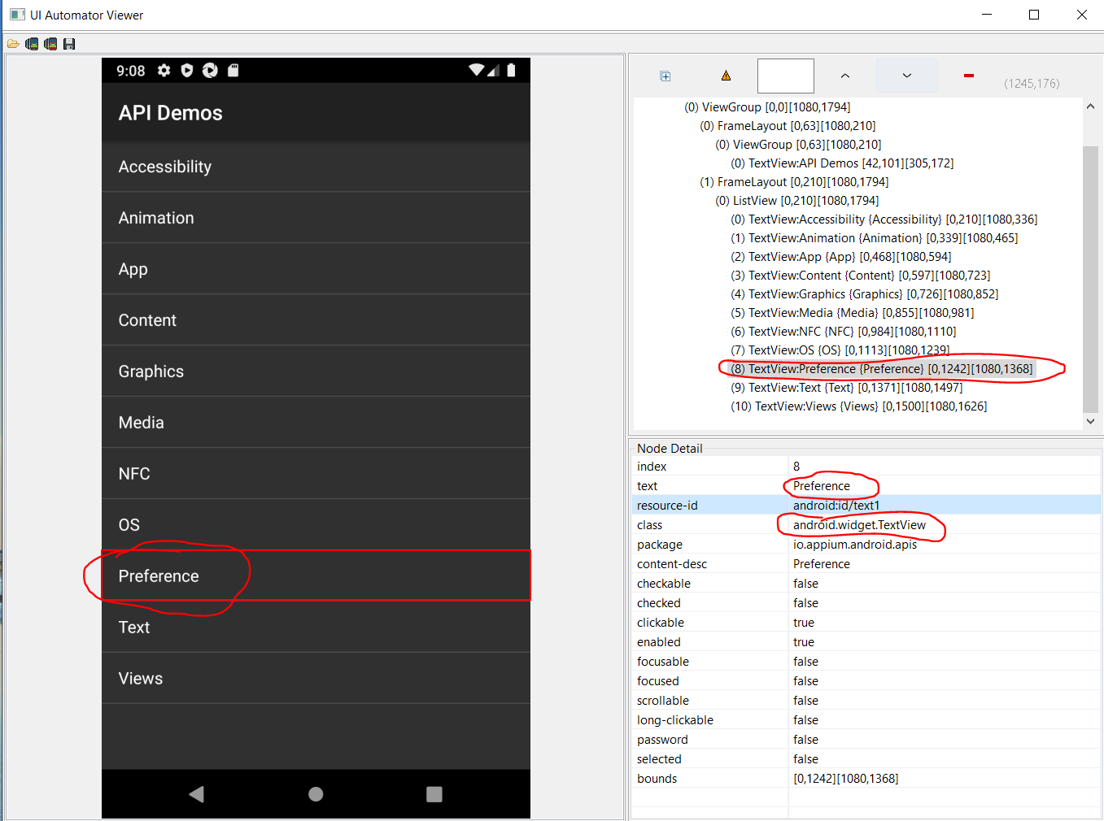

Code in Eclipse:-

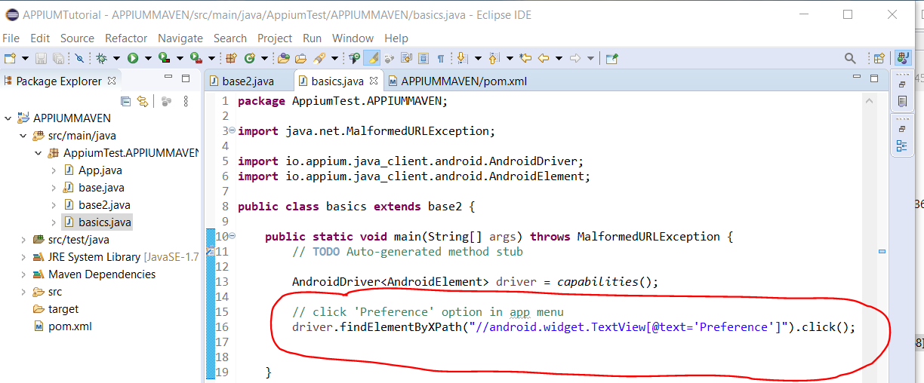

**Adding Java project to GitHub**

Go to GitHub and sign in. Create a new repository:-

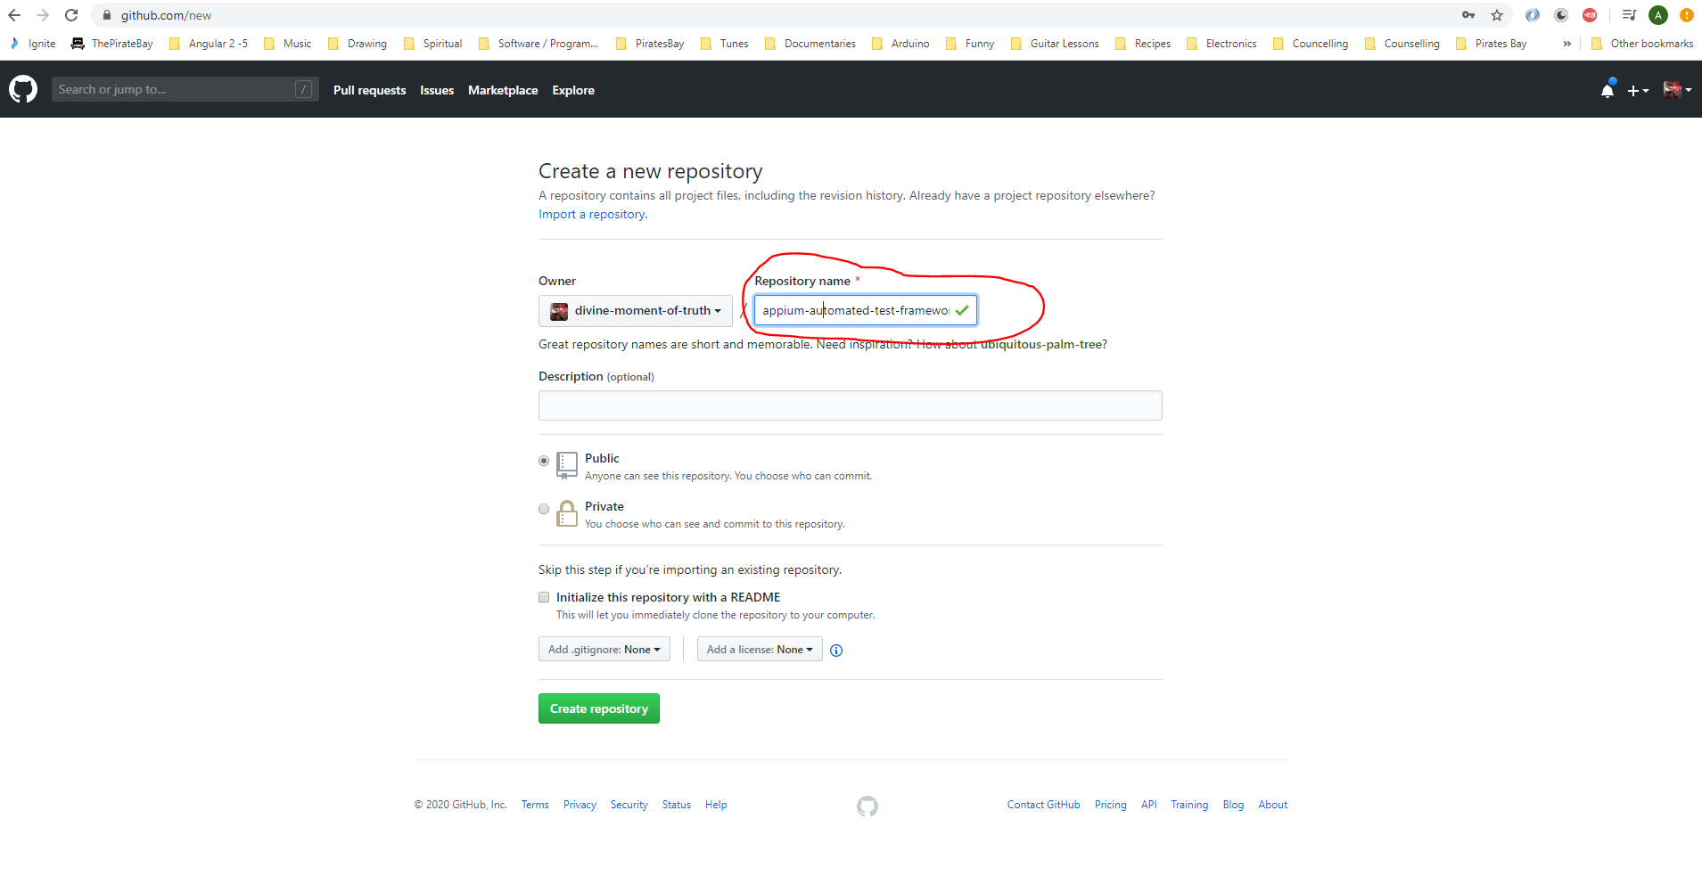

Go to Eclipse and click this button:-

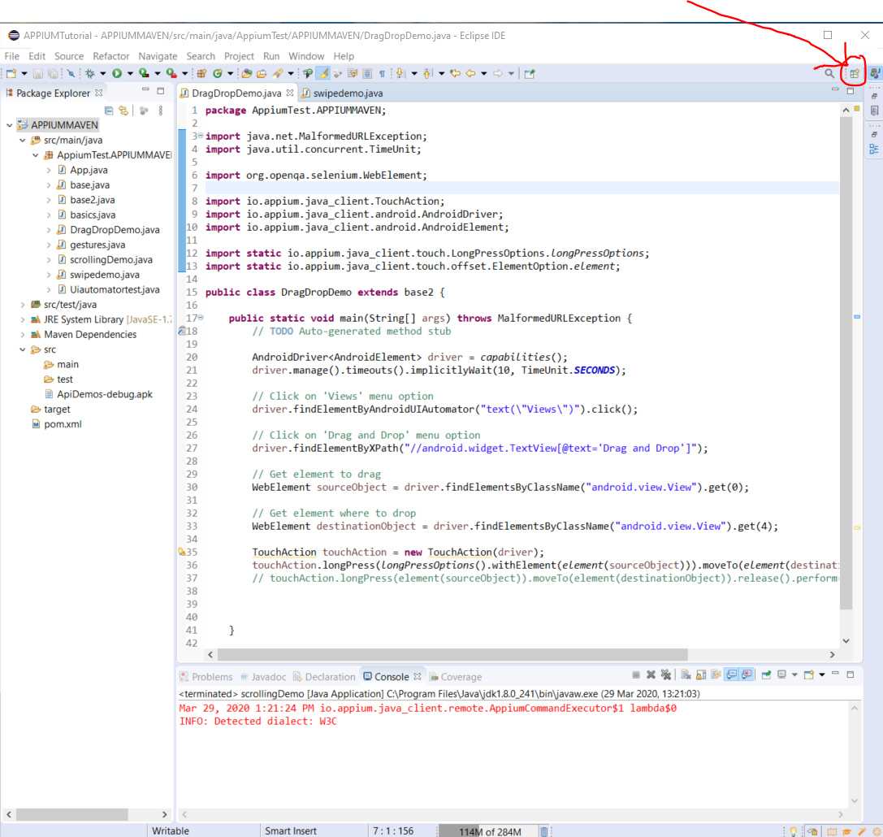

Then select ‘Git’ then click ‘Open’:-

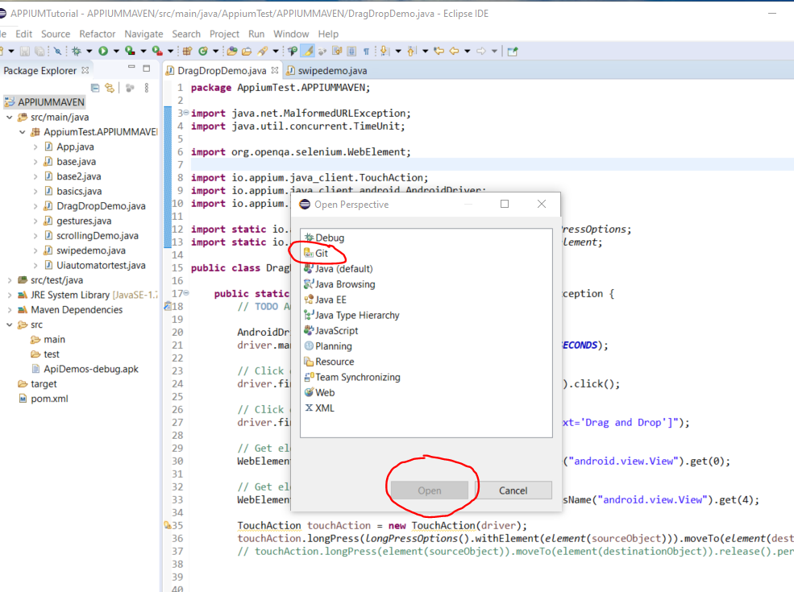

This will open this panel:-

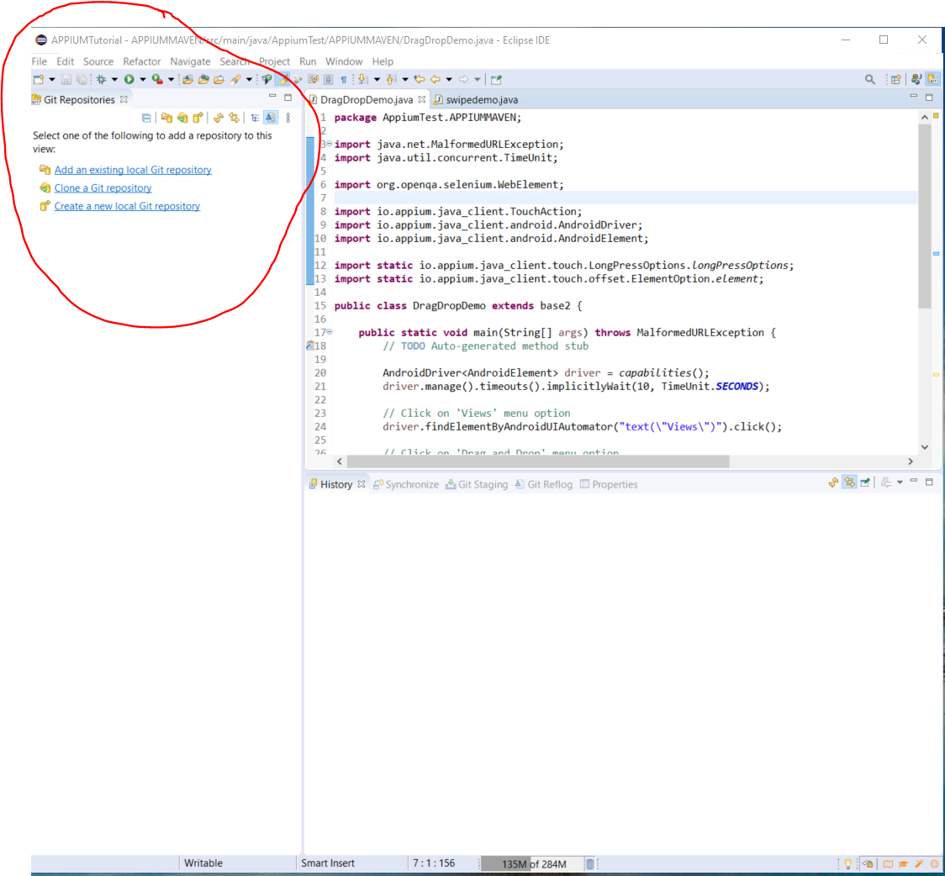

Click the ‘Clone a Git Repository’ option:-

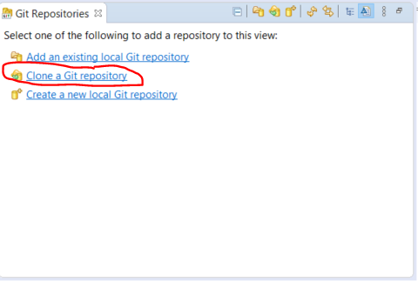

Copy url from Github and paste here:-

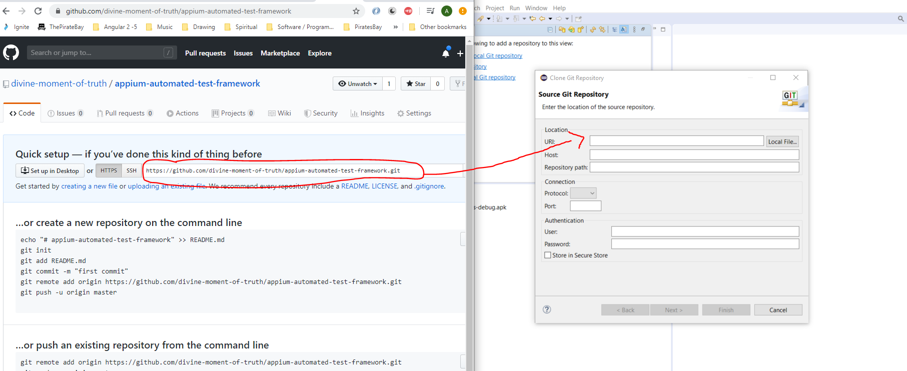

Username:-

divine-moment-of-truth

Password:-

Dudeegg1977

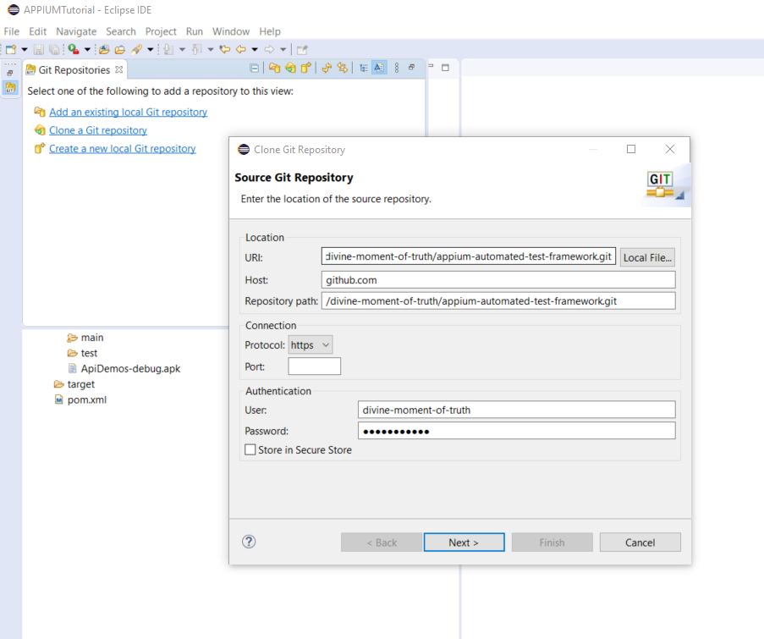

Click ‘Next’

Click ‘Finish’

This gives this:-

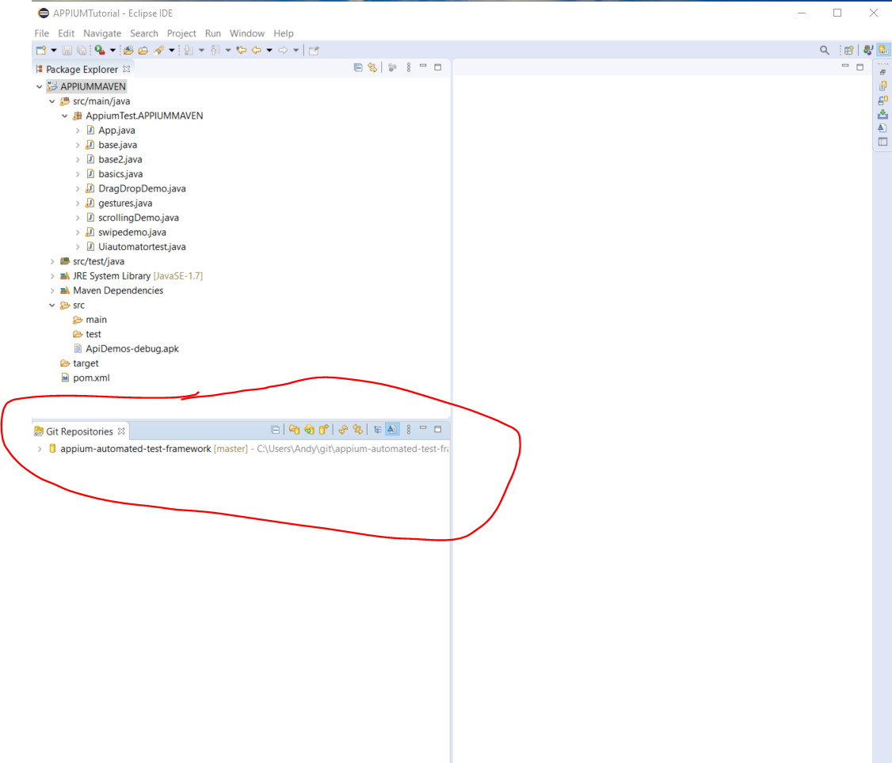

Now, right click your project name in the top left panel:-

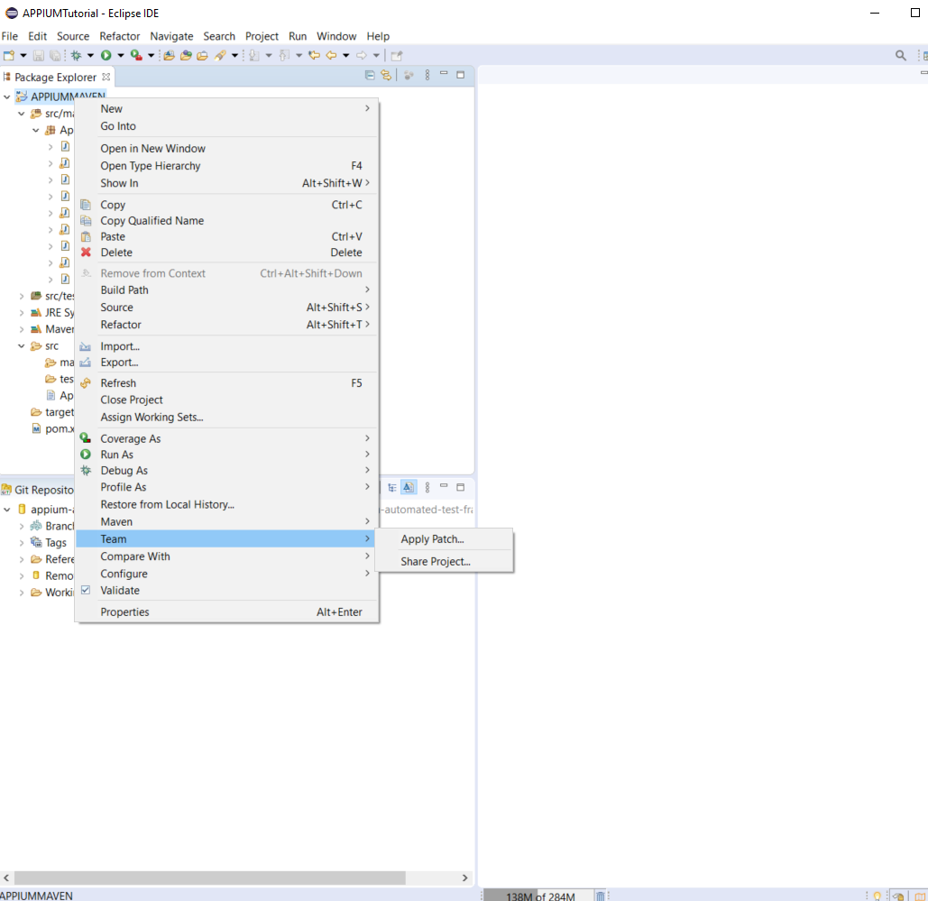

Select ‘Team’ then select ‘Share Project’.

Select your GitHub project from the drop down:-

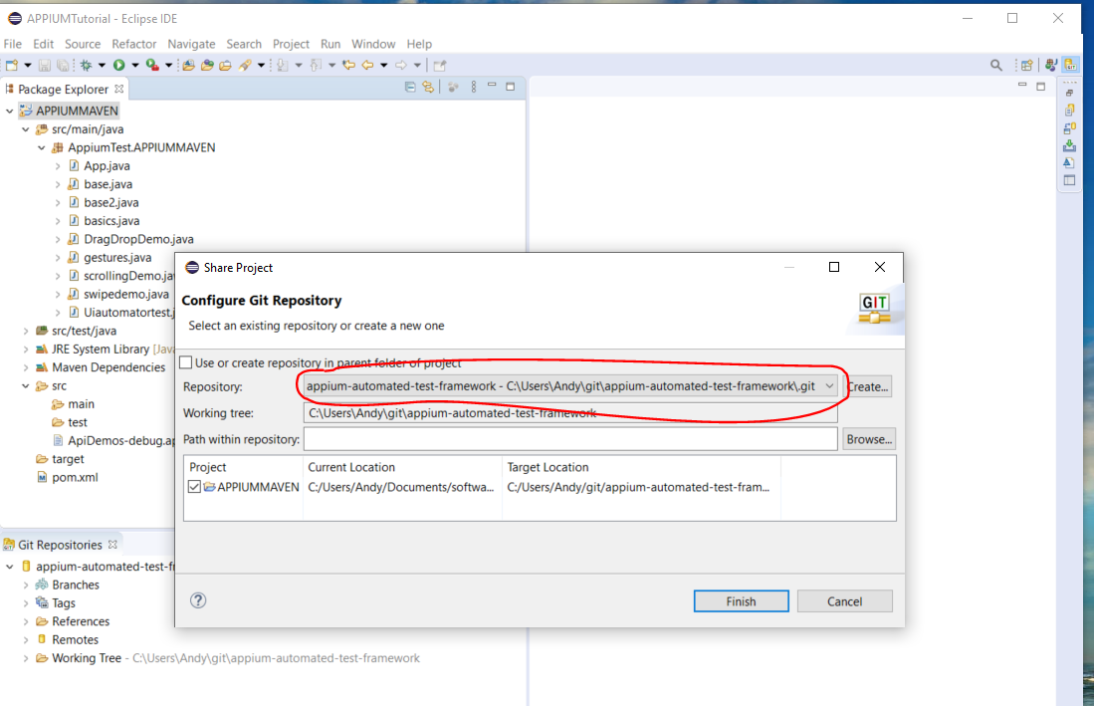

Then click ‘Finish’.

Then, right click your project name in Eclipse and select ‘Team’ again, then select ‘Commit’:-

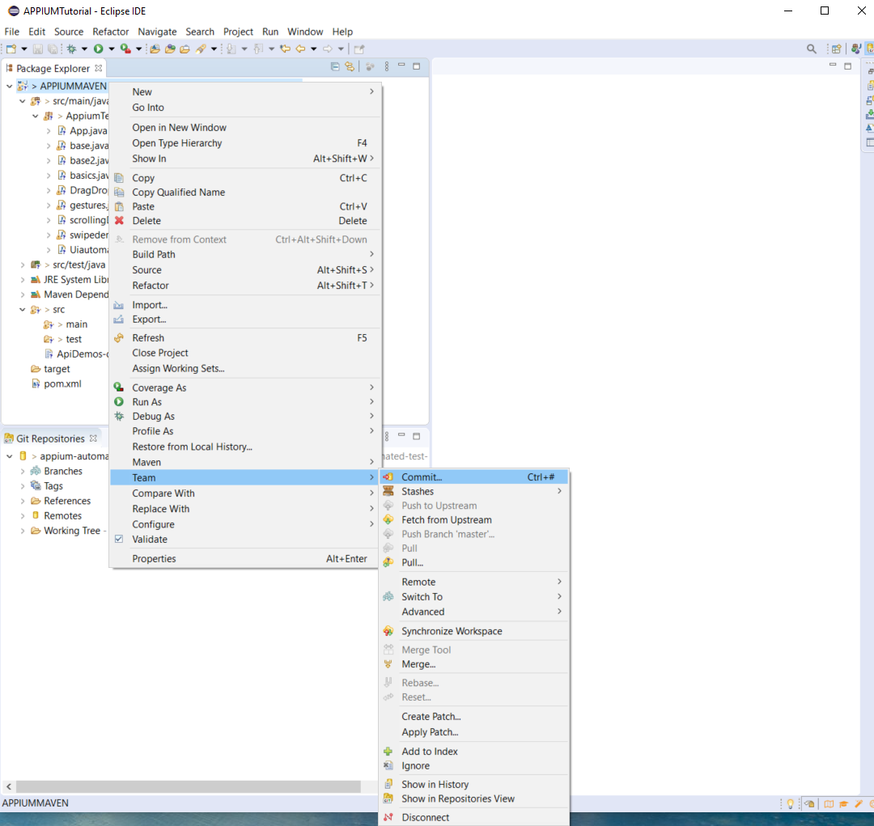

This will open this:-

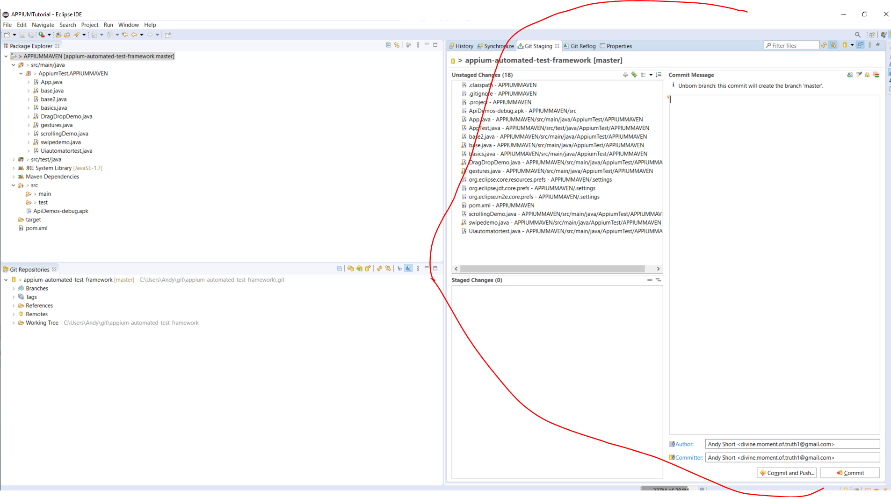

Drag all items from the top window down to the bottom ‘Staging Changes’ window:-

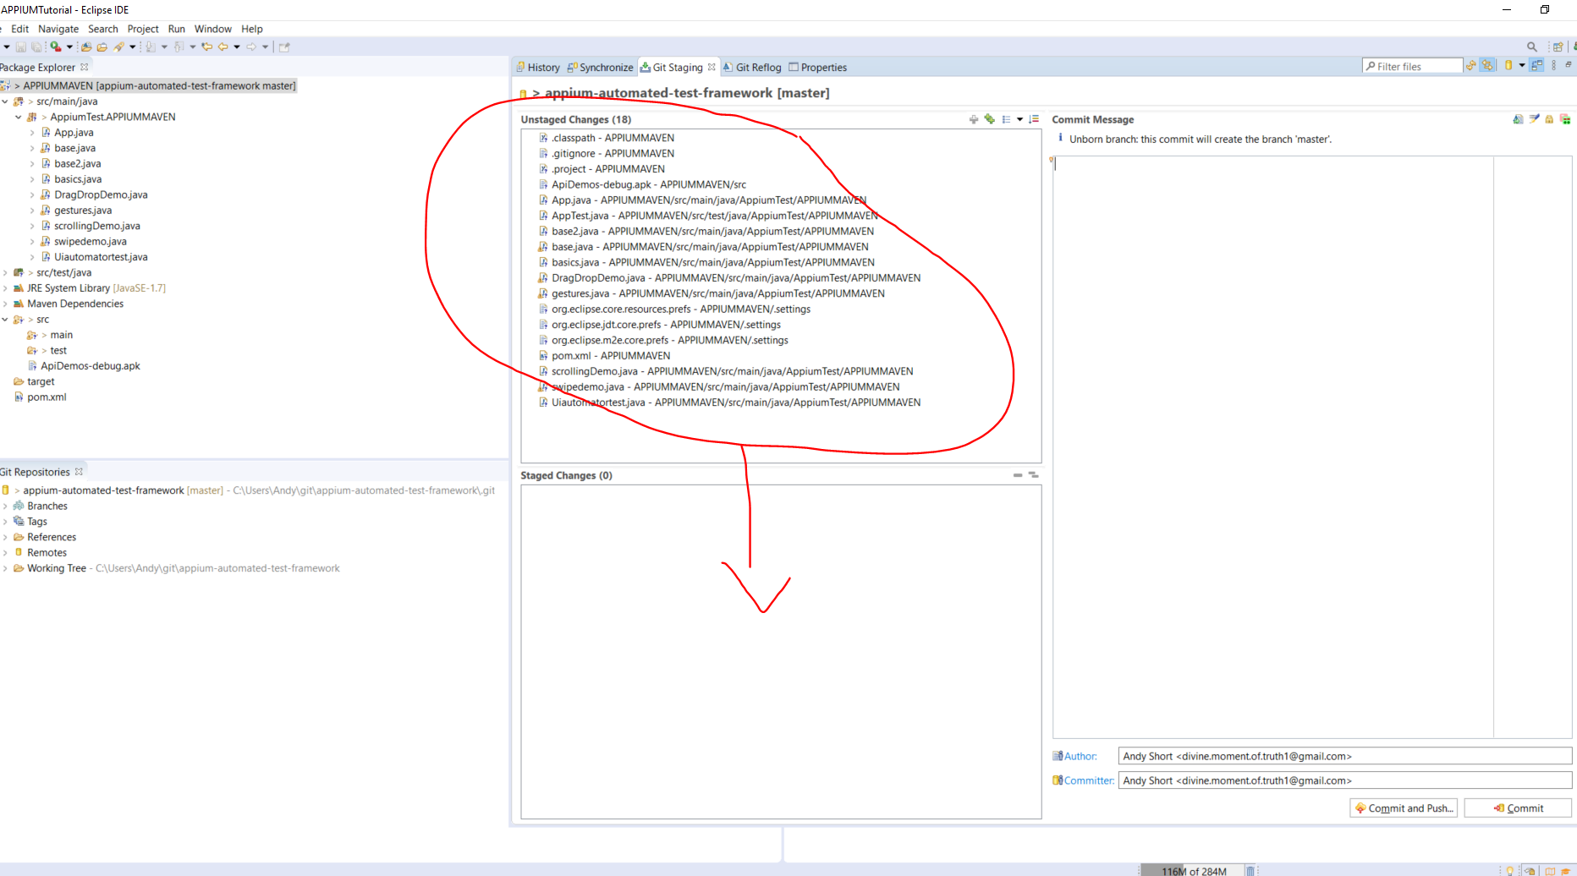

Add a comment to the ‘Commit Message’ window then click ‘Commit and Push’ button:-



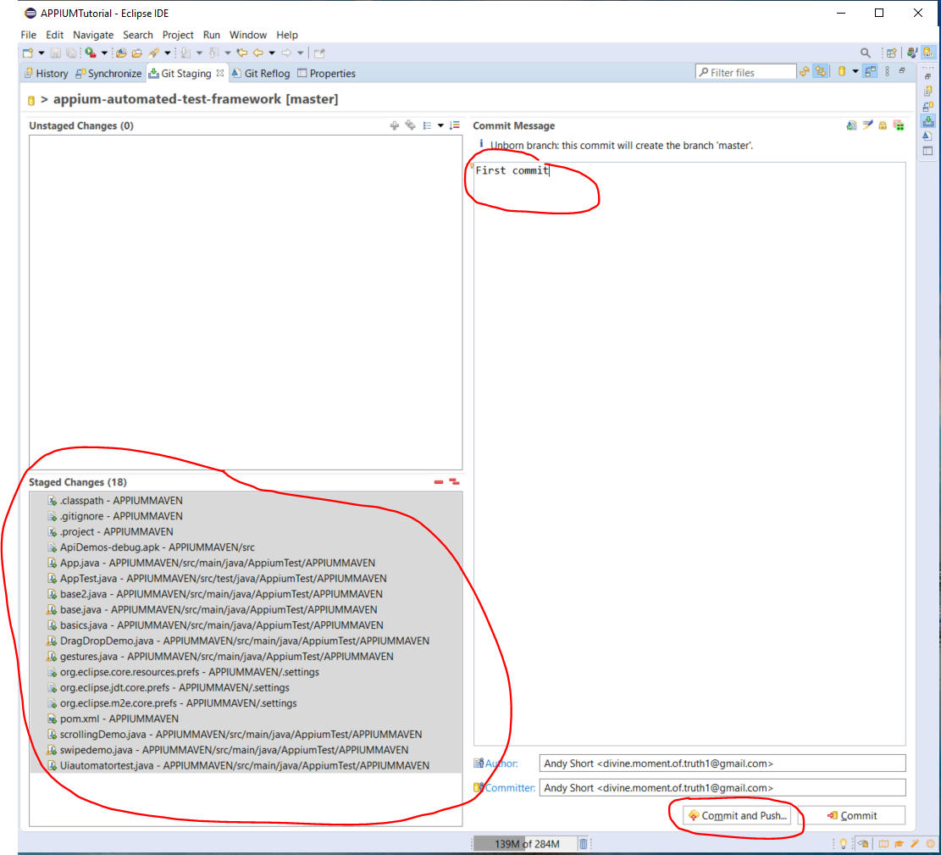

Then, click ‘Next’:-

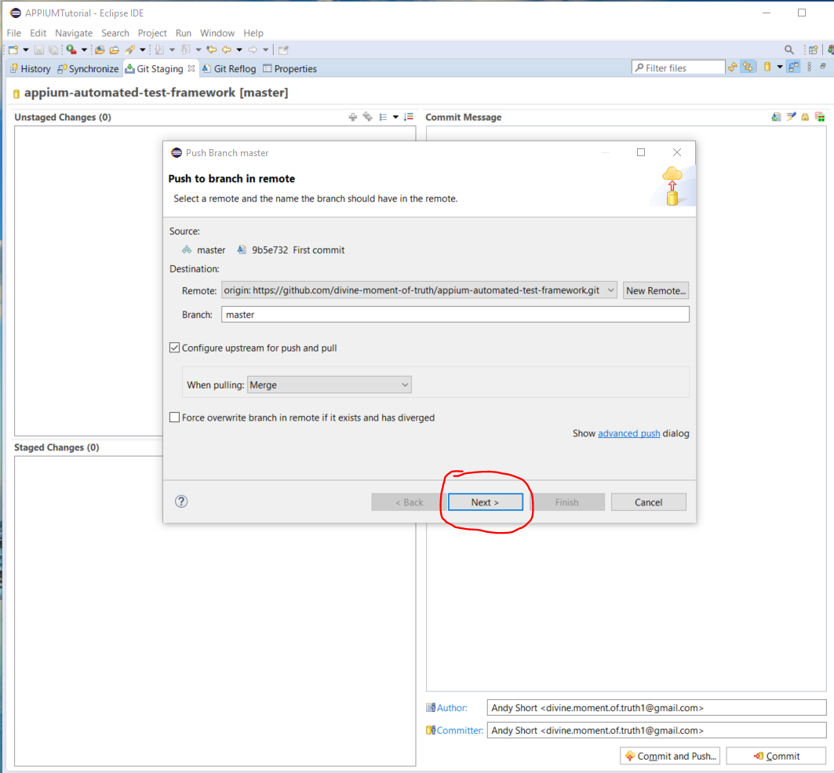

Enter username and password and tick the checkbox:-

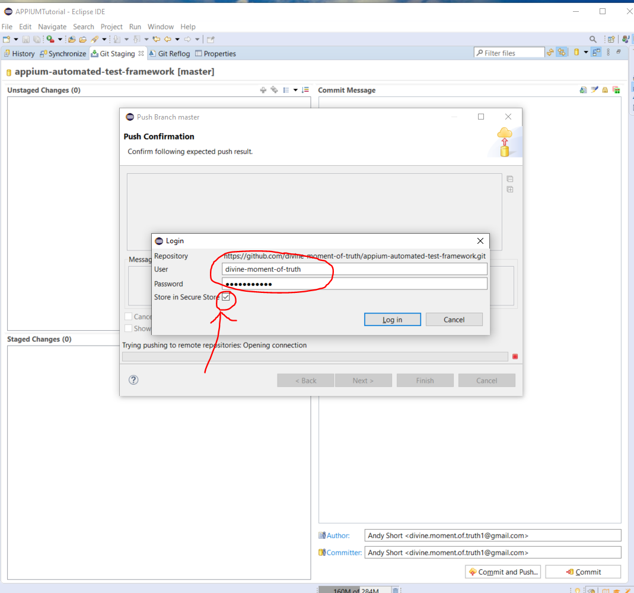

Then click ‘Finish’.

Project is now uploaded to GitHub:-

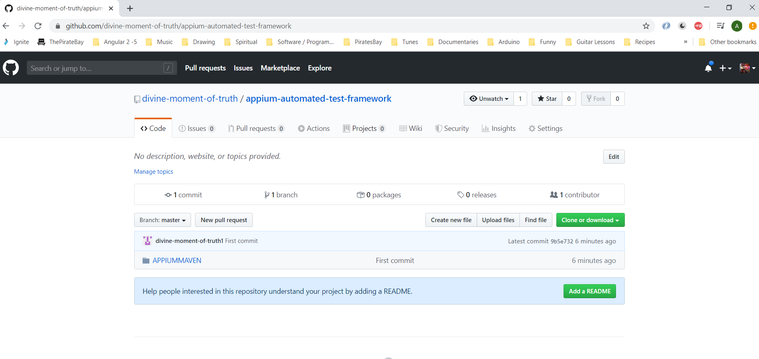

**Configure Appium to Run on a Real Device**

Connect your device to your laptop.

Download this:-

<https://developers.google.com/web/tools/chrome-devtools/remote-debugging>

**Enable Developer Mode (**<https://developer.android.com/studio/debug/dev-options.html>**)**

In your phone go to the following area:-

Settings -> System -> About Phone -> Build Number

**Enable USB Debugging**

In your phone go to the following area:-

Settings -> System -> Developer options -> USB debugging

You can test that your laptop can see you device by opening a command prompt as admin and typing the following:-

*adb devices*

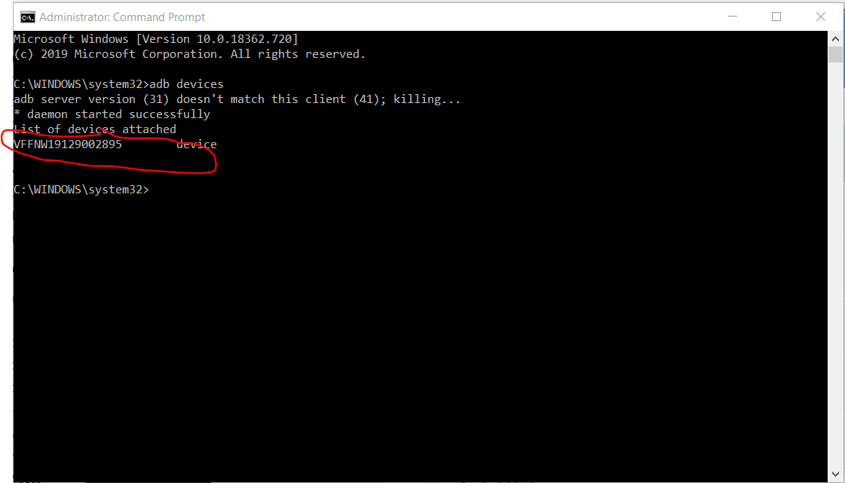

Start Appium server by opening a command prompt as admin and typing:-

*appium*

**Running Tests in Browser**

Creating the following base class:-

*package AppiumTest.APPIUMMAVEN;*

*import java.io.File;*

*import java.net.MalformedURLException;*

*import java.net.URL;*

*import org.openqa.selenium.remote.DesiredCapabilities;*

*import io.appium.java_client.android.AndroidDriver;*

*import io.appium.java_client.android.AndroidElement;*

*import io.appium.java_client.remote.MobileCapabilityType;*

*public class baseChrome {*

*public static AndroidDriver<AndroidElement> capabilities() throws MalformedURLException*

*{*

*AndroidDriver<AndroidElement> driver;*

*String connectionToServerLink = "http://127.0.0.1:4723/wd/hub";*

*DesiredCapabilities cap = new DesiredCapabilities();*

*cap.setCapability(MobileCapabilityType.DEVICE_NAME, "Android Device");*

*cap.setCapability(MobileCapabilityType.AUTOMATION_NAME,"uiautomator2");*

*cap.setCapability(MobileCapabilityType.BROWSER_NAME, "Chrome");*

*// Make a connection to the Appium server*

*driver = new AndroidDriver<>(new URL(connectionToServerLink), cap);*

*return driver;*

*}*

*}*

Now create a new test class called ‘browse.java’ to use the above class:-

**package** AppiumTest.APPIUMMAVEN;

**import** java.net.MalformedURLException;

**import** io.appium.java_client.android.AndroidDriver;

**import** io.appium.java_client.android.AndroidElement;

**public** **class** browse **extends** baseChrome {

**public** **static** **void** main(String[] args) **throws** MalformedURLException {

// **TODO** Auto-generated method stub

AndroidDriver<AndroidElement> driver = *capabilities*();

driver.get("http://google.com");

}

}

No open a command prompt and navigate here:-

*cd c:\Users\Andy*

Then, type the following:-

*npm install chromedriver*

Now copy the following path:-

C:\\Users\\Andy\\node_modules\\chromedriver\\bin\\chromedriver

Add the following line to the ‘baseChrome.java’ class:-

capabilities.setCapability("chromedriver.exe", "c:/Users/Andy/node_modules/chromedriver/bin/");

Add the following to the ‘baseChrome.java’ class:-

ChromeOptions chromeOptions = **new** ChromeOptions();

chromeOptions.setExperimentalOption("w3c", **false**);

capabilities.merge(chromeOptions);

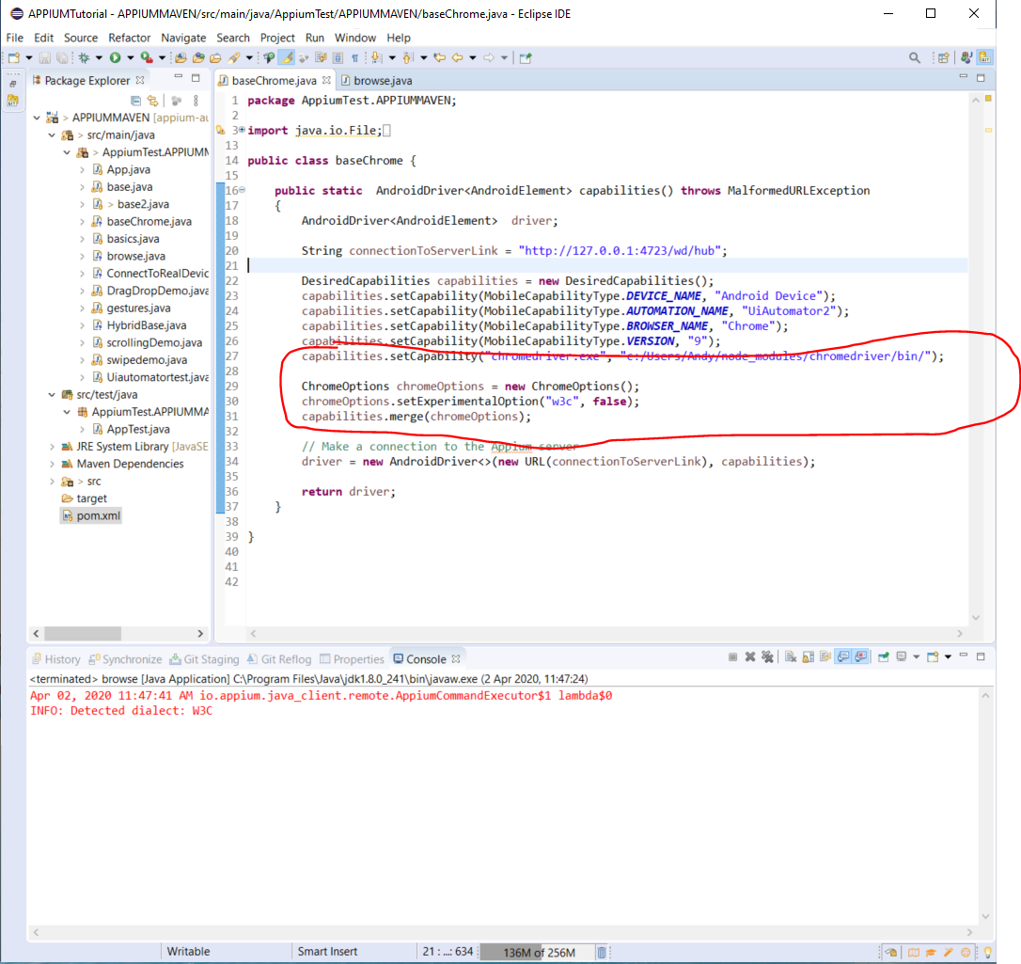

Press F12 on the browser window. This click on the ellipses:-

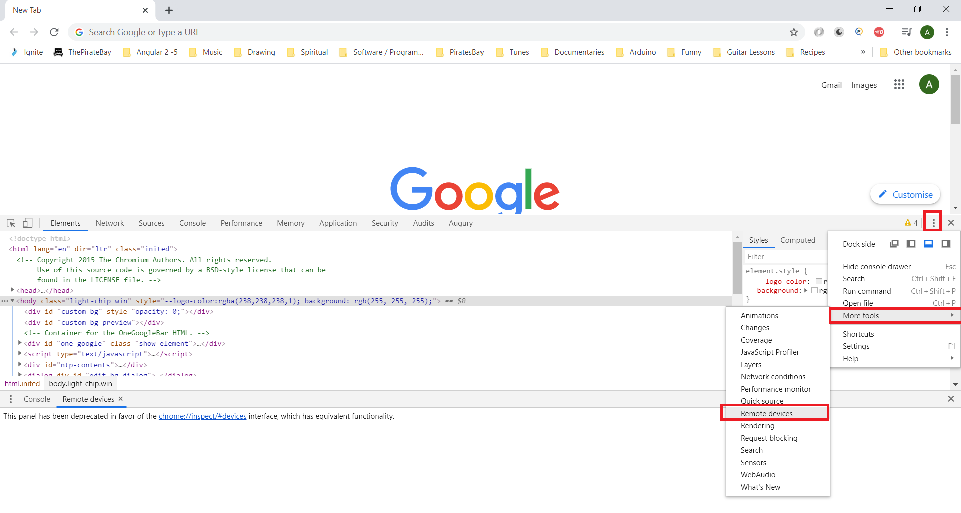

Select ‘More Tools’ then ‘Remote Devices’. This brings up the following (see your device connected):-

NOTE:- You will to change your screen sleep time to ‘Never’ in your mobile devices display settings (Settings -> Display)

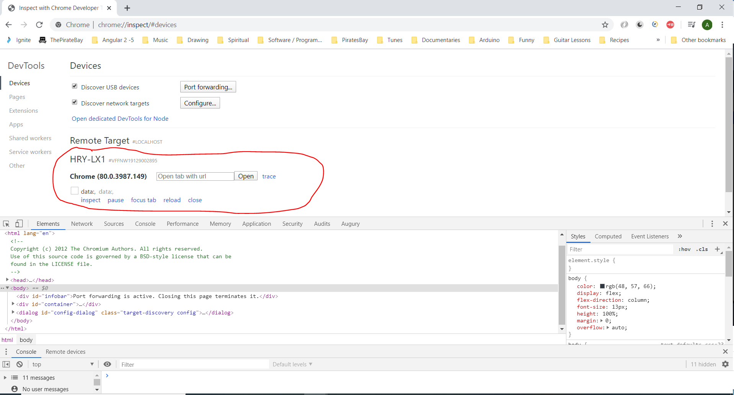

You can enter a new URL in the above input box and a new web page will open on your device e.g. see facebook opened on device:-

Then click the ‘inspect’ link:-

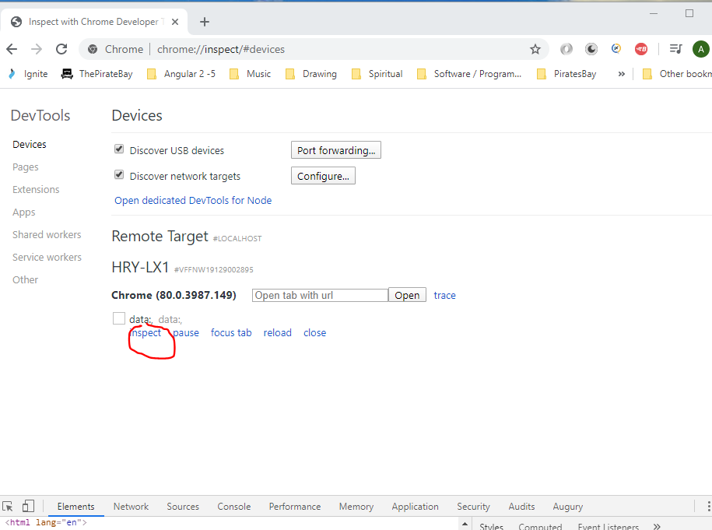

This will open the following:-

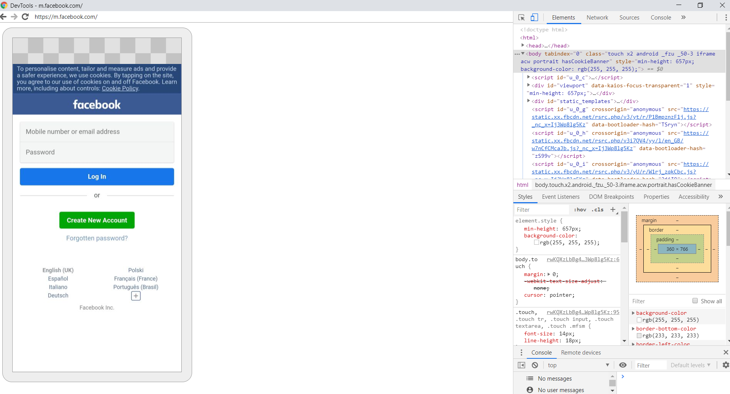

By clicking on the element e.g. the username input box you will see the element appear in the right hand window. By right clicking the element in the right hand window select the ‘copy’ option then the ‘copy xpath’ option:-

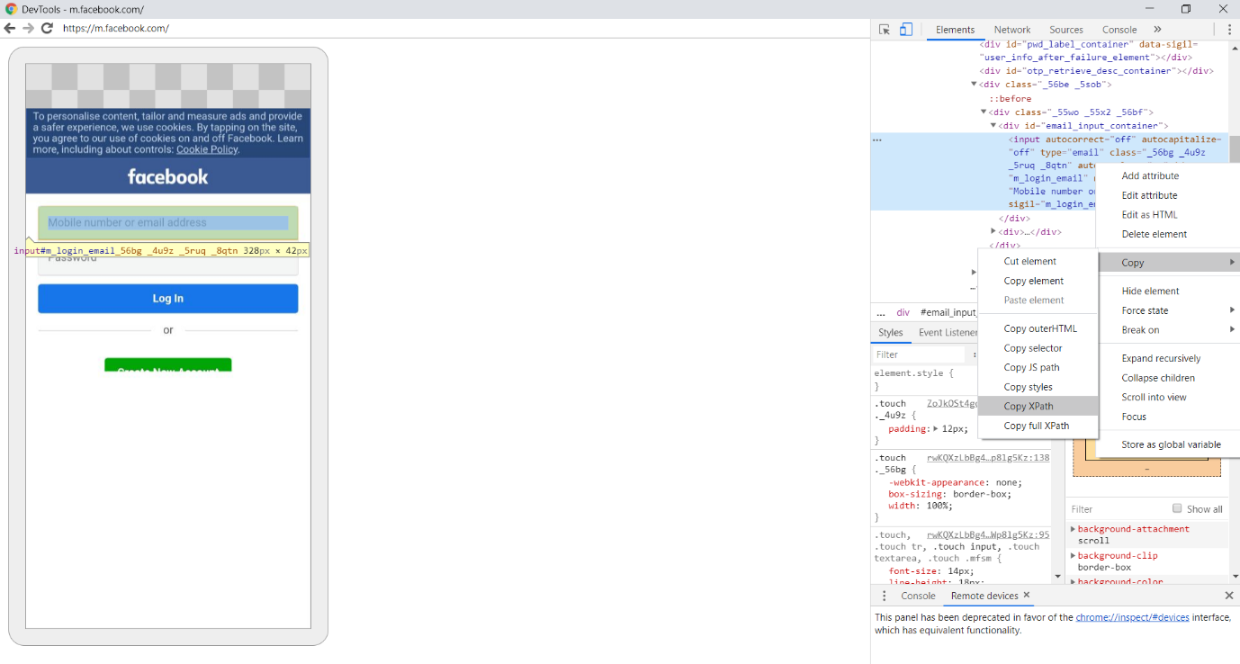

Then paste the xpath into eclipse:-

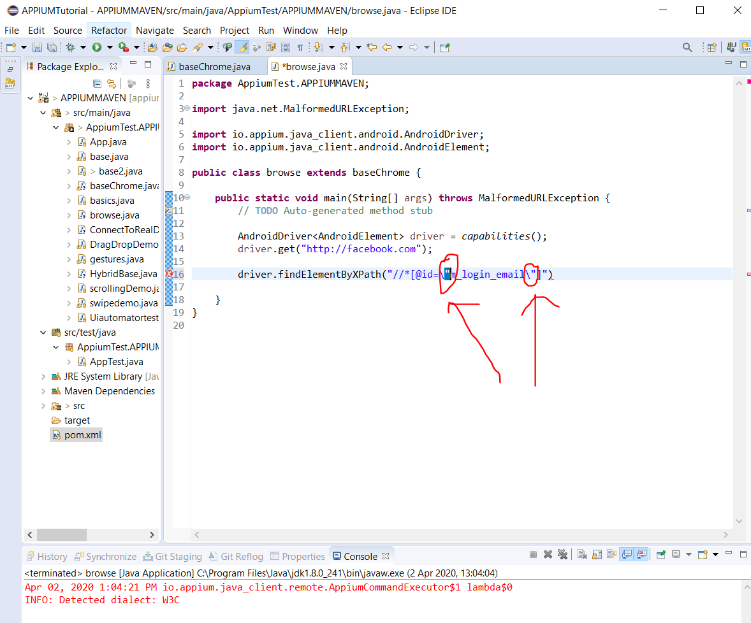

Change the above double quotes into single quotes:-

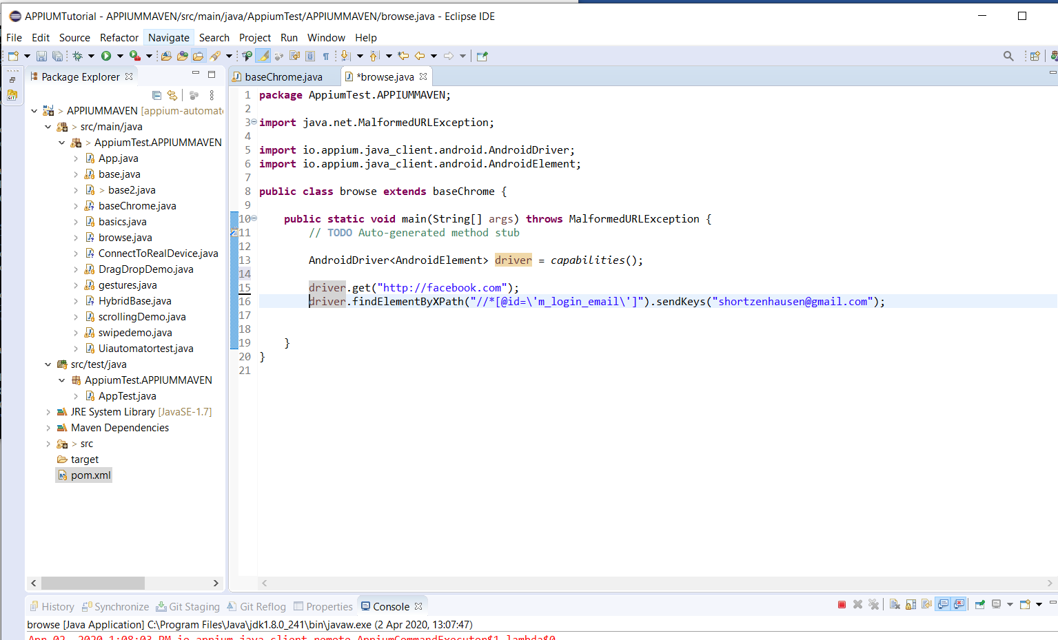

Note:- if you see ‘adb devices – Unauthorized’ in command prompt, then do this:-

adb kill-server

adb start-server

adb devices

Download new app for mobile emulator testing:-

<https://www.rahulshettyacademy.com/#/practice-project>

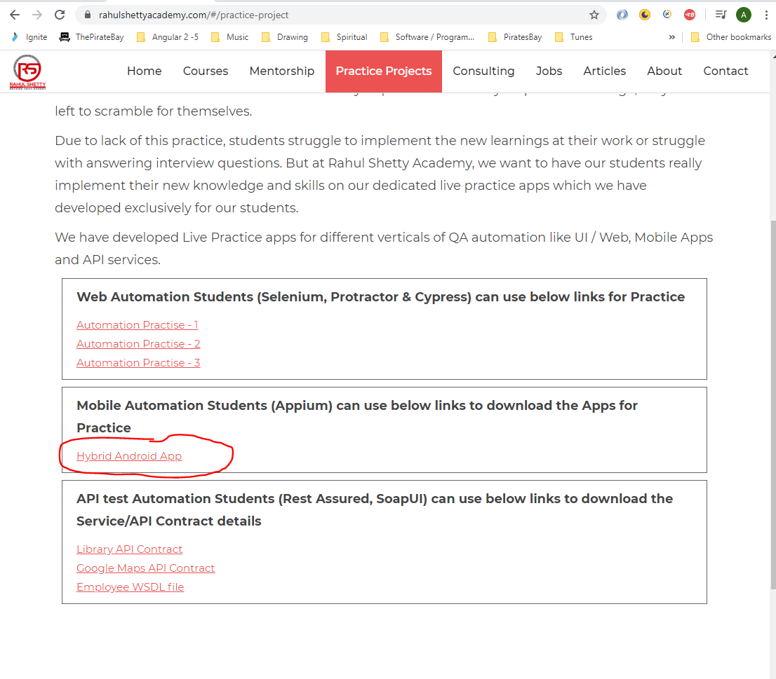

[Divine.moment.of.truth1@gmail.com](mailto:Divine.moment.of.truth1@gmail.com)

dudeegg1977

Open Android Studio and start your emulator:-

Go to ‘All apps’ on your emulator and drag the downloaded app into ‘All apps’:-

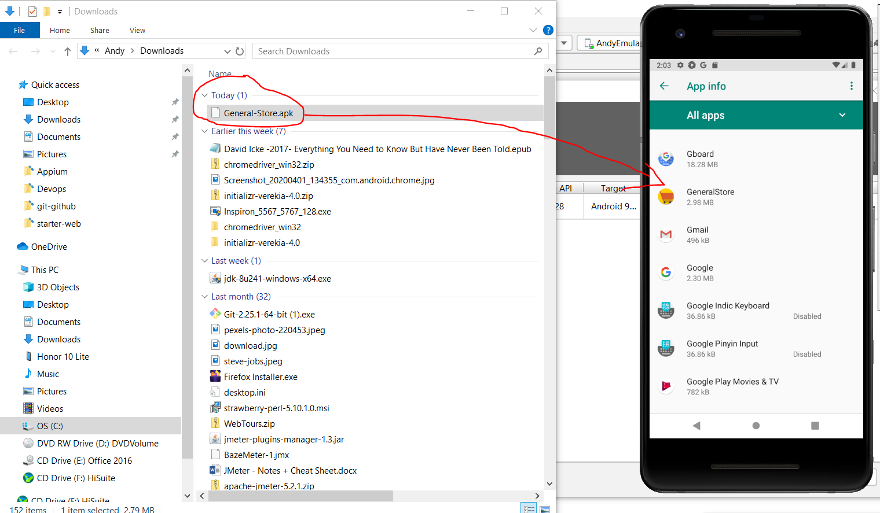

Now start app by going to the device home page then dragging from the bottom upwards to reveal apps:-

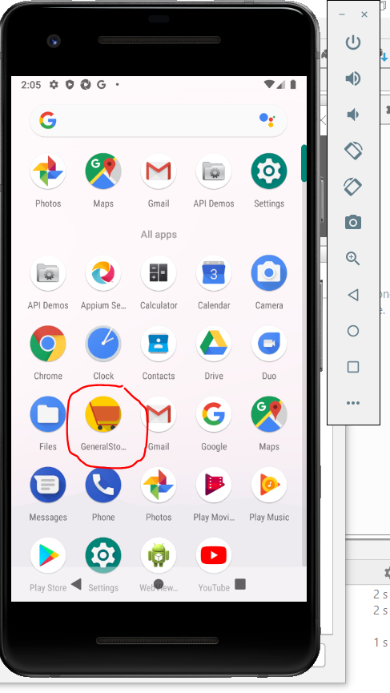

This opens this:-

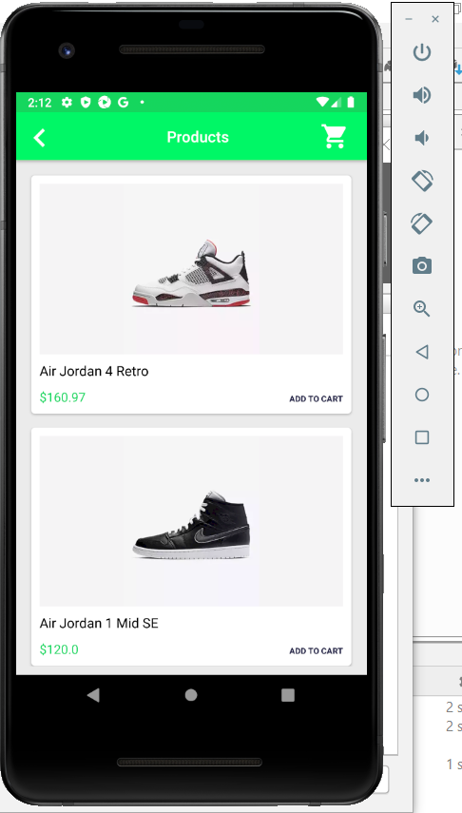

Another way to install the app into the device is by doing this:-

Open Command Prompt and navigate here:-

*cd C:\Users\Andy\AppData\Local\Android\Sdk\platform-tools*

Then, type:-

adb install C:\Users\Andy\Downloads\General-Store.apk

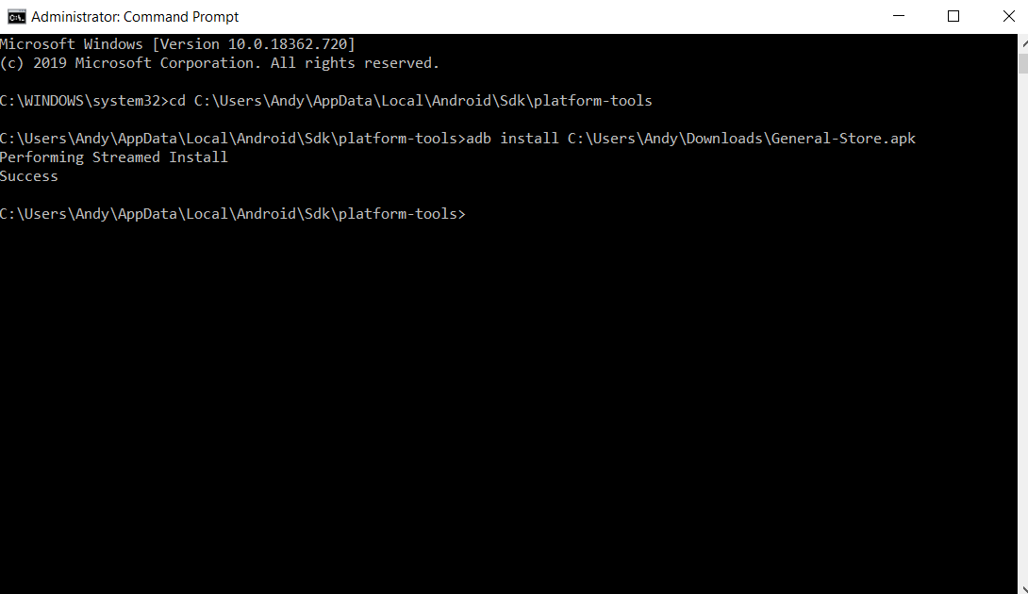

**Test cases:-**

[1] Fill in the first form details (see below):-

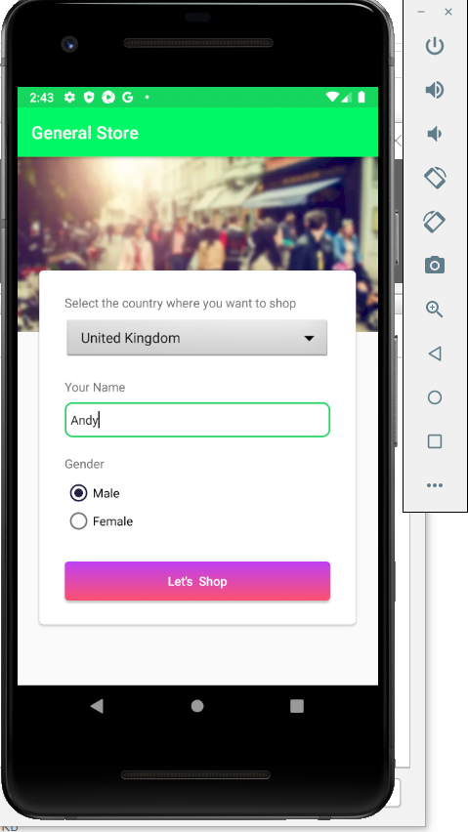

Create a new class in Eclipse – ecommerse_tc_1

Copy the ‘General-Store.apk’ app into your project in Eclipse:-

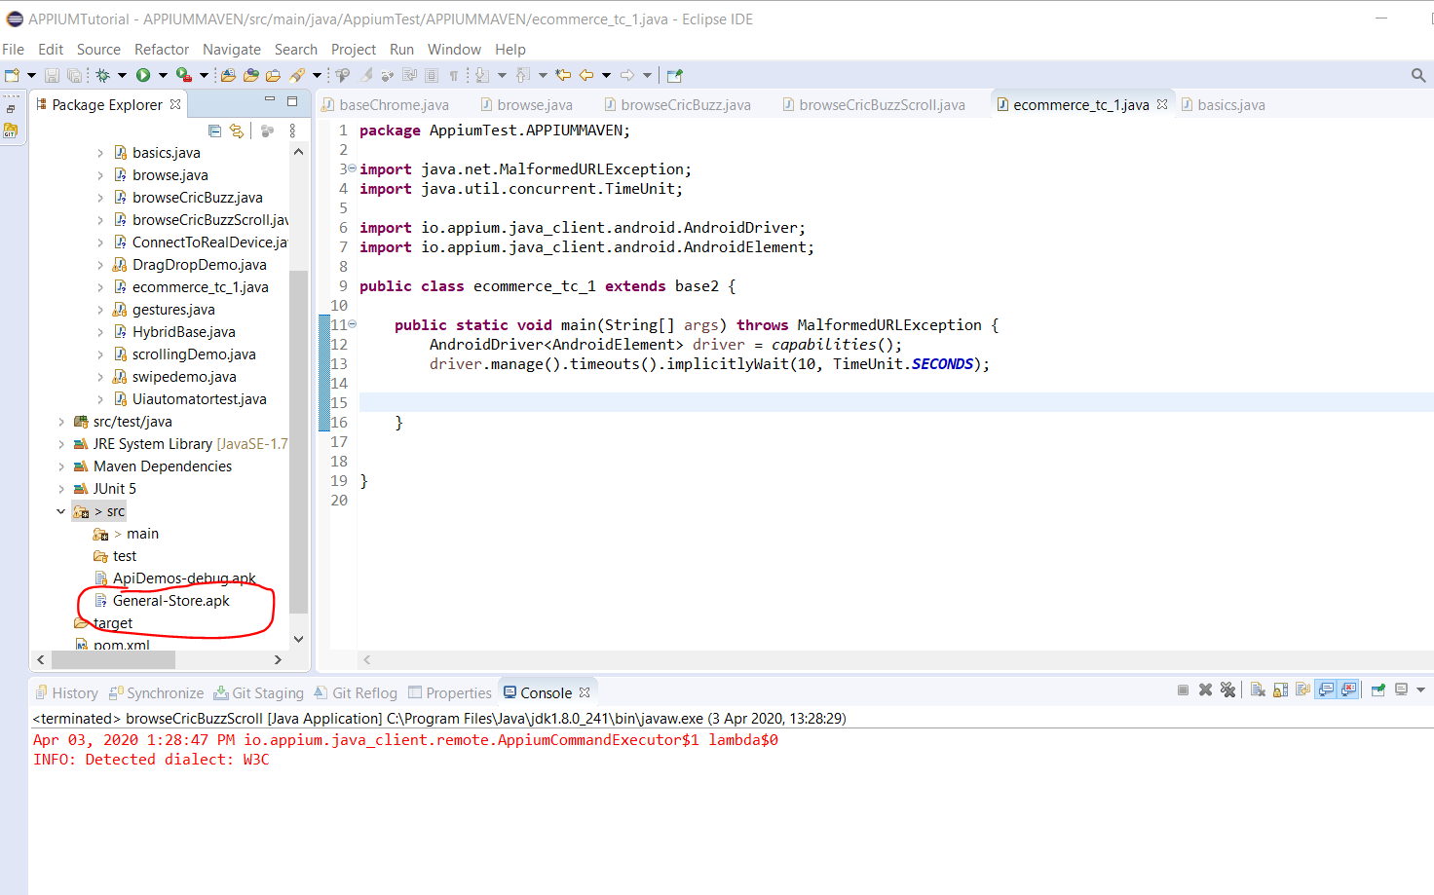

Create a new base class:-

*baseGeneralStoreApp.java*

Create a new test case class:-

*ecommerce_tc_1.java*

Now open the ‘UI Automation Viewer’. Location of app is here:-

# C:\Users\Andy\AppData\Local\Android\Sdk\tools\bin\uiautomatorviewer.bat

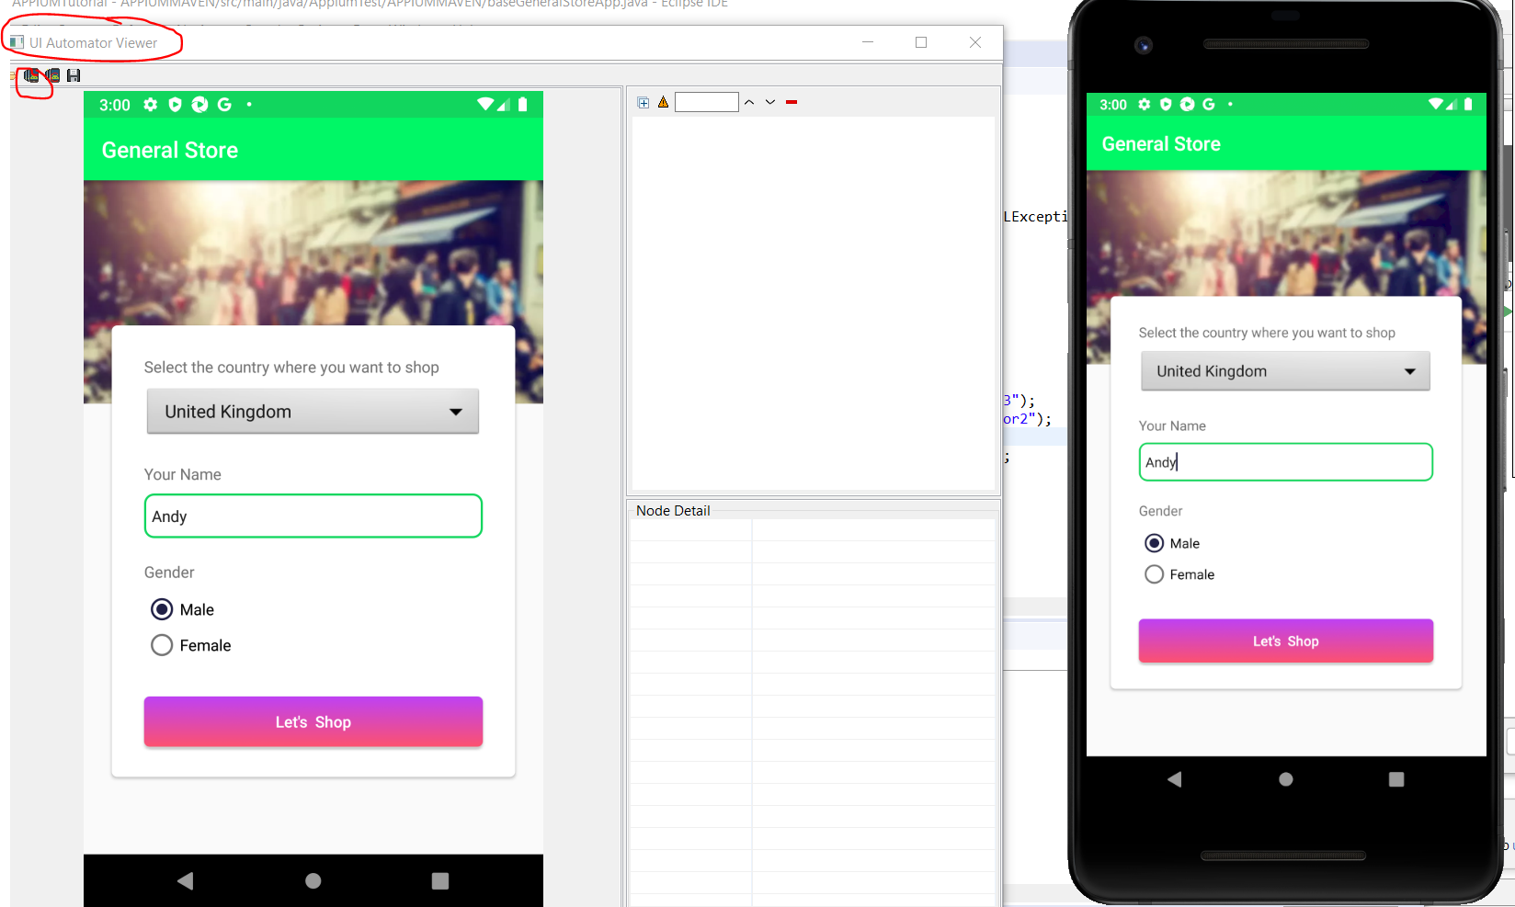

Tp look for Appium Java Client code solutions go to the following website:-

<https://github.com/appium/java-client>

<https://github.com/appium/java-client/tree/master/src/test/java/io/appium/java_client/android>

and here for the scrollable code:-

<https://github.com/appium/java-client/blob/master/src/test/java/io/appium/java_client/android/AndroidSearchingTest.java>

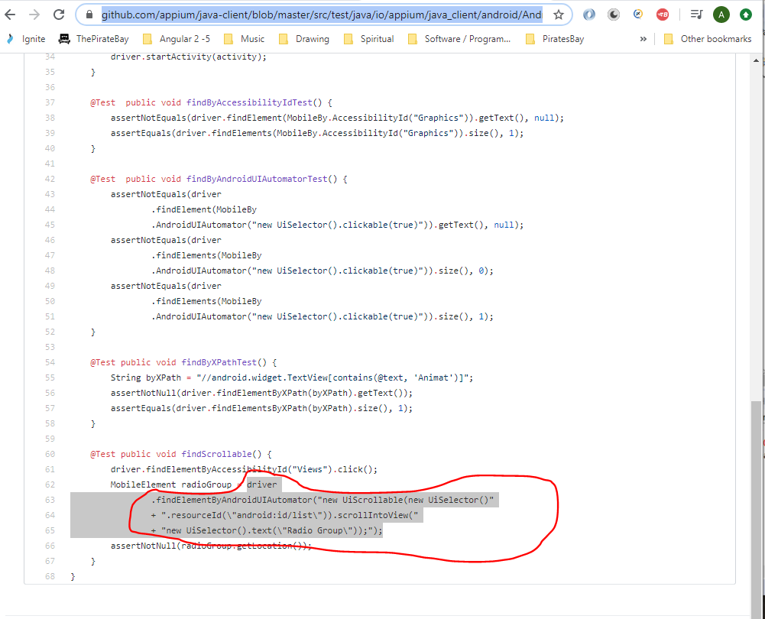

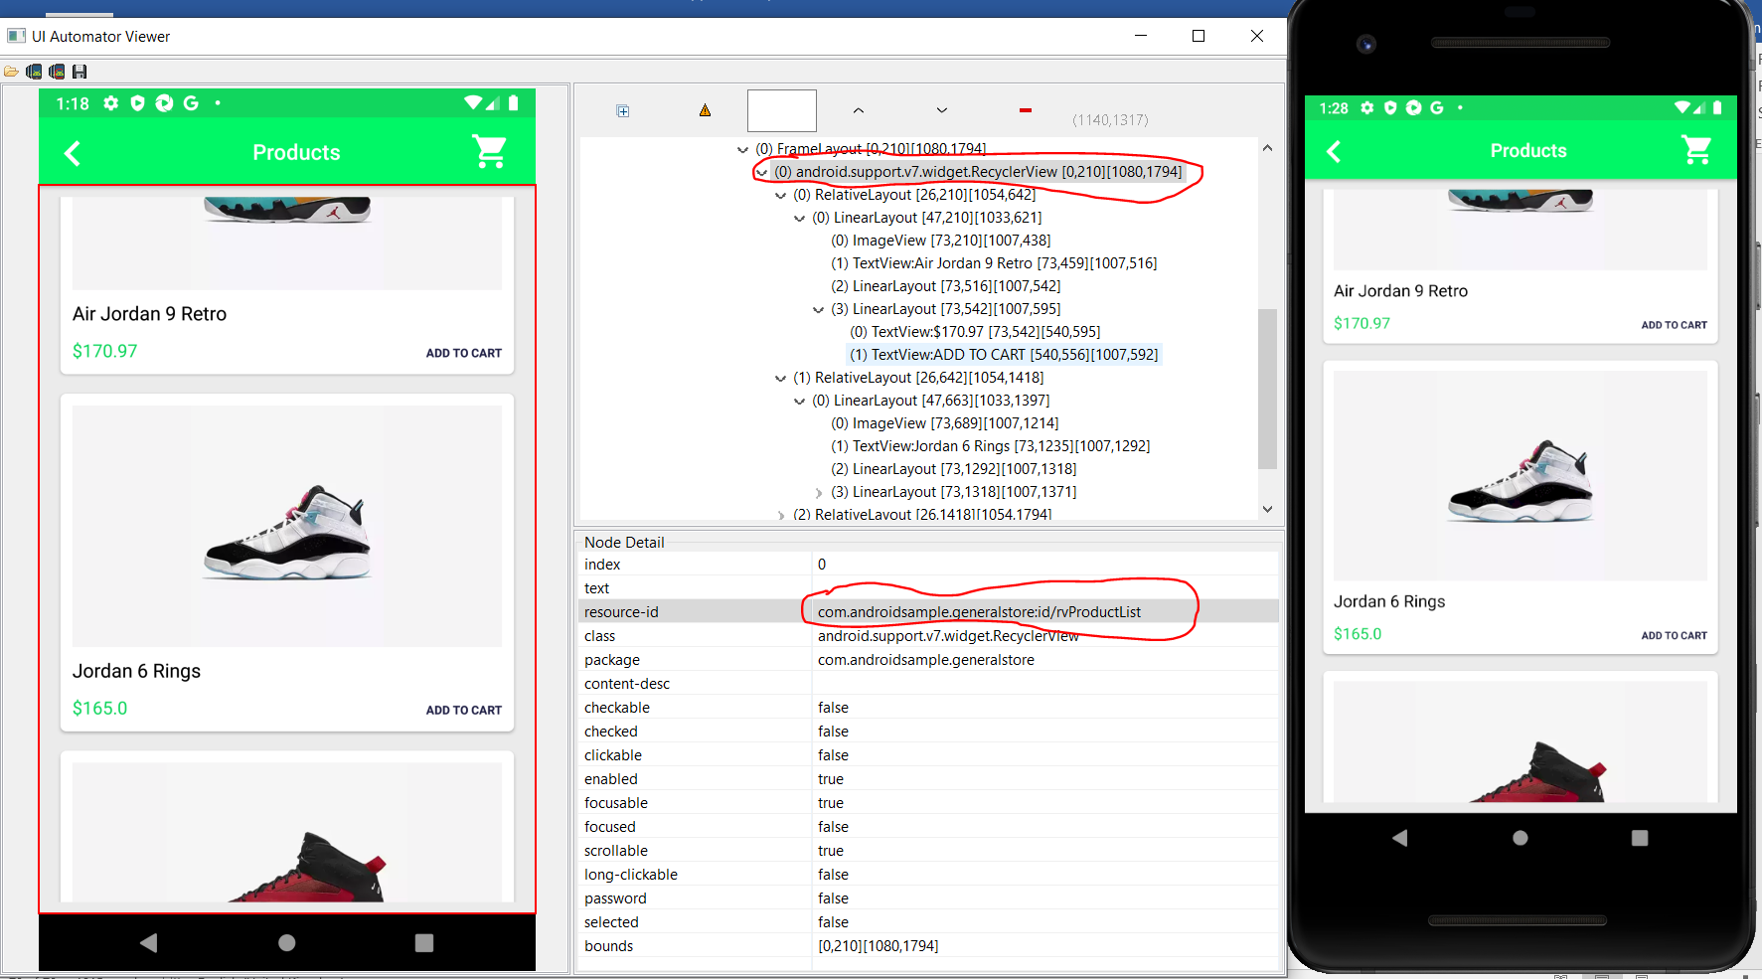

The above section goes here (parent part – look for this – RecyclerView):-

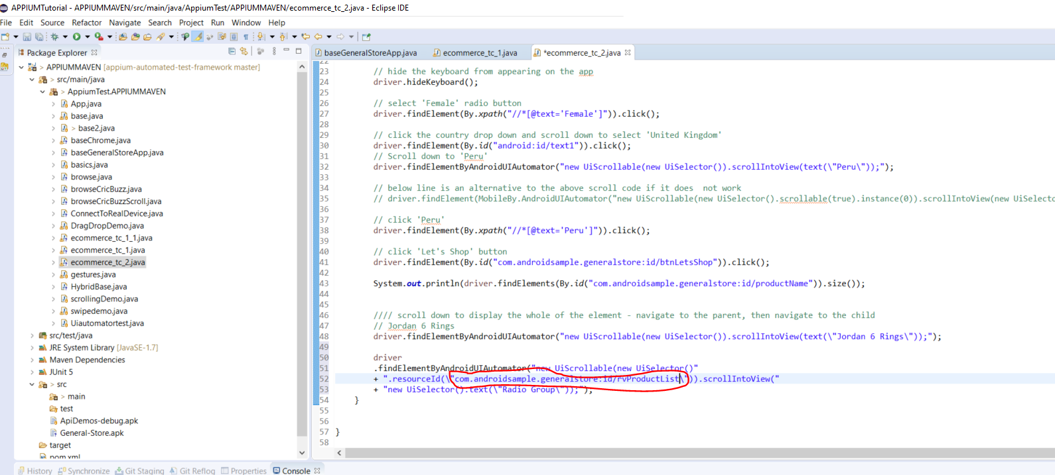

And, this part (the child part):-

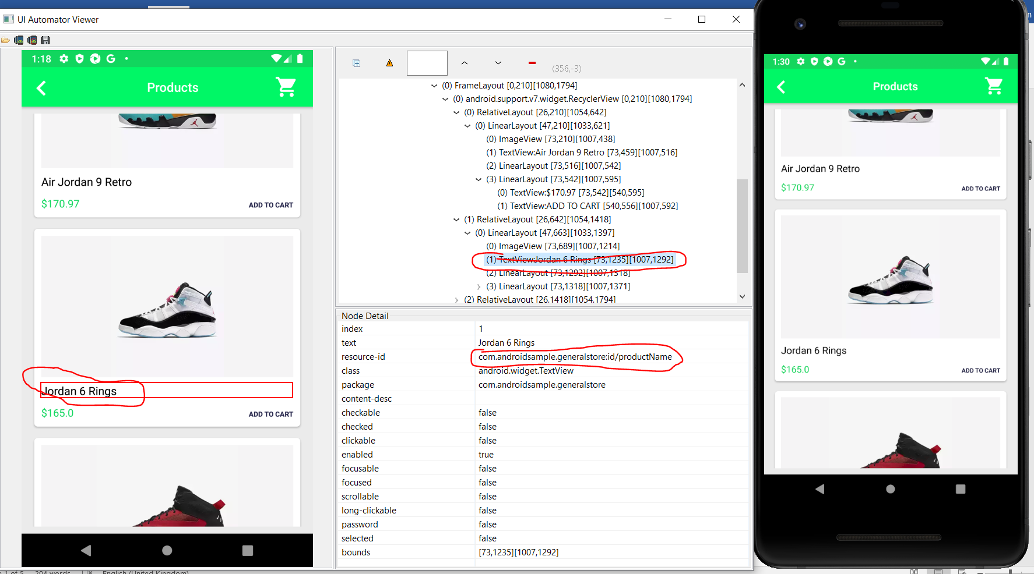

Goes here:-

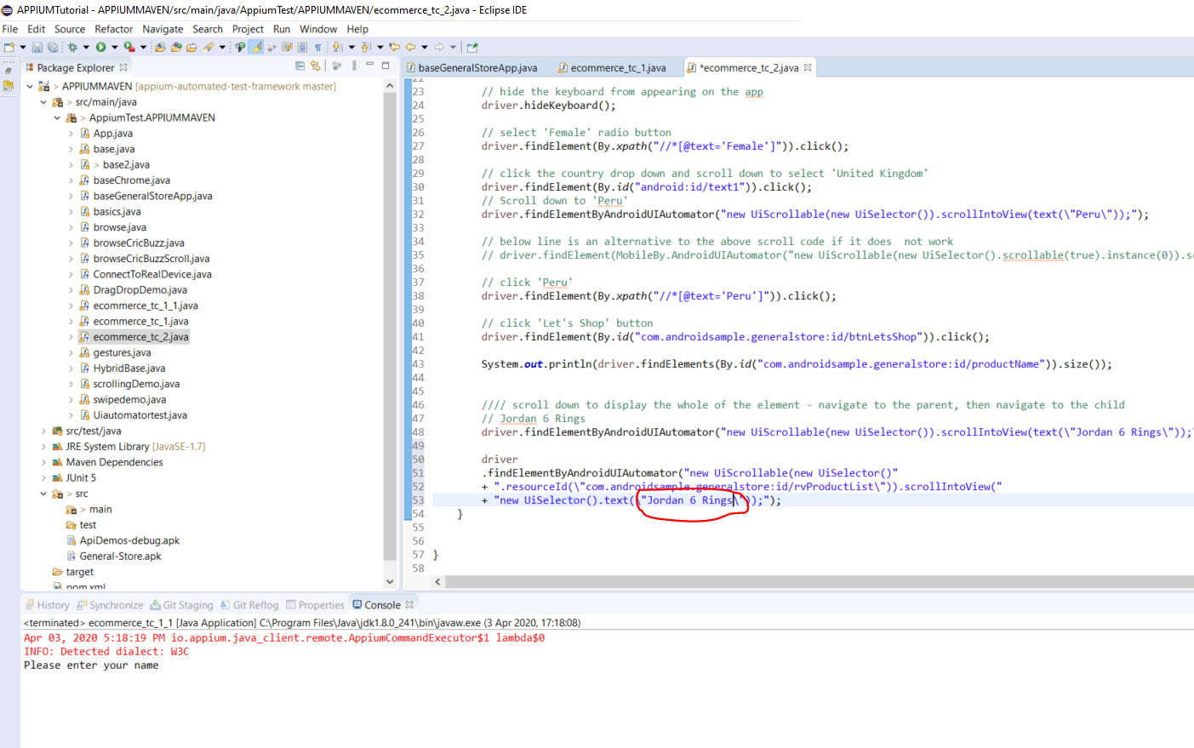

**Committing/ Staging / Pushing to Git**

Right click on project root:-

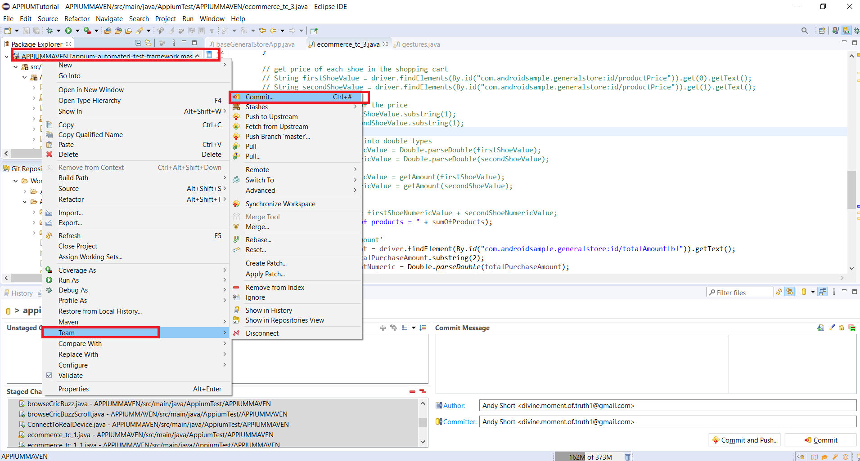

Go to – Team -> Commit

This will open this screen:-

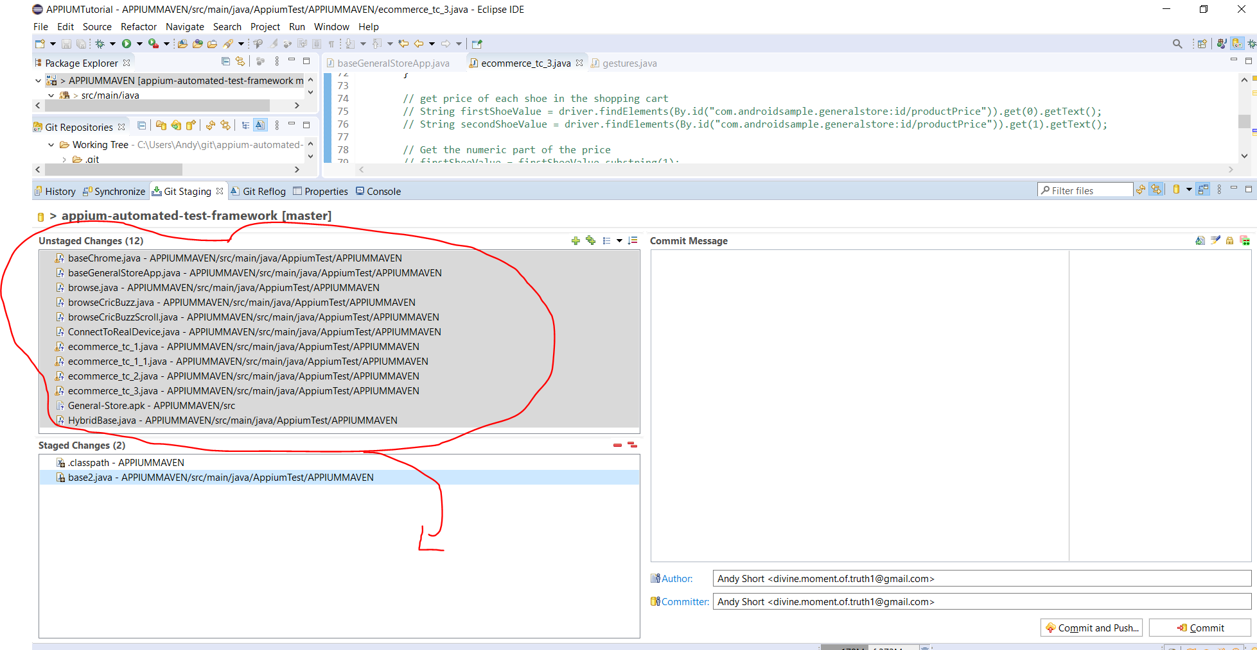

Select all files in the ‘Unstaged Changes’ panel and drag down to the ‘Staged Changes’ panel.

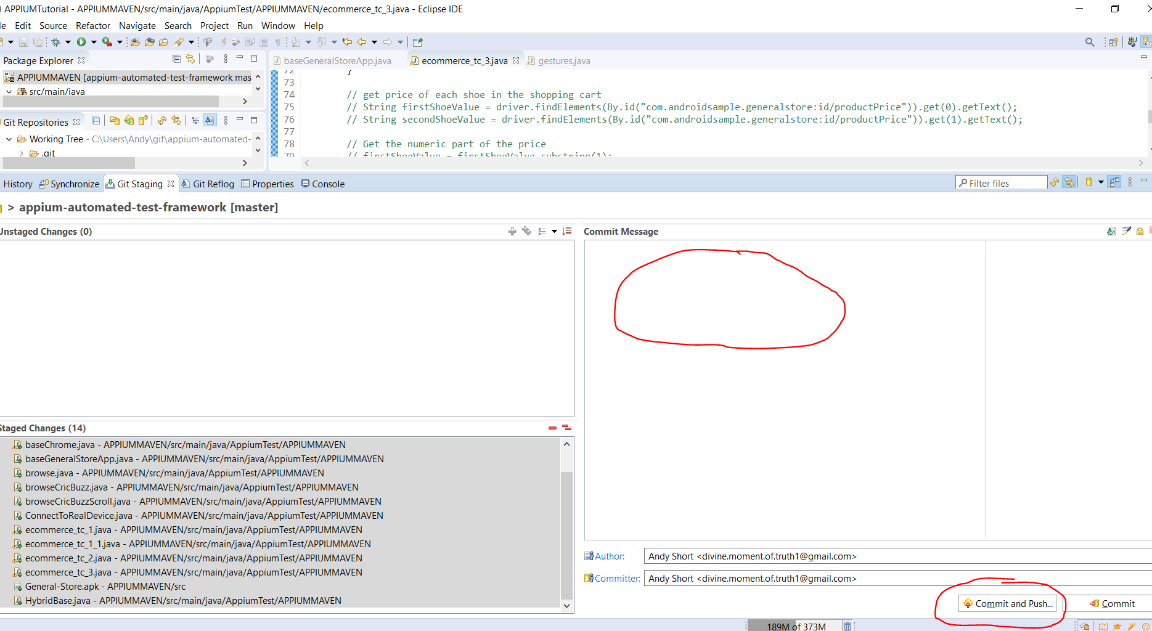

Add a comment in the ‘Commit Message’ panel, then click the ‘Commit and Push’ button.

**How to Handle Objects when rendered in Web View**

Add this code:-

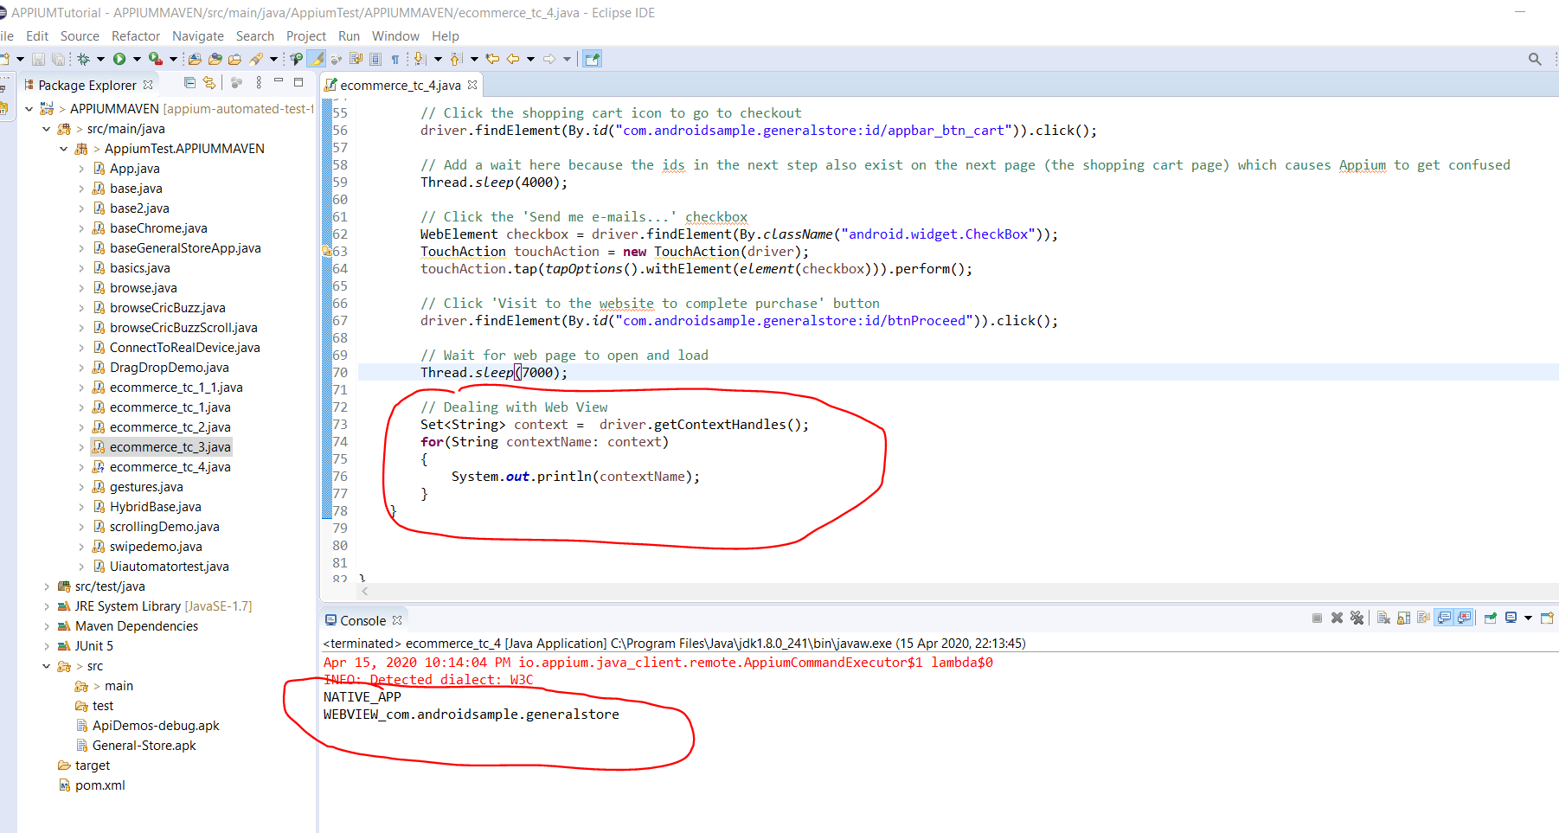

See the console is displaying

NATIVE_APP

And

WEBVIEW_com.androidsample.generalstore

The WEBVIEW_com.androidsample.generalstore is the web view

You can now use Selenium, but you must switch to the WEBVIEW contentext. Add this code:-

// Switch to web view context

driver.context("WEBVIEW_com.androidsample.generalstore");

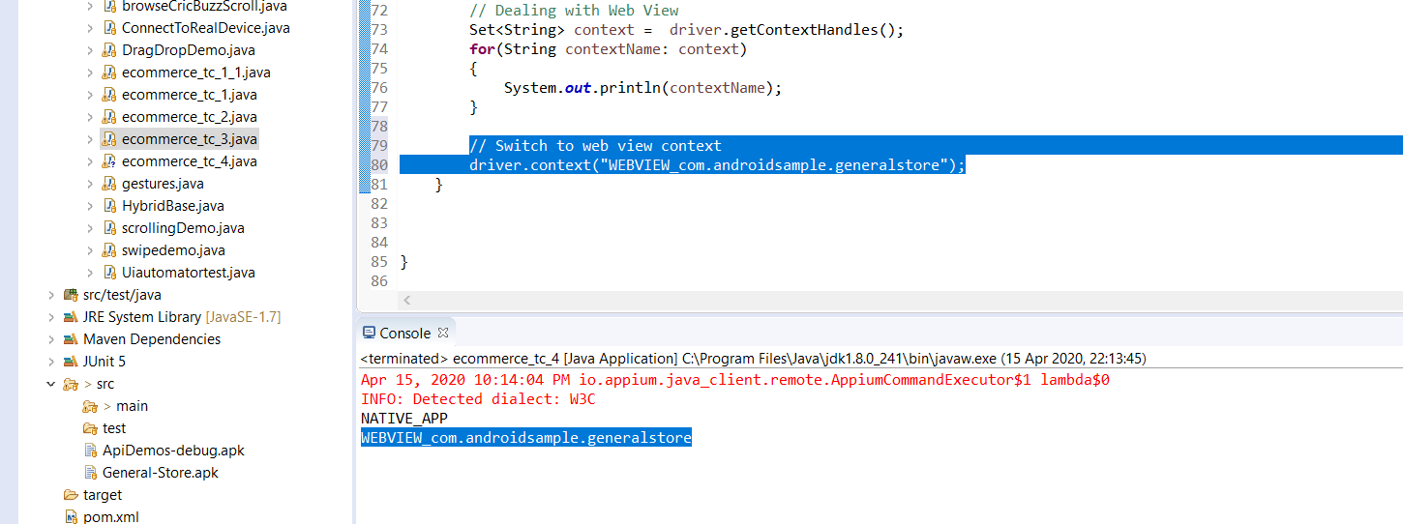

When running the above code I am getting the following error:-

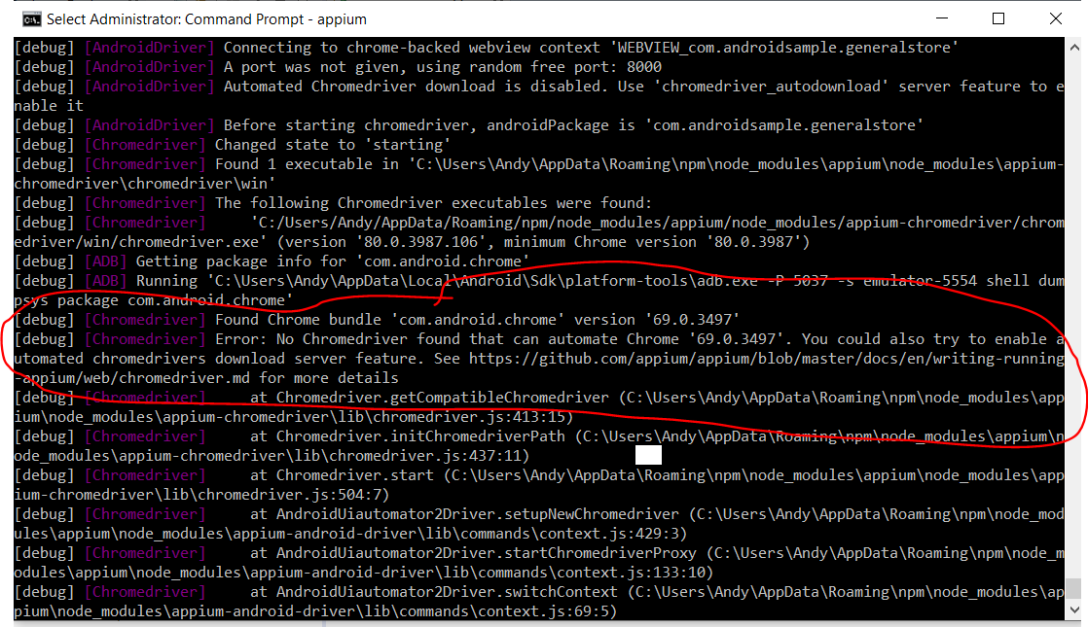

This is because the version of the chrome driver on the device can not be automated.

Navigate to this location on your c: drive:-

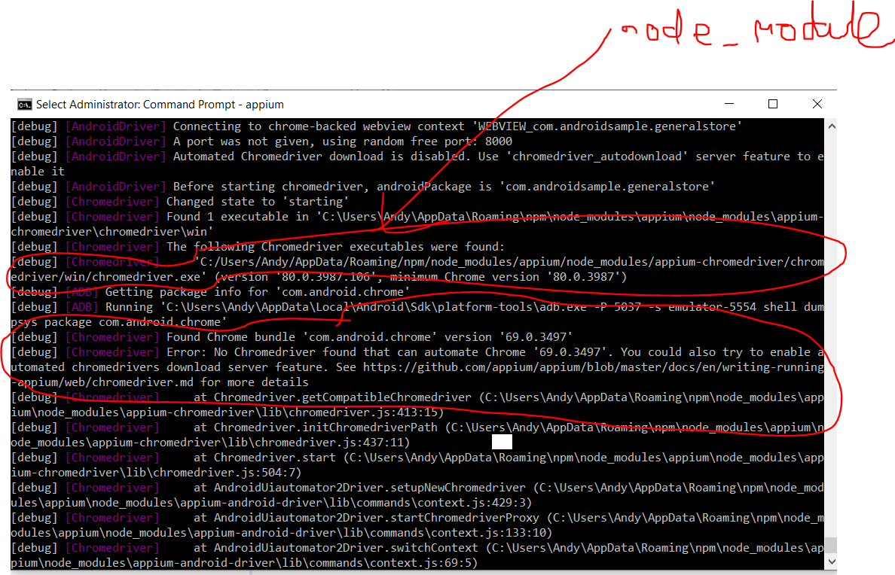

C:\Users\Andy\AppData\Roaming\npm\node_modules\appium\node_modules\appium-chromedriver\chromedriver\win

Looking at the error in the console it is saying that this version of the chrome.exe driver installed in ‘node_modules’ is only compatible with an emulator using a minimum of version 80.0.3987:-

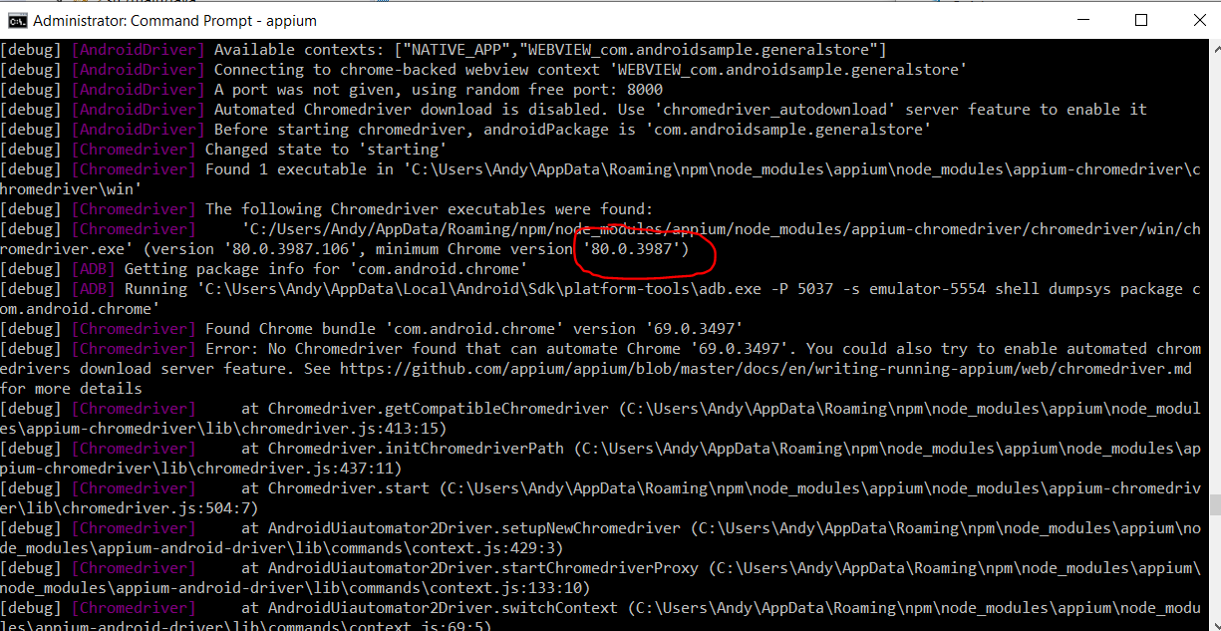

To resolve the problem we need to download the Chrome driver version 69.0.3497.

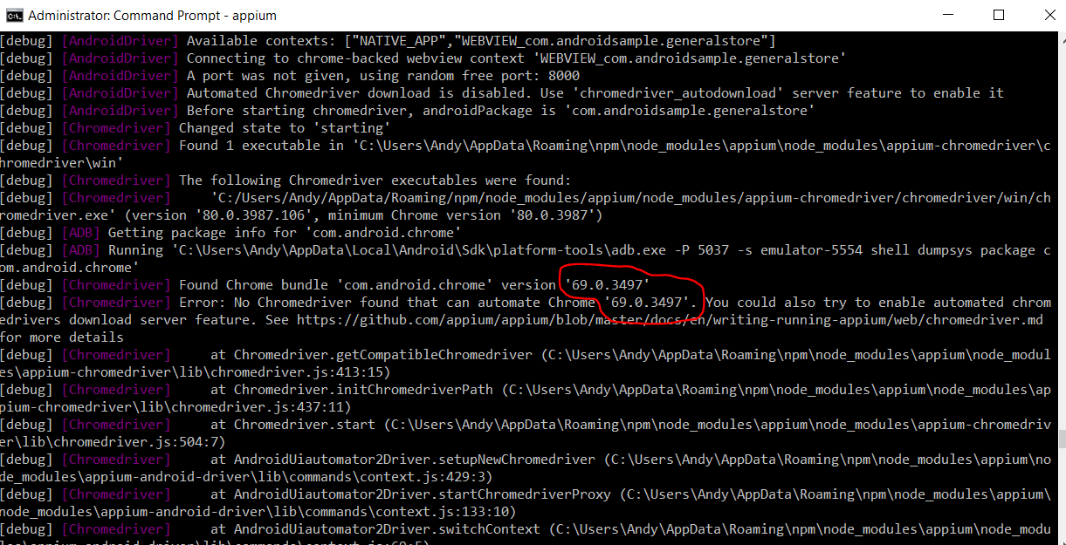

So go to Google and type the following:-

*Chrome download chrome driver*

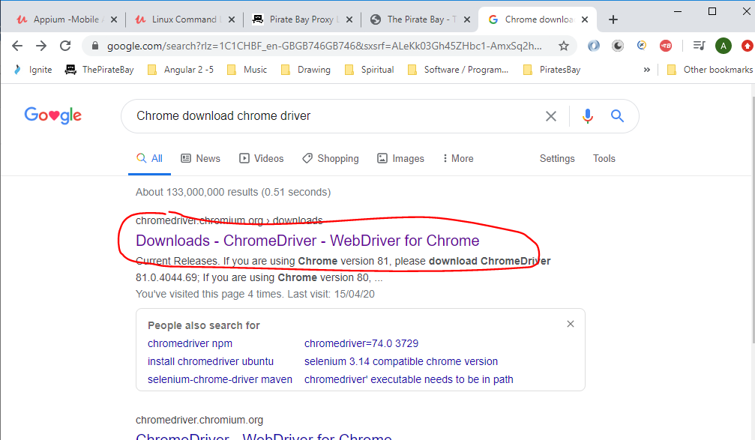

*Click the above link then scroll down:-*

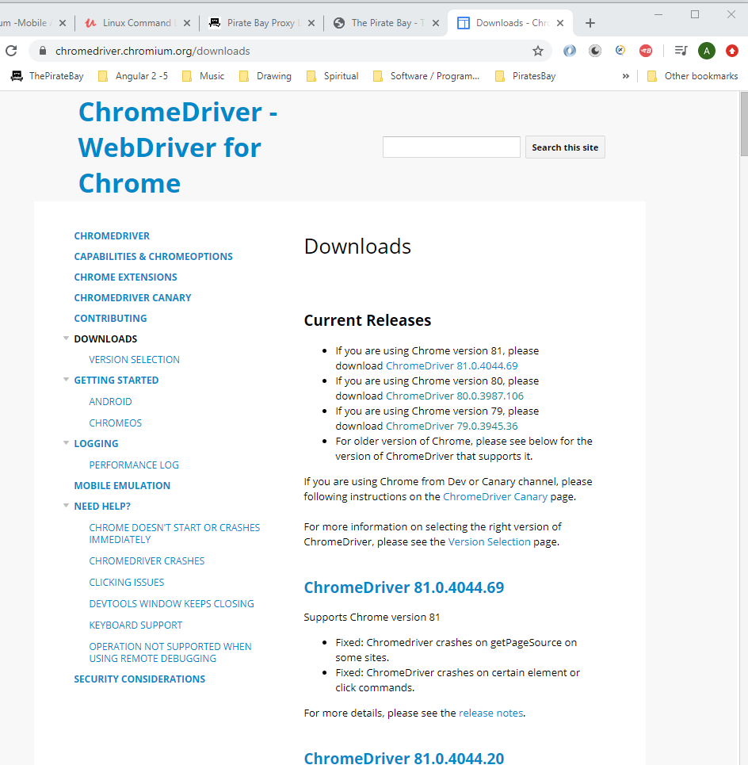

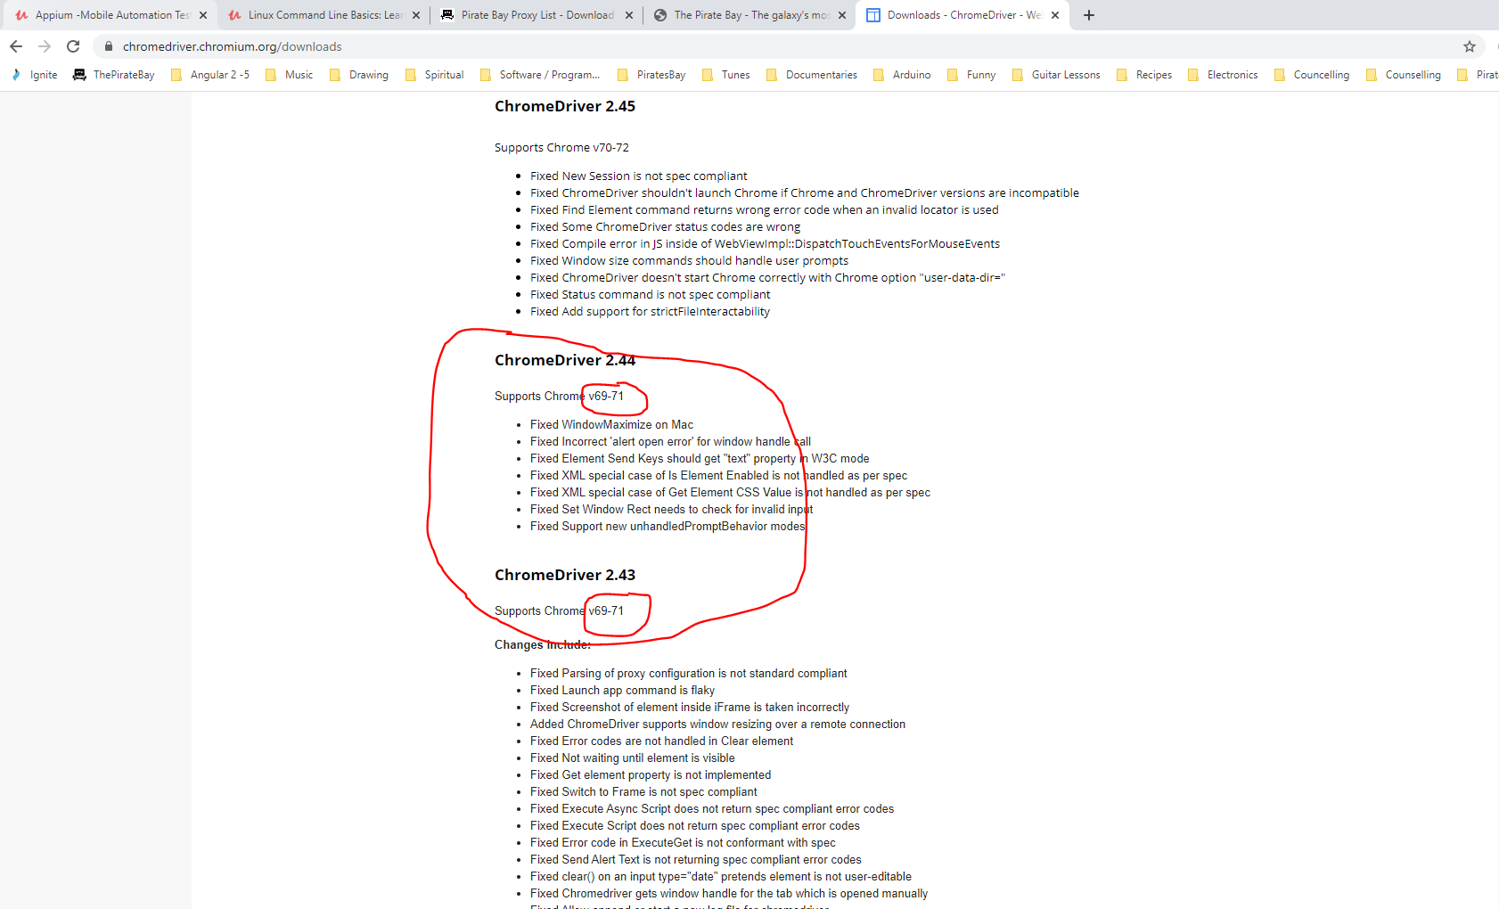

*See below the ChromeDriver 2.44 supports Chrome v69-71 which is what we need (i.e. 69.0.3497)*

*Now go back to Google:-*

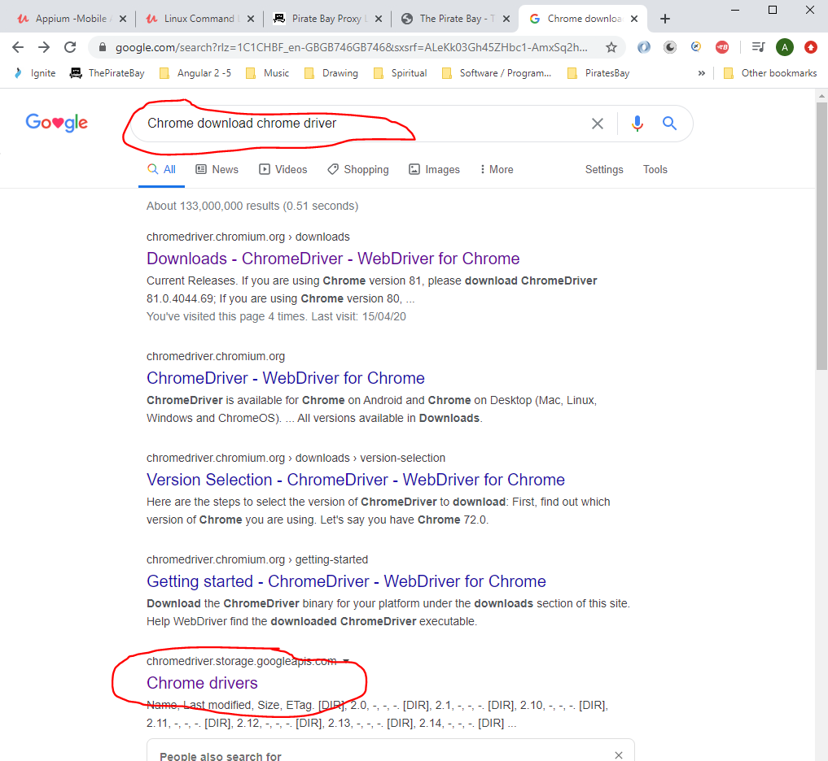

<https://chromedriver.storage.googleapis.com/index.html>

*Click the above link. This takes you here:-*

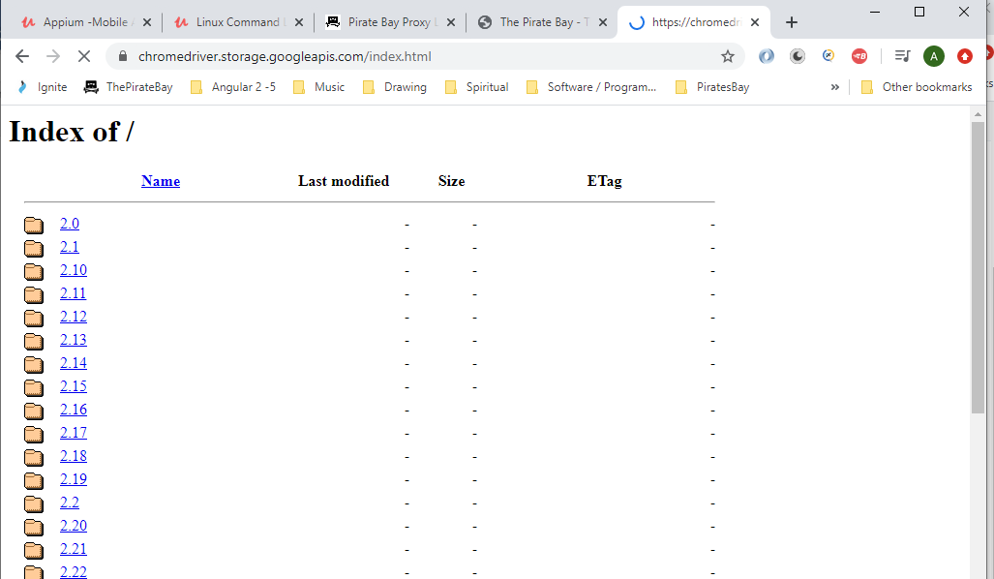

*Scroll down to version 2.44. Download this:-*

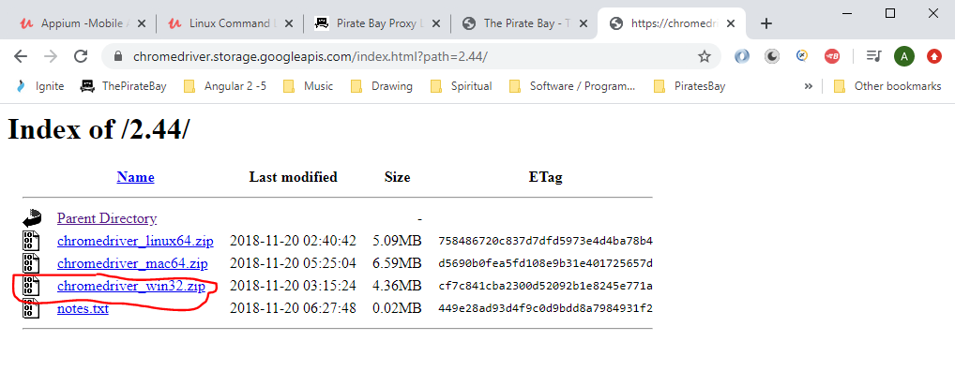

*Unzip file.*

*Copy the unzipped file from here:-*

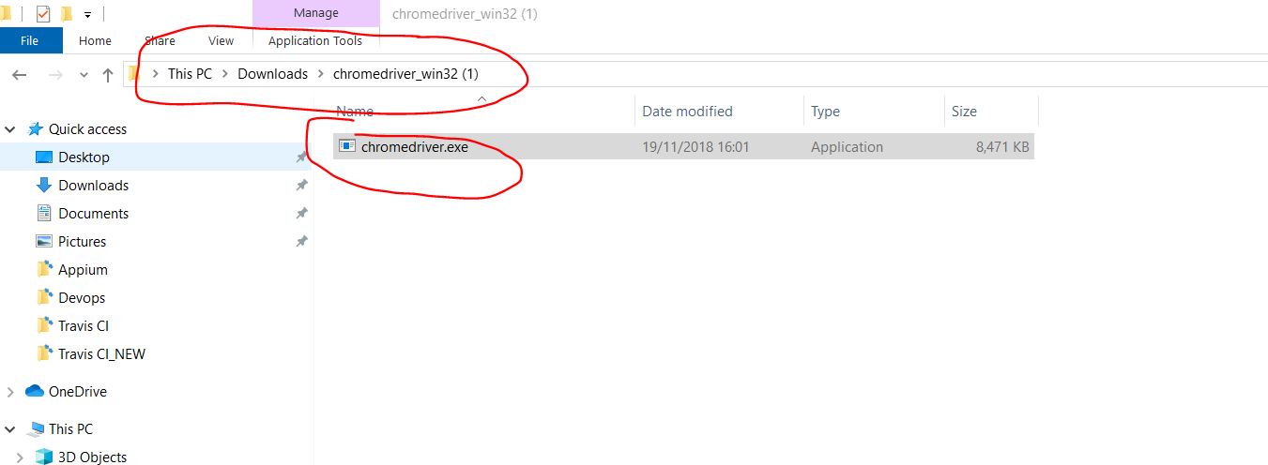

*Paste over the version here:-*

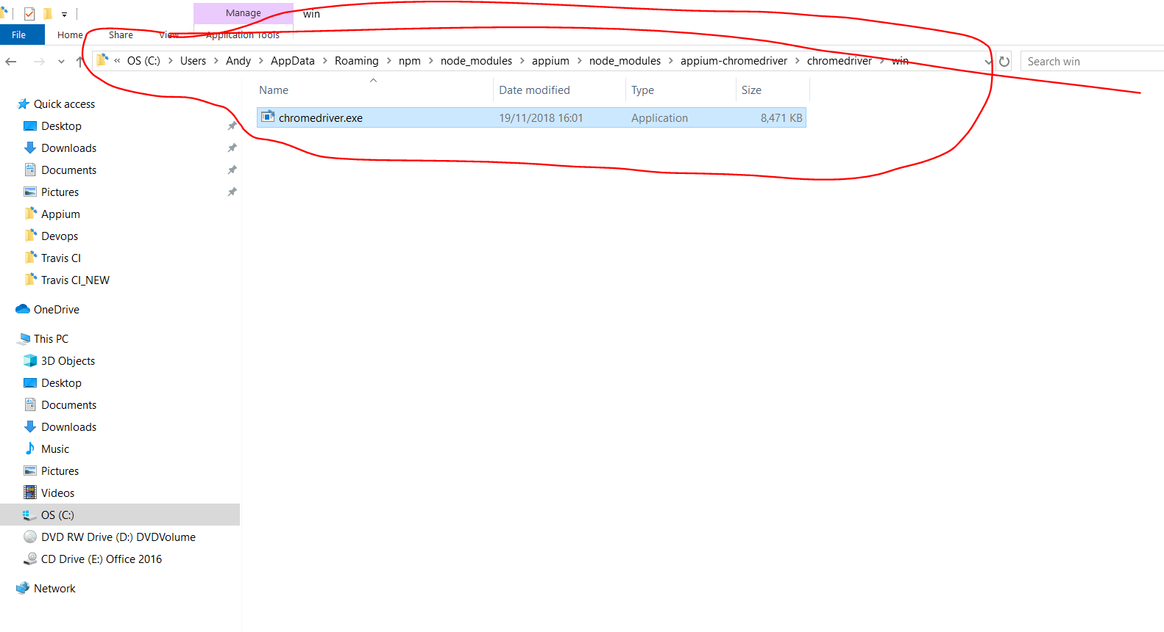

C:\Users\Andy\AppData\Roaming\npm\node_modules\appium\node_modules\appium-chromedriver\chromedriver\win

**TestNG**

<https://testng.org/doc/>

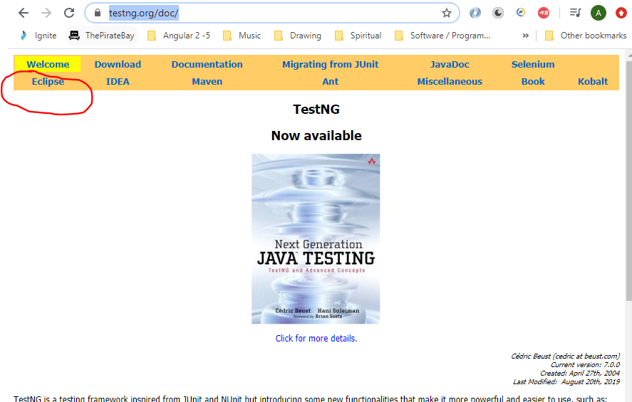

Click on ‘Installation’:-

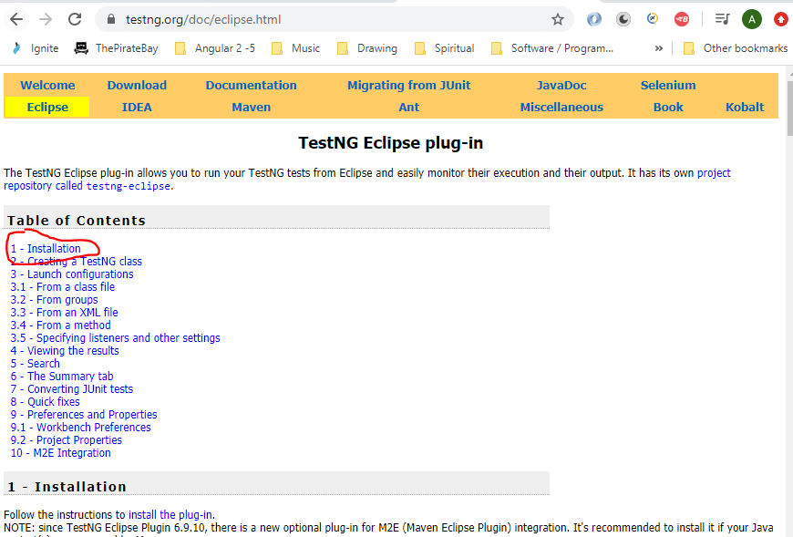

Then click on this link:-

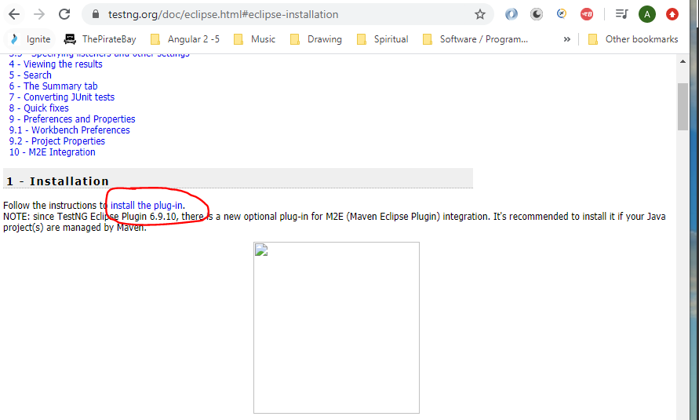

Copy the below url:-

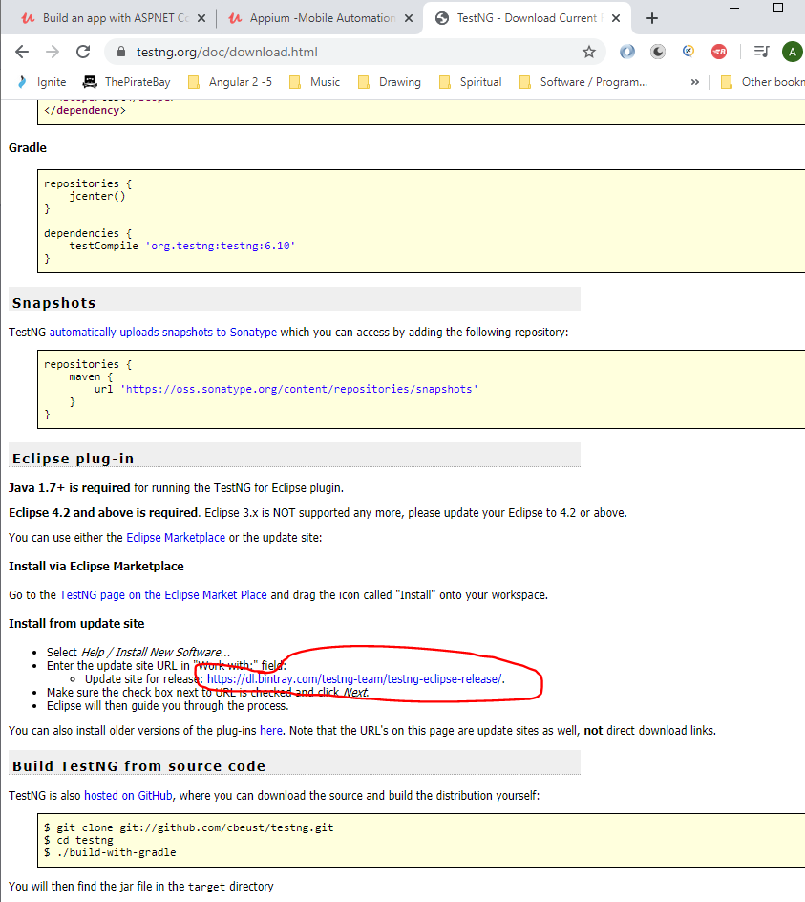

Paste here then click ‘Add’:-

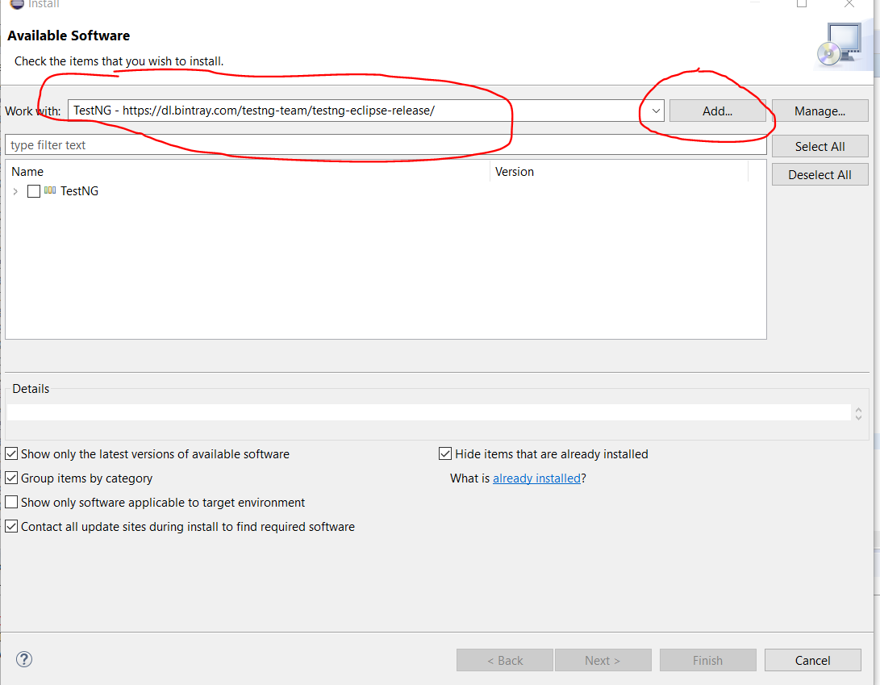

Tick checkbox then click ‘Next’:-

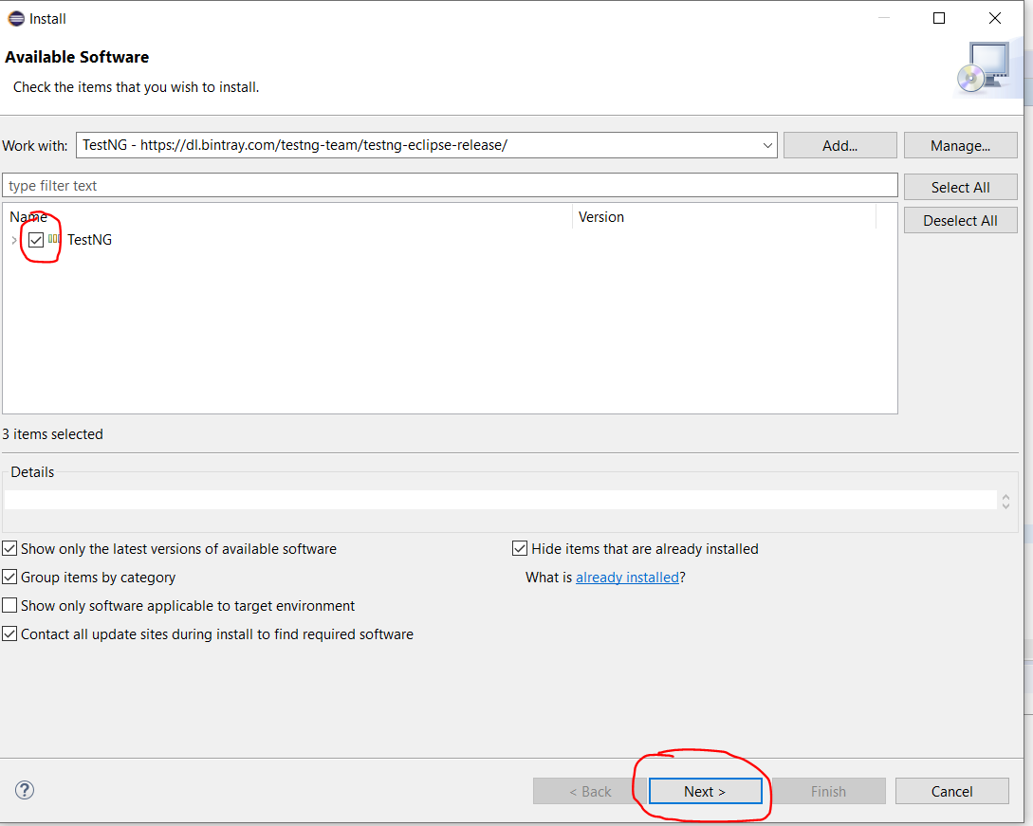

Click ‘Next ‘.

Click ‘I accept….’ Radio bottom.

Click ‘Finish’.

Then restart Eclipse.

Check that TestNG is installed:-

Go to ‘Window -> Preferences’. Then type TestNG:-

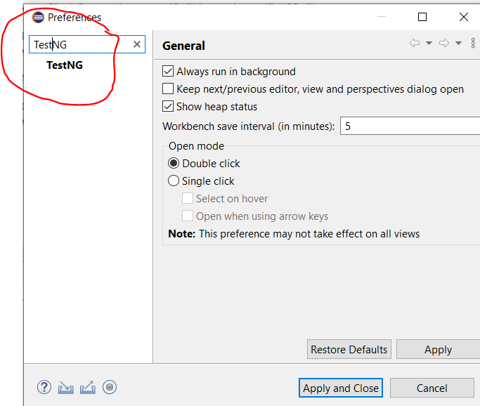

As you can see TestNG was installed successfully.

Go to Eclipse:-

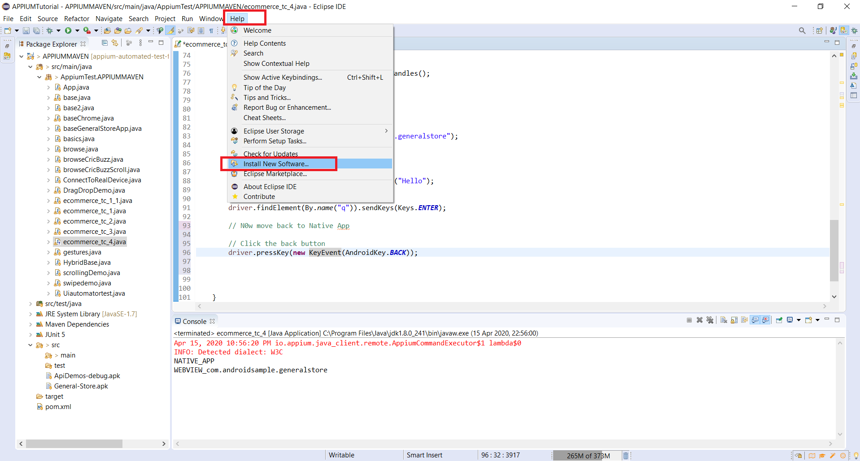

**Maven**

[1] Central repository for dependencies

[2] Maintaining common structure across organisation

[3] Flexibility in integrating with CI tools

[4] Plugins for test framework execution

**Install Maven**

Download from here:-

<https://maven.apache.org/download.cgi>

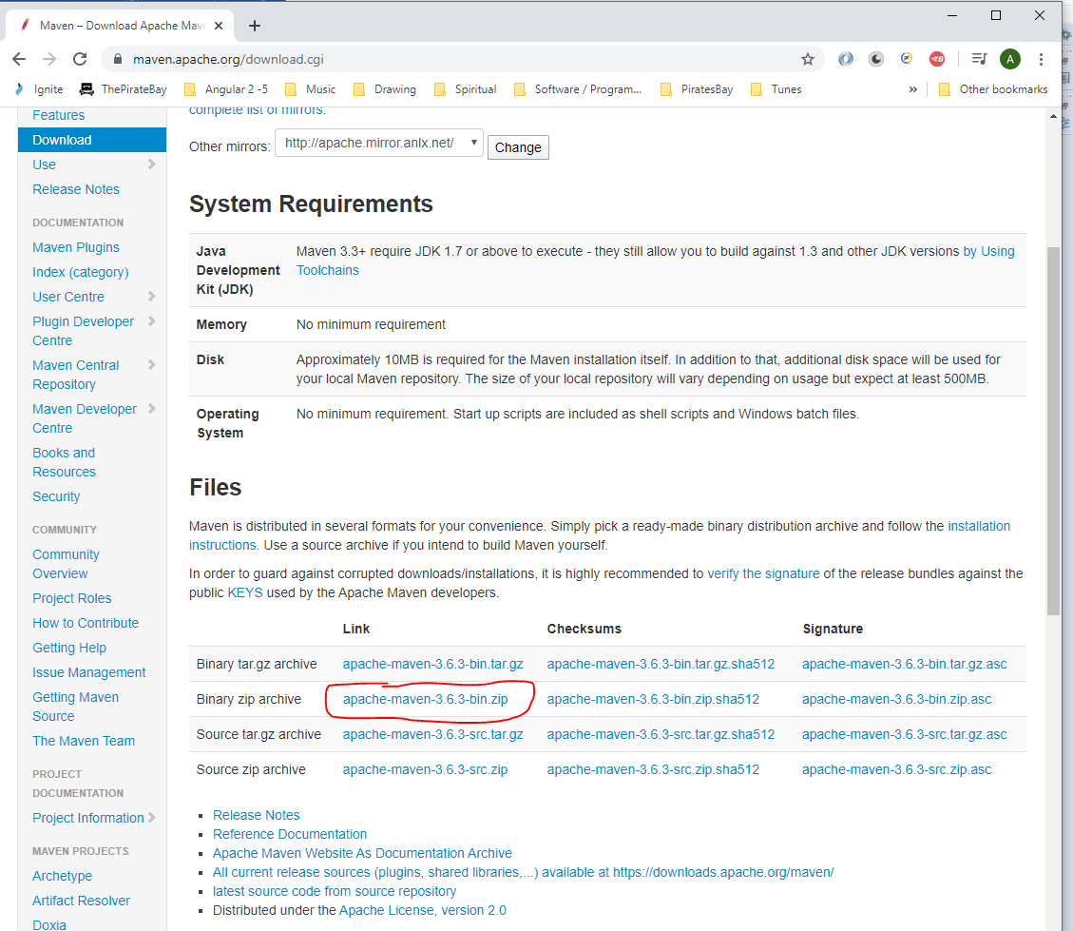

When downloaded create a folder on your C: drive:-

C:\Maven

Unzip the downloaded file into the folder so that it looks like this:-

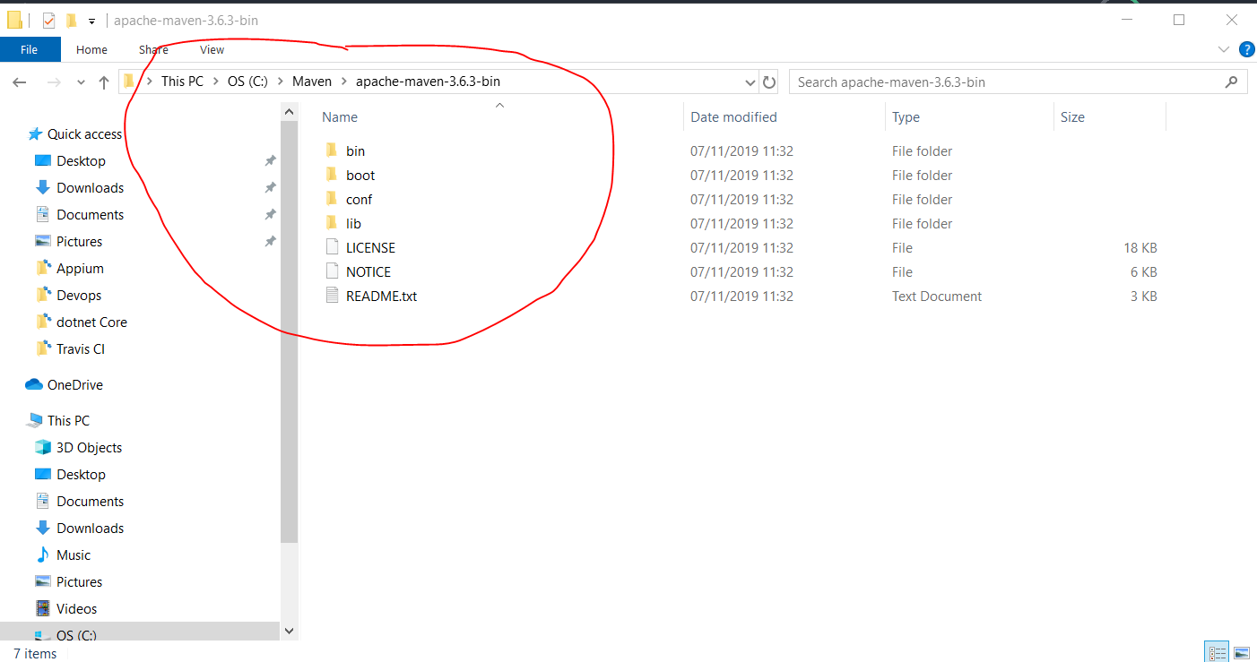

Then add the following entry into the environment variables:-

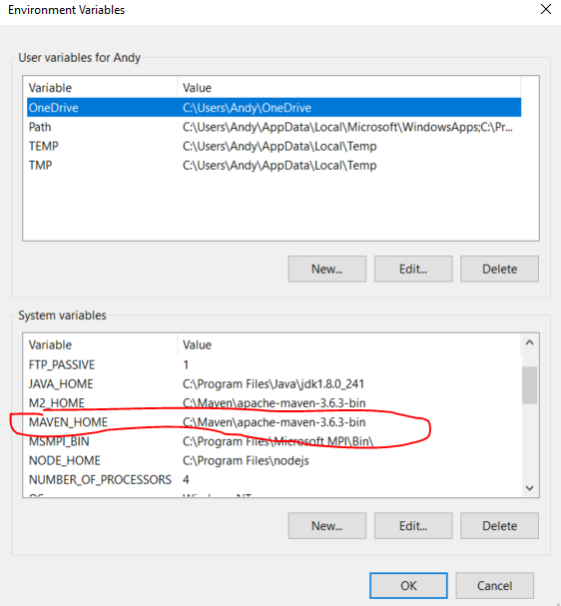

Also, add this path too:-

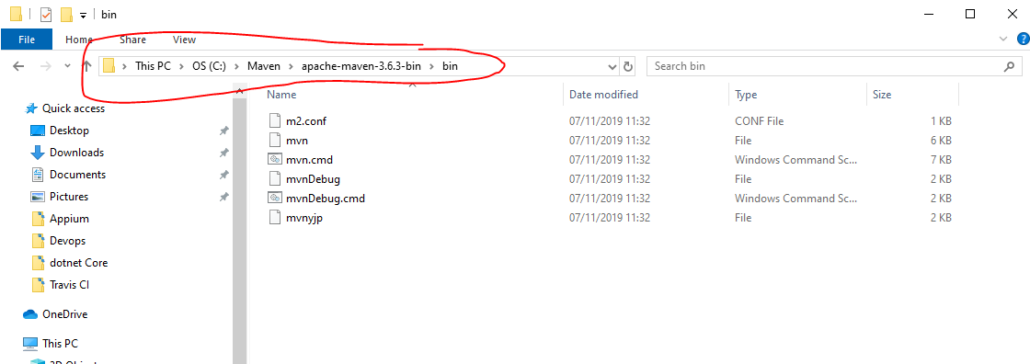

And, add it to the ‘path’ environment variable:-

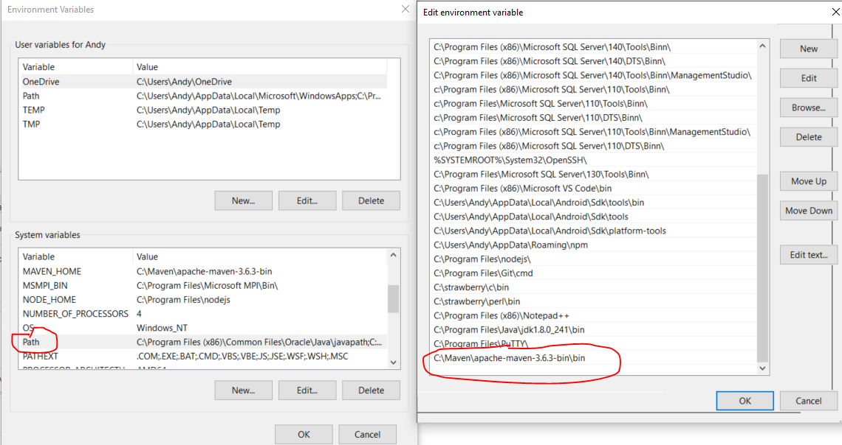

Test that this works by opening command prompt and typing:-

mvn --version

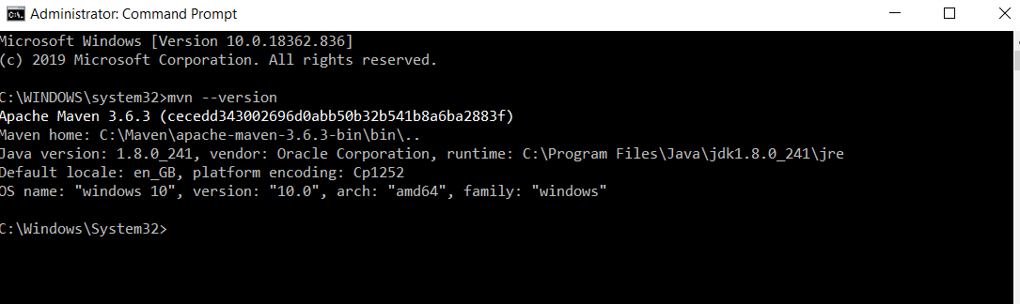

The above shows that Maven is successfully installed.

**Create a Maven project**

In Eclipse right click in the left hand panel and select – New – Project:-

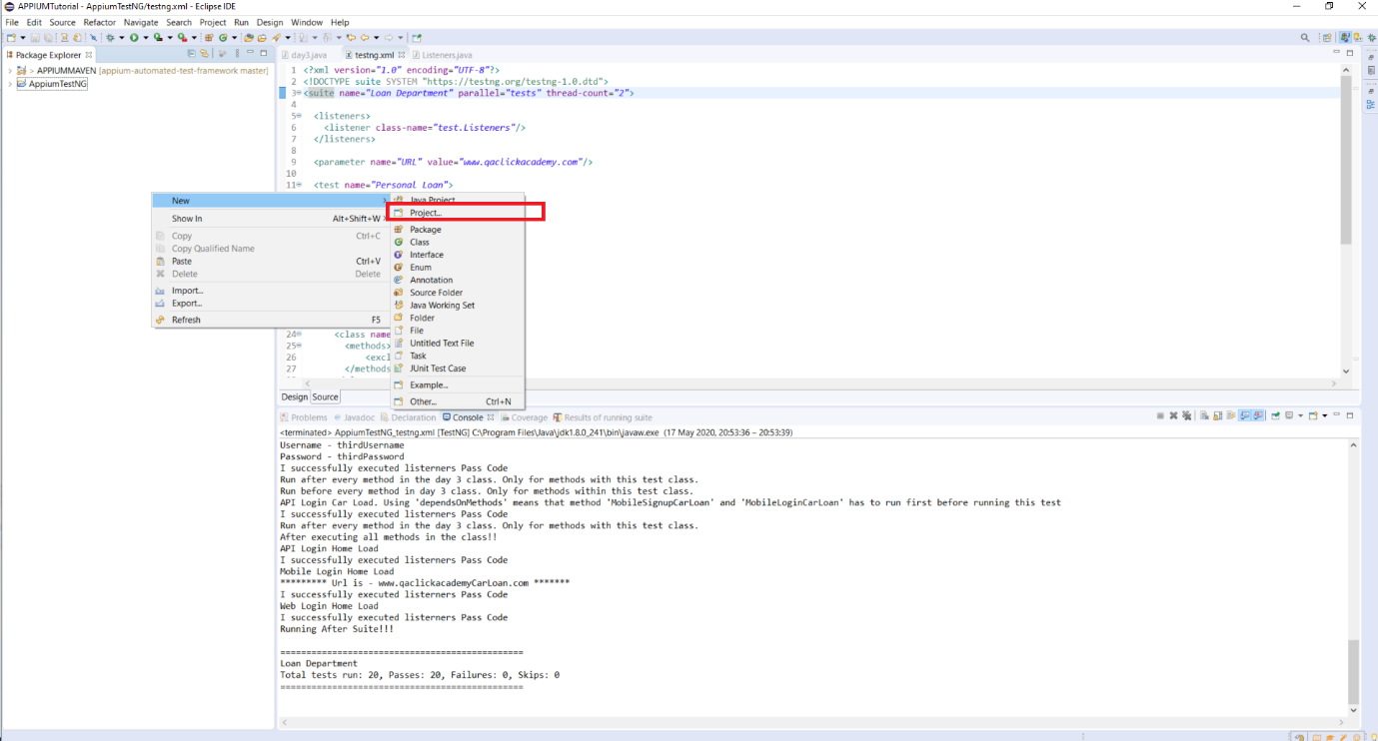

Then select ‘Maven – Maven Project’:-

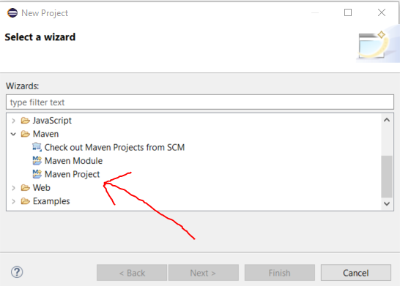

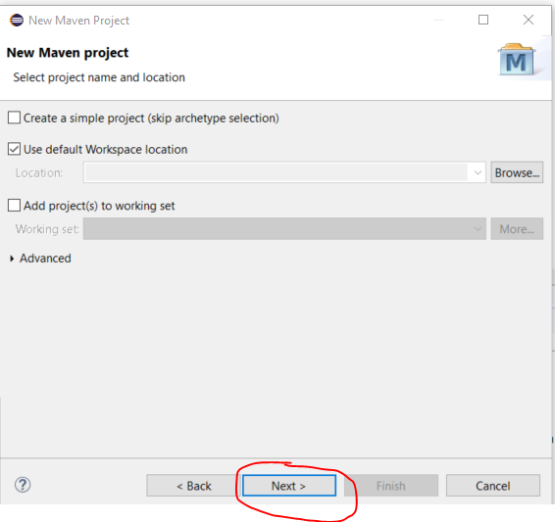

Select this one and click next:-

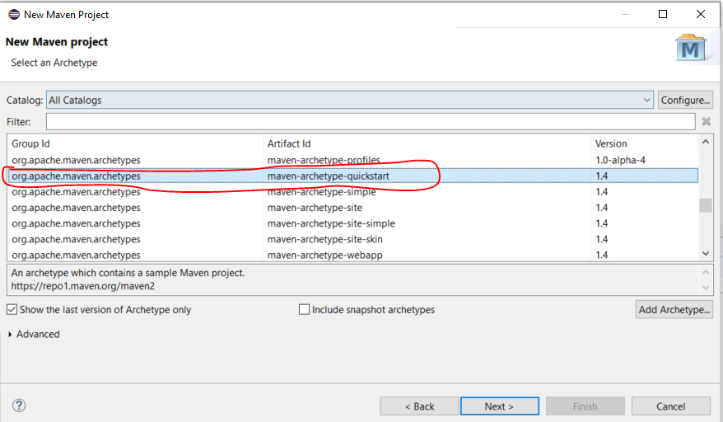

Enter names for ‘GroupId’ and ‘Artifact Id’:-

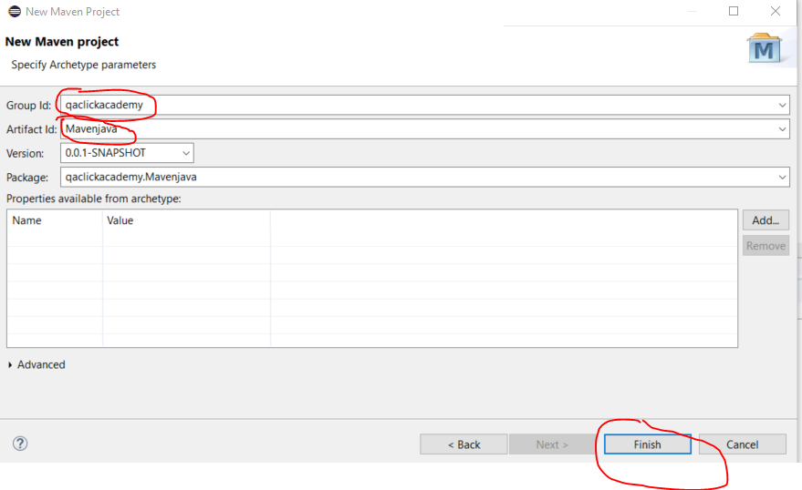

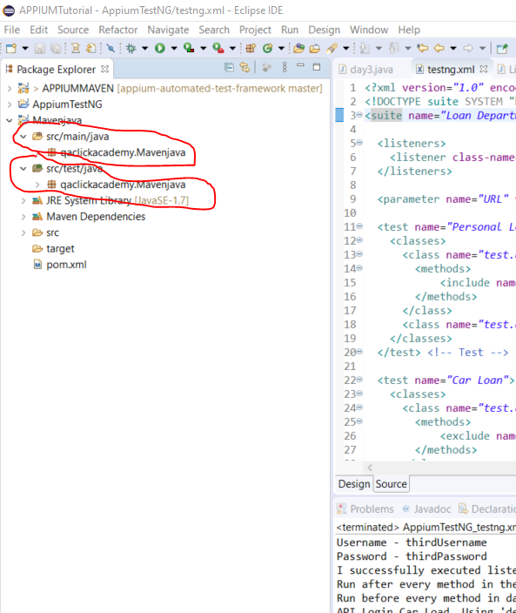

src/main/java – this is where you put common code

src/test/java – this is where you put all test automation code

Add test classes:-

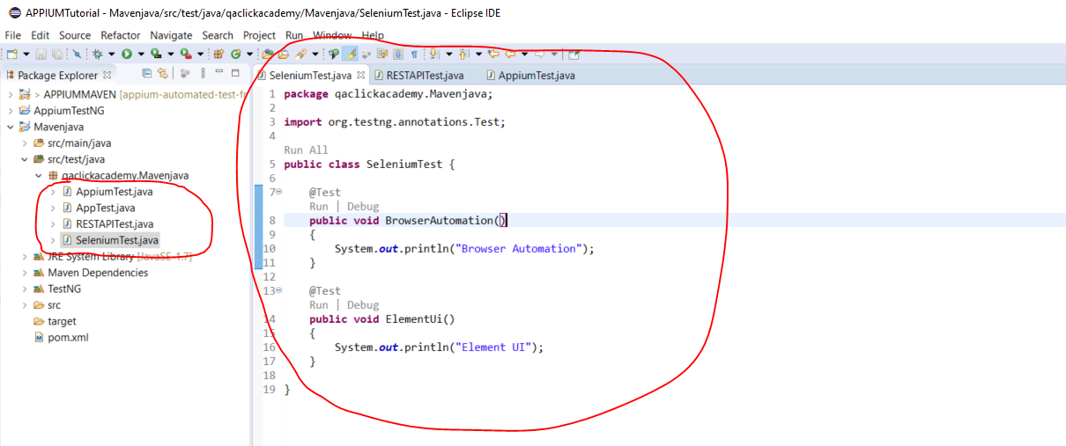

Now add dependencies to pom.xml file:-

Go to MVR Repository to get the following:-

<https://mvnrepository.com/>

Search for the following:-

[1] Selenium Java

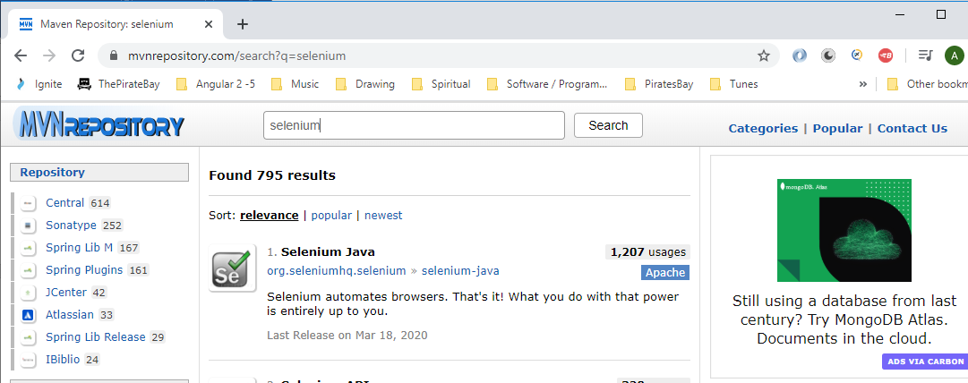

Copy this:-

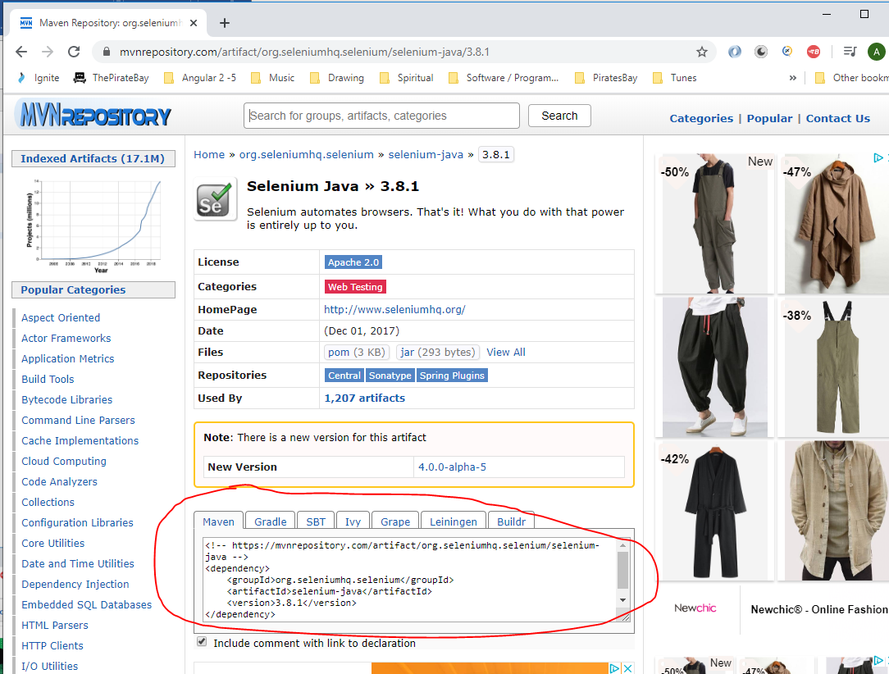

Paste here:-

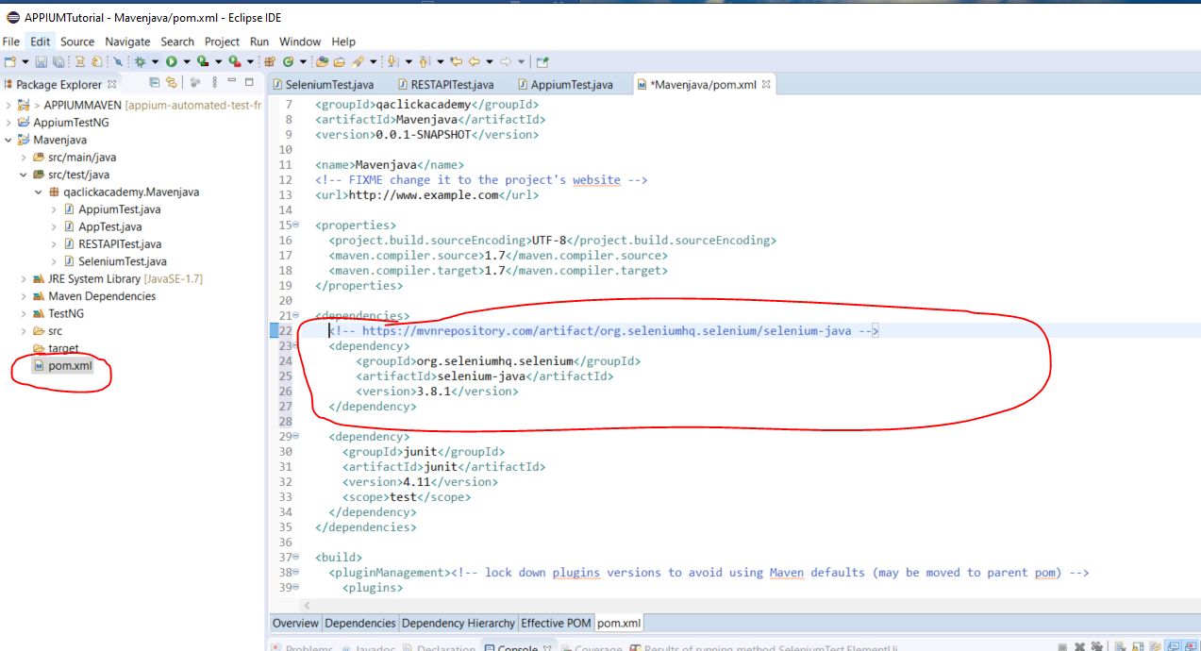

[2] TestNG

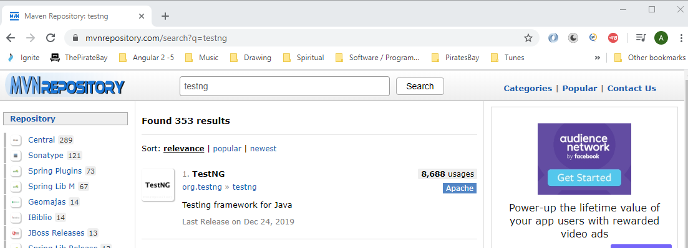

Copy this:-

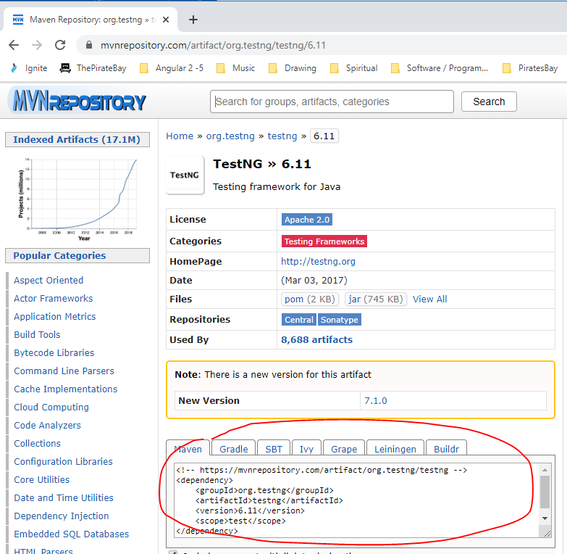

Paste here:-

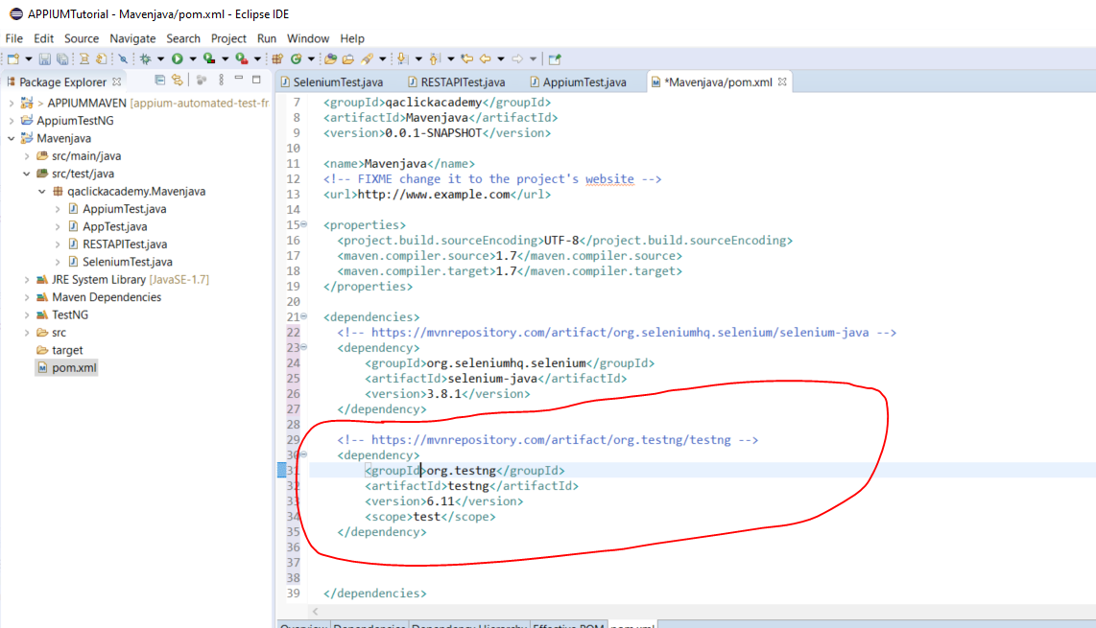

[3] RESTAssured

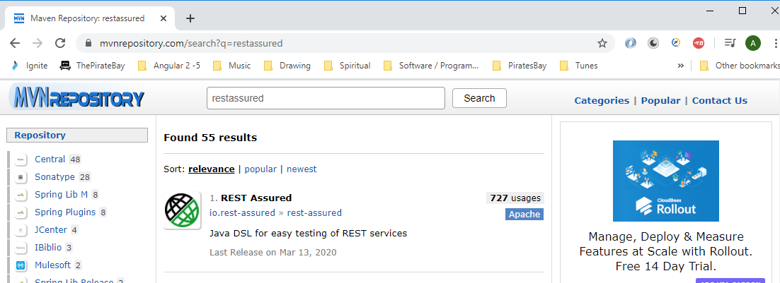

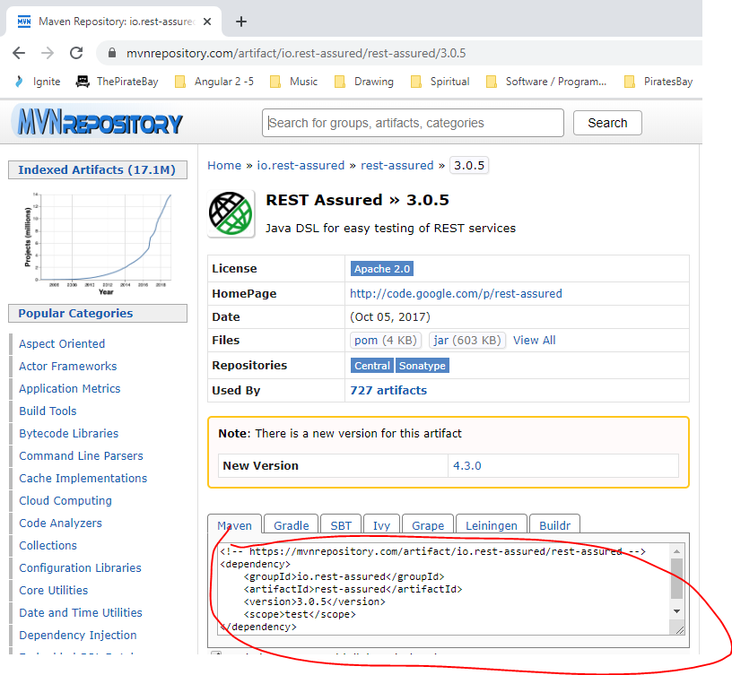

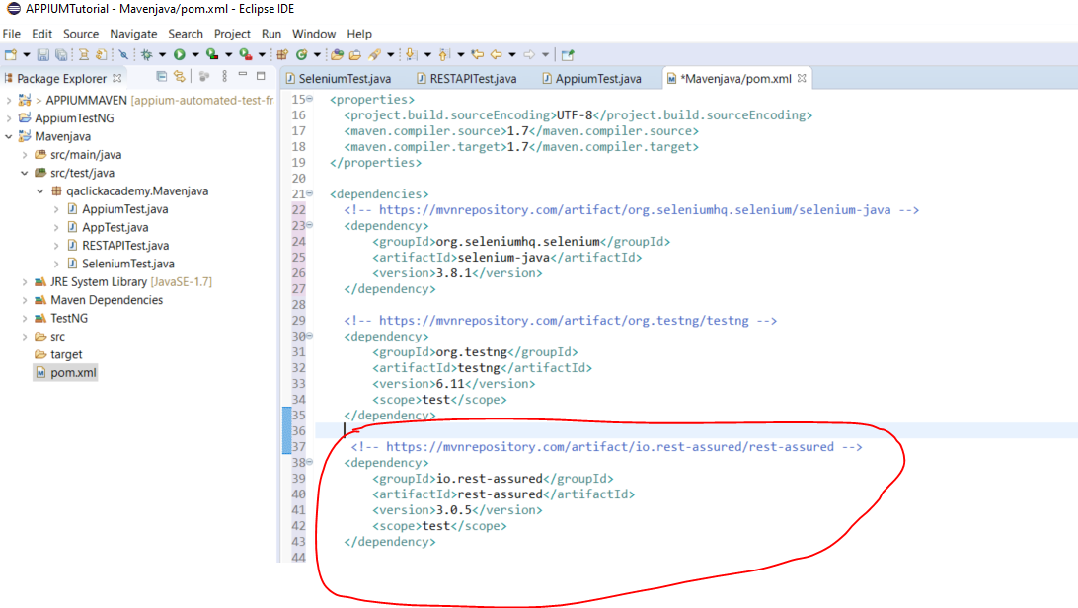

To run all test cases in your Maven project you need ‘Sure Fire Plugin’:-

<https://maven.apache.org/surefire/maven-surefire-plugin/usage.html>

Copy this:-

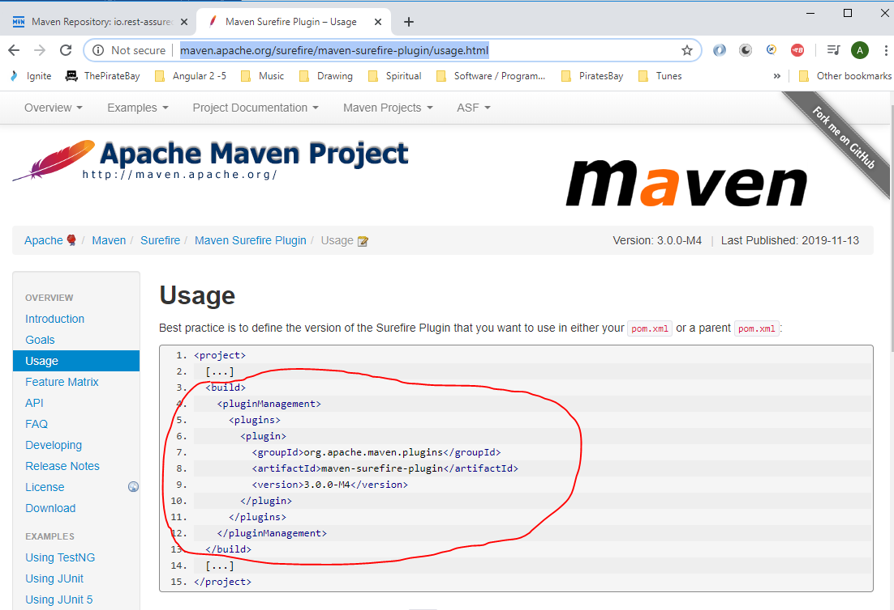

Paste here:-

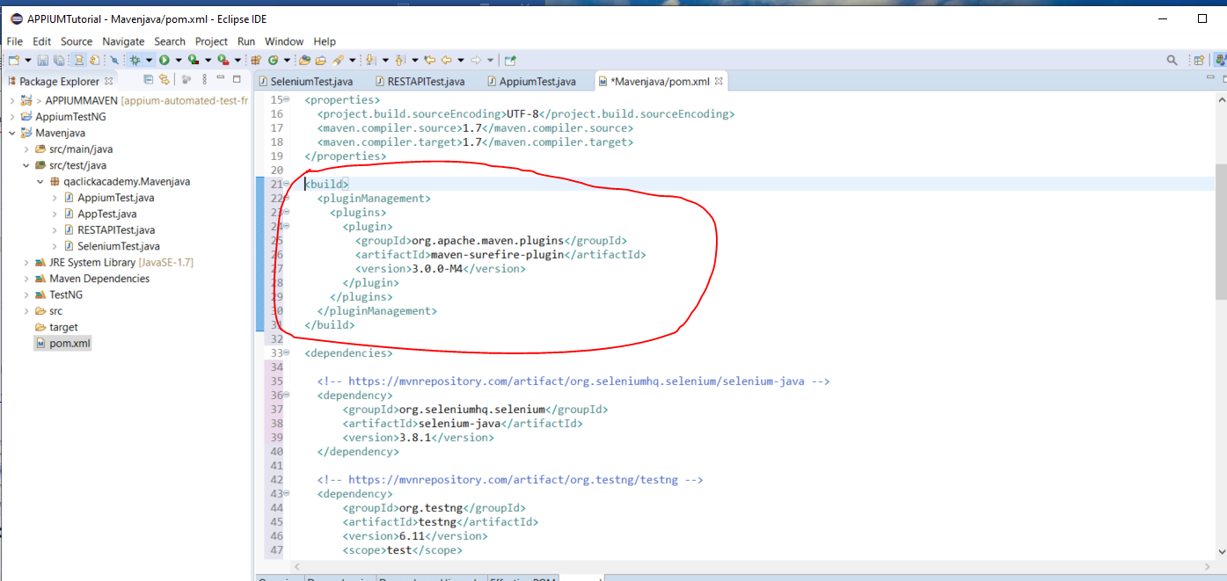

Go here is command prompt:-

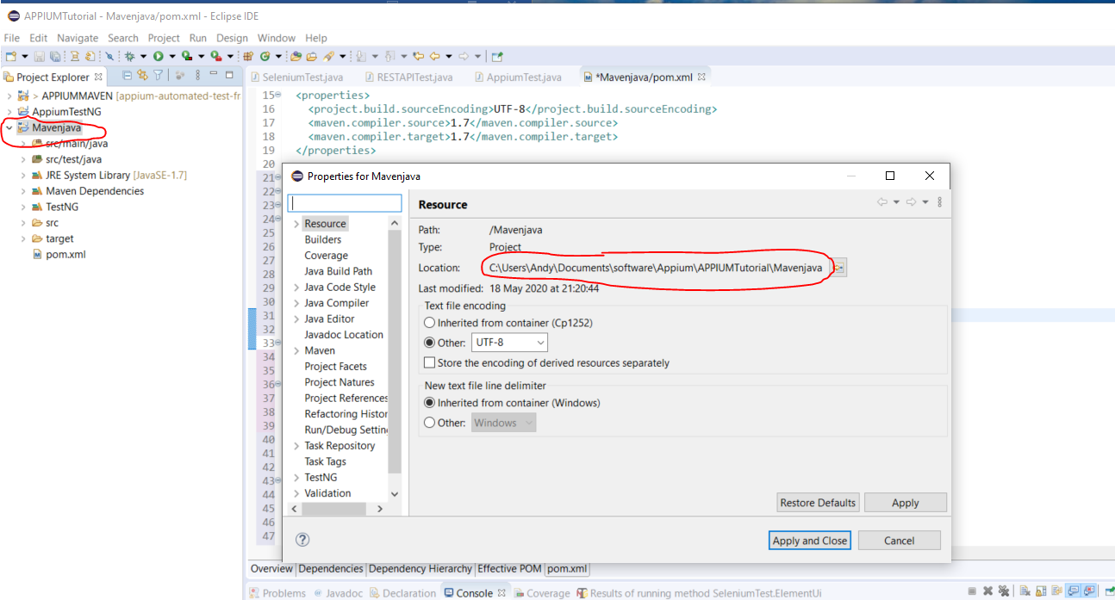

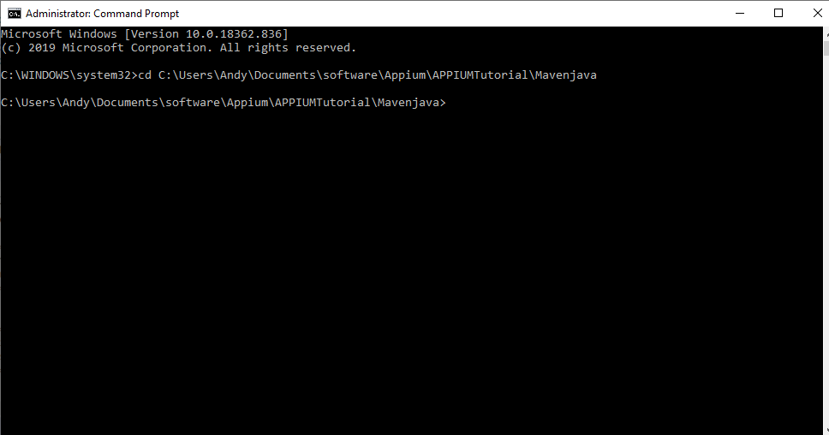

N ow you can run the 3 following commands:-

[1] mvn clear - This clears/removes all temporary files

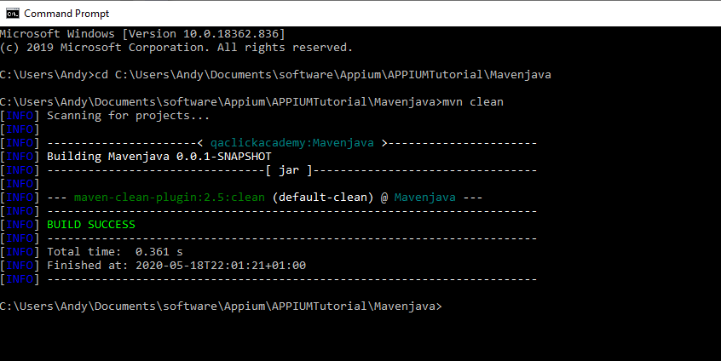

[2] mvn compile - To check if there are any syntax errors in your code

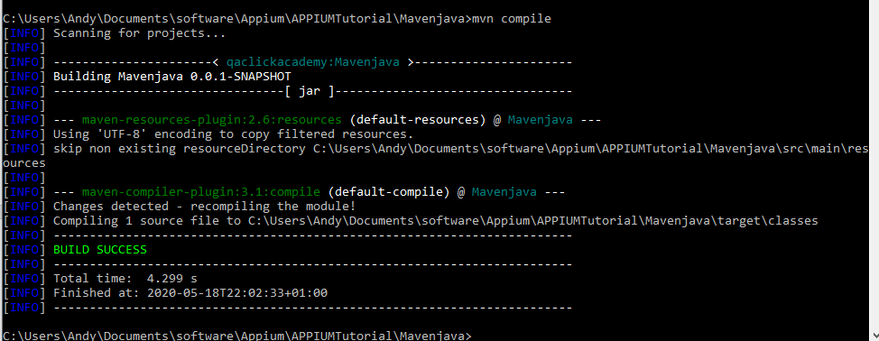

[3] mvn test - Runs all your tests

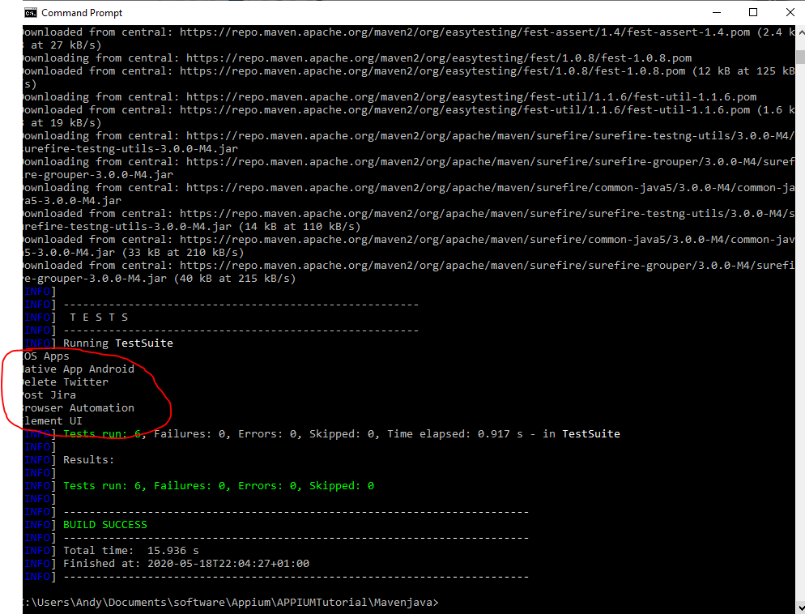

NOTE – IMPORTANT - Ensure to add the word ‘Test’ at the end of each of your test classes:-

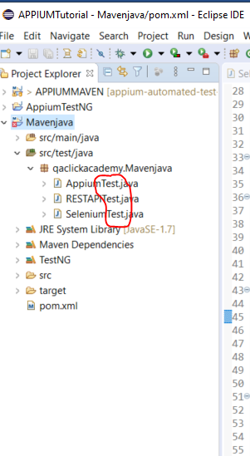

**Create TestNG.xml file for running tests**

Right click project name:-

TestNG -> Convert to TestNG

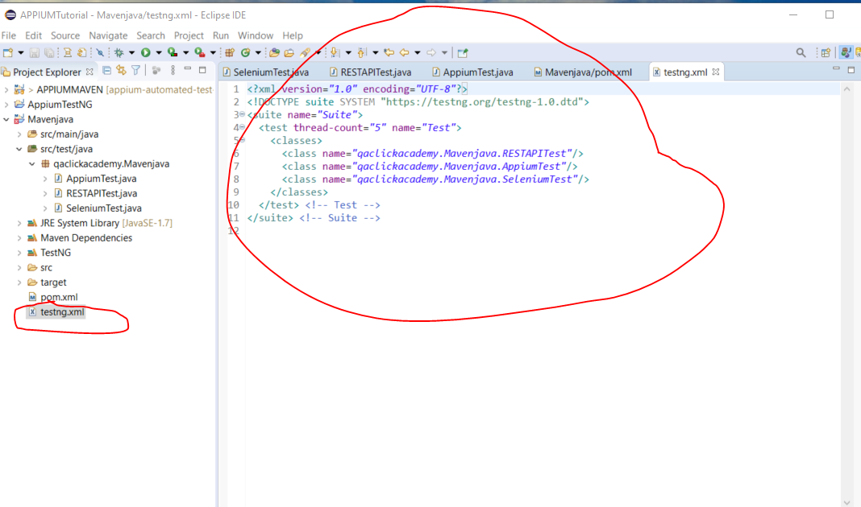

Go to maven surefire plugin again:-

<https://maven.apache.org/surefire/maven-surefire-plugin/examples/testng.html>

Ensure you have this dependency in your pom.xml file:-

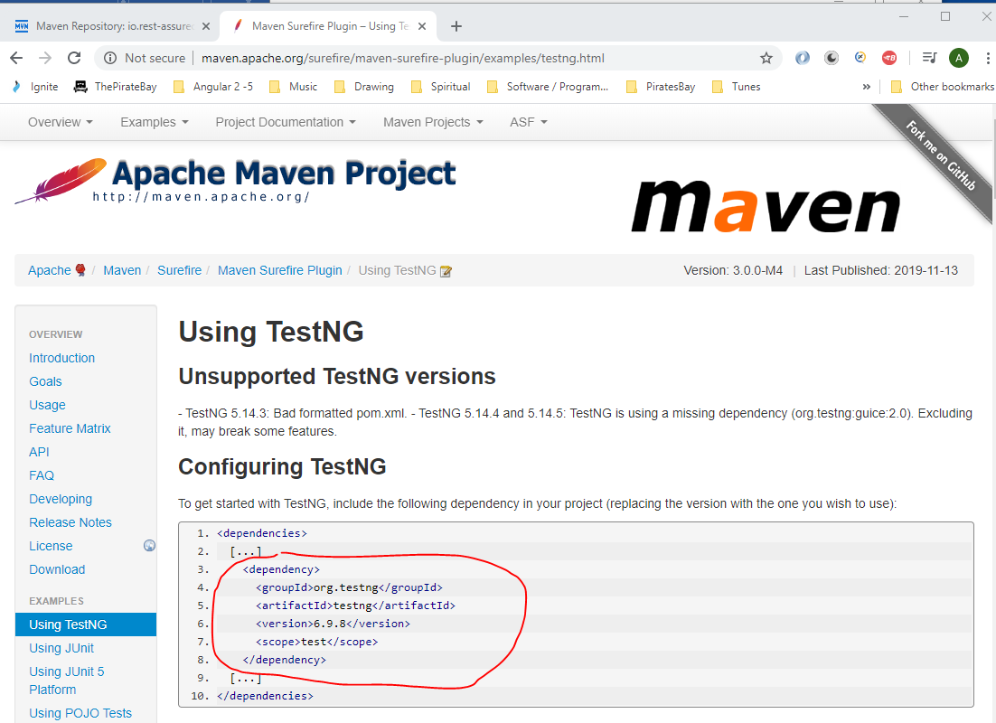

You also need to add this section:-

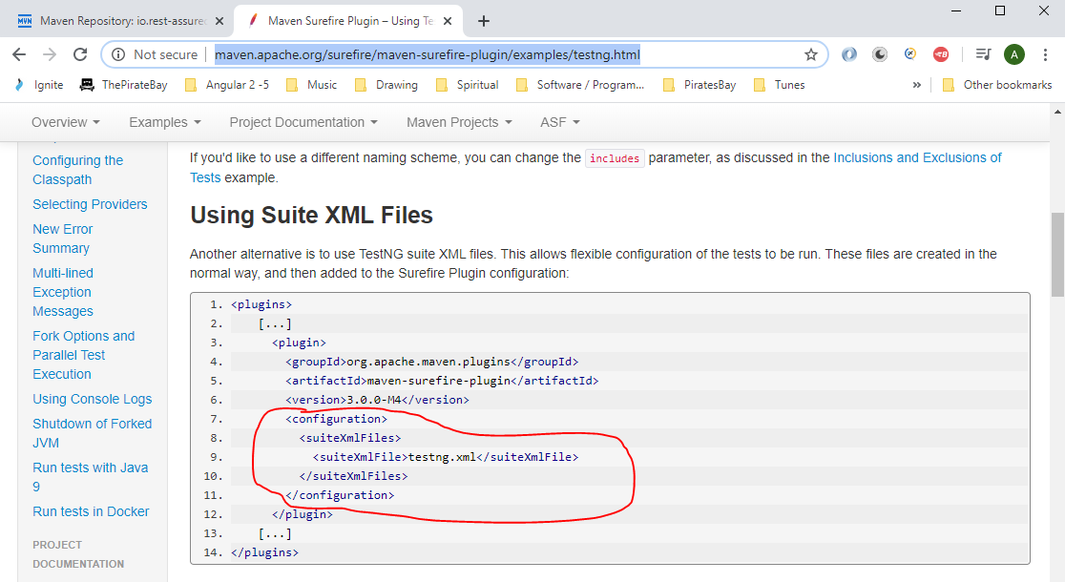

Paste it here:-

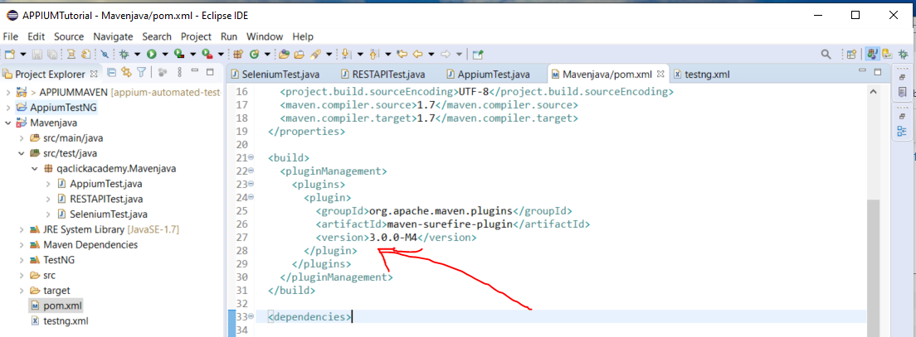

So the Surefire section in the pom.xml file now looks like this:-

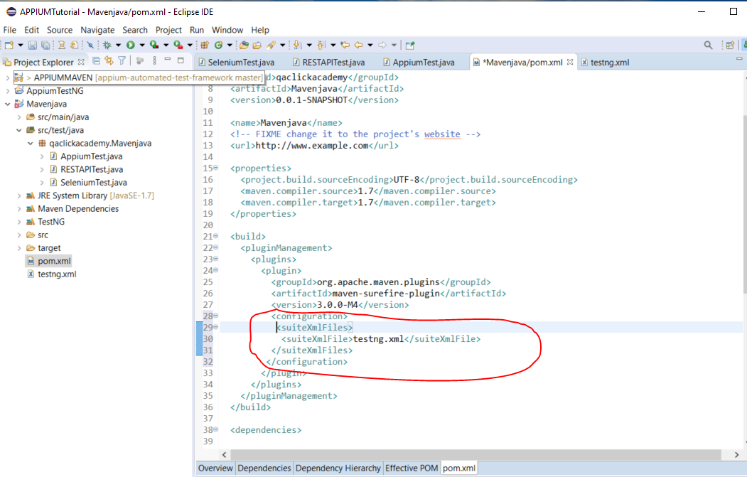

Now maven is using the ‘TestNG.xml’ file to run tests. So what ever you put in your ‘TestNG.xml’ file then these are the tests that will be run.

To run a single test class from the command line enter the following:-

*mvn -Dtest=AppiumTest test*

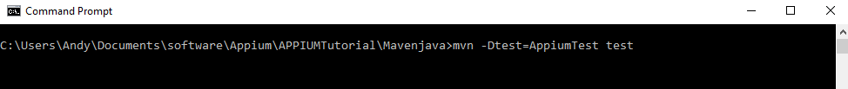

*AppiumTest* - this came from here:-

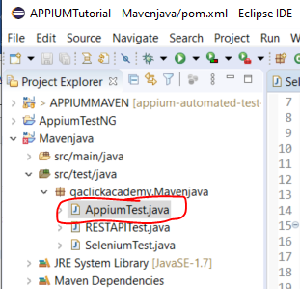

**Maven Profiling**

To create a Maven profile which will only run specific test cases, create the following elements in the ‘pom.xml’ file:-

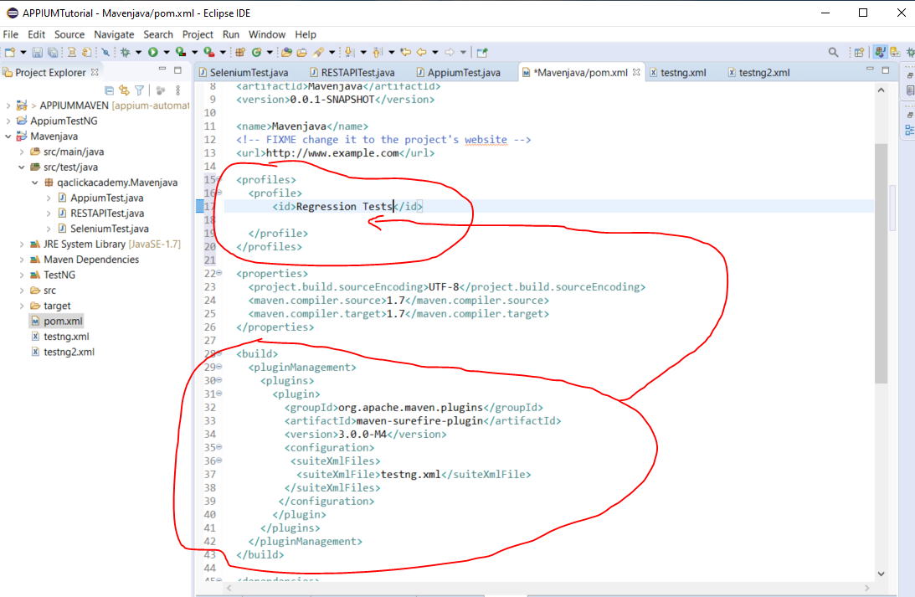

Cut and paste everything from <build></build> tags and paste between the <profile></profile> tags.

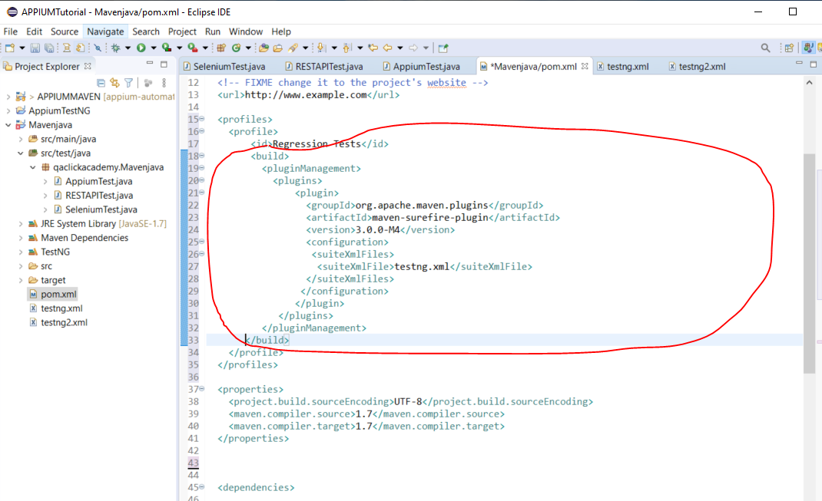

Now, create second profile:-

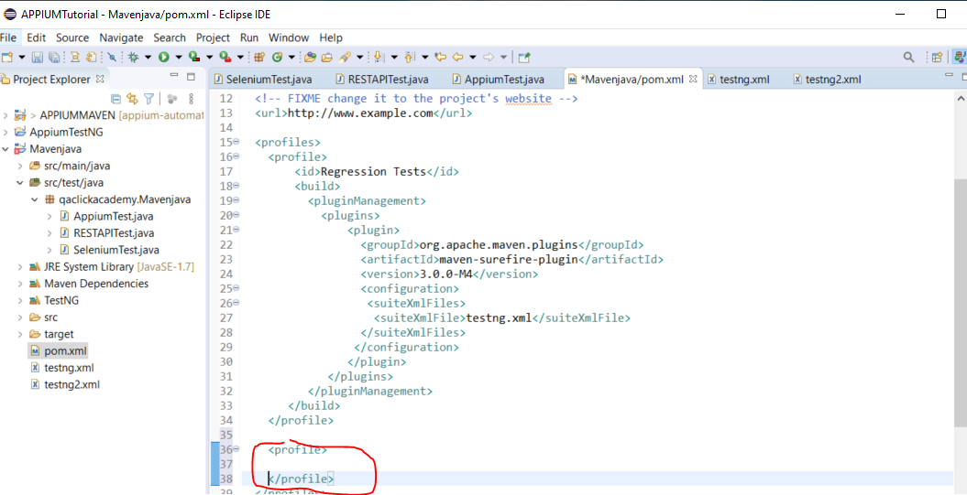

Paste in the same SureFire elements again:-

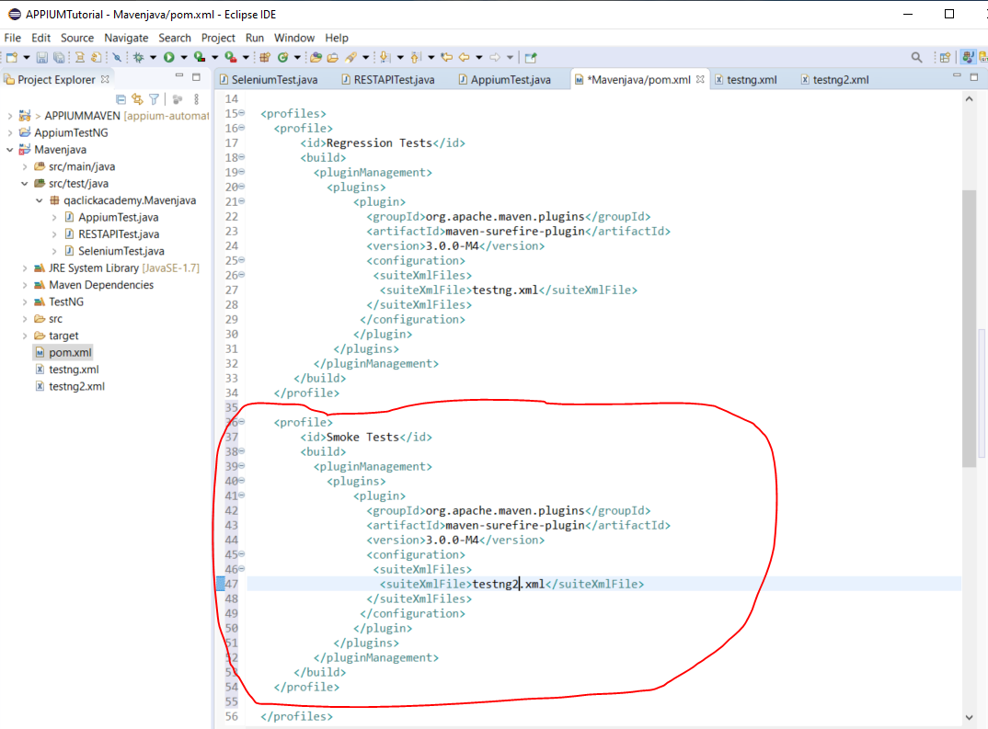

To run one of your profiles, open command prompt and type:-

***mvn test -PRegressionTests***

RegressionTests - this comes from here:-

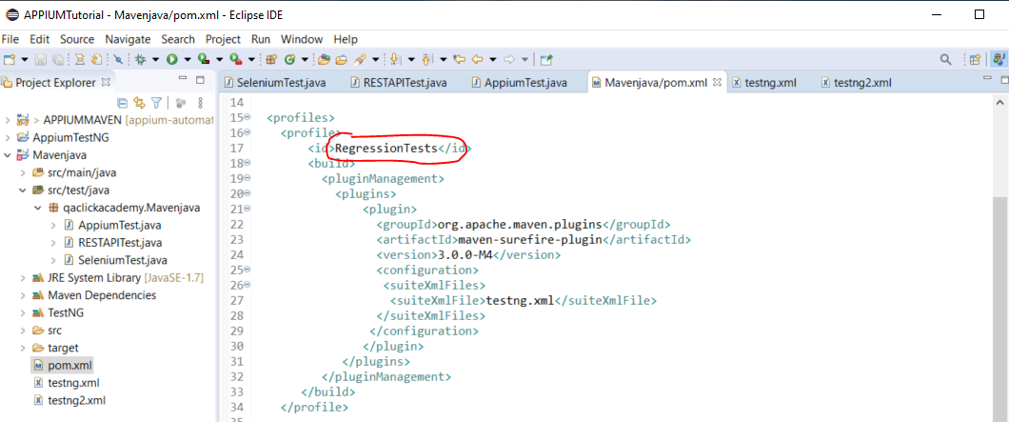

**Jenkins**

Use Jenkins to create a job to run all tests at a specific time.

Download and install to run on your local machine:-

<https://www.jenkins.io/download/>

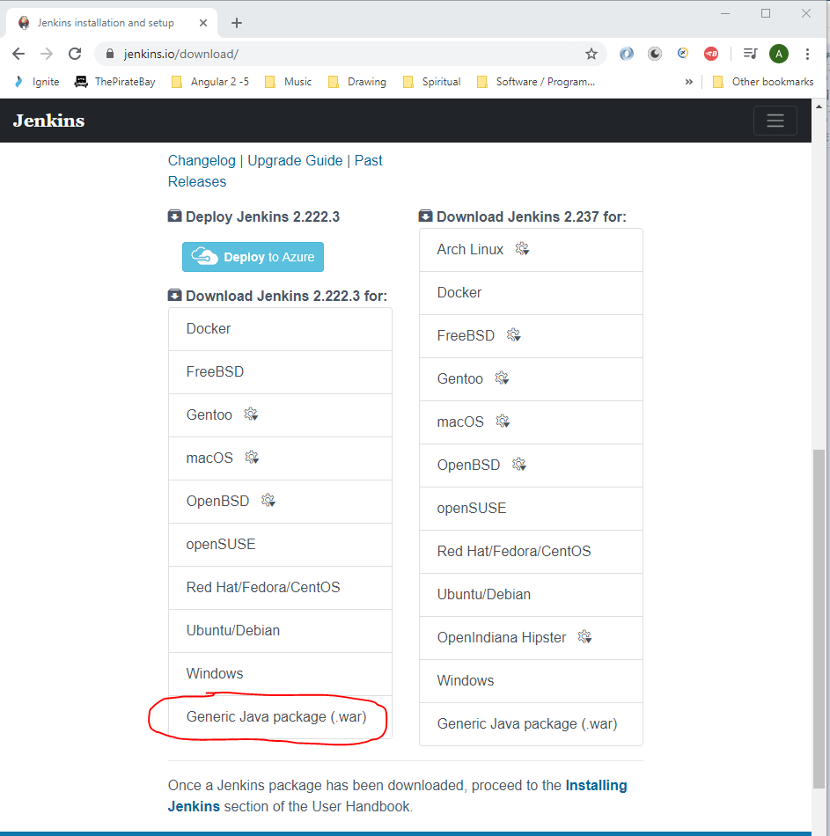

Create a folder on your C: drive called ‘jenkins_server’ and paste the downloaded .war file there:-

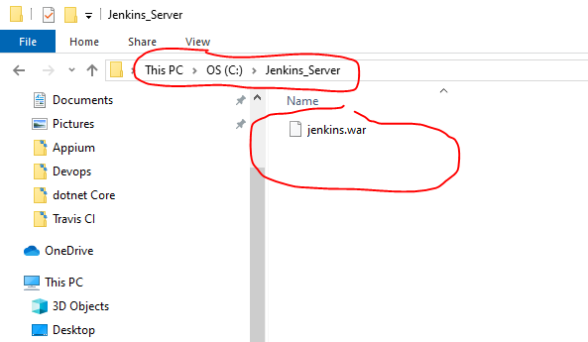

Open command prompt and navigate to:-

C:\jenkins_server

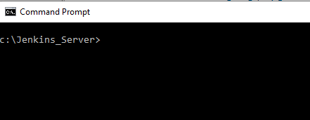

Then the:-

***java -jar jenkins.war -httpPort=8080***

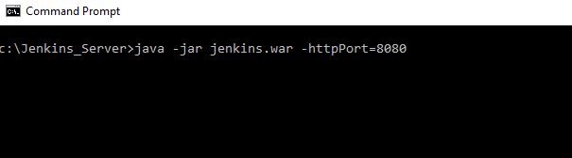

Now open a chrome browser and enter:-

http://localhost:8080

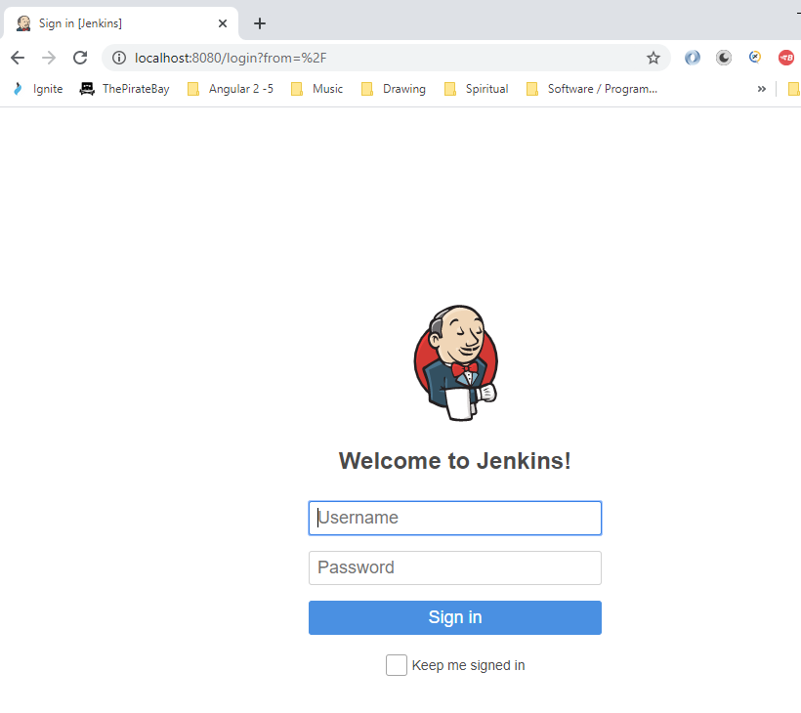

Username:- test_king77

Password:- dudeegg1977

Click on ‘Manage Jenkins’.

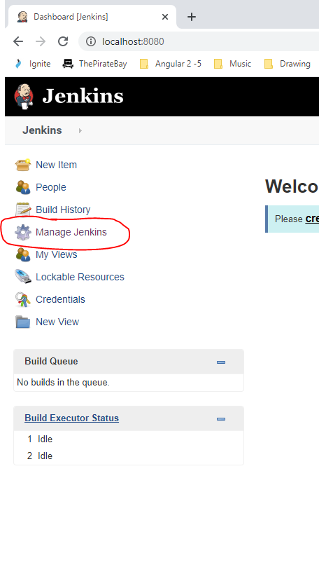

Then:-

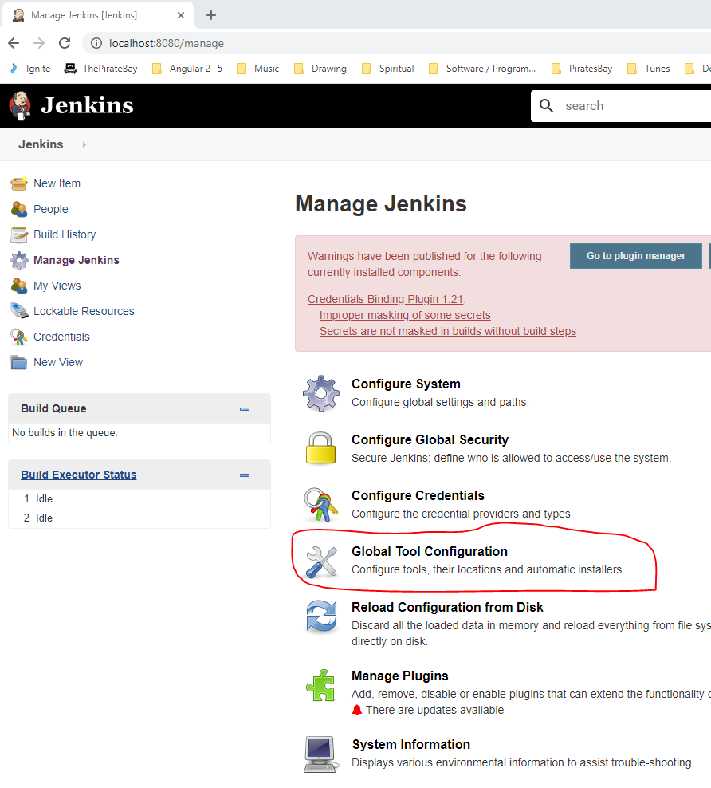

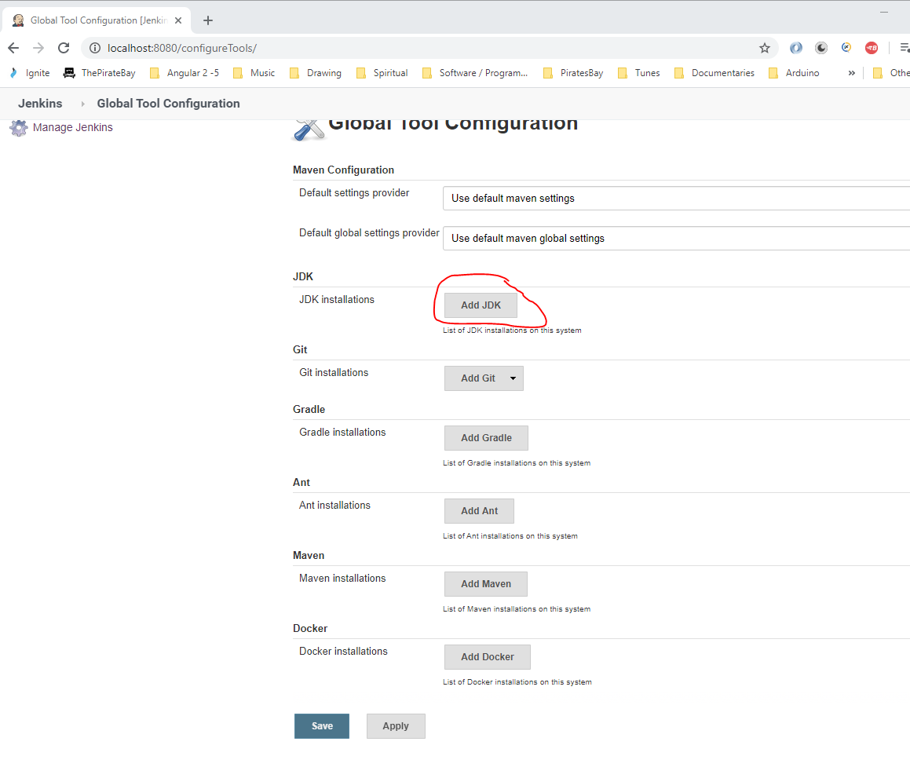

Go to Environment Variables and get the path to the ‘JAVA_PATH’:-

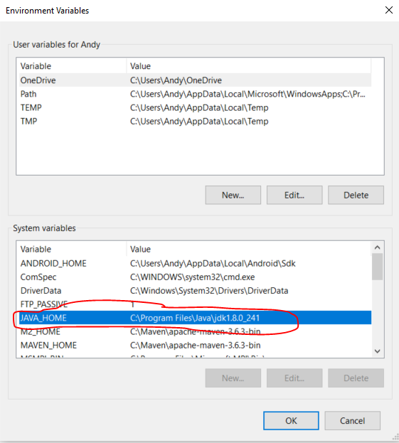

Paste this path into Jenkins here:-

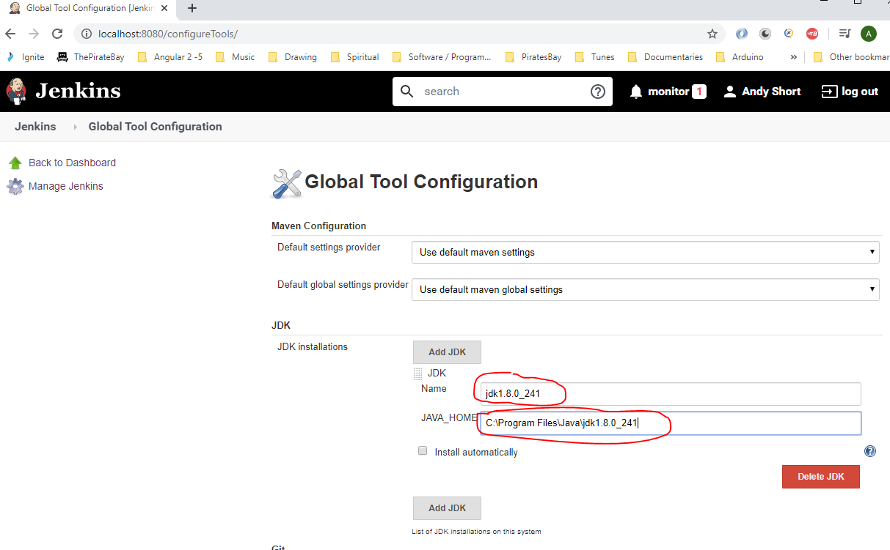

Now do the same for ‘Maven’:-

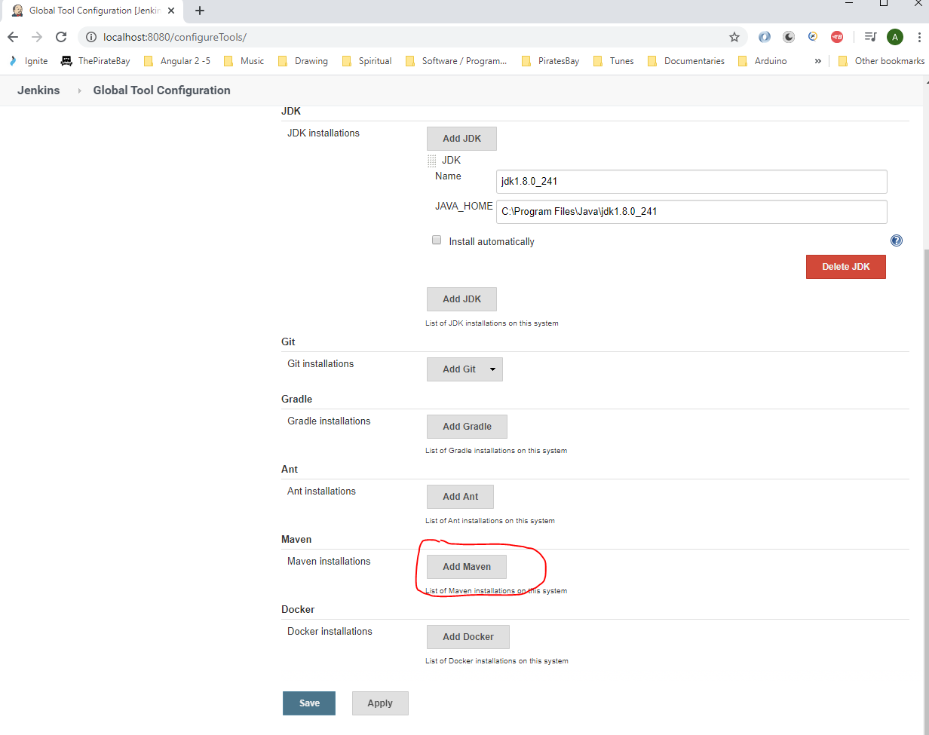

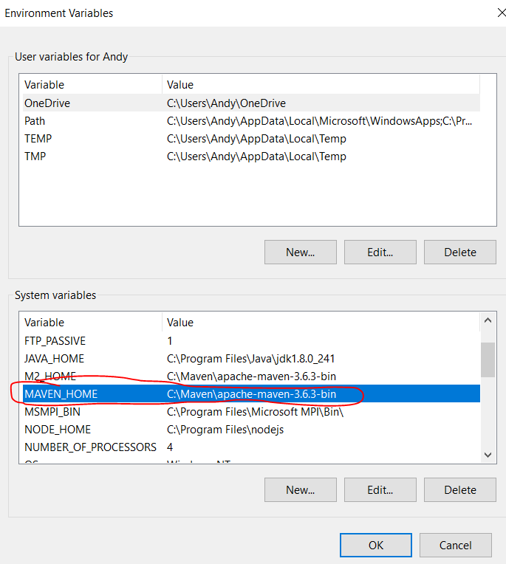

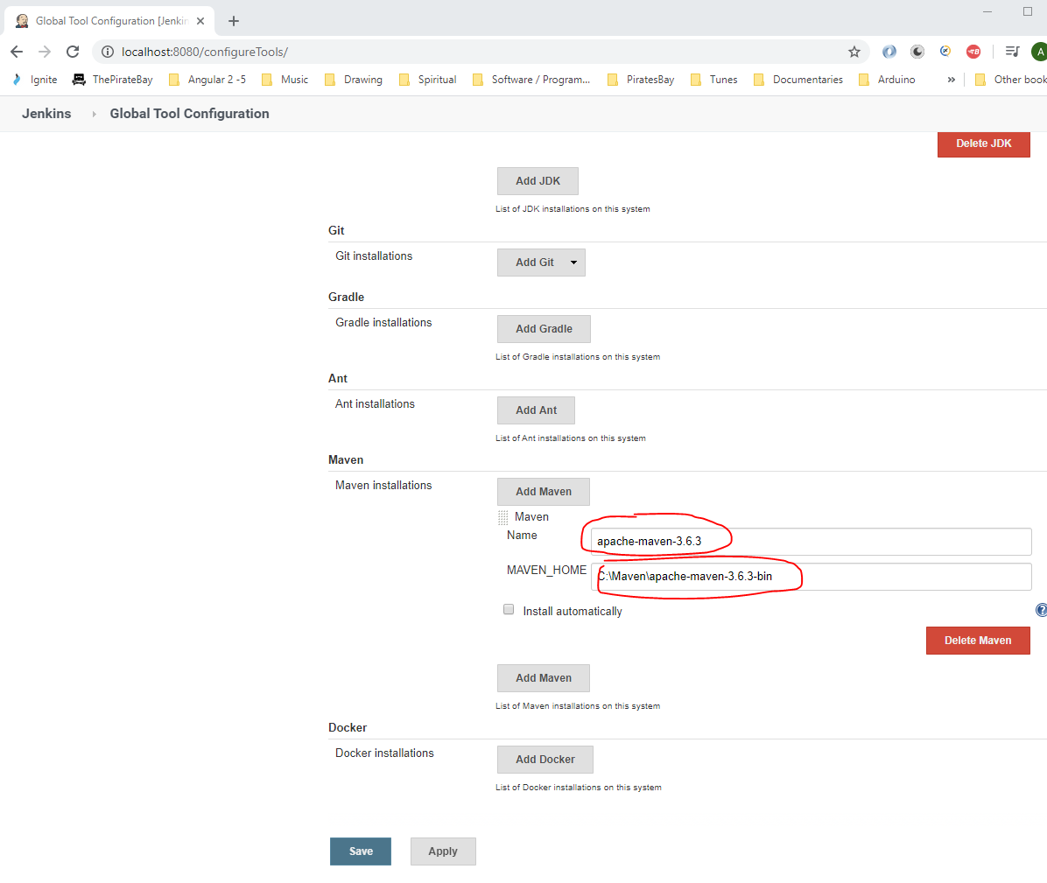

Then click ‘Save’.

**Create Jenkins Job**

Create Jenkins job to run test project:-

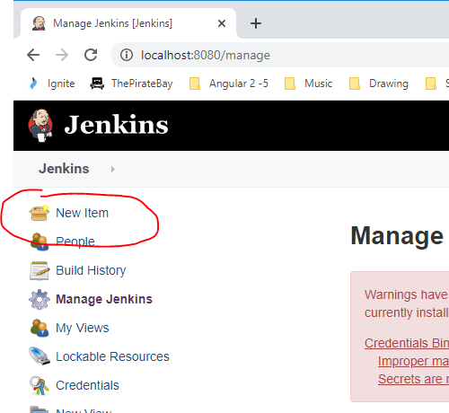

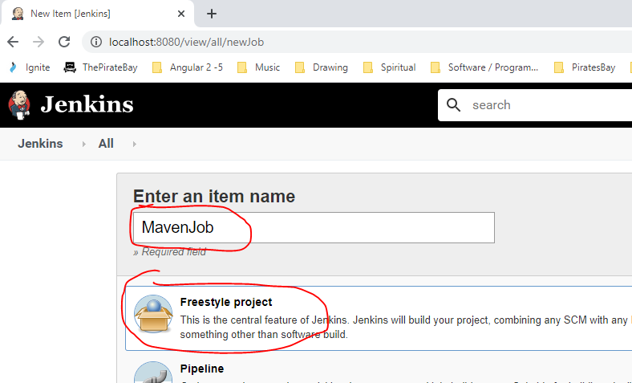

Copy your project from here:-

C:\Users\Andy\Documents\software\Appium\APPIUMTutorial\Mavenjava

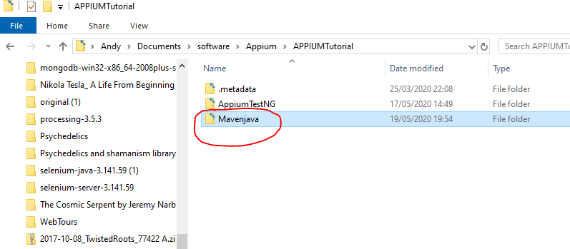

And paste here:-

C:\Users\Andy\.jenkins

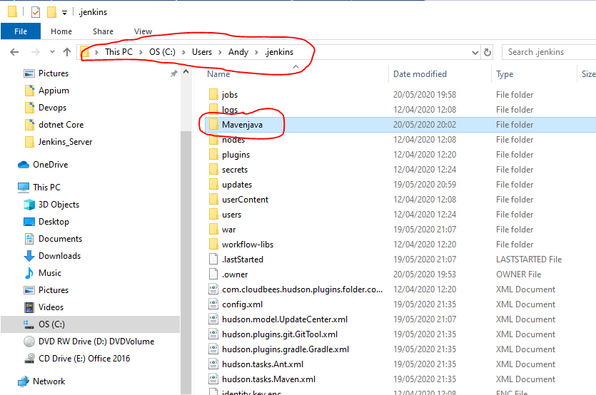

Add the above path to the Jenkins job:-

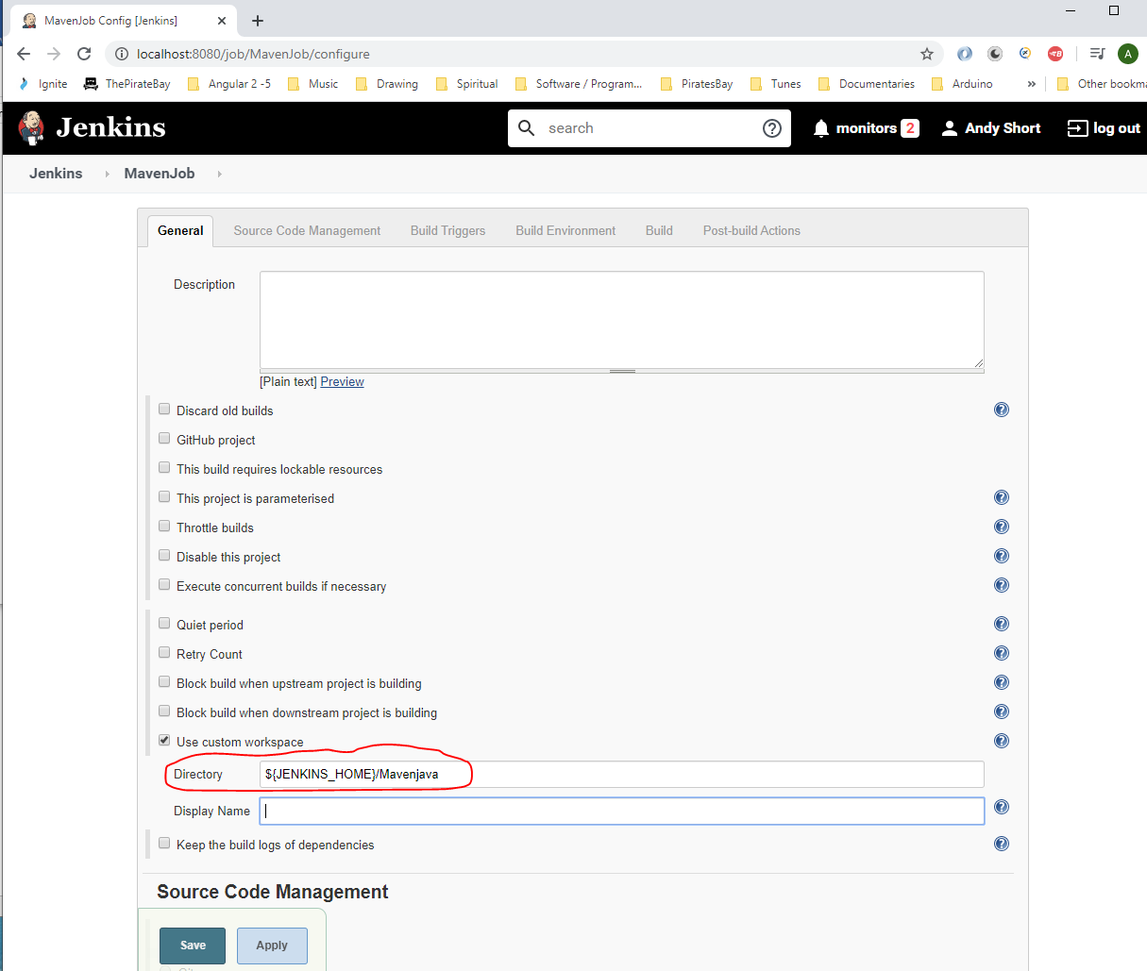

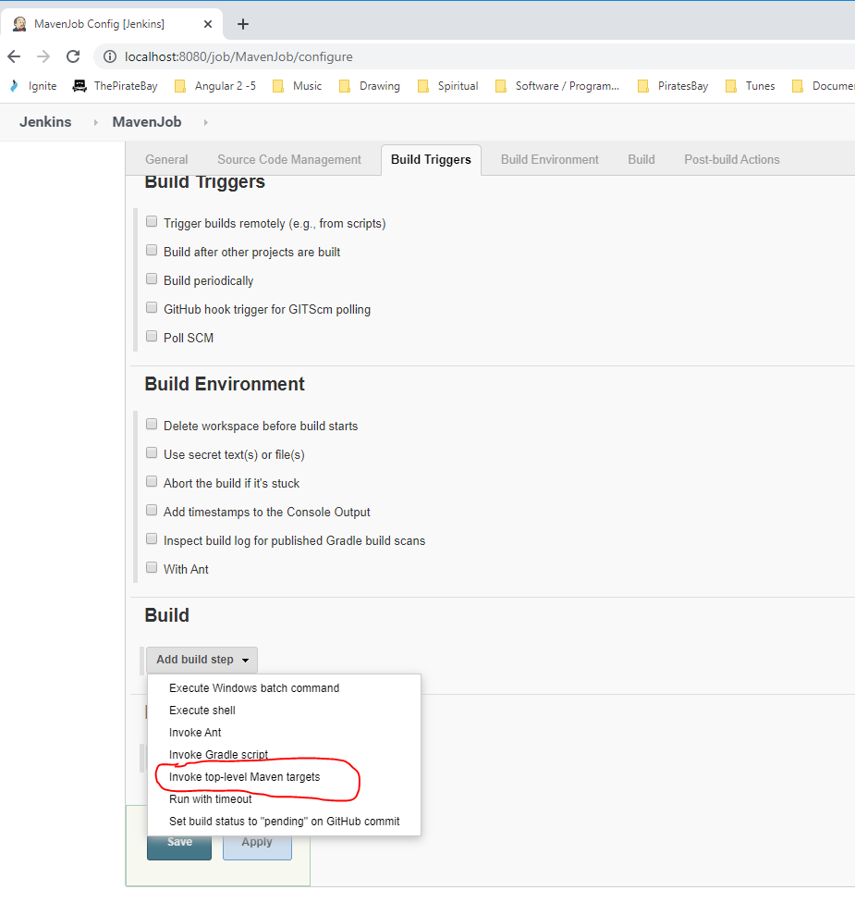

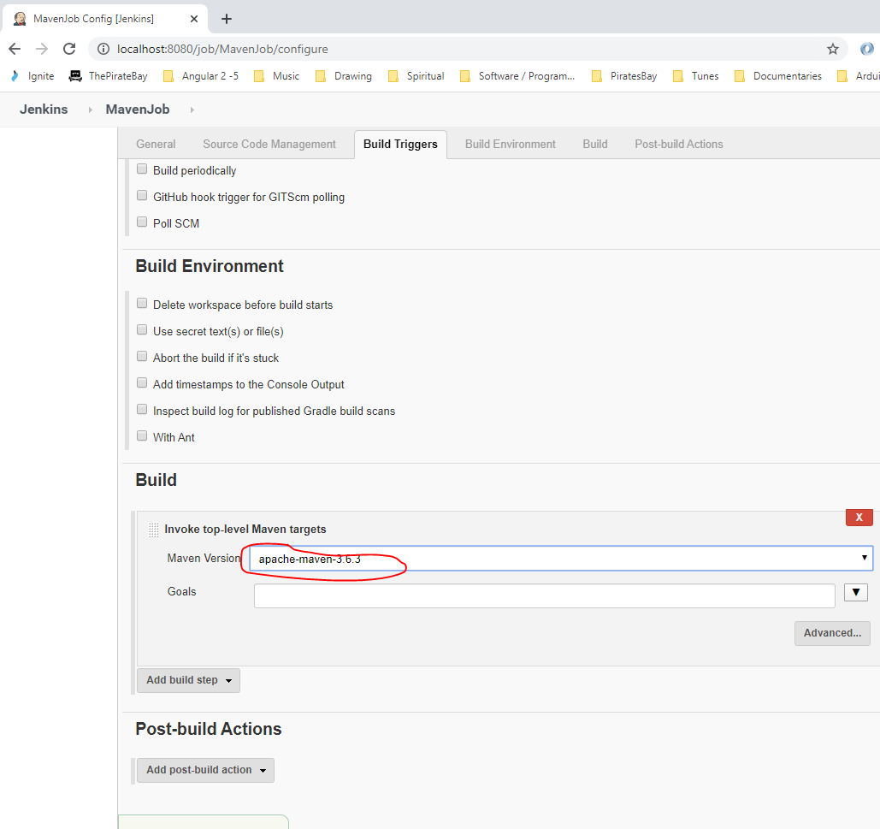

Add this to run profile:-

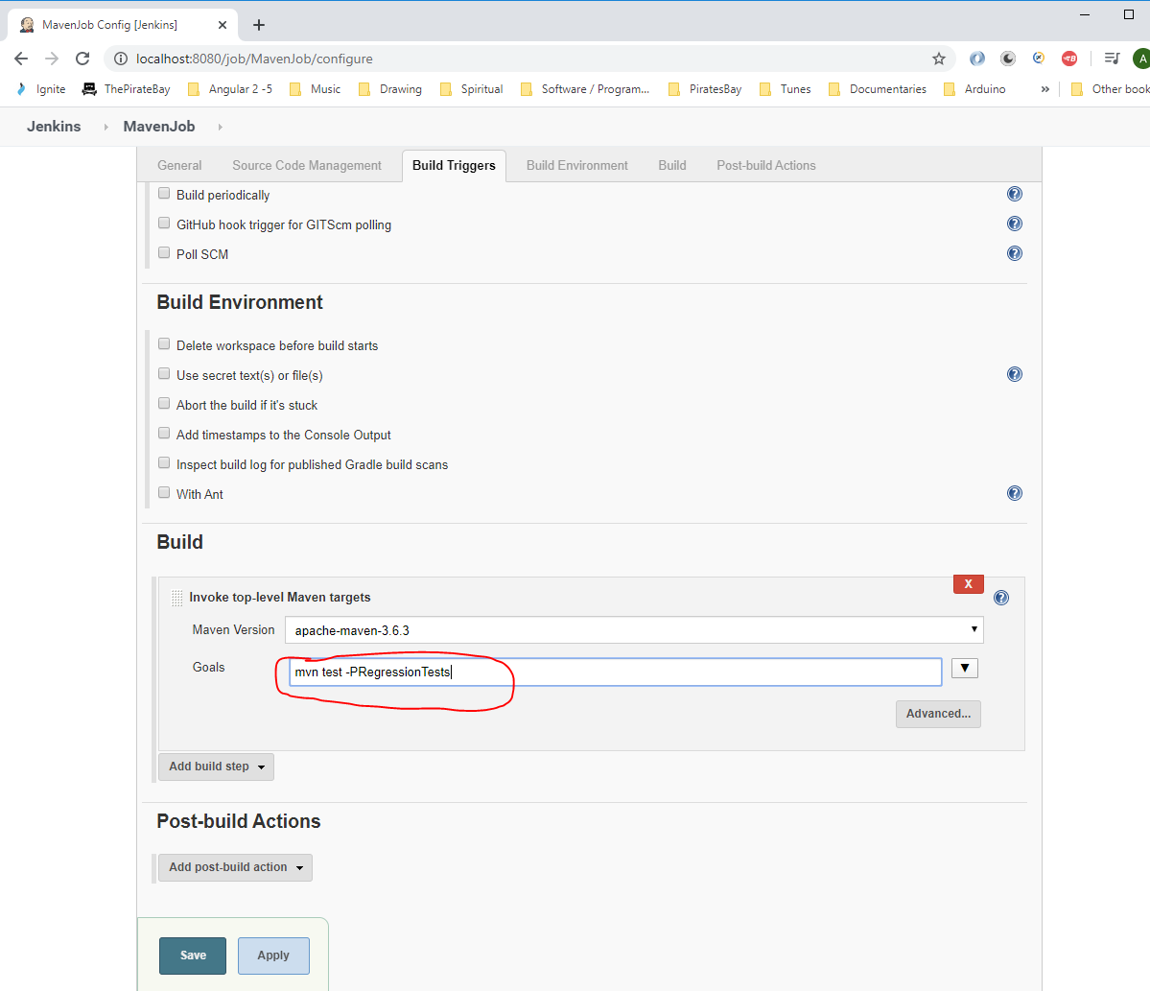

Actually remove the ‘mvn’ part from above or the test will fail. So it should be like this:-

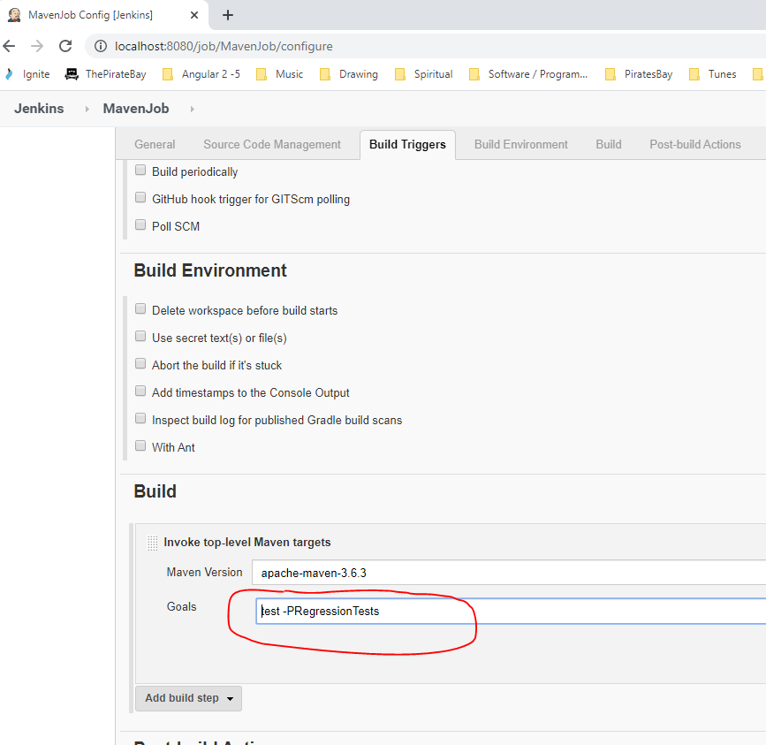

Click ‘Save’.

Click ‘Build Now’:-

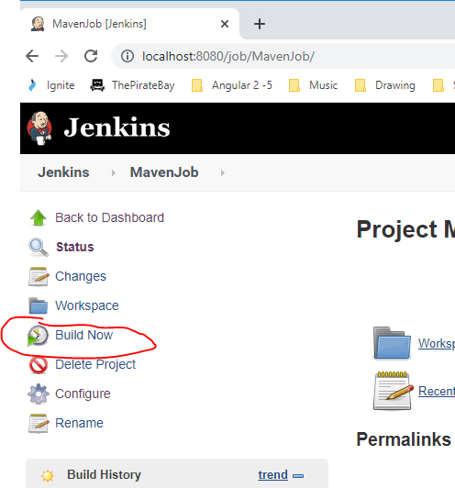

**Appium – Creating Page Object – Page Object Pattern**

Go back the ‘APPIUMMAVEN’ project previously worked on:-

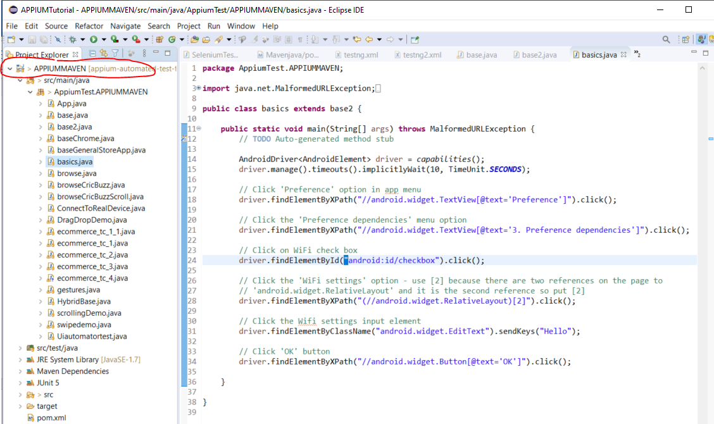

Create a new package here:-

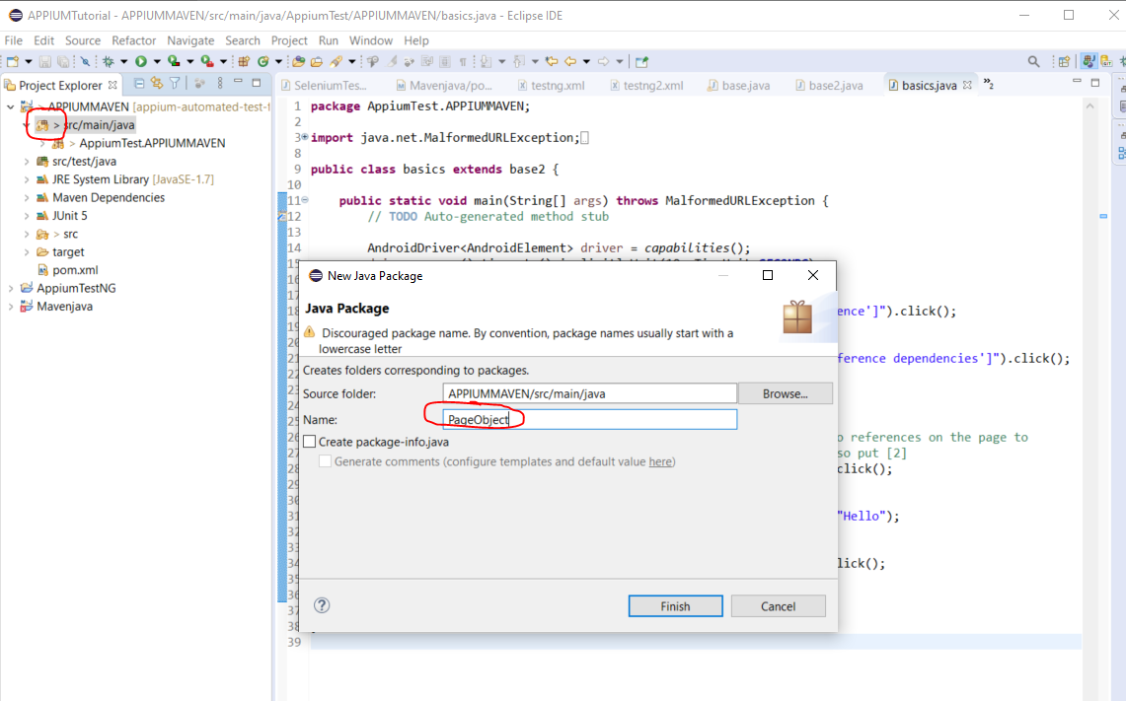

Then create a new class under the new package:-

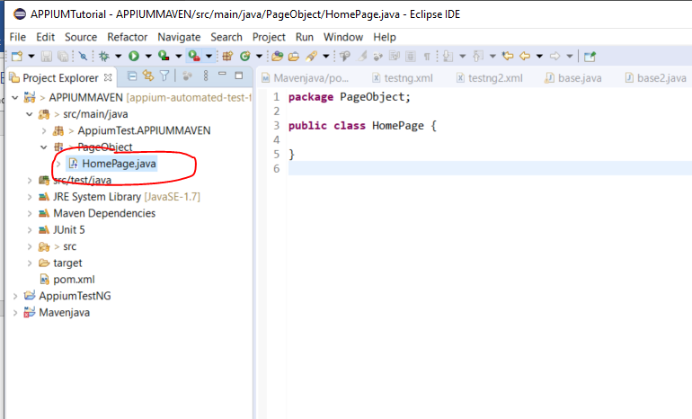

Add this to the HomePage class object:-

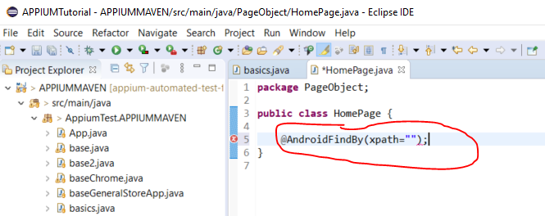

In between the quote marks copy this from you ‘test class ‘basics.java’:-

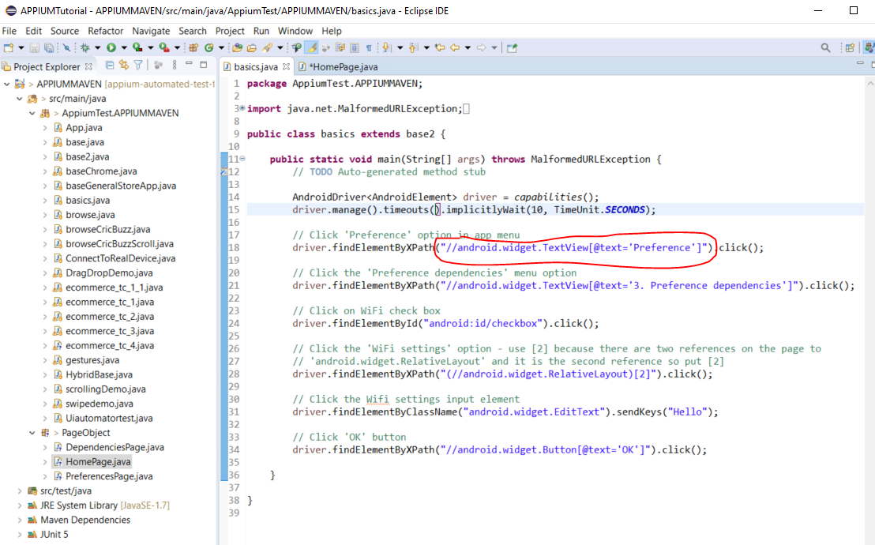

Add this:-

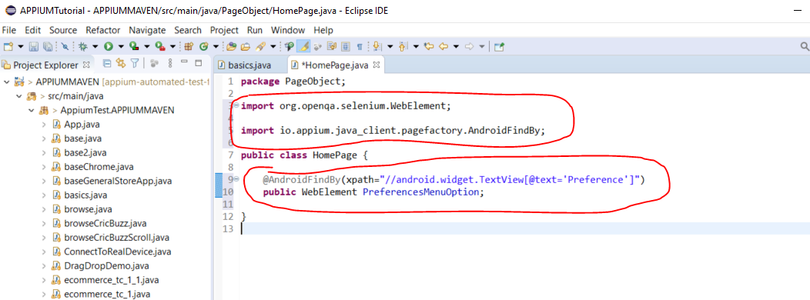

Add a constructor to the HomePage class:-

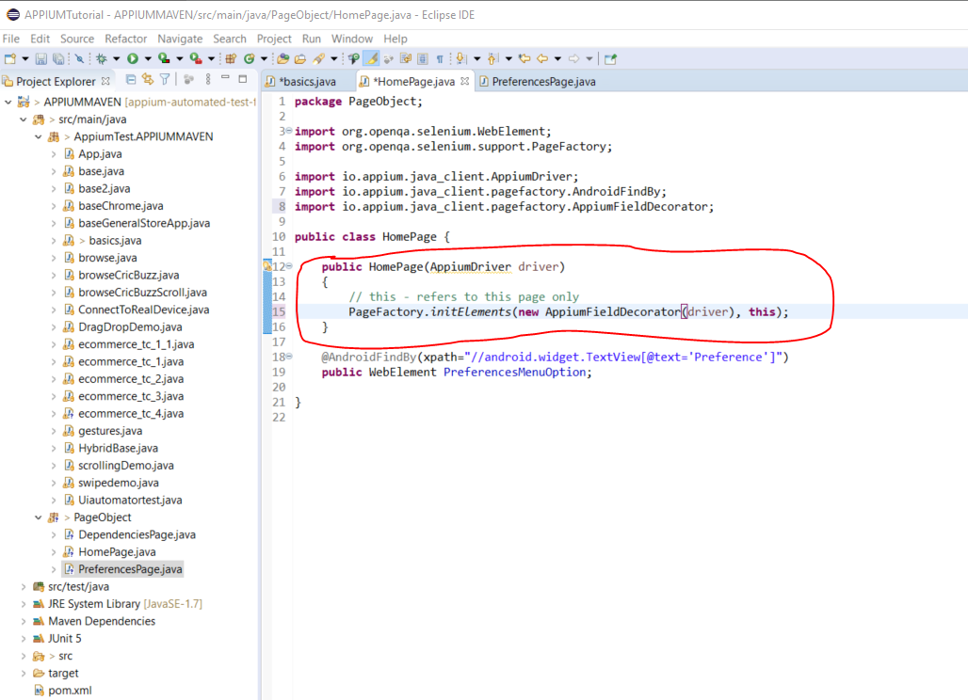

Now to use the page object in the ‘basics.java’ test class do this:-

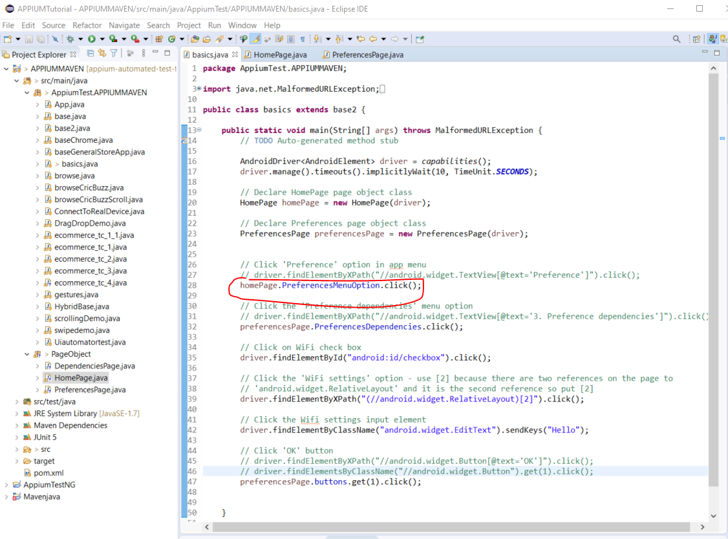

**Framework**

Create a new Maven project:-

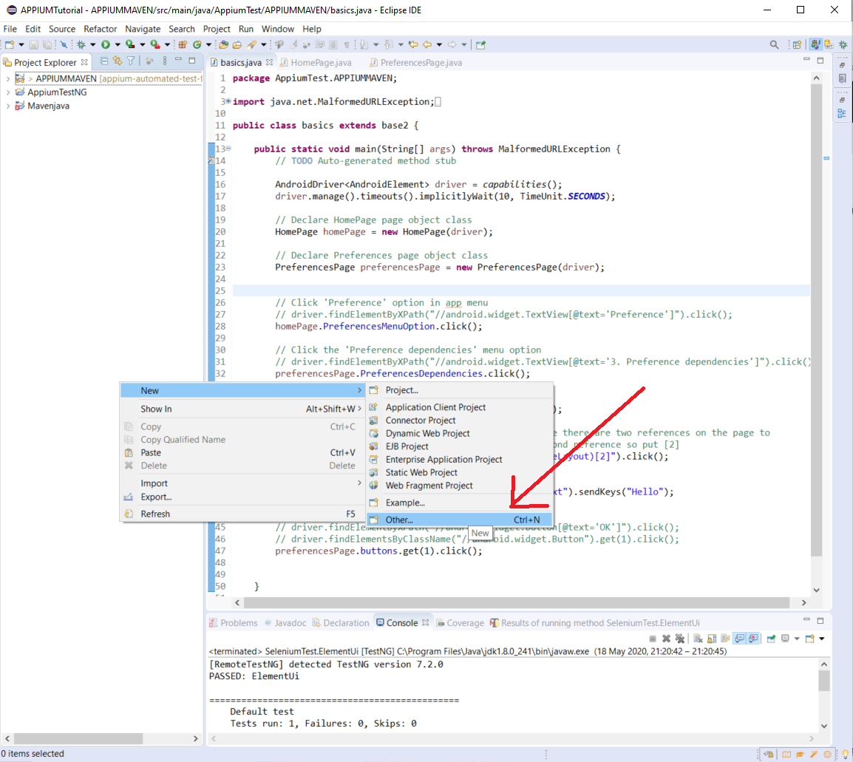

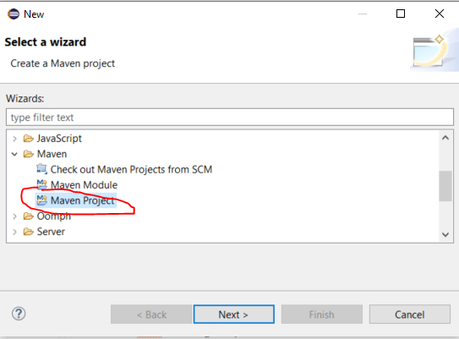

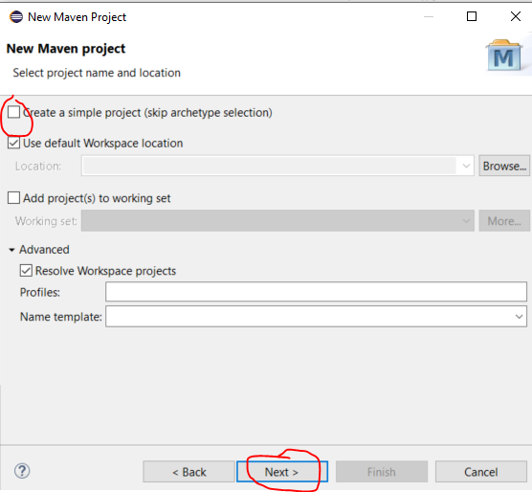

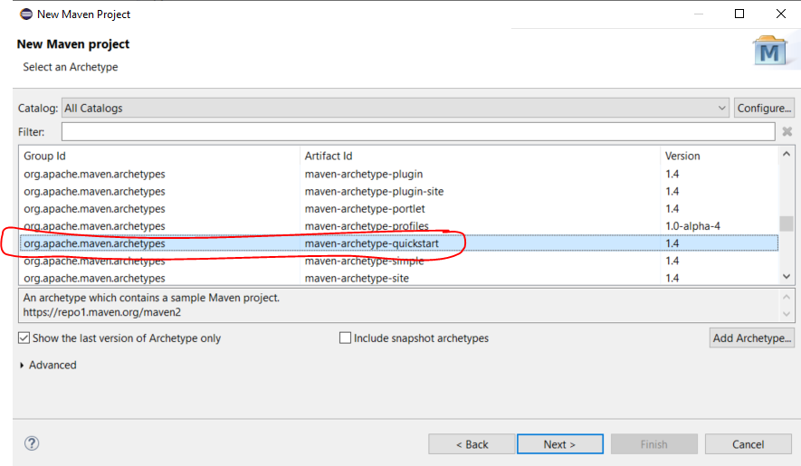

Click ‘Next’.

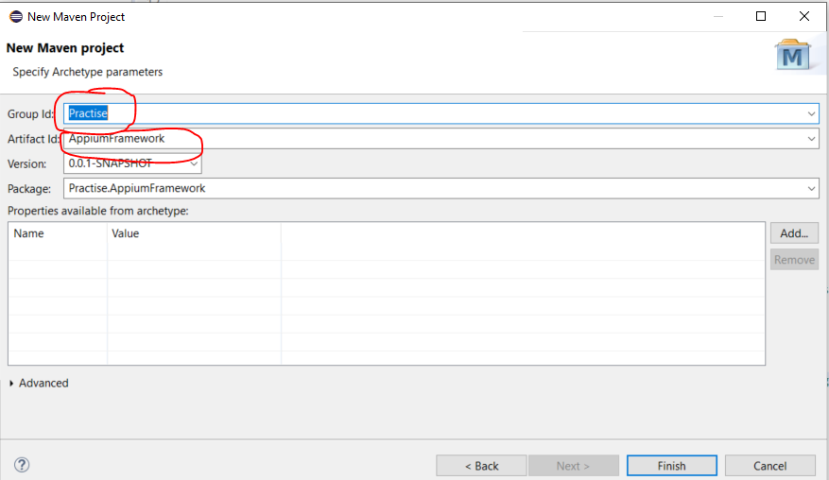

Click ‘Finish’.

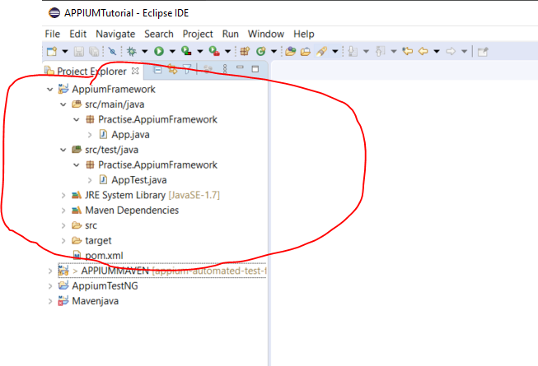

Artifact Id is the project name.

Change the .pom.xml:-

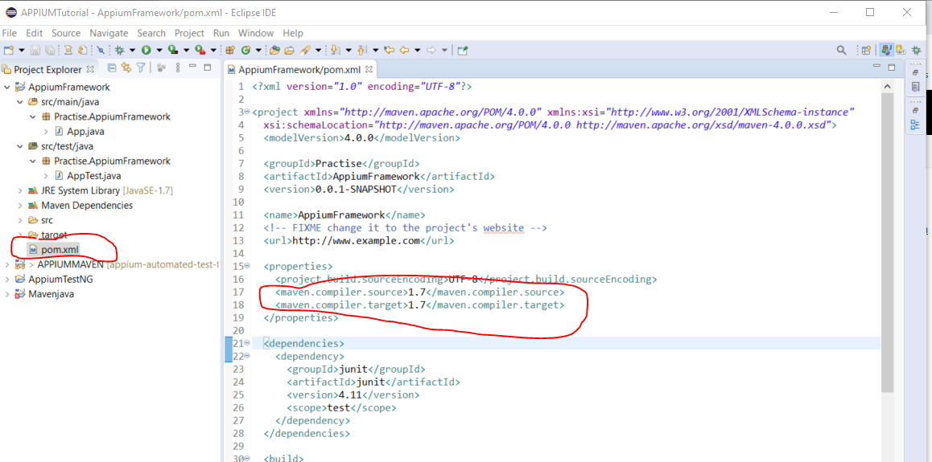

Change from 1.7 to 1.8:-

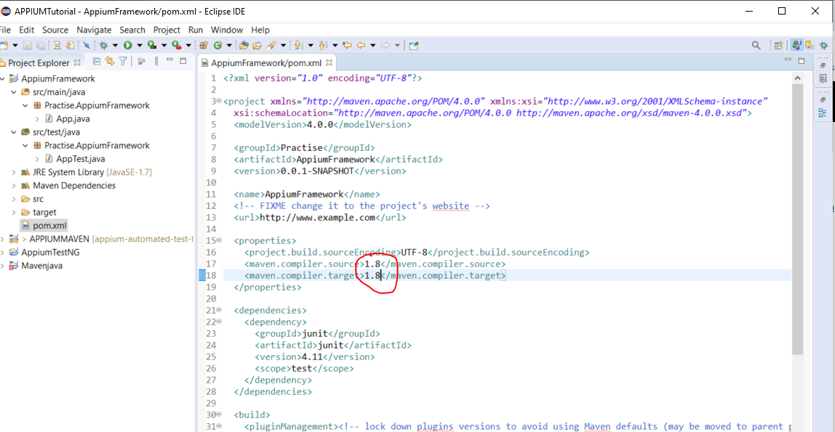

Now get the maven Appium client. Google - Appium client Maven:- 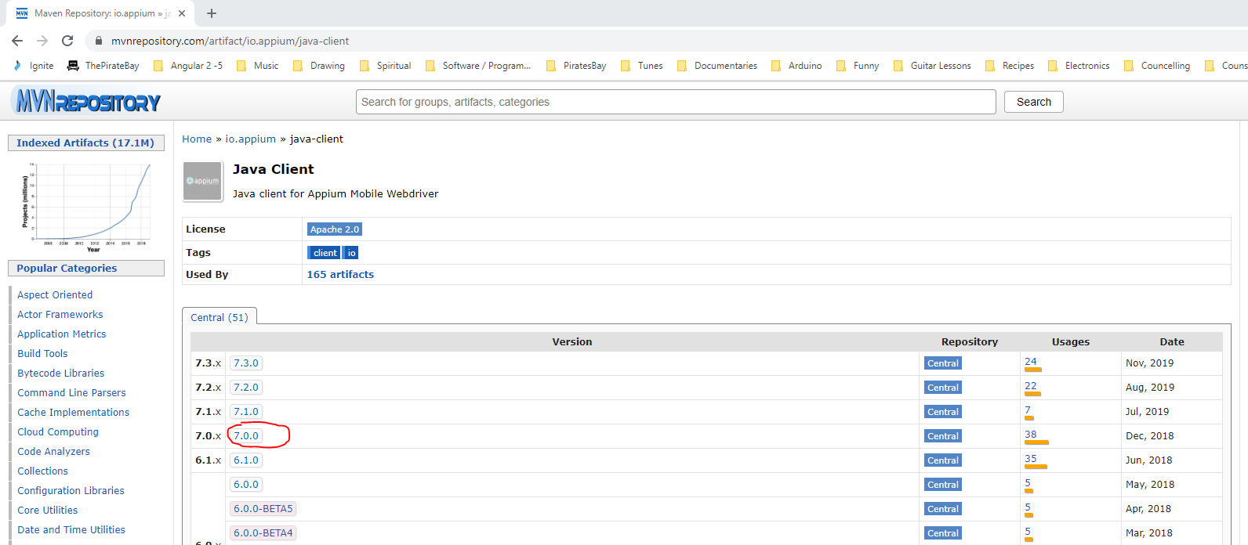

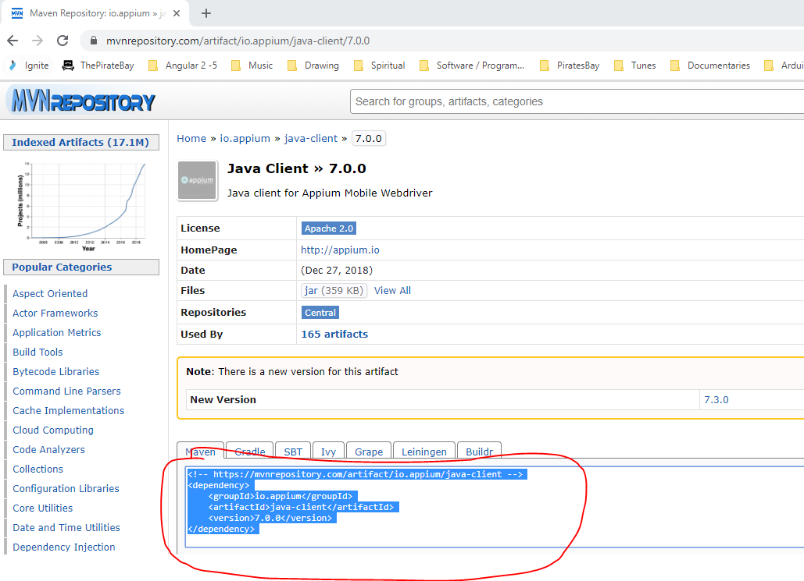

Paste here:-

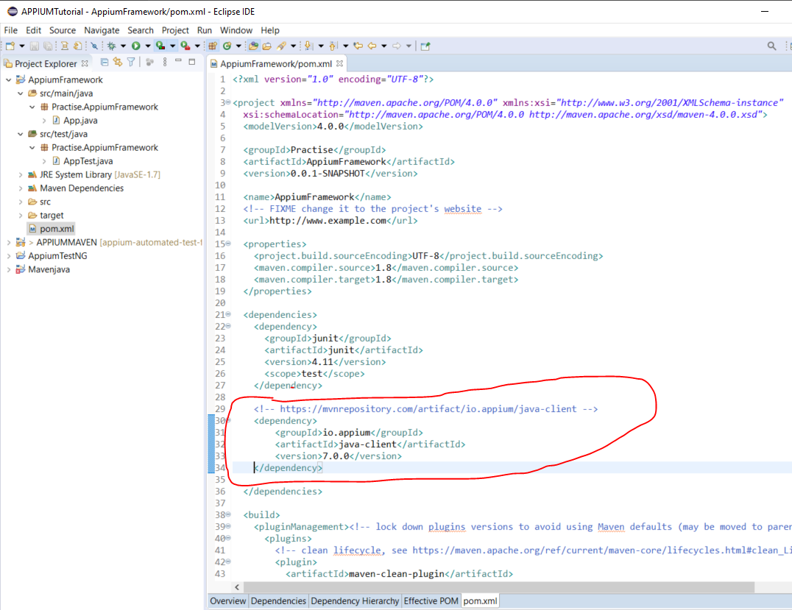

Now add Selenium to pom.xml file:-

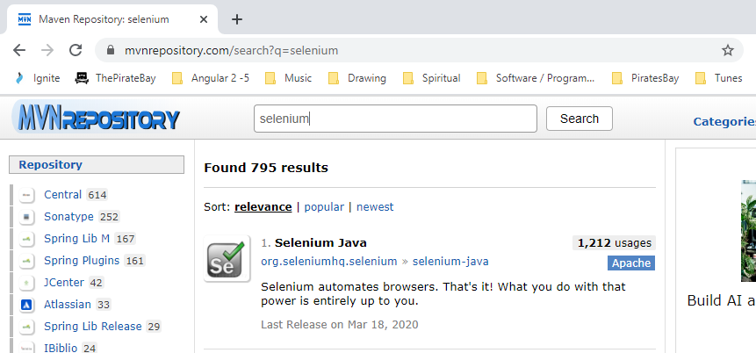

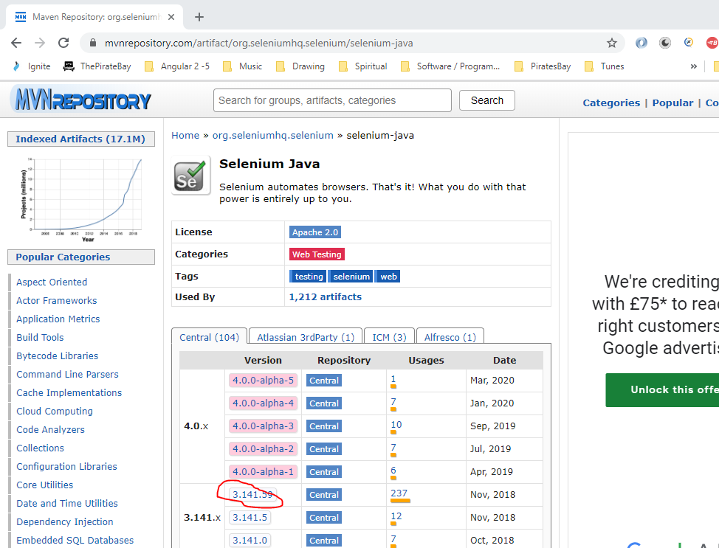

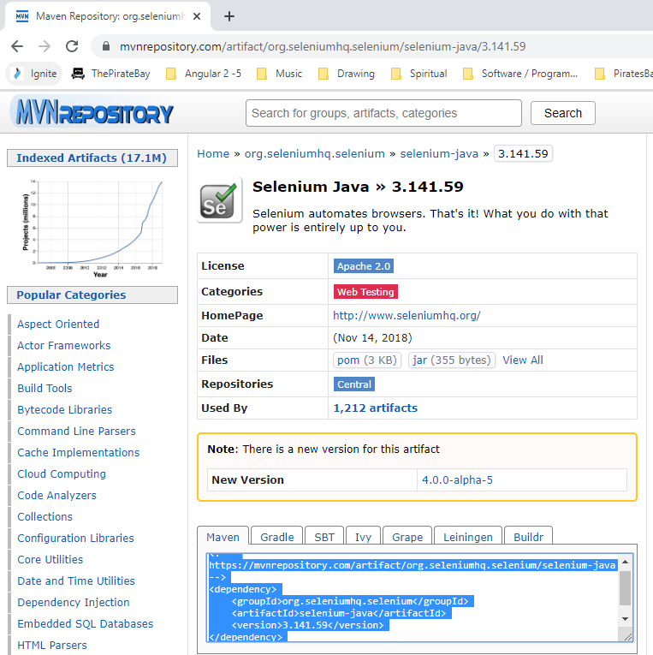

Paste here:-

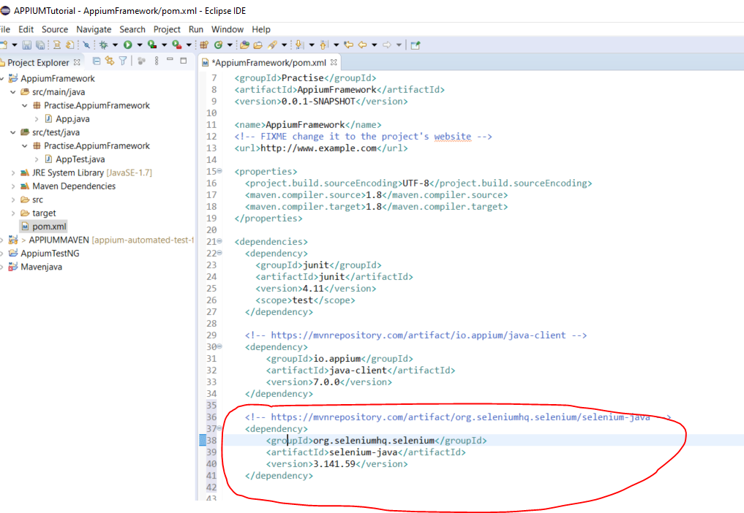

Then right click anywhere in the pom.xl file and select:-

Maven -> Update Project

Now you can copy some of your test case classes from your other project ()

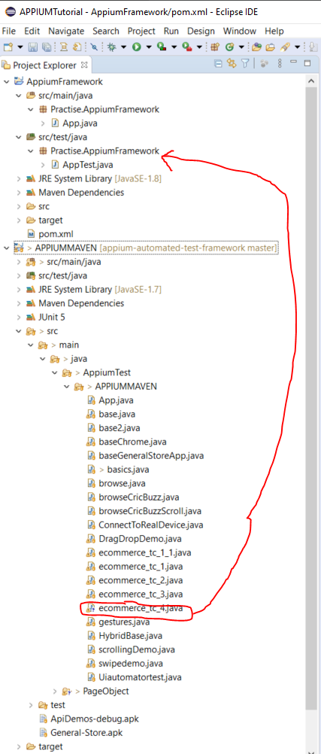

Copy the base class into the following area in the new framework project:-

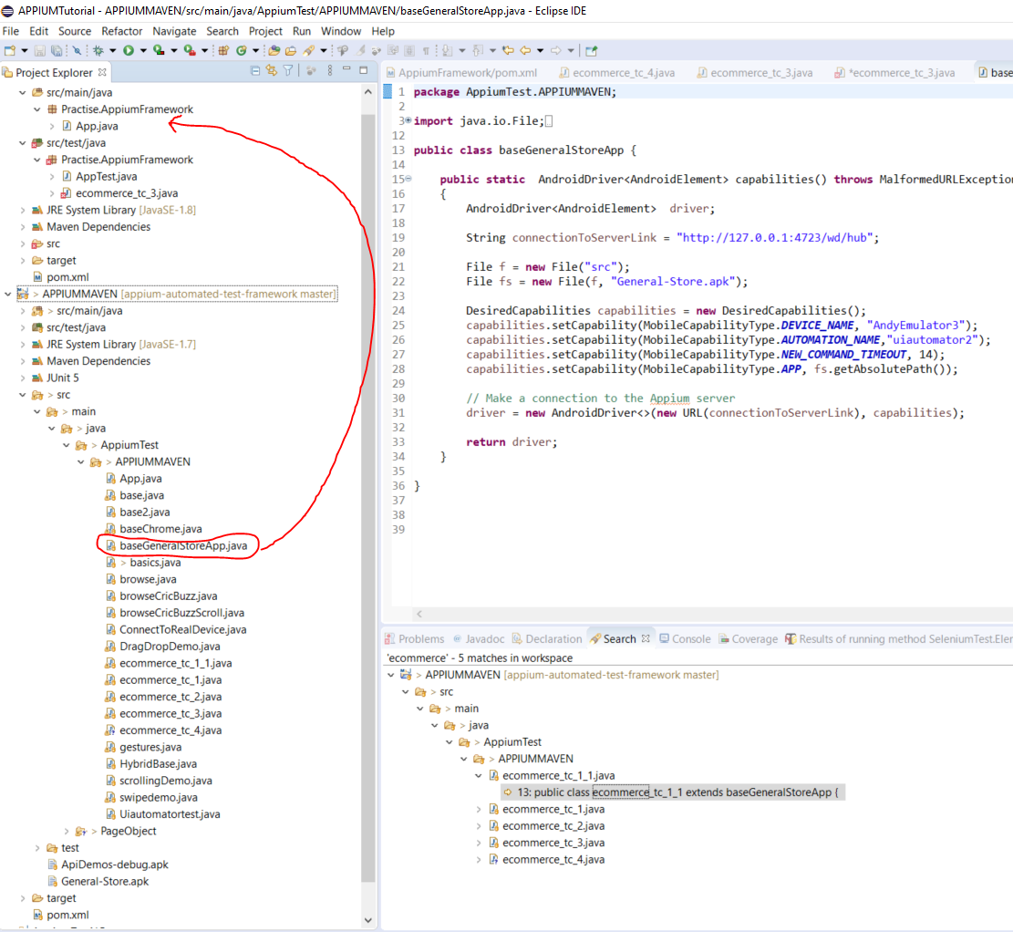

Now update the base class. The following should not be hard coded:-

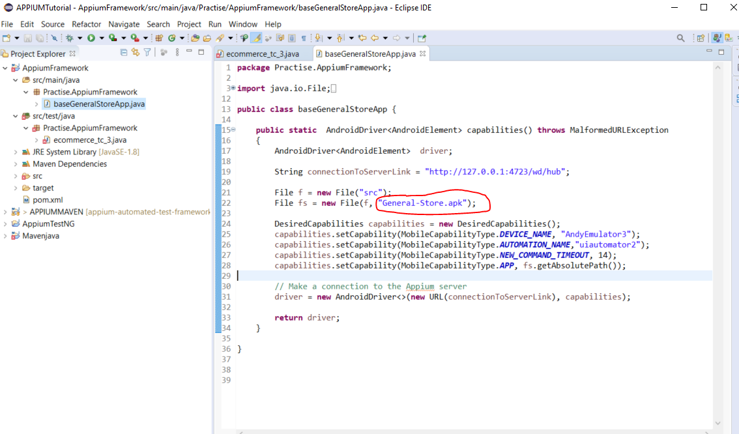

Change to this:-

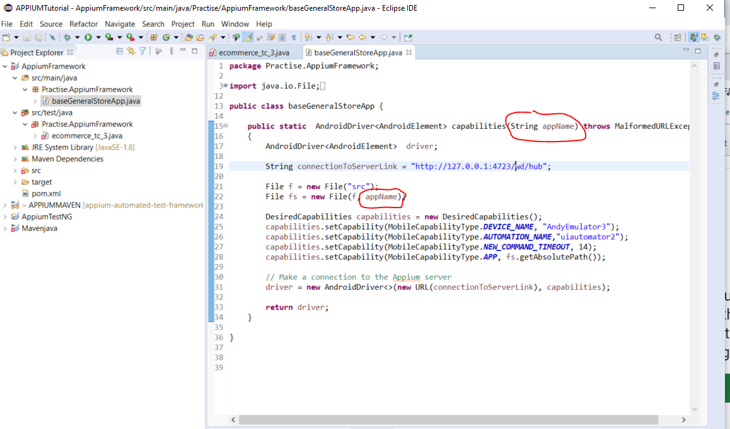

Now, copy the app from your other project and paste here:-

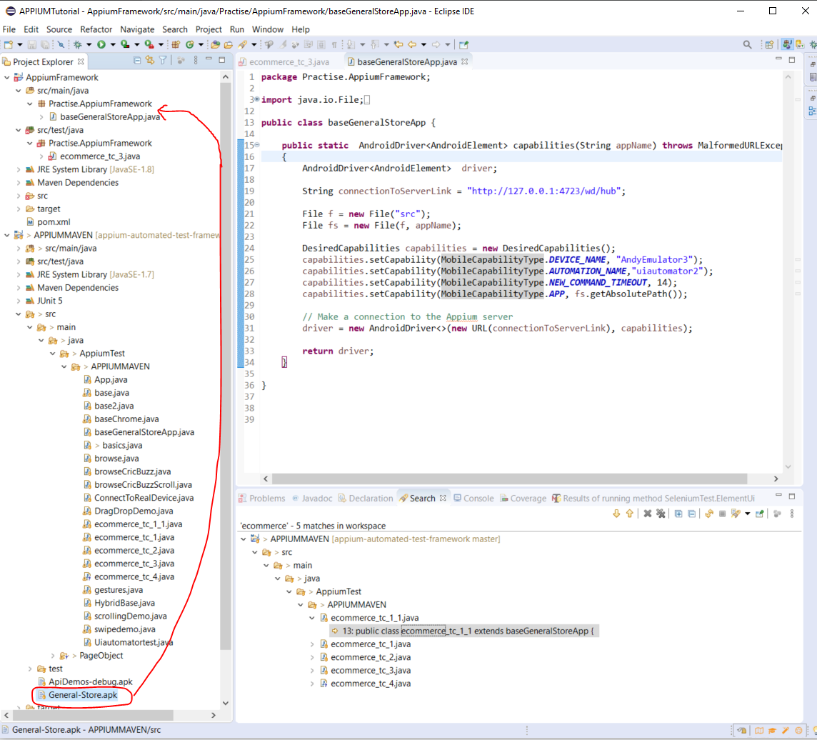

Here:-

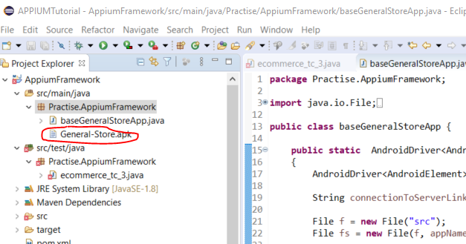

**Create a global config file store the APK file name in:-**

Right click on – ‘src/main/java’.

Select ’New -> Other ->’ then search for ‘File’:-

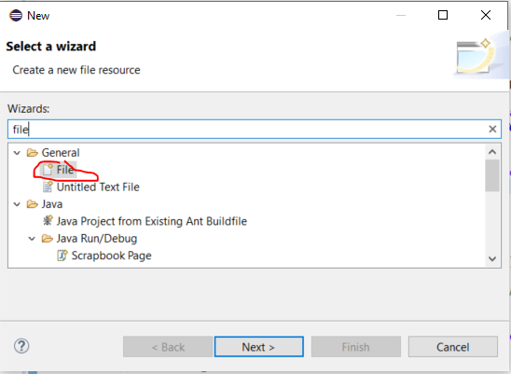

Next.

Add name – global.properties

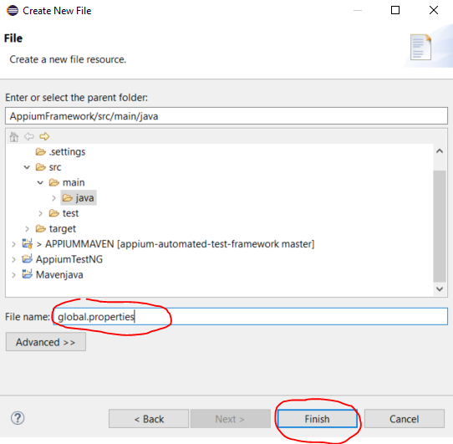

Then click ‘Finish’.

See file appears here:-

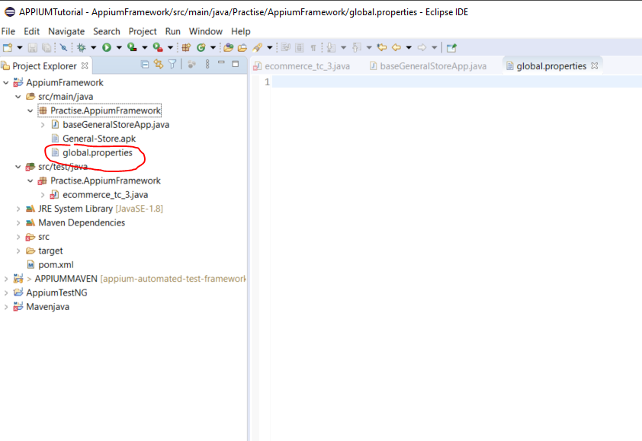

Add this line to ‘global.properties’ file:-

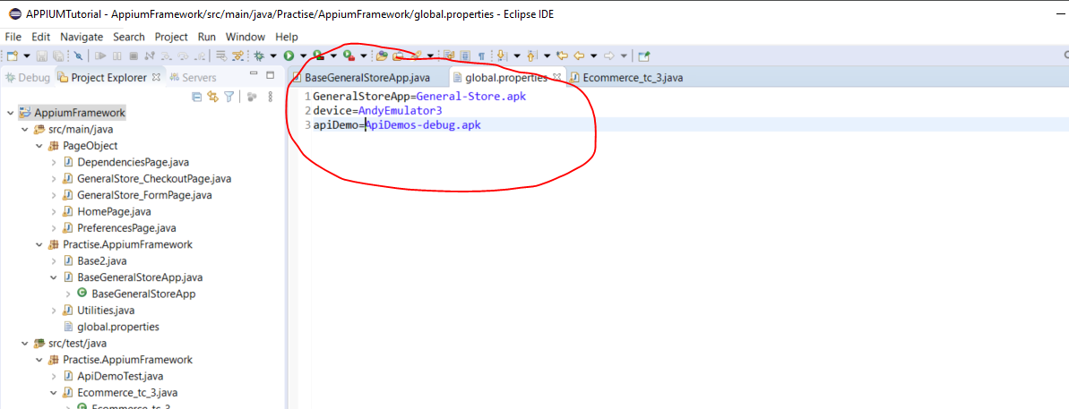

GeneralStoreApp comes from here:-

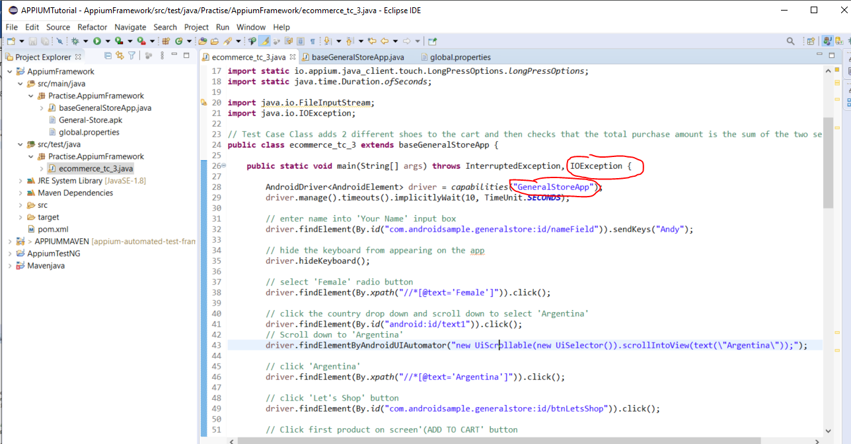

Now add this to your base class:-

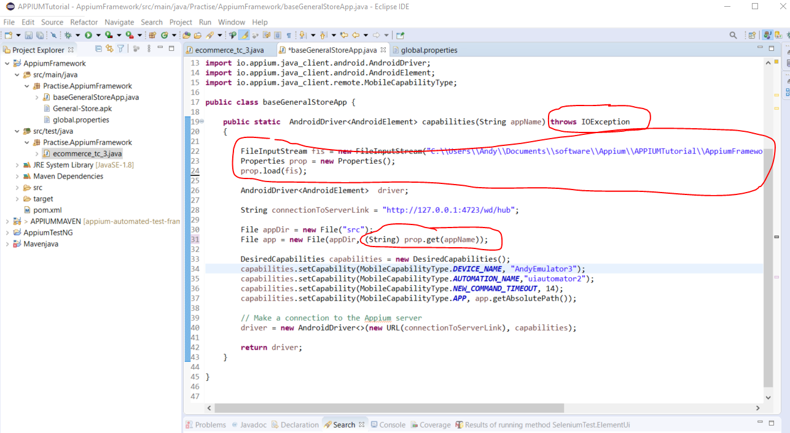

Now remove the hardcoded emulator section:-

First, add a section into the ‘global.properties’ file:-



The device name was taken from here:-

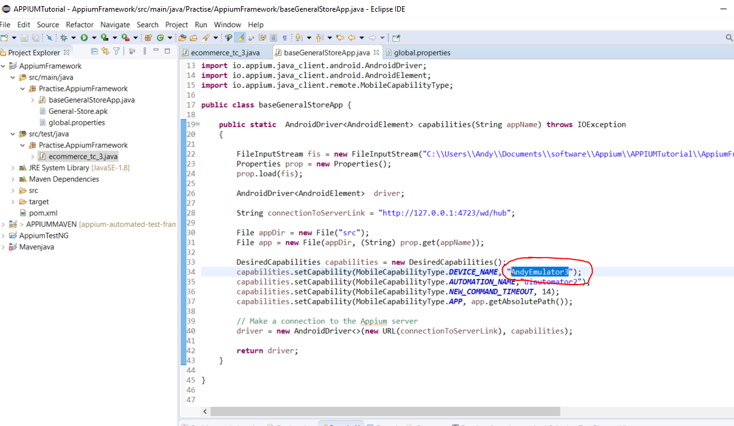

Now add this to the base class:-

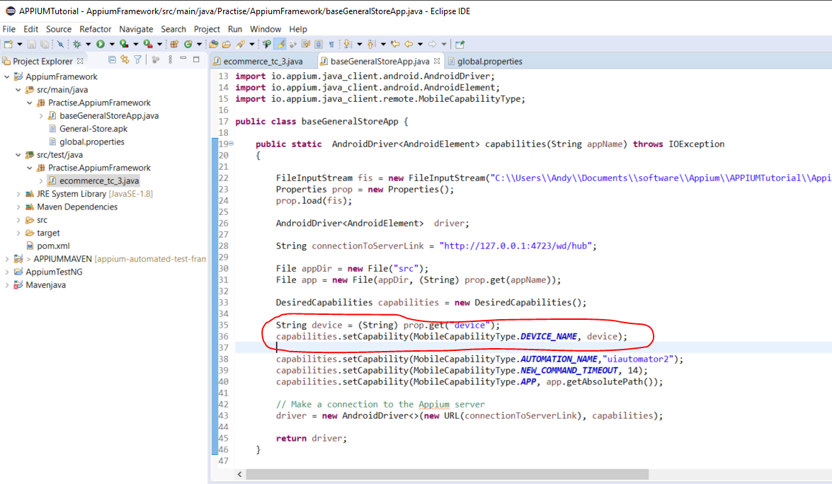

**Now, correct the FileInputStream hardcoded file path:-**

First move the APK file from here:-

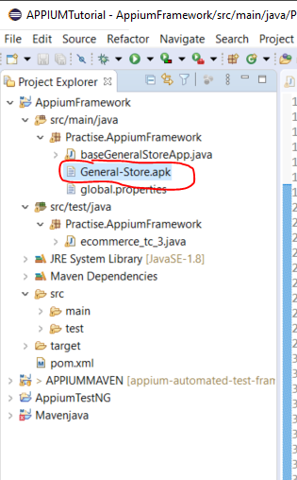

To here:-

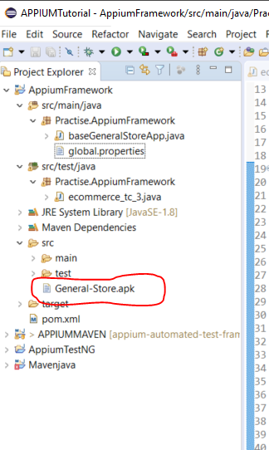

Now replace this section:-

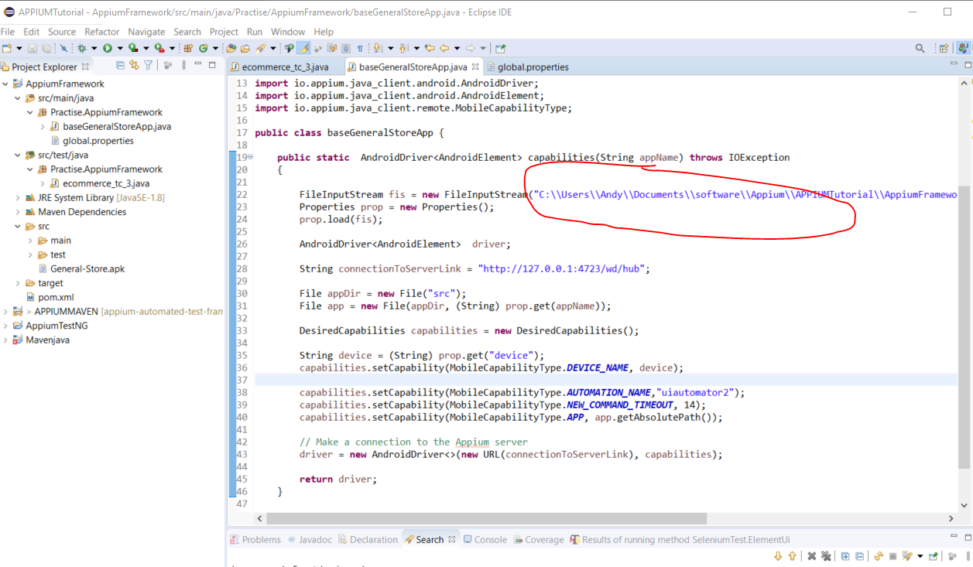

With:-

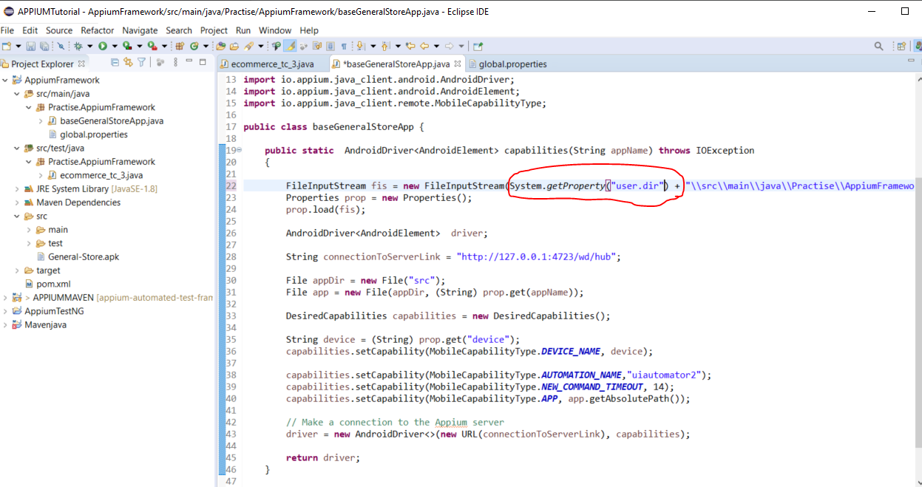

**Now add TestNG annotations to your test class (ecommerce_tc_3):-**

Remove this:-

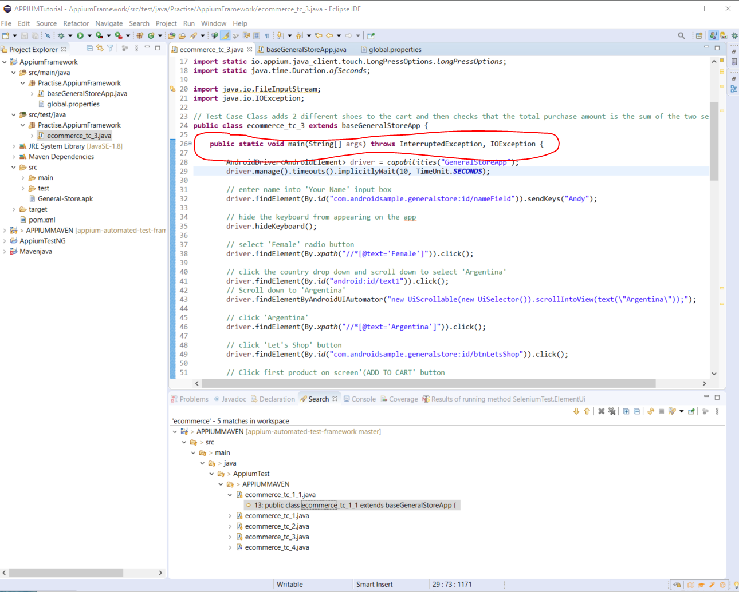

Add this:-

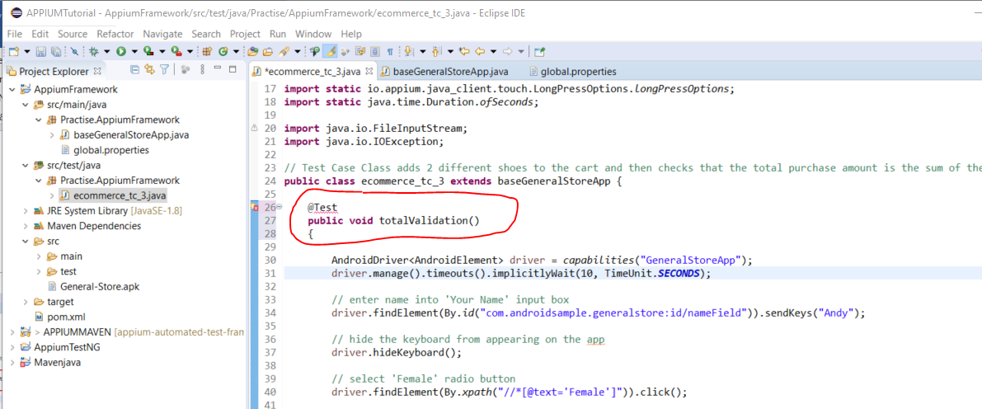

Now you need to add TestNG to your pom.xml file:-

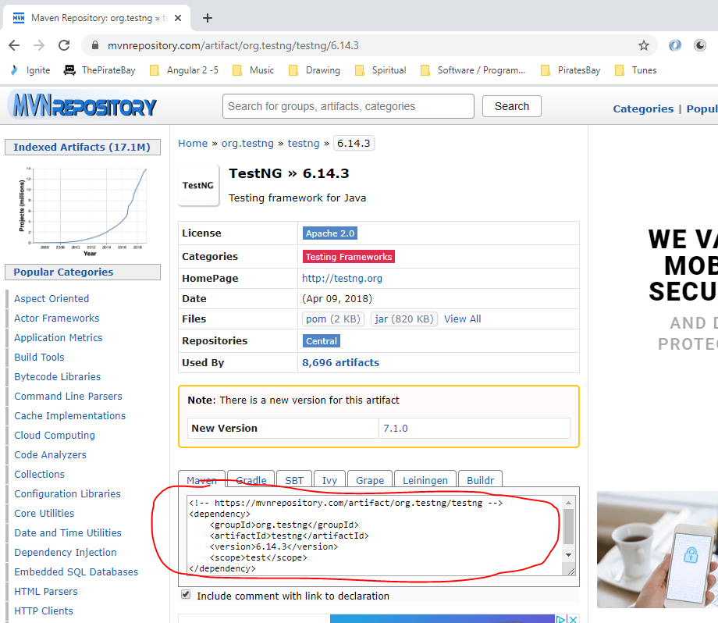

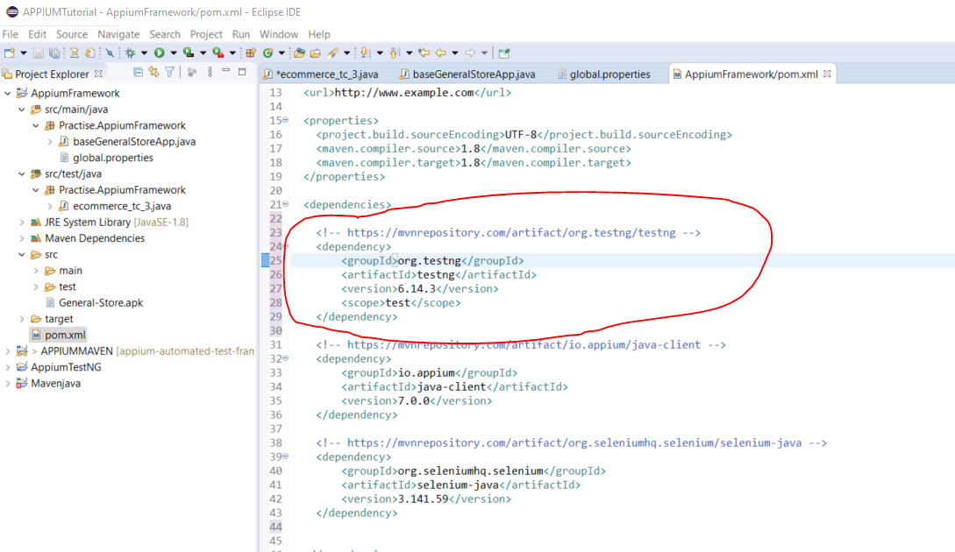

Note:- Remove the Junit entry in the pom.xml file.

Now hover over the ‘@Test’ annotation and import ‘org.testng.annotation’:-

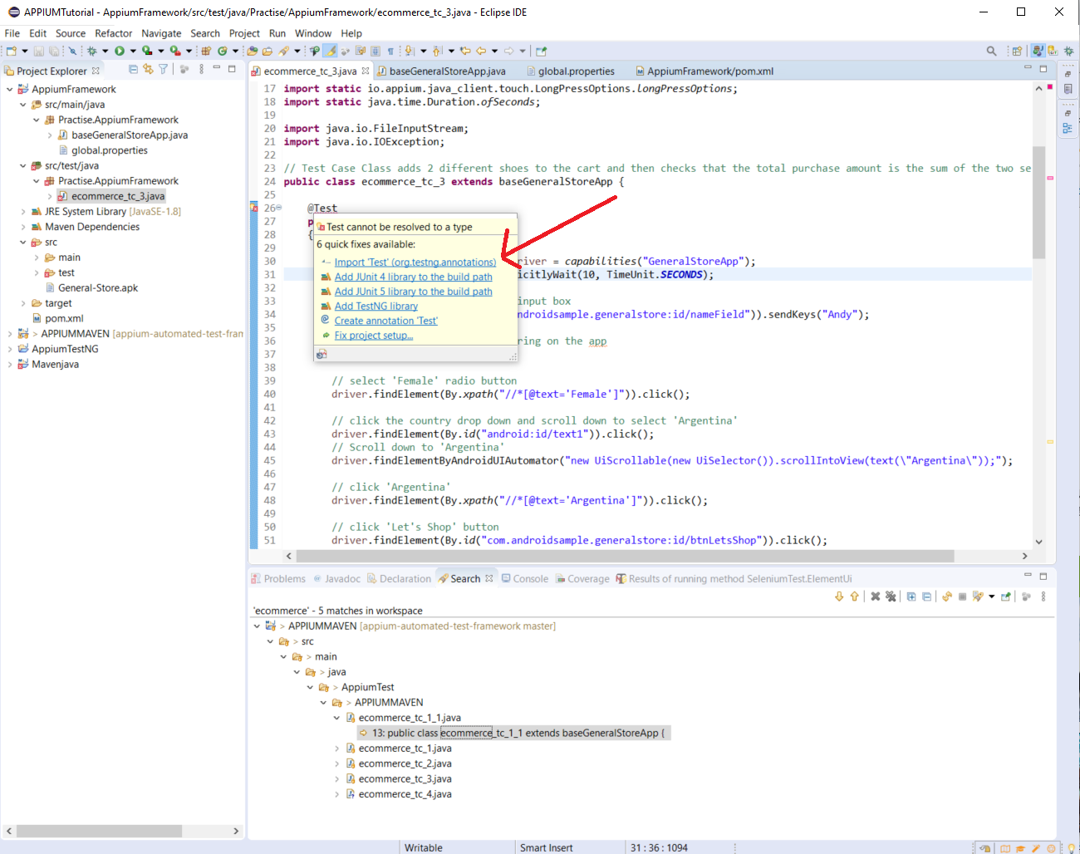

Now right click on the project name in the left hand panel and select:-

TestNG -> Convert to TestNG

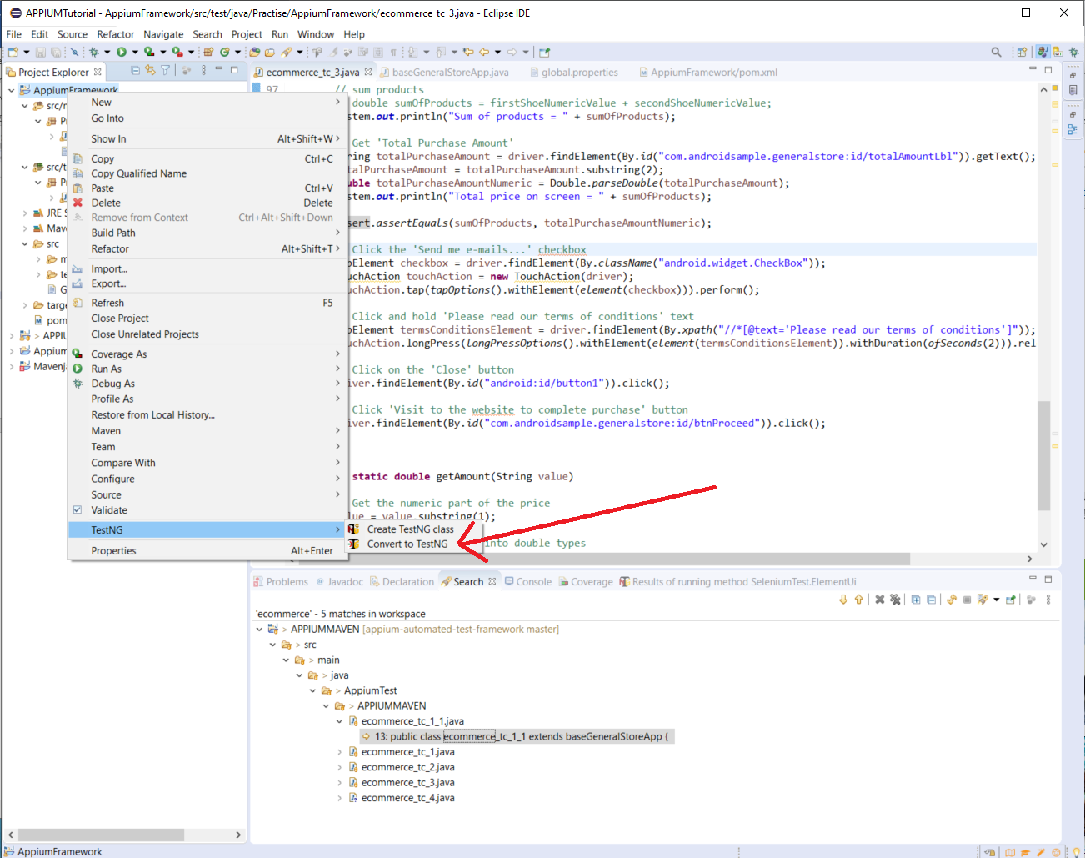

Click ‘Next’.

Click ‘Finish’.

Now copy another test class from the ‘APPIUMMVEN@ project to the ‘AppiumFramework’ project:-

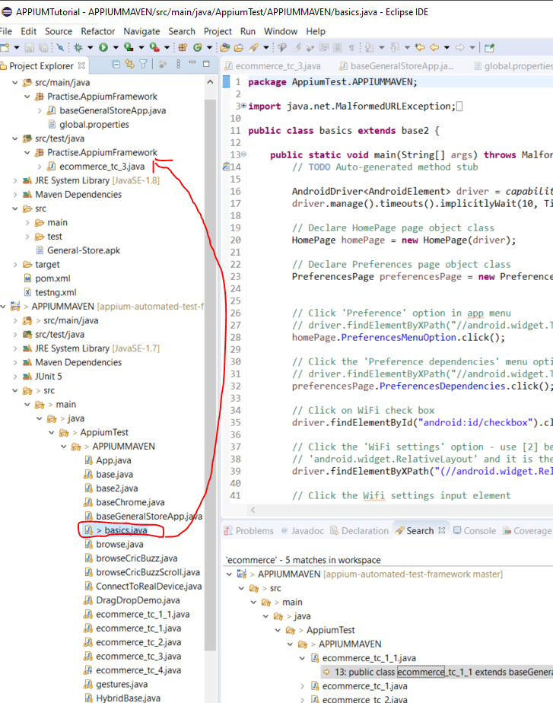

Copy the page object folder from APPIUMMAVEN to here:-

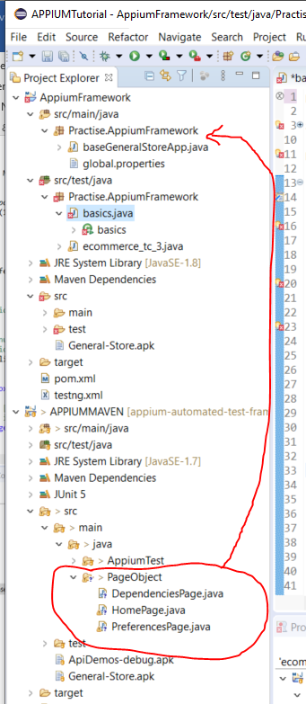

Copy the ‘ApiDemos-debug.apk’ file into your project:-

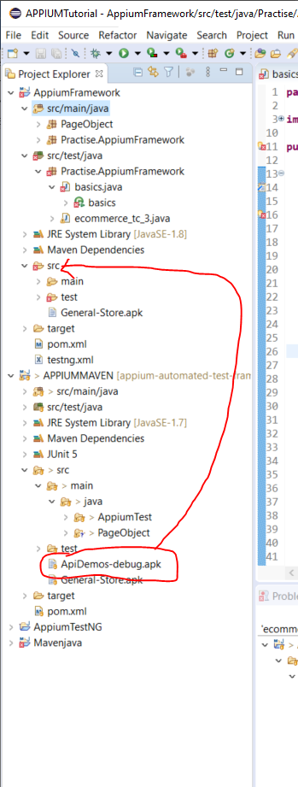

Now update the ‘global.properties’ file:-

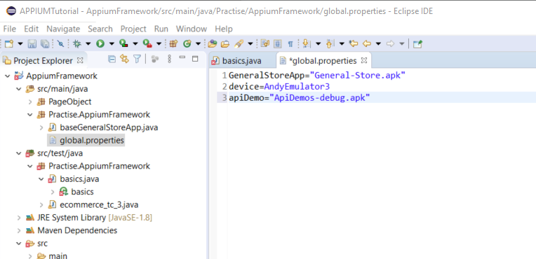

**Write Code To Start Appium Server**

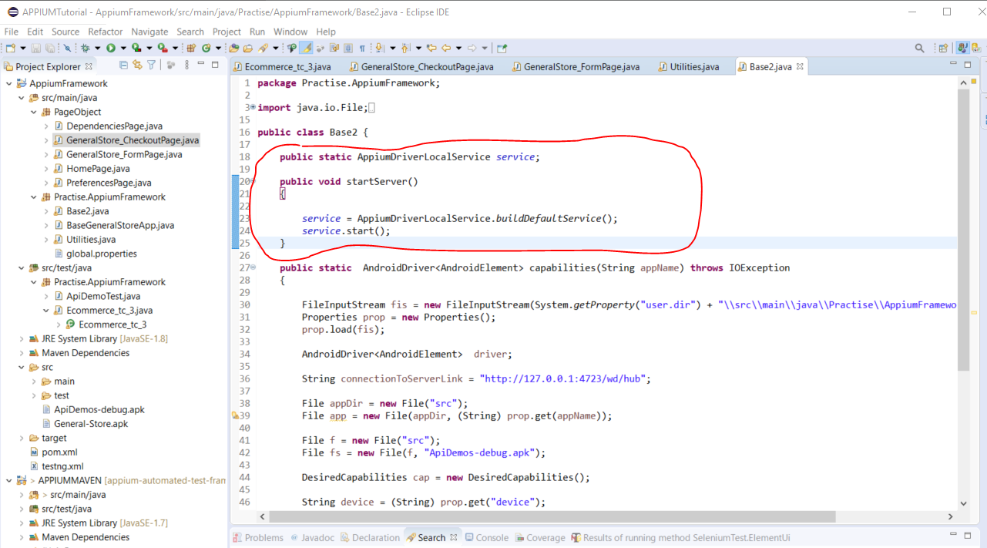

Download the following dependencies and add them to the pom.xml file:-

slf4j-simple

slf4j-api

commons-lang3

commons.io

commons-validator

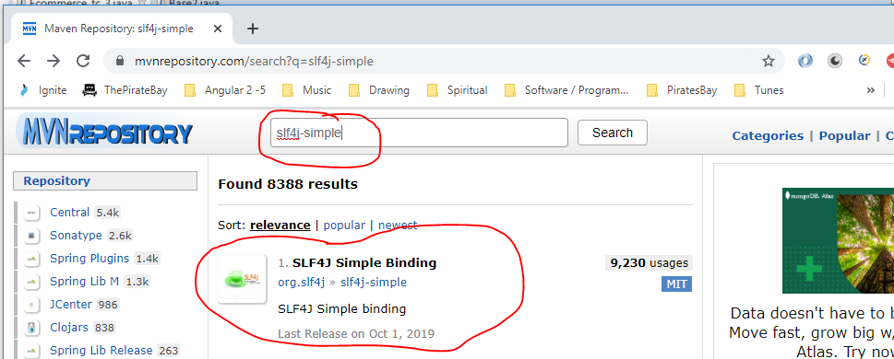

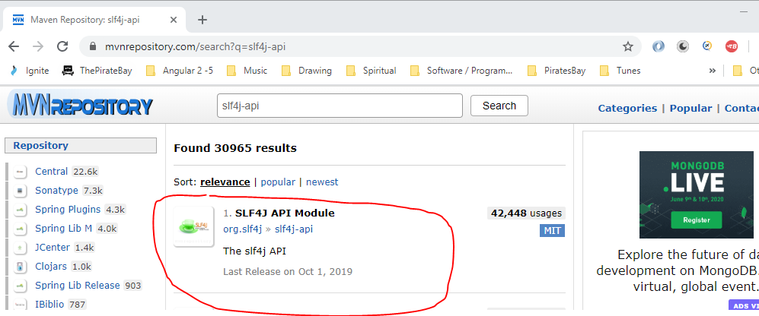

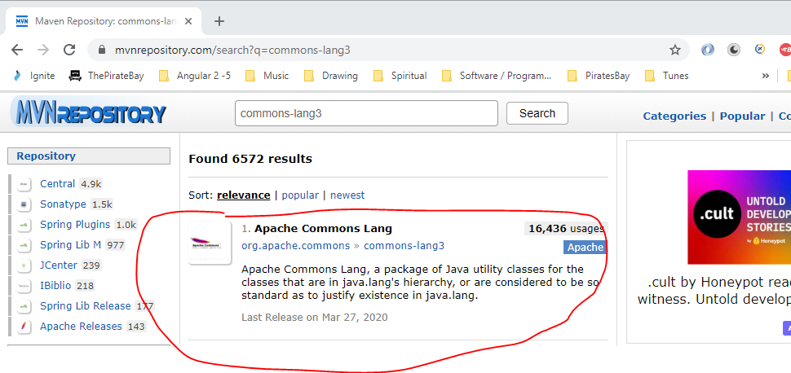

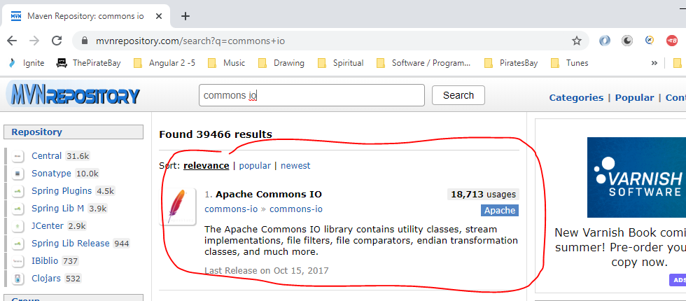

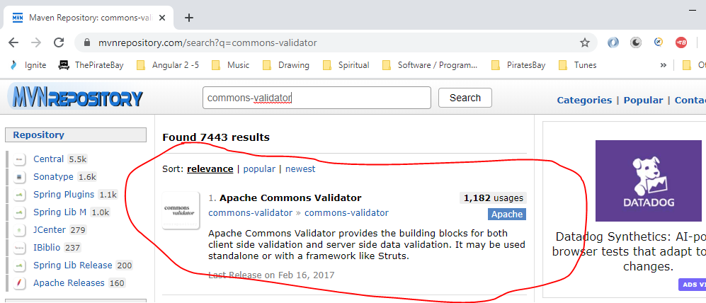

Add this line to test case classes:-

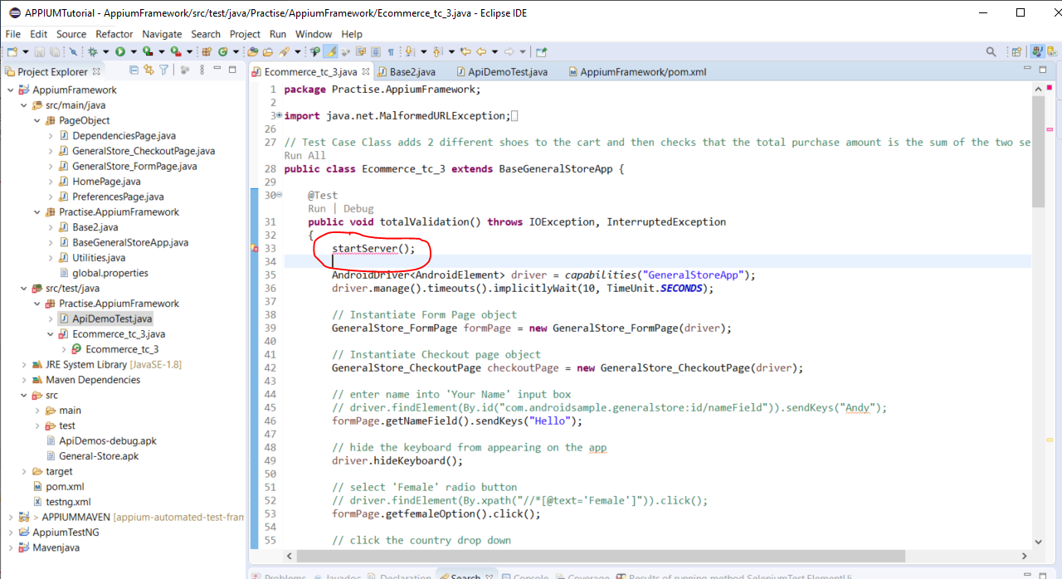

And

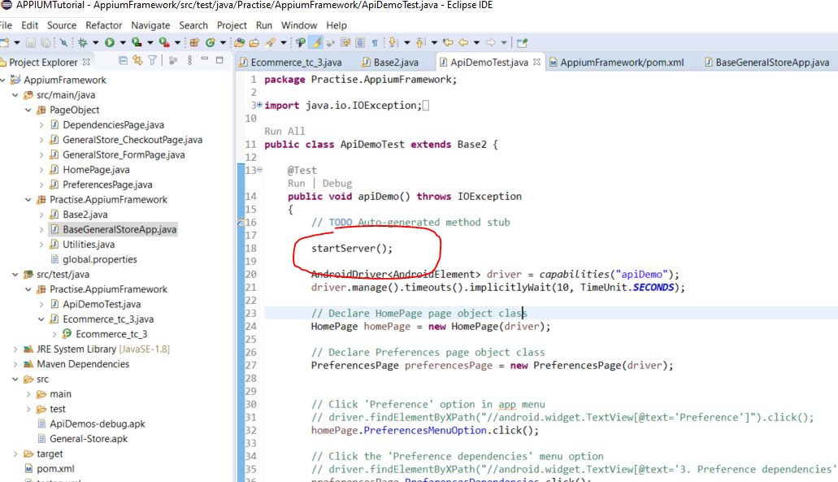

Now return the service in the base class:-

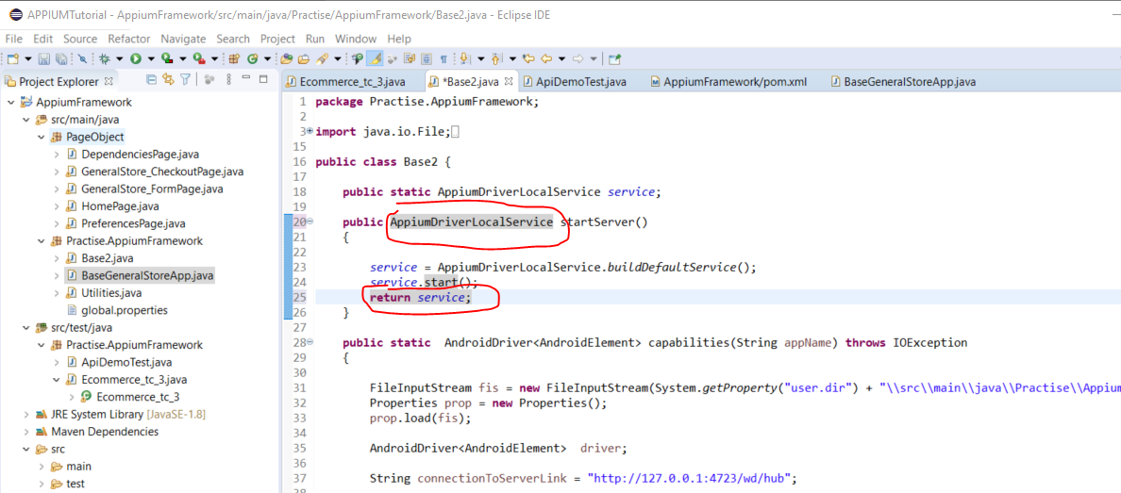

Add this to the test class:-

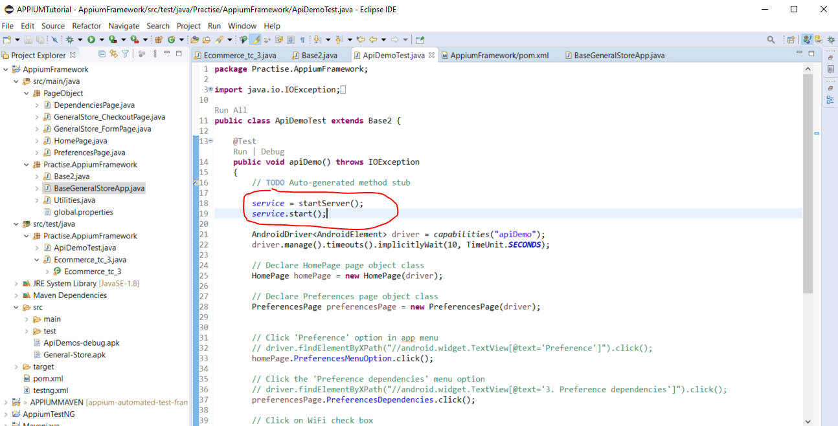

At the end of the test class now add a stop method:-

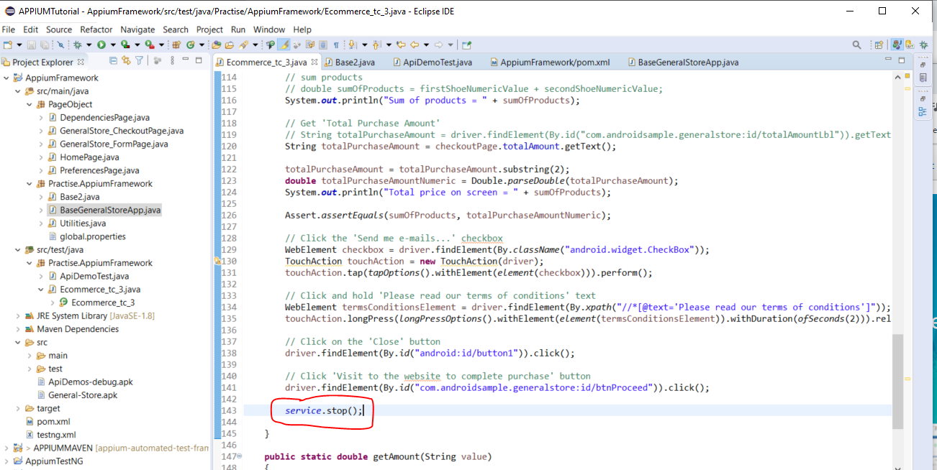

If a test fails before the ‘server.stop();’ line of code is run then the server will still be running, so if you run another test then the tets case will try and start the server again, but since the server is already running you will get an error. So, the following code is used to check if the server if running already:-

Create this method in the base class:-

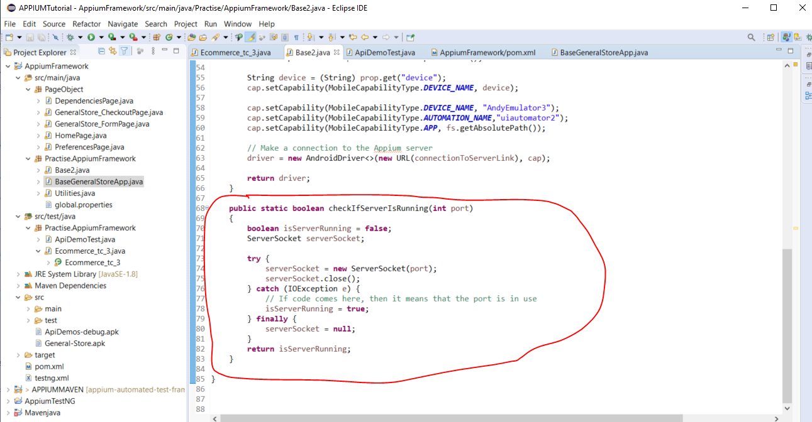

Then edit the code for starting the server in the base class:-

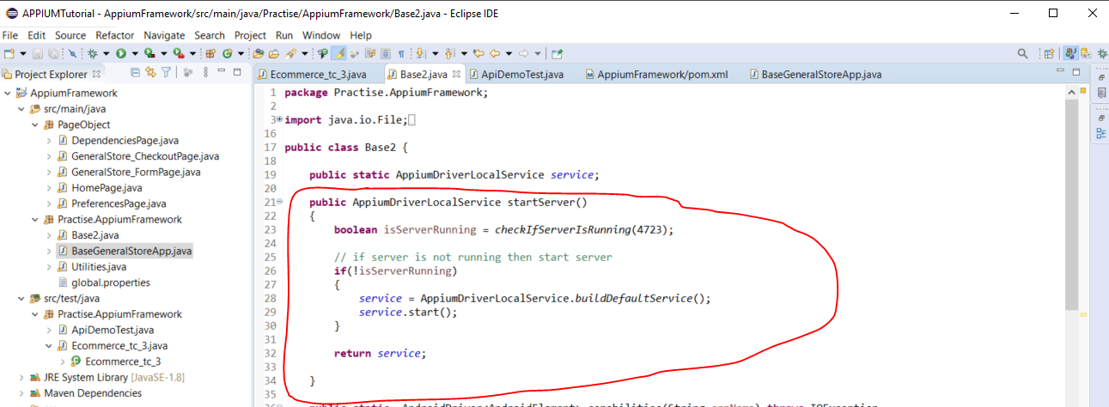

NOTE:- If you want to terminate all port usages on your pc enter the following into command prompt:-

*taskkill /F /IM node.exe*

When trying to open different apps in the same test suite e.g. :-

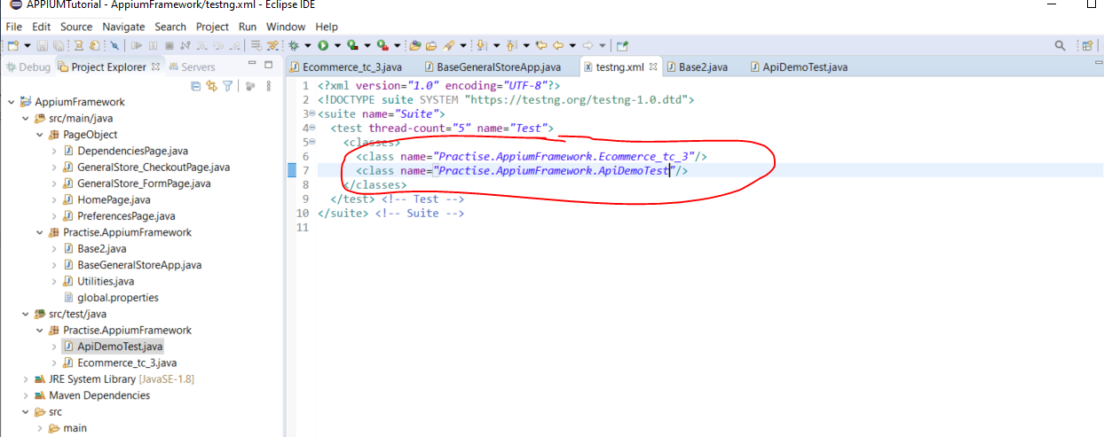

See above these two test cases use different apps (adk’s).

Create batch files to invoke emulators:-

Android emulator exists here:-

cd C:\Users\Andy\AppData\Local\Android\Sdk\emulator

To run the emulator u open command prompt and do this:-

*cd C:\Users\Andy\AppData\Local\Android\Sdk\emulator*

*emulator -avd AndyEmulator3*

Create batch file that does this:-

Open Notepad and enter this:-

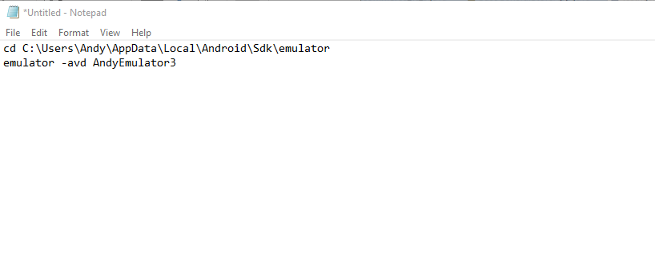

Create a folder here called - ‘resources’:-

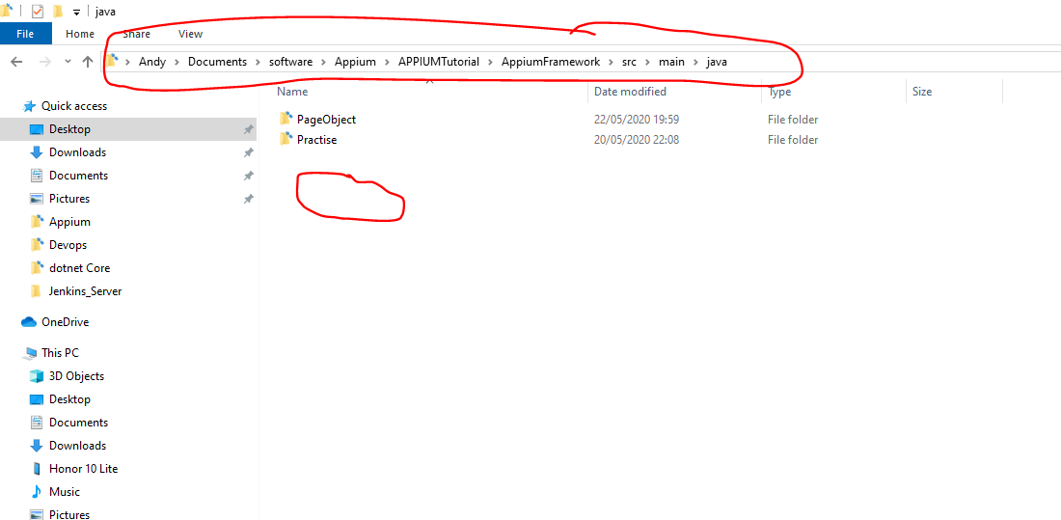

Now, save the notepad file here:-

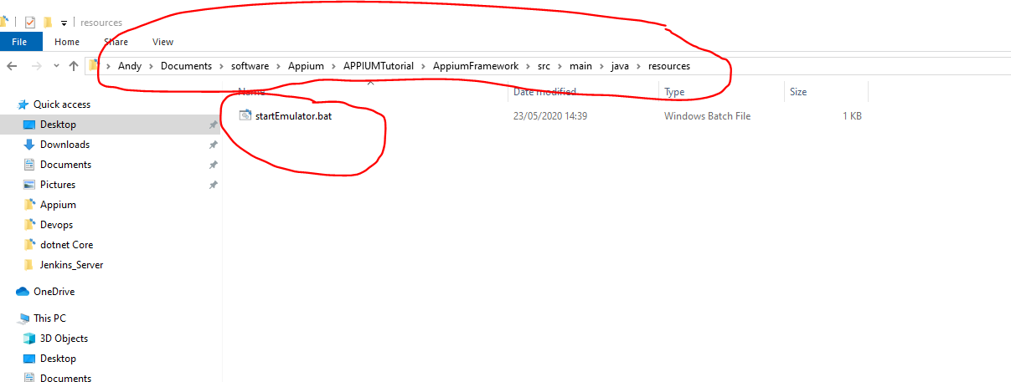

Now call this .bat file from my code:-

Add a method to the base class:-

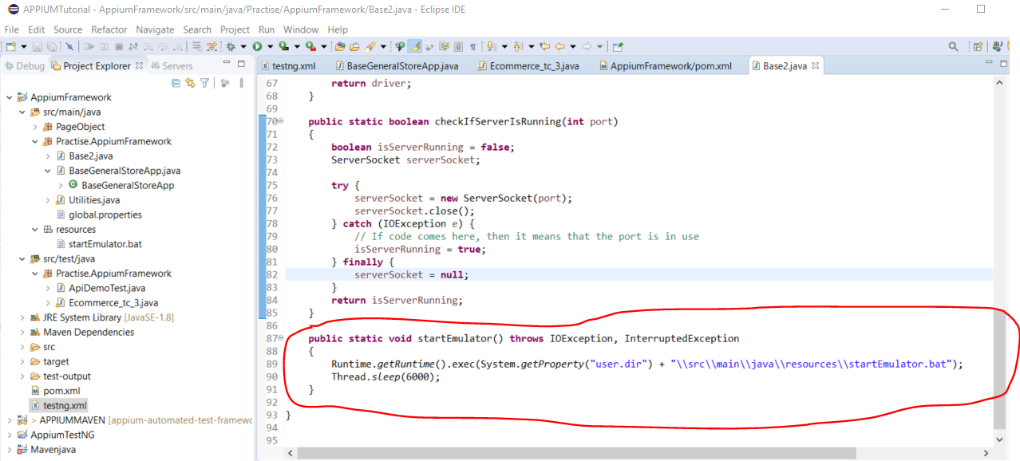

**Create a virtual device emulator**

Emulators can be used instead of an actual real life device.

Go to Android Studio and create a new virtual device:-

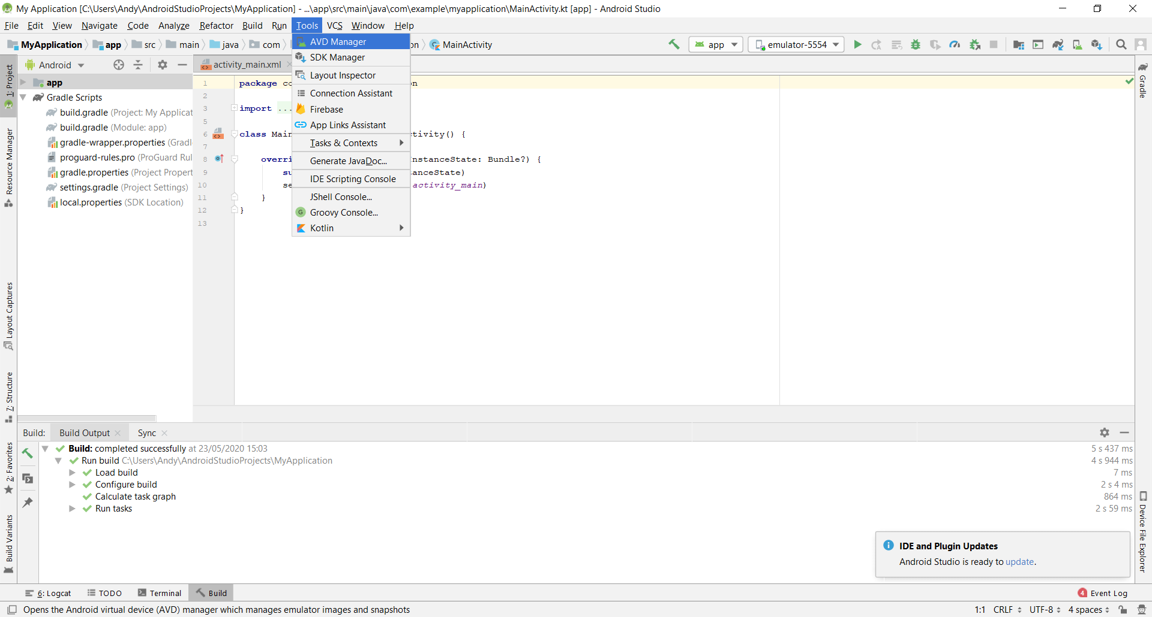

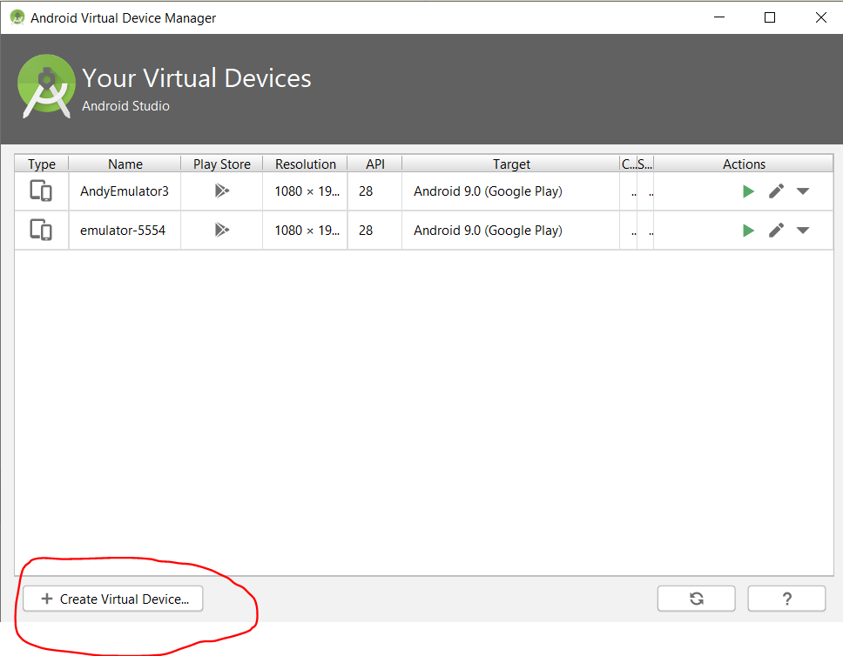

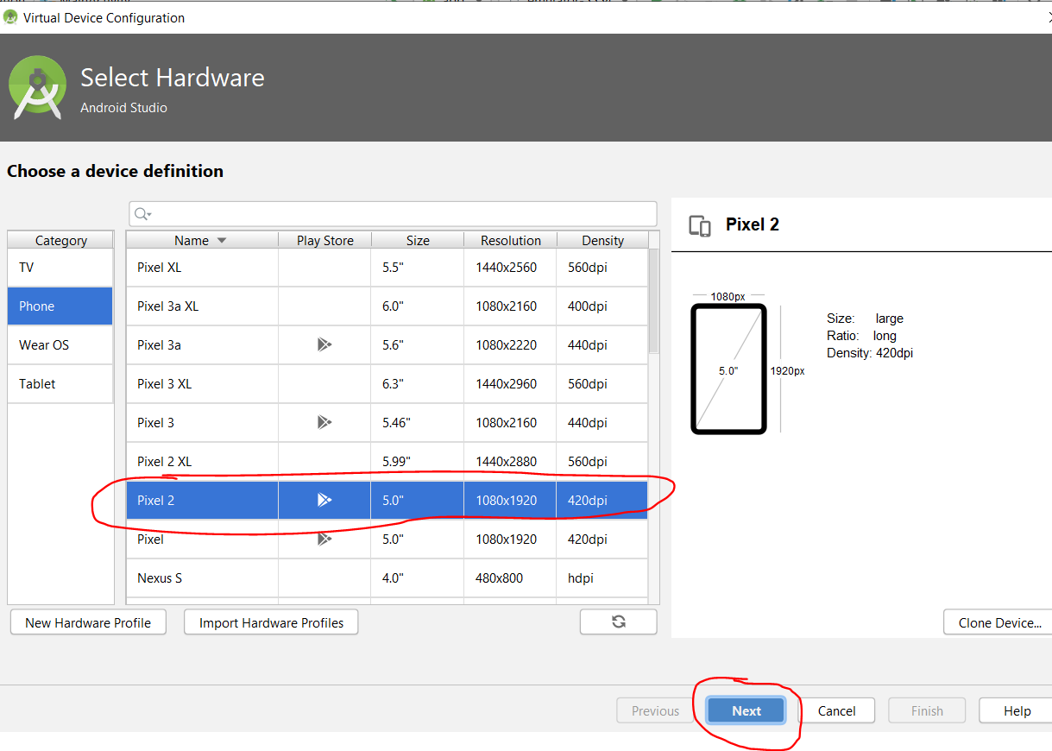

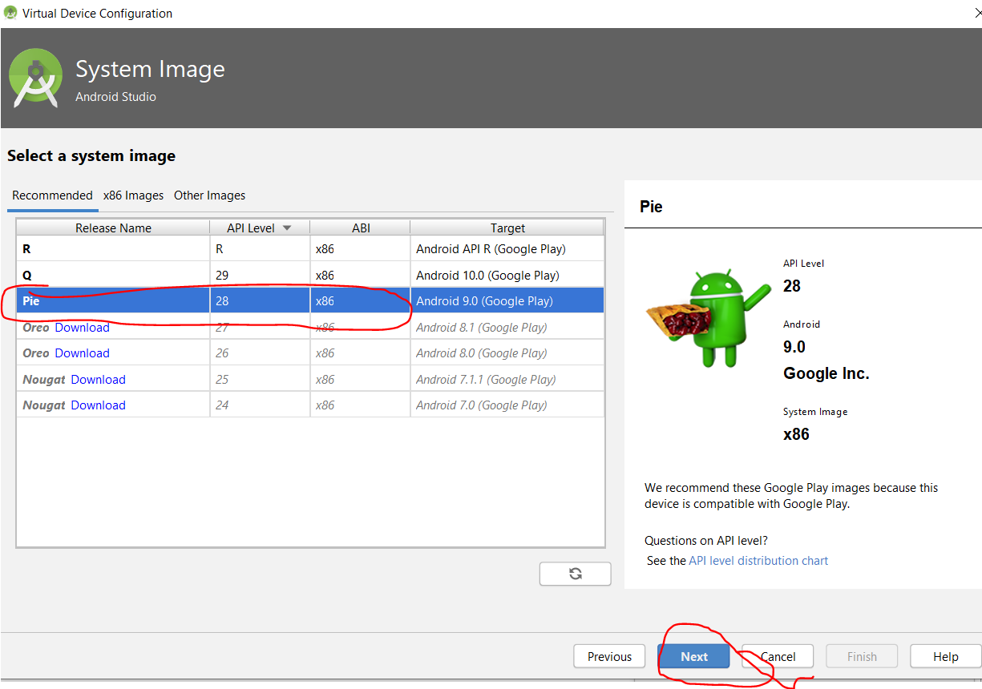

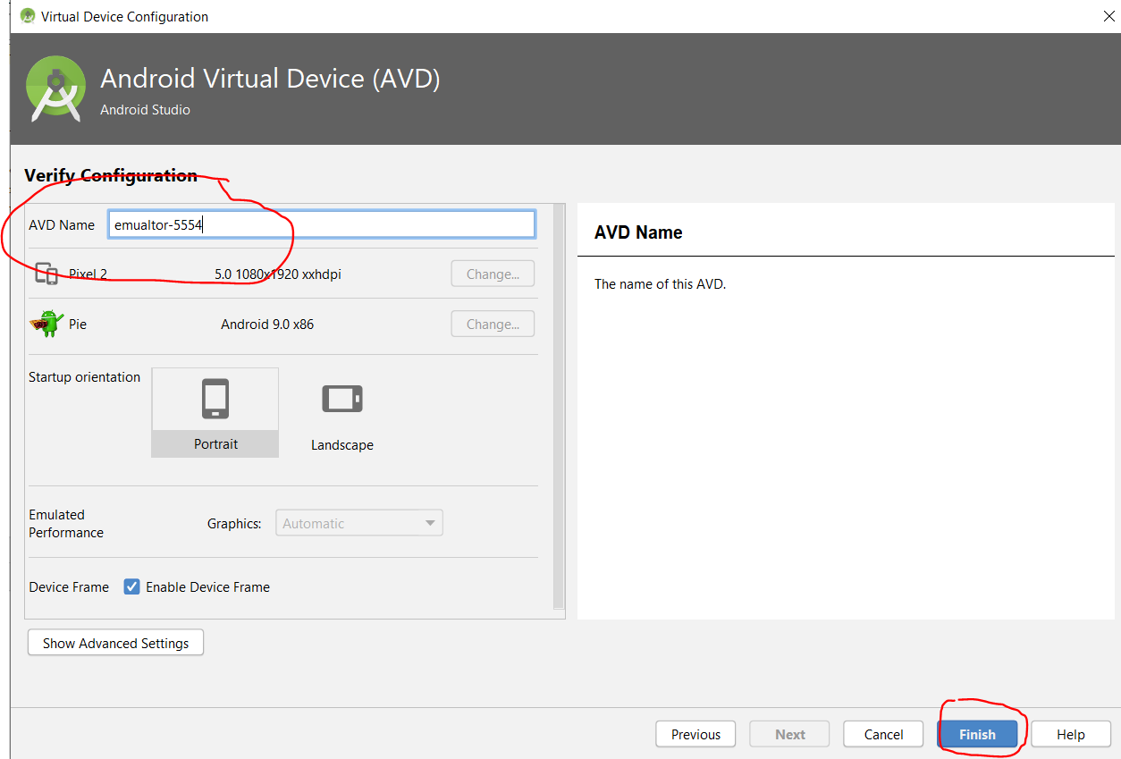

Start the device by opening command prompt and typing this:-

***cd C:\Users\Andy\AppData\Local\Android\Sdk\emulator***

***emulator -avd emulator-5554***

To install the two android apps used in this tutorial find the apk files in your eclipse solution and drag them over onto the device:-

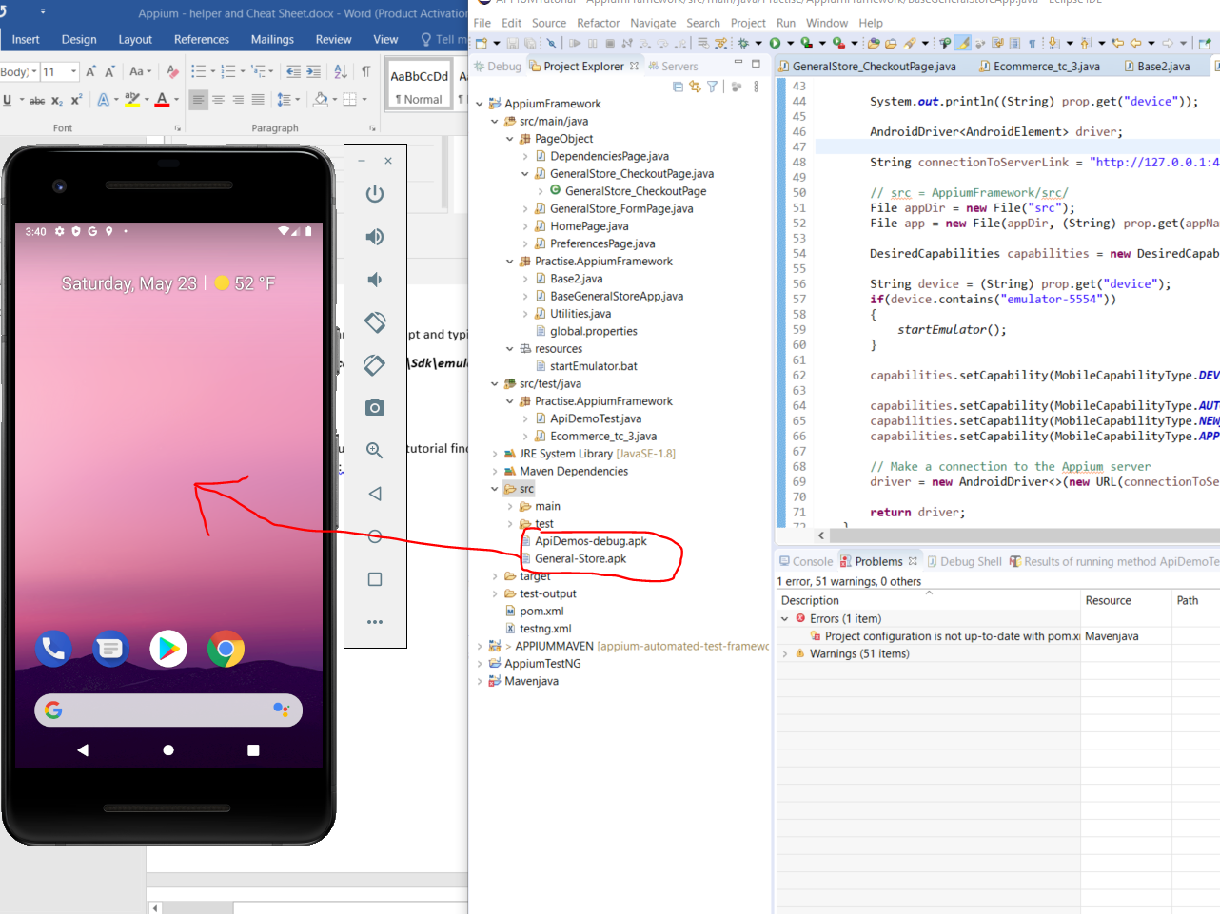

This will install them.

There is an issue if port 4723. To overcome this problem:-

Add a ‘@BeforeTest’ TestNG annotation in your test case class:-

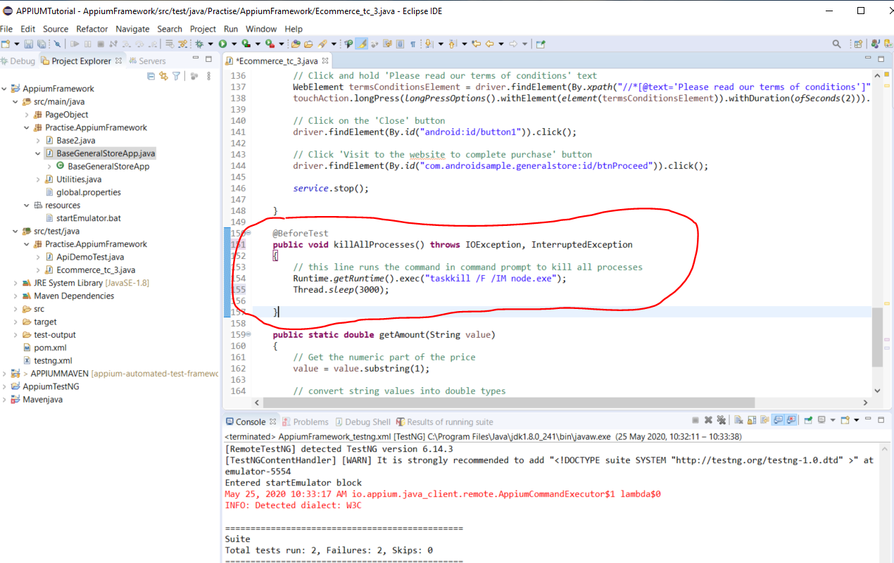

**Add listener to take a screen shot when test fails**

Create a new class under ‘resources’ folder:-

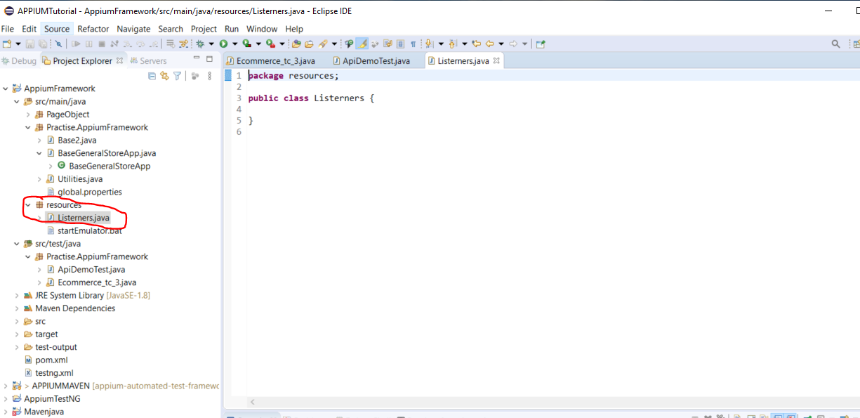

Create a new method in your base class:-

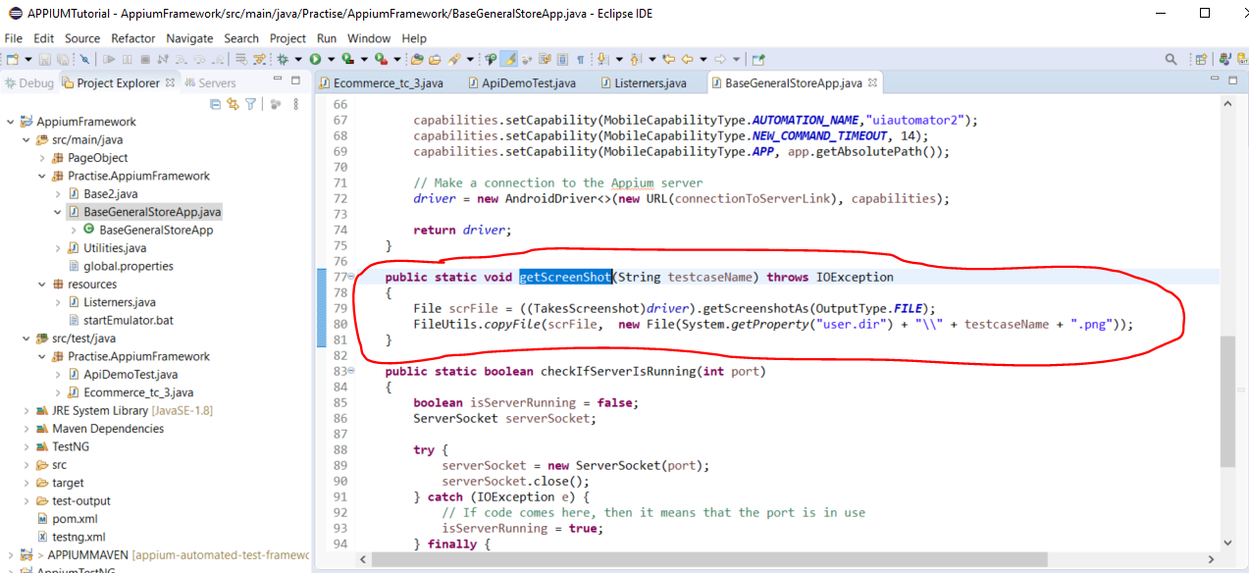

Move this line, as it needs to be declared outside of the ‘capabilities’ method, so that it is global to all methods within the class:-

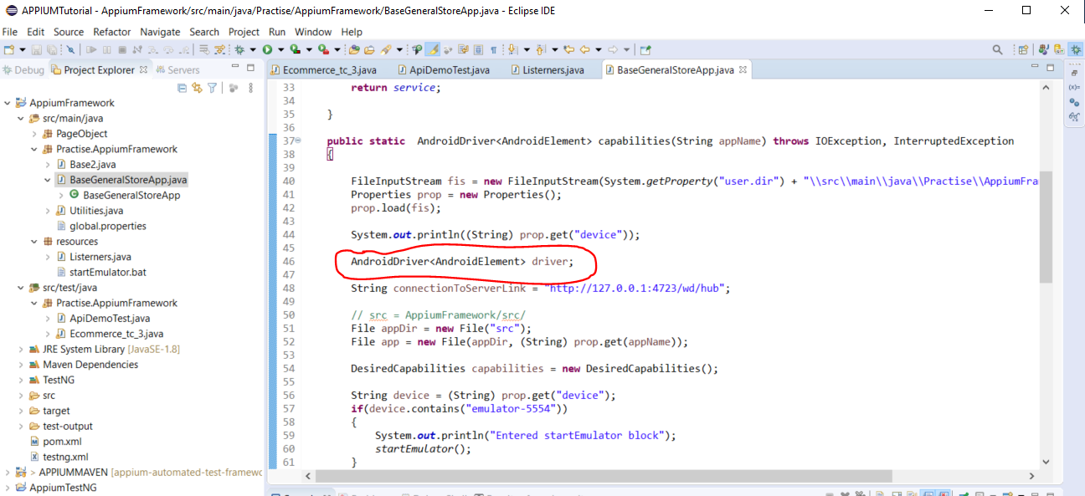

Paste it here:-

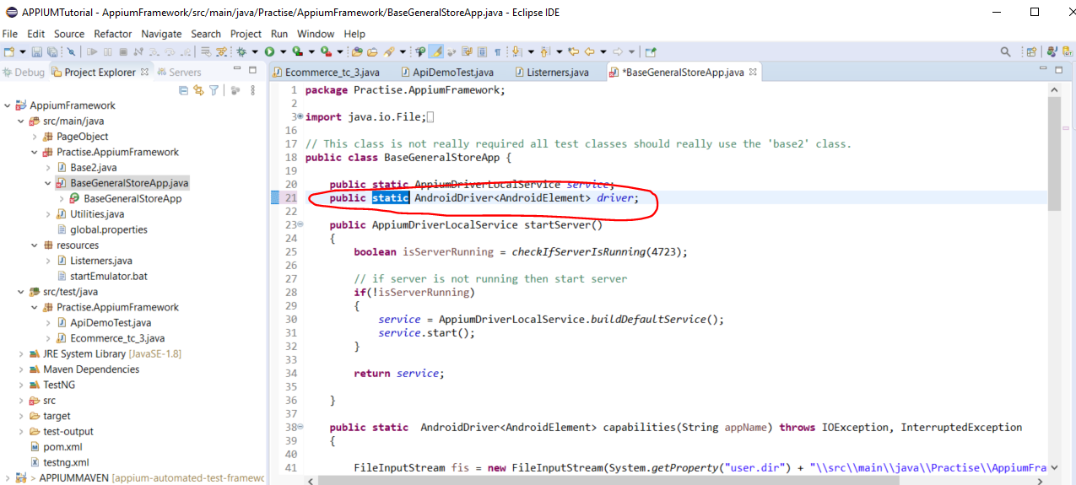

Add this code to the Listeners class:-

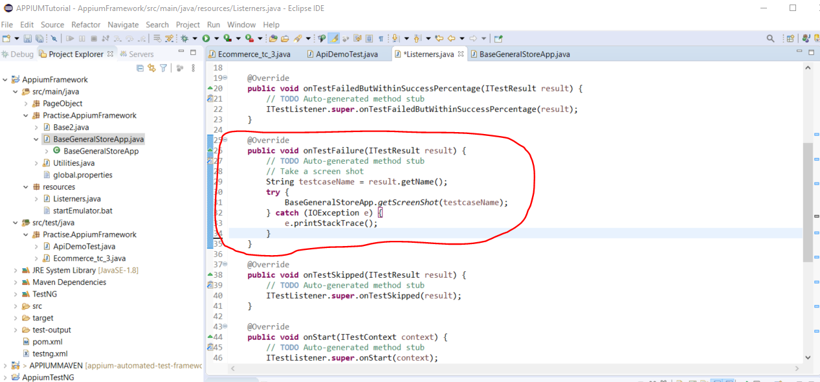

Now add the reference to the Listener class in the ‘testng.xml’ file:-

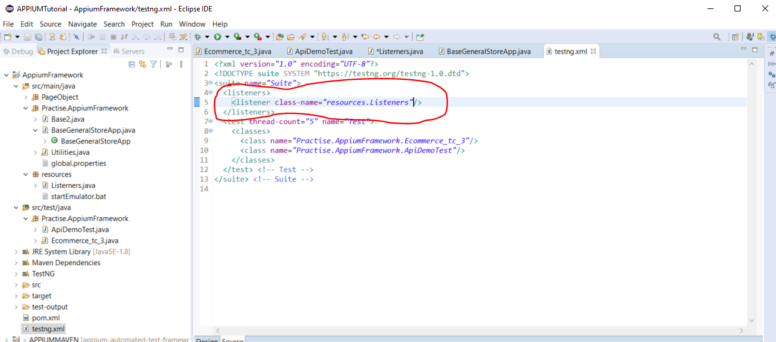

**Generate Html Reports of test results**

Extent Reporting:-

<https://extentreports.com/>

Add the following to the Maven pom.xml file:-

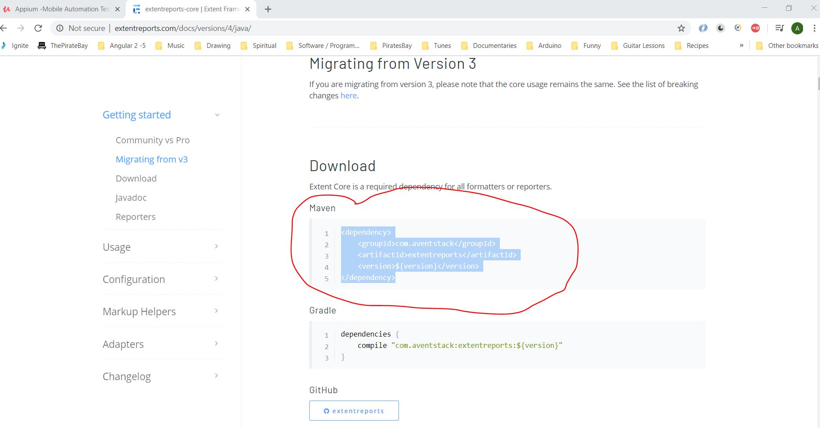

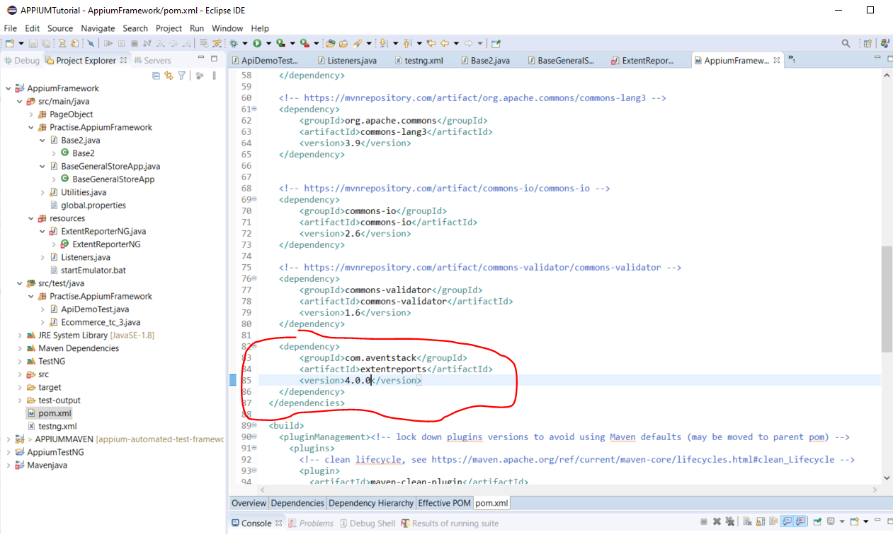

Add this file to the ‘resources’ folder:-

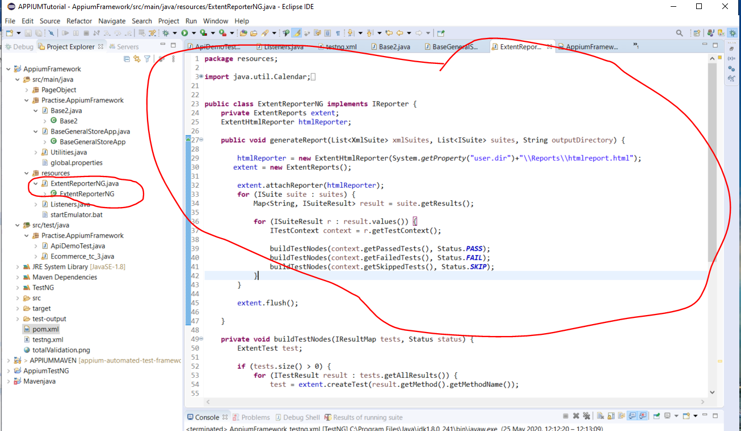

Now, add a reference in your ‘testng.xml’ file:-

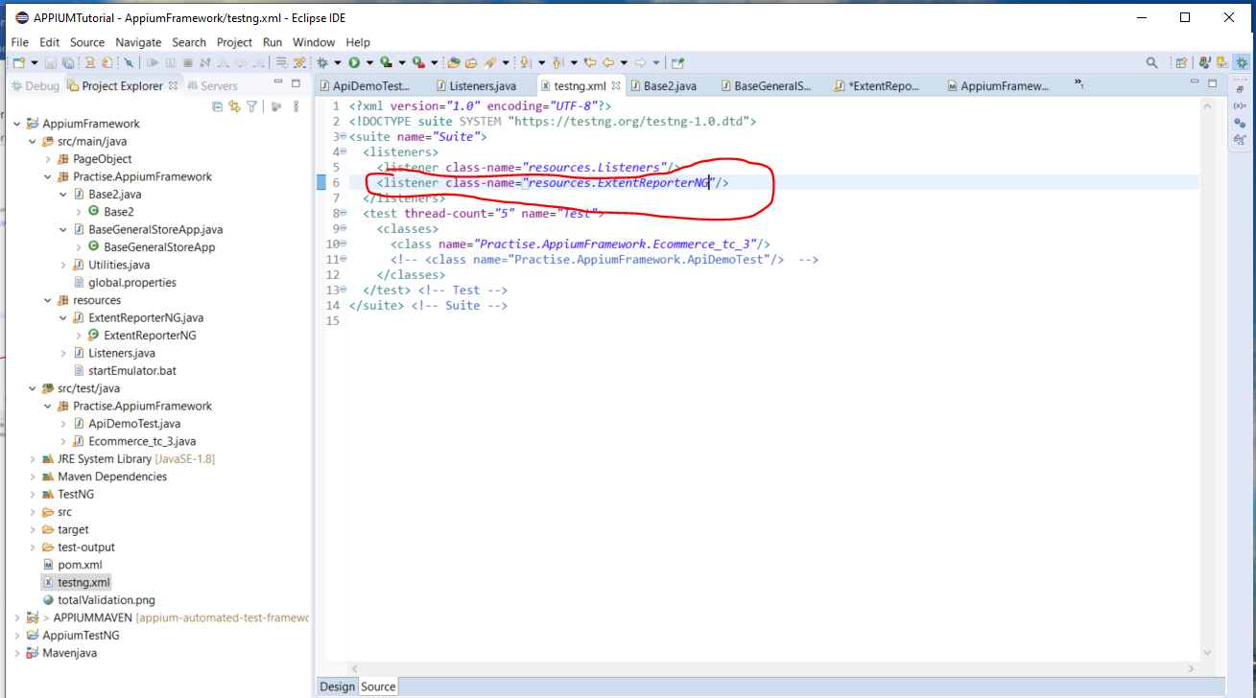

Run tests and see outputted html report here:-

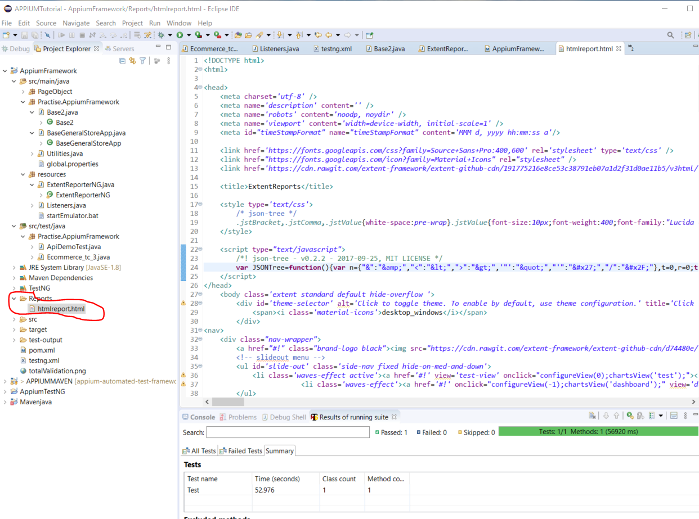

Open html file in a browser to see results:-

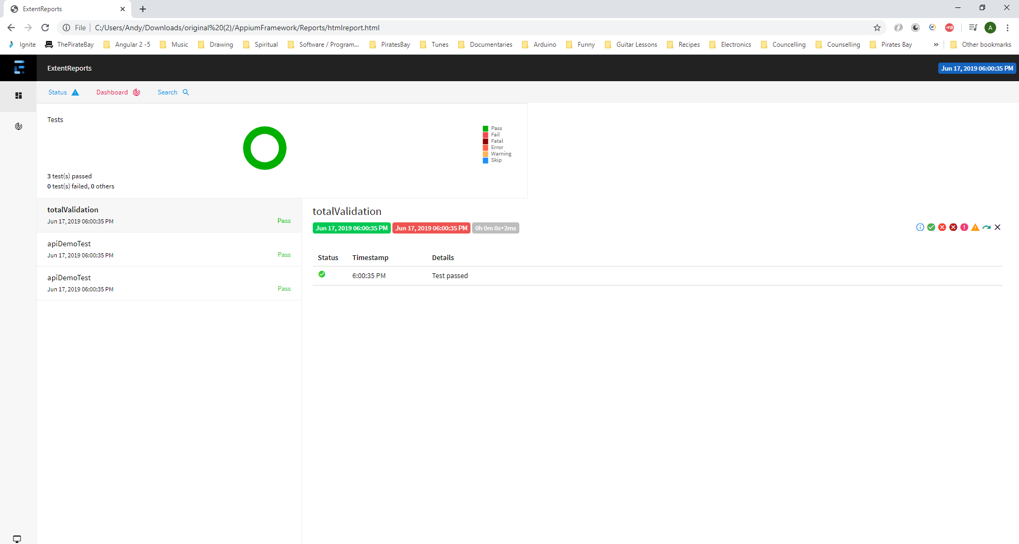

**Parametrized Test Data**

Create a new class here:-

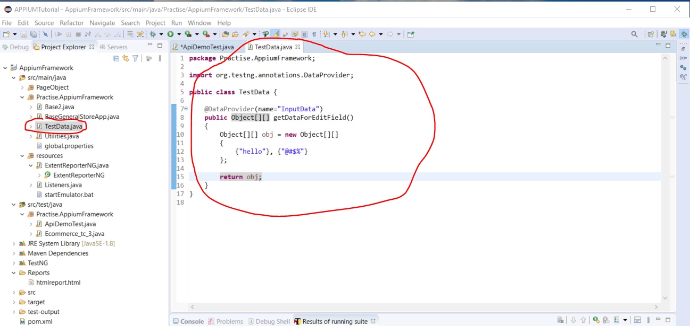

Now add this to the test case class:-

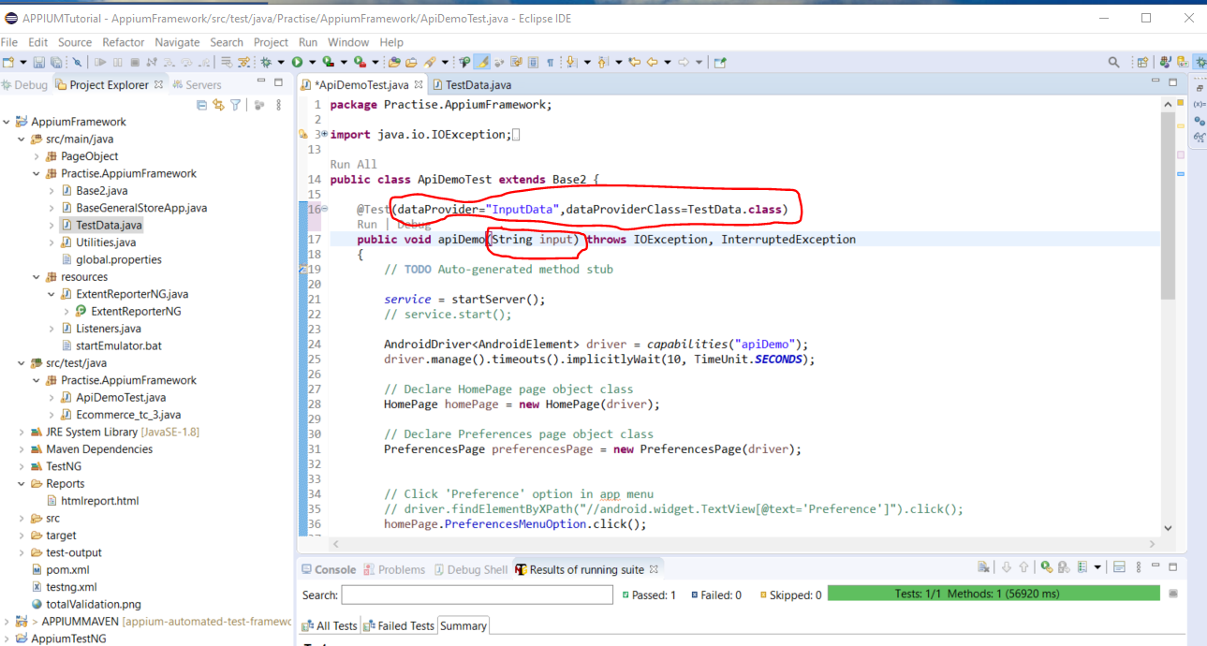

And to use the test data in you test case class change this:-

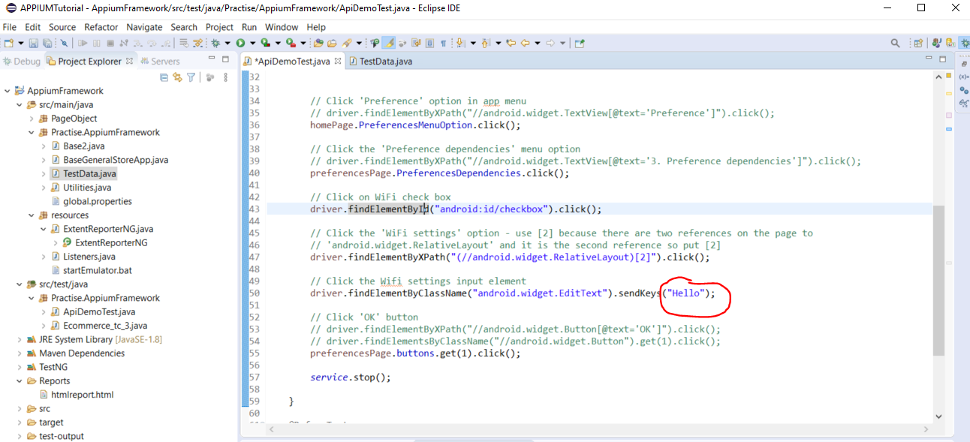

To this:-

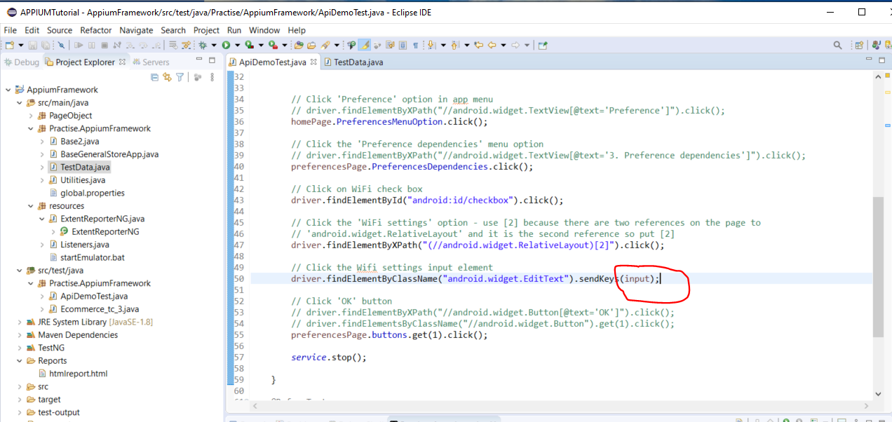

Since the ‘TestData’ class has two pieces of data in it i.e. {"hello"} and {"@#$%"} the test case class will get run twice, once for the “hello” and secondly for the “@#$%”.

**Convert project to Maven Compatible**

To run TestNG.xml file from the pom.xml file:-

<https://maven.apache.org/surefire/maven-surefire-plugin/examples/testng.html>

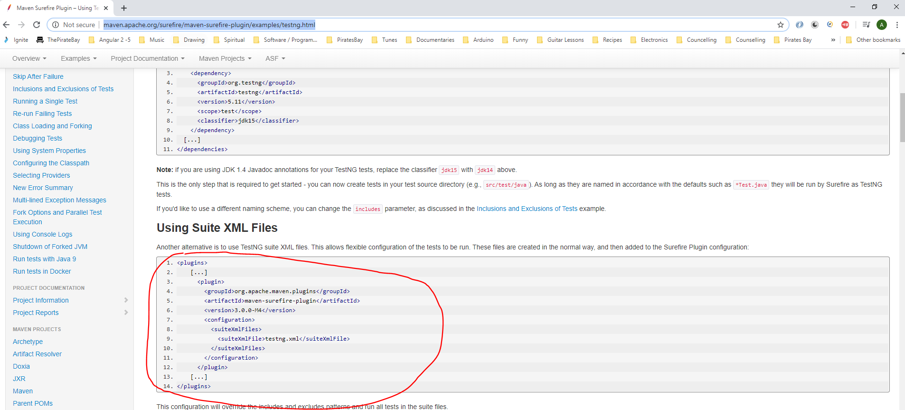

Also, add the Maven Resources Plugin:-

<https://maven.apache.org/plugins/maven-resources-plugin/examples/filter.html>

Copy this:-

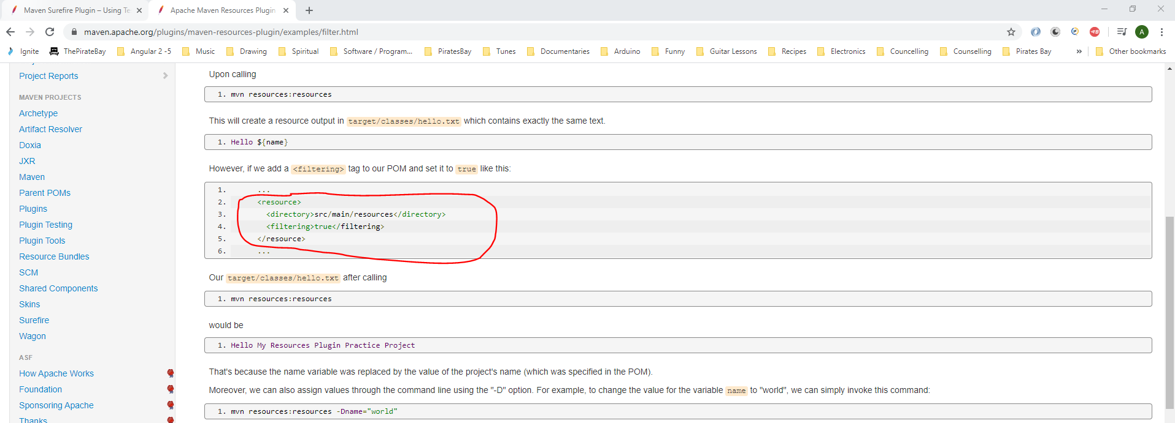

Paste here:-

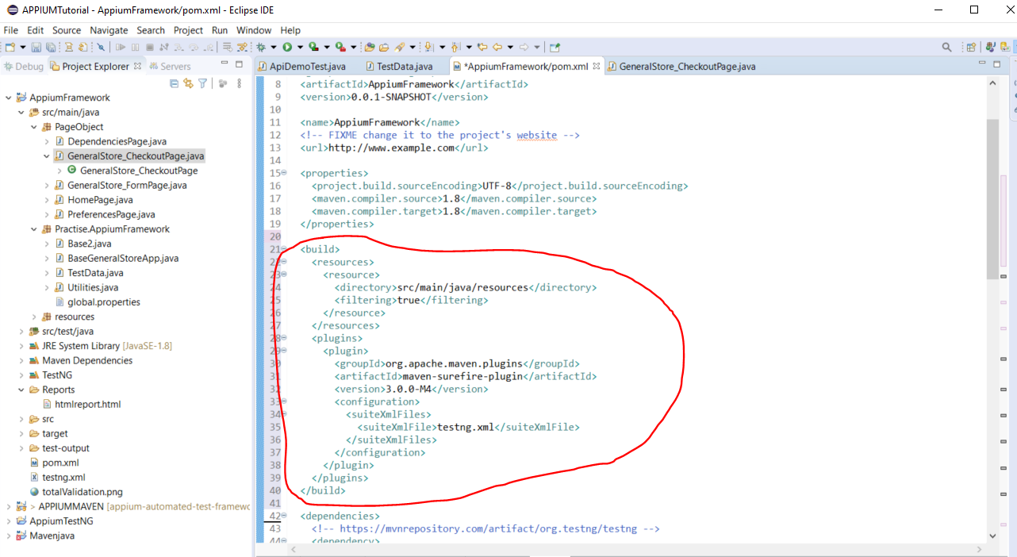

Add the entire section above.

Now you can run your tests from the Maven command line:_

Open Command Prompt and navigate to where your project is:-

*cd C:\Users\Andy\Documents\software\Appium\APPIUMTutorial\AppiumFramework*

Then run you tests:-

*mvn test*

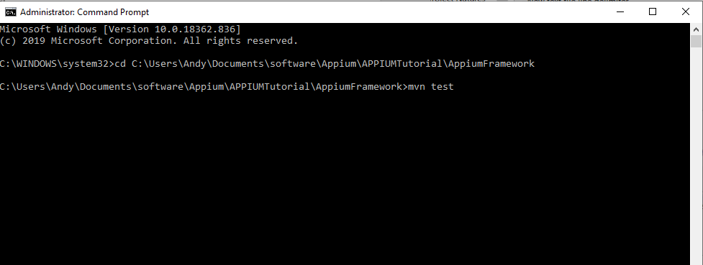

A number of errors were seen:-

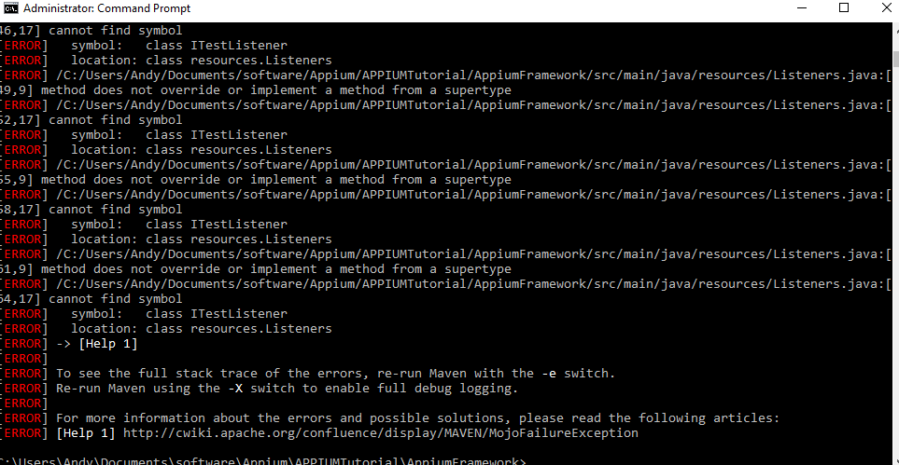

To overcome this problem go to ‘pom.xml’ and remove this line:-

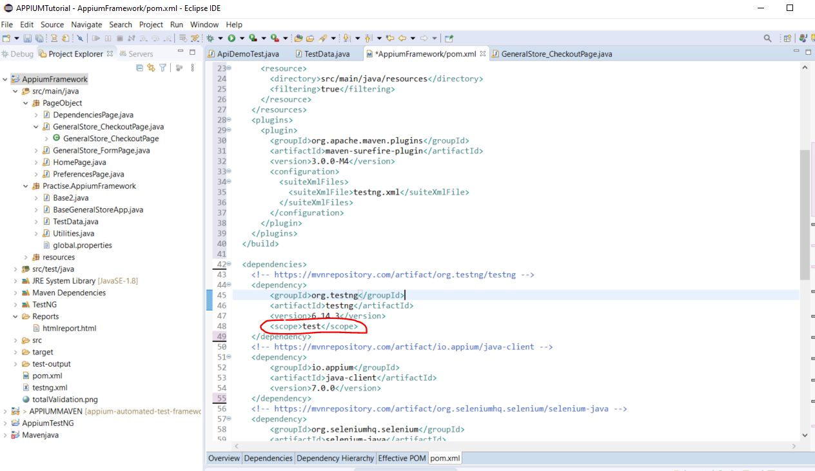

Now, re-run tests:-

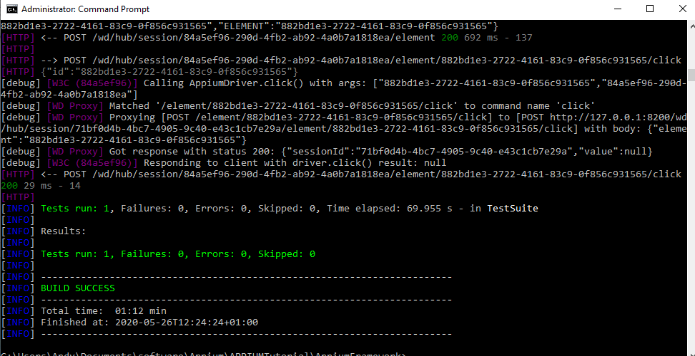

Tests now run successfully.

**Running Tests On Different devices**

You can send through parameters from the command line to do this:-

*mvn test –DdeviceName=emulator-5554*

To pick this variable up in the code do this:-

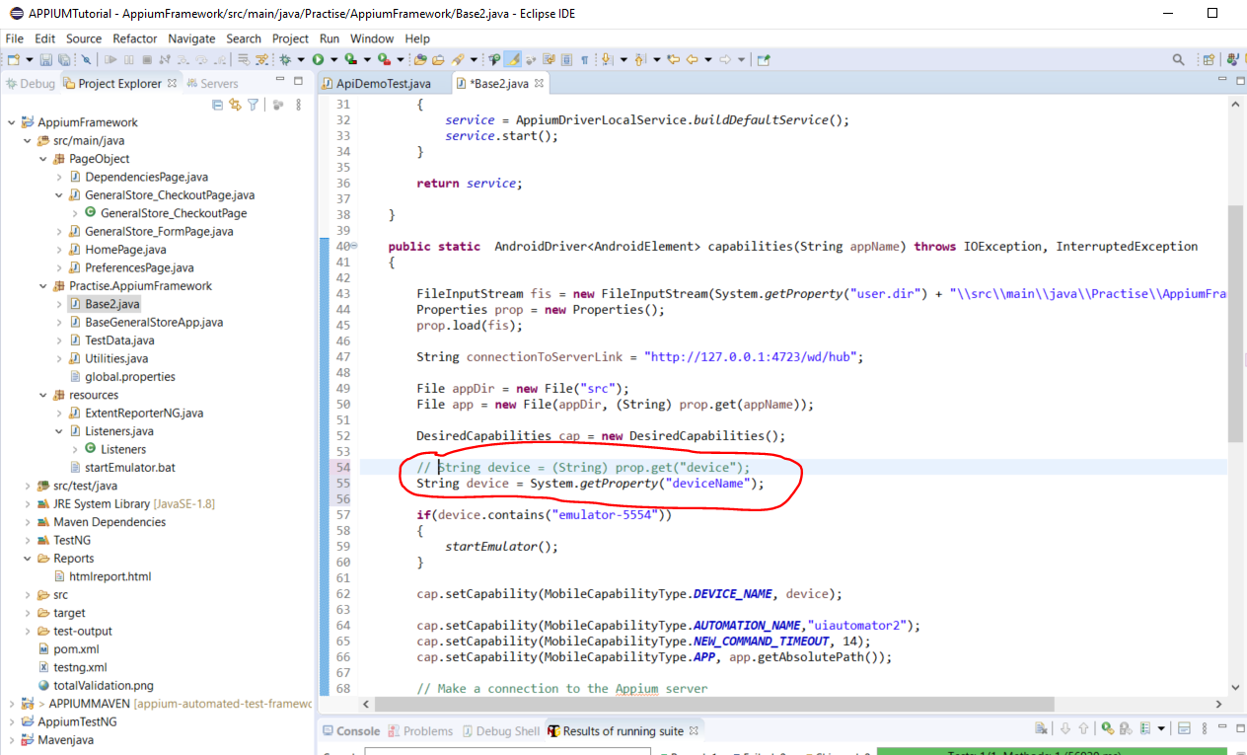

Run tests by entering the following into Command Prompt:-

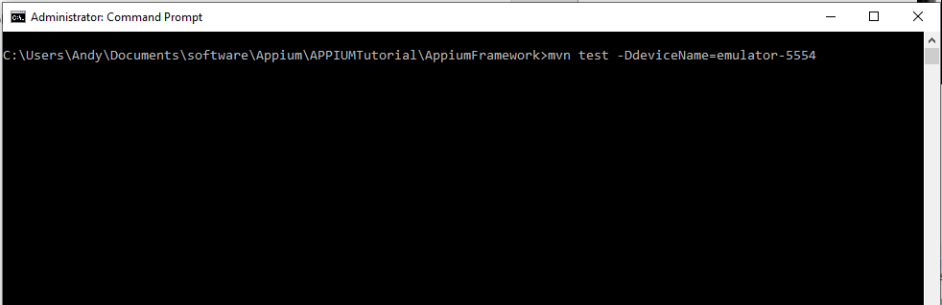

**Running entire framework from Jenkins**

First start Jenkins server. Open Command Prompt and navigate to the Jenkins folder:-

***cd c:\jenkins_server***

***java -jar jenkins.war -httpPort=8080***

Then open a browser and navigate here:-

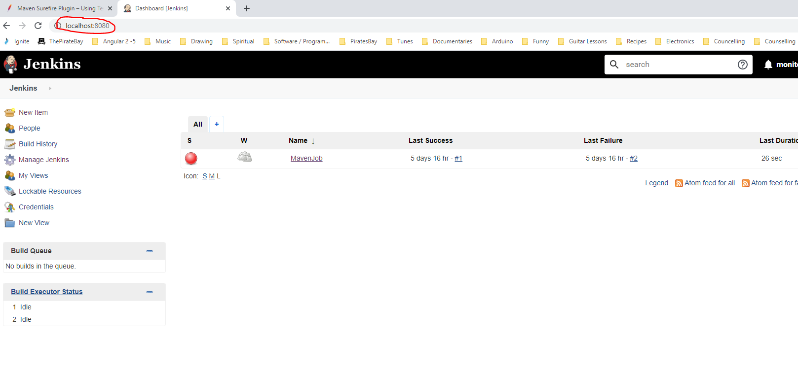

Create a new job:-

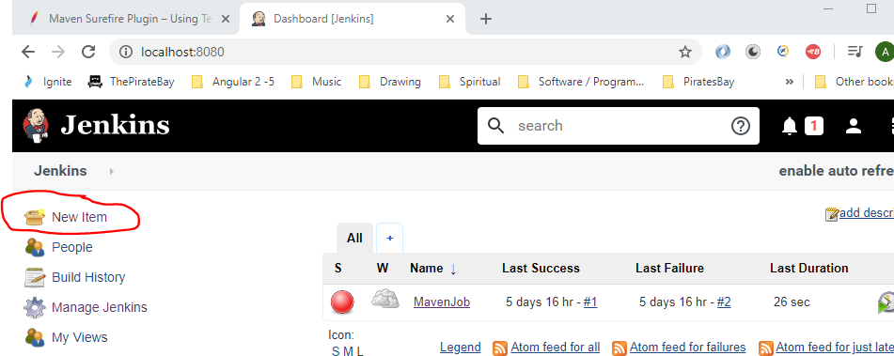

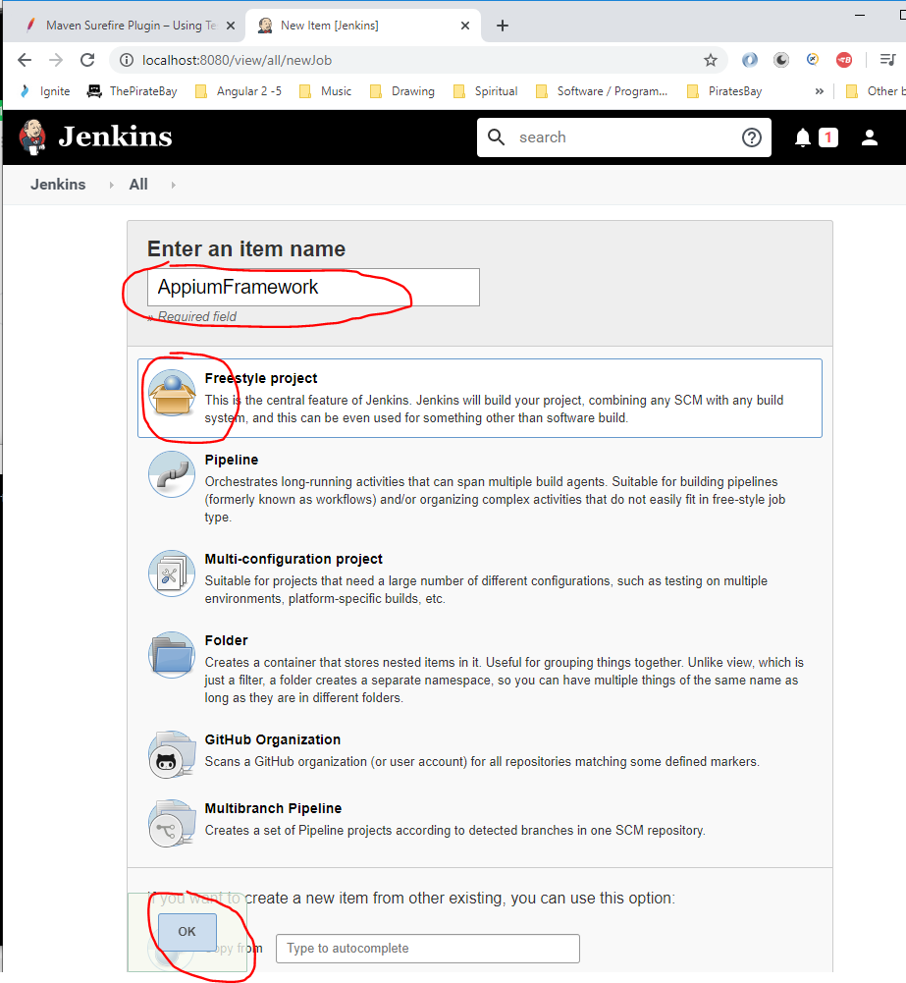

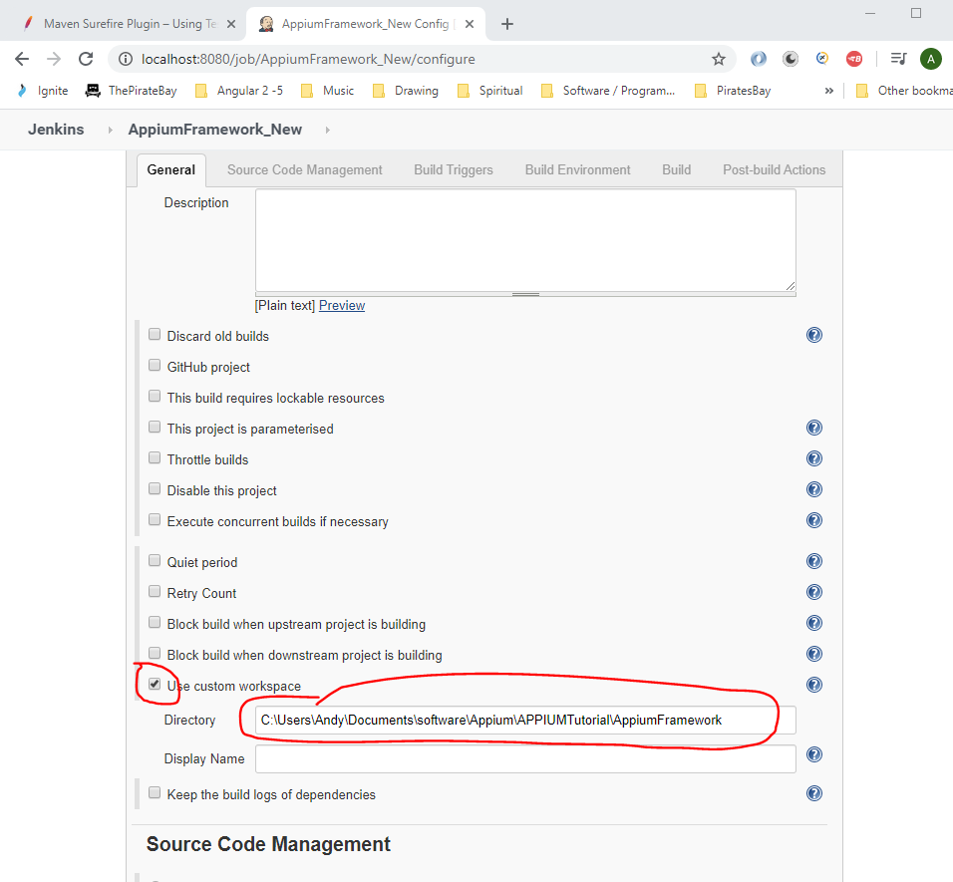

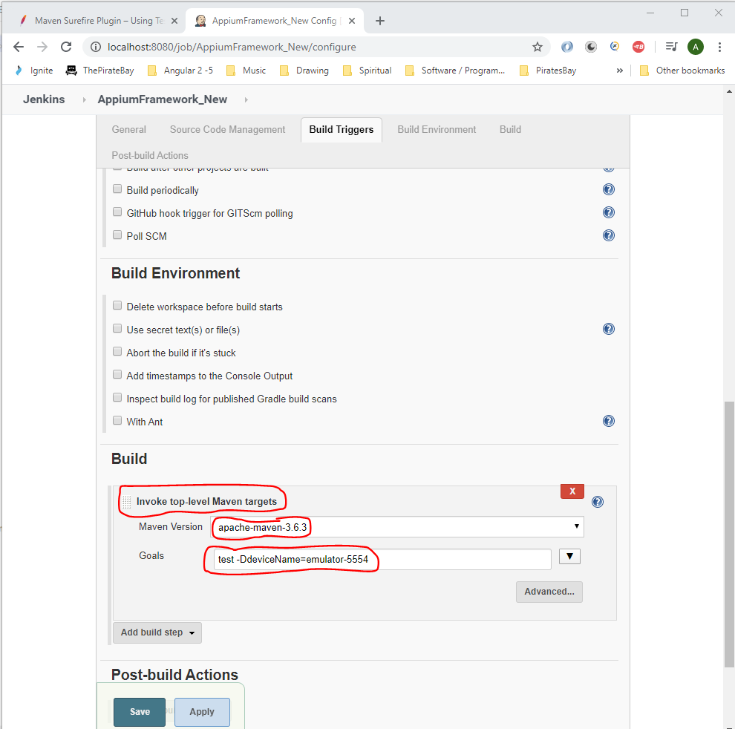

To allow a user to select a device type you can go to the top of Jenkins project and tick this checkbox:-

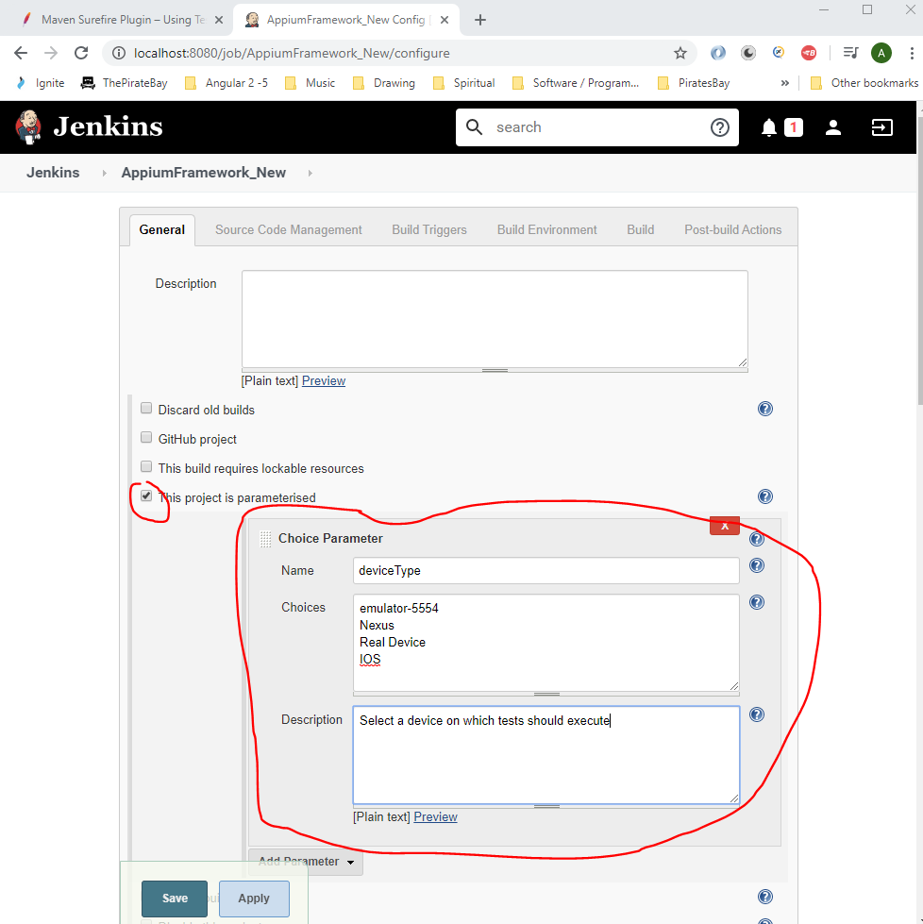

Now change this section:-

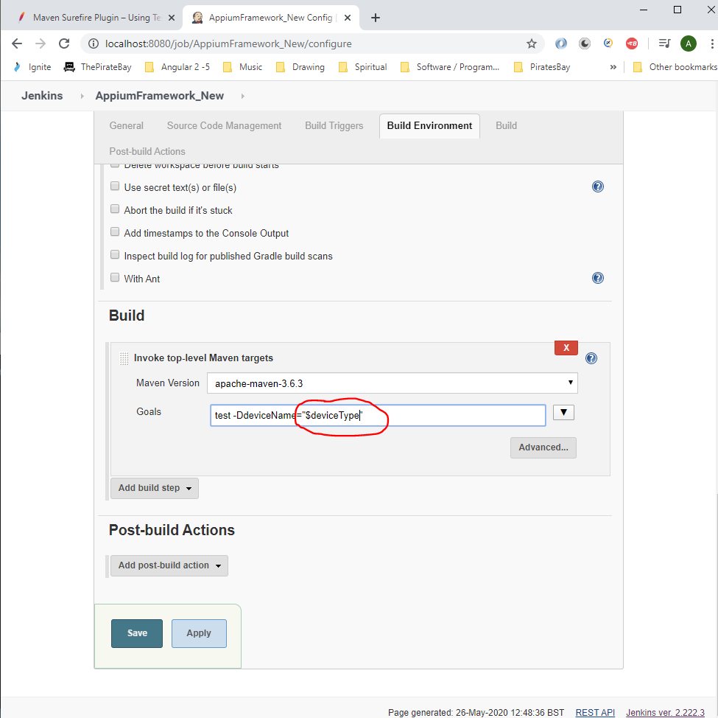

Click ‘Save’.

Now when you click on here you will see a drop down with a number of devices that can be selected:-

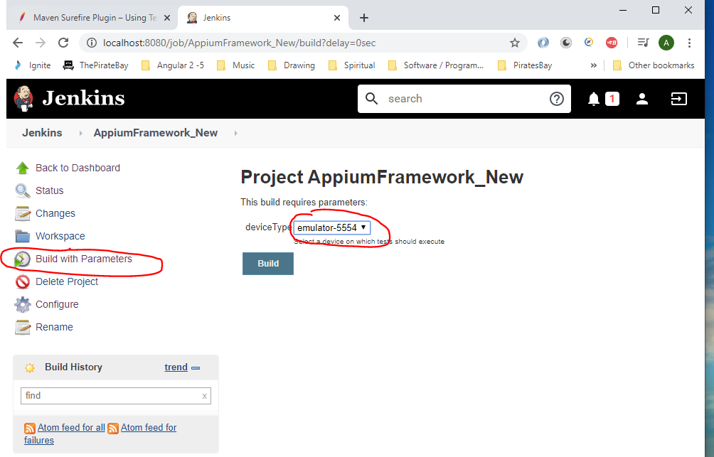

**Git**

Basic Git commands can be found here:-

<https://confluence.atlassian.com/bitbucketserver/basic-git-commands-776639767.html>

**Appendix – Common Errors**

When running you tests and u get the following error this is because ‘developer mode’ is not enable on your phone. Go to:-

***Settings -> About Phone -> tap on ‘Build number’ 7 times to enable developer mode***

Then navigate back on step then select:-

***System & updates -> Developer options***

See error below:-

Exception in thread "main" org.openqa.selenium.SessionNotCreatedException: Unable to create a new remote session. Please check the server log for more details. Original error: An unknown server-side error occurred while processing the command. Original error: Could not find a connected Android device in 21624ms.

Build info: version: '3.141.59', revision: 'e82be7d358', time: '2018-11-14T08:17:03'

System info: host: 'DESKTOP-A6TS6T6', ip: '192.168.56.1', os.name: 'Windows 10', os.arch: 'amd64', os.version: '10.0', java.version: '1.8.0_241'

Driver info: driver.version: AndroidDriver

remote stacktrace: UnknownError: An unknown server-side error occurred while processing the command. Original error: Could not find a connected Android device in 21624ms.

at getResponseForW3CError (C:\Users\Andy\AppData\Roaming\npm\node_modules\appium\node_modules\appium-base-driver\lib\protocol\errors.js:804:9)

at asyncHandler (C:\Users\Andy\AppData\Roaming\npm\node_modules\appium\node_modules\appium-base-driver\lib\protocol\protocol.js:392:37)

Build info: version: '3.141.59', revision: 'e82be7d358', time: '2018-11-14T08:17:03'

System info: host: 'DESKTOP-A6TS6T6', ip: '192.168.56.1', os.name: 'Windows 10', os.arch: 'amd64', os.version: '10.0', java.version: '1.8.0_241'

Driver info: driver.version: AndroidDriver

at io.appium.java_client.remote.AppiumCommandExecutor$1.createSession(AppiumCommandExecutor.java:208)

at io.appium.java_client.remote.AppiumCommandExecutor.createSession(AppiumCommandExecutor.java:217)

at io.appium.java_client.remote.AppiumCommandExecutor.execute(AppiumCommandExecutor.java:239)

at org.openqa.selenium.remote.RemoteWebDriver.execute(RemoteWebDriver.java:552)

at io.appium.java_client.DefaultGenericMobileDriver.execute(DefaultGenericMobileDriver.java:42)

at io.appium.java_client.AppiumDriver.execute(AppiumDriver.java:1)

at io.appium.java_client.android.AndroidDriver.execute(AndroidDriver.java:1)

at org.openqa.selenium.remote.RemoteWebDriver.startSession(RemoteWebDriver.java:213)

at org.openqa.selenium.remote.RemoteWebDriver.<init>(RemoteWebDriver.java:131)

at io.appium.java_client.DefaultGenericMobileDriver.<init>(DefaultGenericMobileDriver.java:38)

at io.appium.java_client.AppiumDriver.<init>(AppiumDriver.java:84)

at io.appium.java_client.AppiumDriver.<init>(AppiumDriver.java:94)

at io.appium.java_client.android.AndroidDriver.<init>(AndroidDriver.java:95)

at AppiumTest.APPIUMMAVEN.base2.capabilities(base2.java:30)

at AppiumTest.APPIUMMAVEN.Uiautomatortest.main(Uiautomatortest.java:17)

Caused by: java.lang.reflect.InvocationTargetException

at sun.reflect.NativeMethodAccessorImpl.invoke0(Native Method)

at sun.reflect.NativeMethodAccessorImpl.invoke(NativeMethodAccessorImpl.java:62)

at sun.reflect.DelegatingMethodAccessorImpl.invoke(DelegatingMethodAccessorImpl.java:43)

at java.lang.reflect.Method.invoke(Method.java:498)

at io.appium.java_client.remote.AppiumCommandExecutor$1.createSession(AppiumCommandExecutor.java:186)

... 14 more

Caused by: org.openqa.selenium.WebDriverException: An unknown server-side error occurred while processing the command. Original error: Could not find a connected Android device in 21624ms.

Build info: version: '3.141.59', revision: 'e82be7d358', time: '2018-11-14T08:17:03'

System info: host: 'DESKTOP-A6TS6T6', ip: '192.168.56.1', os.name: 'Windows 10', os.arch: 'amd64', os.version: '10.0', java.version: '1.8.0_241'

Driver info: driver.version: AndroidDriver

remote stacktrace: UnknownError: An unknown server-side error occurred while processing the command. Original error: Could not find a connected Android device in 21624ms.

at getResponseForW3CError (C:\Users\Andy\AppData\Roaming\npm\node_modules\appium\node_modules\appium-base-driver\lib\protocol\errors.js:804:9)

at asyncHandler (C:\Users\Andy\AppData\Roaming\npm\node_modules\appium\node_modules\appium-base-driver\lib\protocol\protocol.js:392:37)

at sun.reflect.NativeConstructorAccessorImpl.newInstance0(Native Method)

at sun.reflect.NativeConstructorAccessorImpl.newInstance(NativeConstructorAccessorImpl.java:62)

at sun.reflect.DelegatingConstructorAccessorImpl.newInstance(DelegatingConstructorAccessorImpl.java:45)

at java.lang.reflect.Constructor.newInstance(Constructor.java:423)

at org.openqa.selenium.remote.W3CHandshakeResponse.lambda$errorHandler$0(W3CHandshakeResponse.java:62)

at org.openqa.selenium.remote.HandshakeResponse.lambda$getResponseFunction$0(HandshakeResponse.java:30)

at org.openqa.selenium.remote.ProtocolHandshake.lambda$createSession$0(ProtocolHandshake.java:126)

at java.util.stream.ReferencePipeline$3$1.accept(ReferencePipeline.java:193)

at java.util.Spliterators$ArraySpliterator.tryAdvance(Spliterators.java:958)

at java.util.stream.ReferencePipeline.forEachWithCancel(ReferencePipeline.java:126)

at java.util.stream.AbstractPipeline.copyIntoWithCancel(AbstractPipeline.java:499)

at java.util.stream.AbstractPipeline.copyInto(AbstractPipeline.java:486)

at java.util.stream.AbstractPipeline.wrapAndCopyInto(AbstractPipeline.java:472)

at java.util.stream.FindOps$FindOp.evaluateSequential(FindOps.java:152)

at java.util.stream.AbstractPipeline.evaluate(AbstractPipeline.java:234)

at java.util.stream.ReferencePipeline.findFirst(ReferencePipeline.java:464)

at org.openqa.selenium.remote.ProtocolHandshake.createSession(ProtocolHandshake.java:128)

... 19 more